# astigmatism

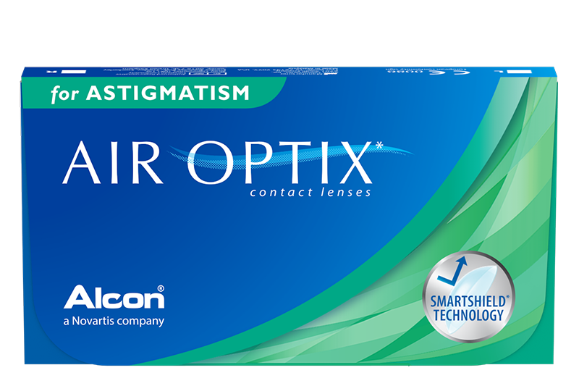

Product information

|  |  |
| --- | --- |
| **Brands** | Air Optix |
| **Availability** | While supplies last. This product is being discontinued by the manufacturer. |
| **Replacement** | Monthly |
| **Material** | 67% lotrafilcon B polymer, 33% H2O |

Description

**AIR OPTIX® for Astigmatism contact lenses are specially designed with two unique technologies to give you moisture and consistent comfort. Air Optix are generally worn up to 4 weeks depending on your doctor's recommendation.  
  
*Limited time offer. While supplies last. Only on your Air Optix for Astigmatism order on this website. Discount applied on the current website price at the time of order. Cannot be combined with any other offers. Promotions are subject to change without notice. We reserve the right to cancel orders that are in breach of the terms and conditions of this offer.**