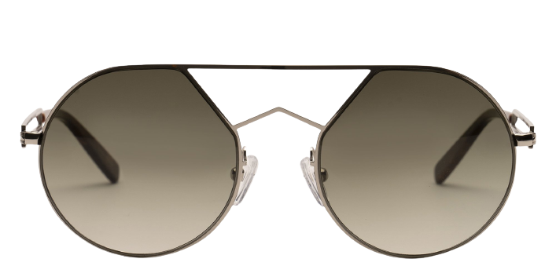 **Blood Sun**

|  |  |
| --- | --- |
| **Brand** | kits |
| **Gender** | unisex |
| **Lenses** | Prescription lenses available |
| **Material** | metal |

**Product Information**

**Description**

**For aviator inspired eyewear with a sleek, modern aesthetic, reach for the Blood sunglasses from KITS. The durable metal frames are exceptionally sturdy, and the double bridge adds stability and style. With thoughtfully shaped temple tips in acetate, these stylish frames take comfort to the next level. Please note these frames are best suited to those with average/medium sized faces.**

|  |
| --- |
| **What you'll get:**   * **Optical grade sun lenses with 100% UV protection.** * **Soft case and cleaning cloth.** * **Unconditional 30 days return policy.  Free return shipping.** |