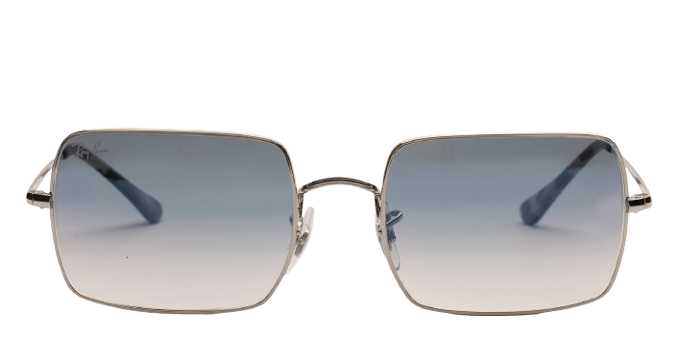 **Ray-ban_rb1969**

Product information

|  |  |
| --- | --- |
| **Brands** | Ray-ban |
| **Gender** | Unisex |
| **Lenses** | Prescription lenses available |
| **Material** | Eco Acetate |

Description

**Look sharp in the stylish Ray-Ban RB1969 sunglasses. Crafted in the style of Ray-Ban's popular silhouette, these rectangular frames feature an on-trend double bridge that adds to their militaristic look. Ray-Ban makes the RB1969 in a corrosion-resistant metal, with flexible temple tips to help secure the fit. Enjoy no-nonsense style and exceptional comfort wearing RB1969 sunglasses by Ray-Ban.**

|  |
| --- |
| What You’ll Get   * **Optical grade sun lenses with 100% UV protection.** * **Designer case and cloth.** * **Unconditional 30 days return policy. Free return shipping.** |