LE CROSSOVER

×

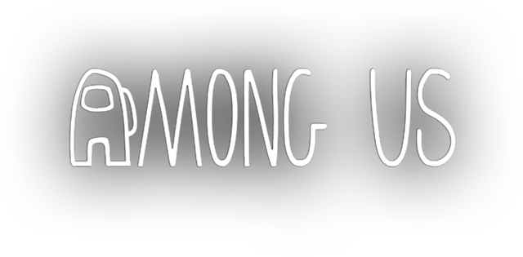

MADE IN NORMALUX !