Students’ Social Media Addiction
Kwizera Mugwaneza Frank
2025-11-10
6 Research Questions:
1. “Is daily social media usage hours associated with academic performance?”

Variables involved:
- Avg_Daily_Usage_Hours: Quantitative The average number of hours per day the student spends on social media platforms, calculated from self-reported weekday and weekend usage estimates.
- Affects_Academic_Performance: Categorical A binary indicator (“Yes”/“No”) reflecting whether the student perceives their social media use as having a negative impact on their academic performance.
2. “Is social media addiction level associated with relationship satisfaction?”

Variables involved:
- Addicted_Score: Categorical A composite score from 1 (low addiction) to 10 (high addiction) based on a standardized survey scale (e.g., Bergen Social Media Addiction Scale), quantifying the degree of problematic usage.
- Conflicts_Over_Social_Media: Qualitative The number of arguments or disagreements the student reports having had with family, friends, or partners due to their social media use, serving as a proxy for social friction.
3. “Is age associated with social media addiction severity?”

Variables involved:
- Age: Quantitative The student’s age in completed years at the time of the survey, used to segment analysis by age group and control for developmental differences.
- Addicted_Score: Categorical A composite score from 1 (low addiction) to 10 (high addiction) based on a standardized survey scale (e.g., Bergen Social Media Addiction Scale), quantifying the degree of problematic usage.
4. “Is country of residence associated with social media usage patterns?”
5. “Is frequency of checking social media associated with academic engagement?”
6. “Is preferred social media platform associated with addiction level?”

1. Load data set(s) and libraries
## Load Packages
library(readr)
library(descr)
library(stats)
## Load Data
Data<-read.csv("C:\\Users\\kwize\\Documents\\Ashesi\\Statistics\\Project\\Project2\\Students_Social_Media_Addiction.csv")
## View Data
#View(Data)
# Construct a Frequency Table
freq(Data$Age)
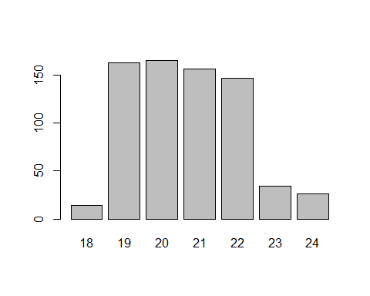
## Data$Age
## Frequency Percent
## 18 14 1.986
## 19 163 23.121
## 20 165 23.404
## 21 156 22.128
## 22 147 20.851
## 23 34 4.823
## 24 26 3.688
## Total 705 100.000
## Construct a histogram
hist(Data$Age)
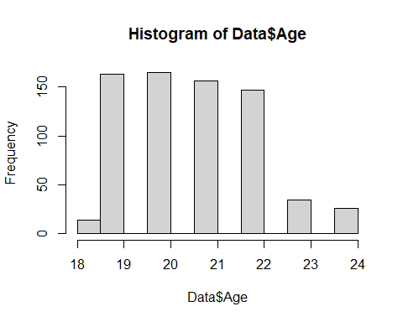
## Summary
summary(Data$Age)
## Min. 1st Qu. Median Mean 3rd Qu. Max.
## 18.00 19.00 21.00 20.66 22.00 24.00

2. Create variable subset

3. Data management I: check for and recode errors and NAs, if the need be.

4. Data management II: further subset and create secondary variable, if the need be.

5. Descriptive statistics (sample means, standard deviations, proportions) and univariate displays

6. Bivariate tables and graphs

7. Bivariate analysis (hypothesis tests and post-hoc tests)

8. Moderation

9. Save

