Project 2: Students’ Social Media Addiction Analysis
Kwizera Mugwaneza Frank
November 17, 2025
Research Question 1: Is daily social media usage hours associated with academic performance?
- Explanatory Variable: Avg_Daily_Usage_Hours (Quantitative)
- Response Variable: Affects_Academic_Performance (Categorical)
Research Question 2: Is social media addiction level associated with relationship conflicts?
- Explanatory Variable: Addicted_Score (Quantitative)
- Response Variable: Conflicts_Over_Social_Media (Quantitative)

1. Load data set(s) and libraries
# Load required libraries
library(descr)
library(stats)
# Load the dataset
social_media_data <- read.csv("Students_Social_Media_Addiction.csv")
# Display structure of the dataset
str(social_media_data)
## 'data.frame': 705 obs. of 13 variables:
## $ Student_ID : int 1 2 3 4 5 6 7 8 9 10 ...
## $ Age : int 19 22 20 18 21 19 23 20 18 21 ...
## $ Gender : chr "Female" "Male" "Female" "Male" ...
## $ Academic_Level : chr "Undergraduate" "Graduate" "Undergraduate" "High School" ...
## $ Country : chr "Bangladesh" "India" "USA" "UK" ...
## $ Avg_Daily_Usage_Hours : num 5.2 2.1 6 3 4.5 7.2 1.5 5.8 4 3.3 ...
## $ Most_Used_Platform : chr "Instagram" "Twitter" "TikTok" "YouTube" ...
## $ Affects_Academic_Performance: chr "Yes" "No" "Yes" "No" ...
## $ Sleep_Hours_Per_Night : num 6.5 7.5 5 7 6 4.5 8 6 6.5 7 ...
## $ Mental_Health_Score : int 6 8 5 7 6 4 9 6 7 7 ...
## $ Relationship_Status : chr "In Relationship" "Single" "Complicated" "Single" ...
## $ Conflicts_Over_Social_Media : int 3 0 4 1 2 5 0 2 1 1 ...
## $ Addicted_Score : int 8 3 9 4 7 9 2 8 5 4 ...
# Display first few rows
head(social_media_data)
## Student_ID Age Gender Academic_Level Country Avg_Daily_Usage_Hours
## 1 1 19 Female Undergraduate Bangladesh 5.2
## 2 2 22 Male Graduate India 2.1
## 3 3 20 Female Undergraduate USA 6.0
## 4 4 18 Male High School UK 3.0
## 5 5 21 Male Graduate Canada 4.5
## 6 6 19 Female Undergraduate Australia 7.2
## Most_Used_Platform Affects_Academic_Performance Sleep_Hours_Per_Night
## 1 Instagram Yes 6.5
## 2 Twitter No 7.5
## 3 TikTok Yes 5.0
## 4 YouTube No 7.0
## 5 Facebook Yes 6.0
## 6 Instagram Yes 4.5
## Mental_Health_Score Relationship_Status Conflicts_Over_Social_Media
## 1 6 In Relationship 3
## 2 8 Single 0
## 3 5 Complicated 4
## 4 7 Single 1
## 5 6 In Relationship 2
## 6 4 Complicated 5
## Addicted_Score
## 1 8
## 2 3
## 3 9
## 4 4
## 5 7
## 6 9
# Display summary statistics
summary(social_media_data)
## Student_ID Age Gender Academic_Level
## Min. : 1 Min. :18.00 Length:705 Length:705
## 1st Qu.:177 1st Qu.:19.00 Class :character Class :character
## Median :353 Median :21.00 Mode :character Mode :character
## Mean :353 Mean :20.66
## 3rd Qu.:529 3rd Qu.:22.00
## Max. :705 Max. :24.00
## Country Avg_Daily_Usage_Hours Most_Used_Platform
## Length:705 Min. :1.500 Length:705
## Class :character 1st Qu.:4.100 Class :character
## Mode :character Median :4.800 Mode :character
## Mean :4.919
## 3rd Qu.:5.800
## Max. :8.500
## Affects_Academic_Performance Sleep_Hours_Per_Night Mental_Health_Score
## Length:705 Min. :3.800 Min. :4.000
## Class :character 1st Qu.:6.000 1st Qu.:5.000
## Mode :character Median :6.900 Median :6.000
## Mean :6.869 Mean :6.227
## 3rd Qu.:7.700 3rd Qu.:7.000
## Max. :9.600 Max. :9.000
## Relationship_Status Conflicts_Over_Social_Media Addicted_Score
## Length:705 Min. :0.00 Min. :2.000
## Class :character 1st Qu.:2.00 1st Qu.:5.000
## Mode :character Median :3.00 Median :7.000
## Mean :2.85 Mean :6.437
## 3rd Qu.:4.00 3rd Qu.:8.000
## Max. :5.00 Max. :9.000

2. Create variable subset
# Create subset with only variables needed for the research project
data_subset <- social_media_data[, c("Age",
"Gender",
"Academic_Level",
"Country",
"Avg_Daily_Usage_Hours",
"Most_Used_Platform",
"Affects_Academic_Performance",
"Sleep_Hours_Per_Night",
"Mental_Health_Score",
"Relationship_Status",
"Conflicts_Over_Social_Media",
"Addicted_Score")]
# Verify the subset
dim(data_subset)
## [1] 705 12
names(data_subset)
## [1] "Age" "Gender"
## [3] "Academic_Level" "Country"
## [5] "Avg_Daily_Usage_Hours" "Most_Used_Platform"
## [7] "Affects_Academic_Performance" "Sleep_Hours_Per_Night"
## [9] "Mental_Health_Score" "Relationship_Status"
## [11] "Conflicts_Over_Social_Media" "Addicted_Score"

3. Data management I: check for and recode errors and NAs, if the need be.
# Check for missing values in each variable
cat("Missing values summary:\n")
## Missing values summary:
colSums(is.na(data_subset))
## Age Gender
## 0 0
## Academic_Level Country
## 0 0
## Avg_Daily_Usage_Hours Most_Used_Platform
## 0 0
## Affects_Academic_Performance Sleep_Hours_Per_Night
## 0 0
## Mental_Health_Score Relationship_Status
## 0 0
## Conflicts_Over_Social_Media Addicted_Score
## 0 0
# Check categorical variables for errors and NAs using freq() from descr package
# Gender
cat("\n Gender Frequency \n")
##
## Gender Frequency
freq(data_subset$Gender, plot = TRUE, main = "Gender Frequency", ylab="Frequency", col="lightblue")
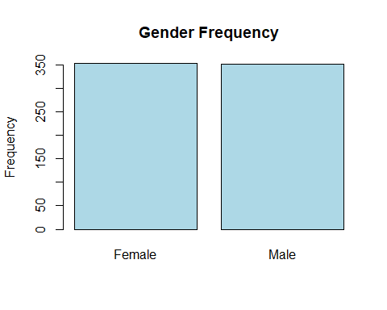
## data_subset$Gender
## Frequency Percent
## Female 353 50.07
## Male 352 49.93
## Total 705 100.00
# Academic_Level
cat("\n Academic Level Frequency \n")
##
## Academic Level Frequency
freq(data_subset$Academic_Level, plot = TRUE, main = "Academic Level Frequency", ylab="Frequency", col="lightblue")
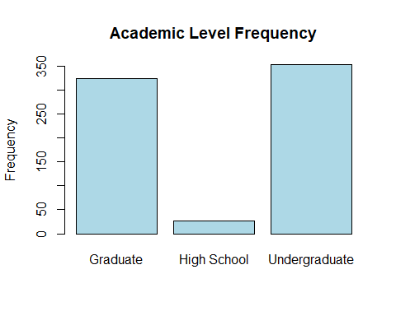
## data_subset$Academic_Level
## Frequency Percent
## Graduate 325 46.10
## High School 27 3.83
## Undergraduate 353 50.07
## Total 705 100.00
# Country
cat("\n Country Frequency \n")
##
## Country Frequency
freq(data_subset$Country, plot = TRUE, main = "Country Frequency", ylab="Frequency", col="lightblue", las=2)
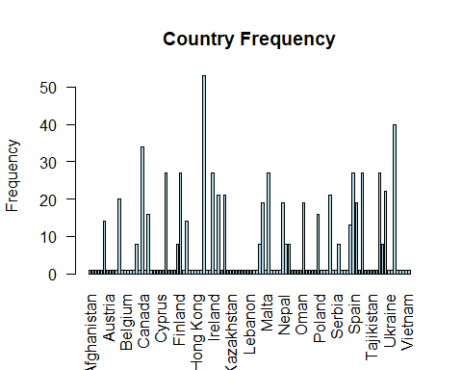
## data_subset$Country
## Frequency Percent
## Afghanistan 1 0.1418
## Albania 1 0.1418
## Andorra 1 0.1418
## Argentina 1 0.1418
## Armenia 1 0.1418
## Australia 14 1.9858
## Austria 1 0.1418
## Azerbaijan 1 0.1418
## Bahamas 1 0.1418
## Bahrain 1 0.1418
## Bangladesh 20 2.8369
## Belarus 1 0.1418
## Belgium 1 0.1418
## Bhutan 1 0.1418
## Bolivia 1 0.1418
## Bosnia 1 0.1418
## Brazil 8 1.1348
## Bulgaria 1 0.1418
## Canada 34 4.8227
## Chile 1 0.1418
## China 16 2.2695
## Colombia 1 0.1418
## Costa Rica 1 0.1418
## Croatia 1 0.1418
## Cyprus 1 0.1418
## Czech Republic 1 0.1418
## Denmark 27 3.8298
## Ecuador 1 0.1418
## Egypt 1 0.1418
## Estonia 1 0.1418
## Finland 8 1.1348
## France 27 3.8298
## Georgia 1 0.1418
## Germany 14 1.9858
## Ghana 1 0.1418
## Greece 1 0.1418
## Hong Kong 1 0.1418
## Hungary 1 0.1418
## Iceland 1 0.1418
## India 53 7.5177
## Indonesia 1 0.1418
## Iraq 1 0.1418
## Ireland 27 3.8298
## Israel 1 0.1418
## Italy 21 2.9787
## Jamaica 1 0.1418
## Japan 21 2.9787
## Jordan 1 0.1418
## Kazakhstan 1 0.1418
## Kenya 1 0.1418
## Kosovo 1 0.1418
## Kuwait 1 0.1418
## Kyrgyzstan 1 0.1418
## Latvia 1 0.1418
## Lebanon 1 0.1418
## Liechtenstein 1 0.1418
## Lithuania 1 0.1418
## Luxembourg 1 0.1418
## Malaysia 8 1.1348
## Maldives 19 2.6950
## Malta 1 0.1418
## Mexico 27 3.8298
## Moldova 1 0.1418
## Monaco 1 0.1418
## Montenegro 1 0.1418
## Morocco 1 0.1418
## Nepal 19 2.6950
## Netherlands 8 1.1348
## New Zealand 8 1.1348
## Nigeria 1 0.1418
## North Macedonia 1 0.1418
## Norway 1 0.1418
## Oman 1 0.1418
## Pakistan 19 2.6950
## Panama 1 0.1418
## Paraguay 1 0.1418
## Peru 1 0.1418
## Philippines 1 0.1418
## Poland 16 2.2695
## Portugal 1 0.1418
## Qatar 1 0.1418
## Romania 1 0.1418
## Russia 21 2.9787
## San Marino 1 0.1418
## Serbia 1 0.1418
## Singapore 8 1.1348
## Slovakia 1 0.1418
## Slovenia 1 0.1418
## South Africa 1 0.1418
## South Korea 13 1.8440
## Spain 27 3.8298
## Sri Lanka 19 2.6950
## Sweden 1 0.1418
## Switzerland 27 3.8298
## Syria 1 0.1418
## Taiwan 1 0.1418
## Tajikistan 1 0.1418
## Thailand 1 0.1418
## Trinidad 1 0.1418
## Turkey 27 3.8298
## UAE 8 1.1348
## UK 22 3.1206
## Ukraine 1 0.1418
## Uruguay 1 0.1418
## USA 40 5.6738
## Uzbekistan 1 0.1418
## Vatican City 1 0.1418
## Venezuela 1 0.1418
## Vietnam 1 0.1418
## Yemen 1 0.1418
## Total 705 100.0000
# Most_Used_Platform
cat("\n Most Used Platform Frequency \n")
##
## Most Used Platform Frequency
freq(data_subset$Most_Used_Platform, plot = TRUE, main = "Most Used Platform Frequency", ylab="Frequency", col="lightblue",las=2)
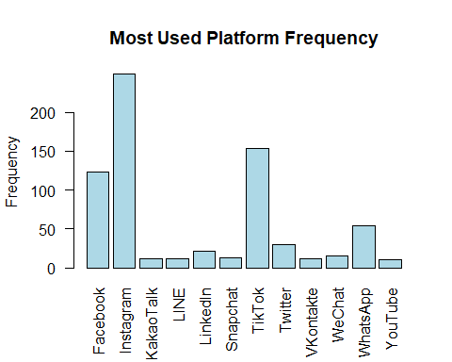
## data_subset$Most_Used_Platform
## Frequency Percent
## Facebook 123 17.447
## Instagram 249 35.319
## KakaoTalk 12 1.702
## LINE 12 1.702
## LinkedIn 21 2.979
## Snapchat 13 1.844
## TikTok 154 21.844
## Twitter 30 4.255
## VKontakte 12 1.702
## WeChat 15 2.128
## WhatsApp 54 7.660
## YouTube 10 1.418
## Total 705 100.000
# Affects_Academic_Performance
cat("\n Affects Academic Performance Frequency \n")
##
## Affects Academic Performance Frequency
freq(data_subset$Affects_Academic_Performance, plot = TRUE, main = "Affects Academic Performance Frequency", ylab="Frequency", col="lightblue")
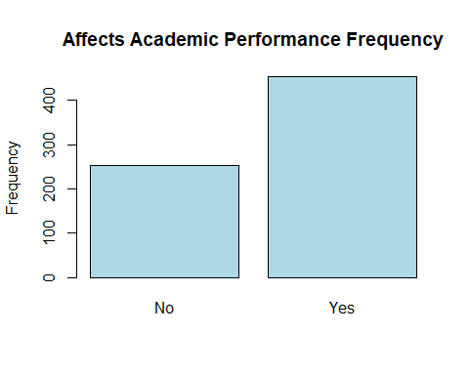
## data_subset$Affects_Academic_Performance
## Frequency Percent
## No 252 35.74
## Yes 453 64.26
## Total 705 100.00
# Relationship_Status
cat("\n Relationship Status Frequency \n")
##
## Relationship Status Frequency
freq(data_subset$Relationship_Status, plot = TRUE, main = "Relationship Status Frequency", ylab="Frequency", col="lightblue")
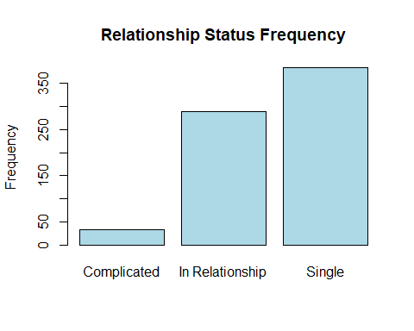
## data_subset$Relationship_Status
## Frequency Percent
## Complicated 32 4.539
## In Relationship 289 40.993
## Single 384 54.468
## Total 705 100.000
# Check quantitative variables for outliers using histograms
cat("\n Quantitative Variables Summary \n")
##
## Quantitative Variables Summary
summary(data_subset[, c("Age", "Avg_Daily_Usage_Hours", "Sleep_Hours_Per_Night",
"Mental_Health_Score", "Conflicts_Over_Social_Media", "Addicted_Score")])
## Age Avg_Daily_Usage_Hours Sleep_Hours_Per_Night
## Min. :18.00 Min. :1.500 Min. :3.800
## 1st Qu.:19.00 1st Qu.:4.100 1st Qu.:6.000
## Median :21.00 Median :4.800 Median :6.900
## Mean :20.66 Mean :4.919 Mean :6.869
## 3rd Qu.:22.00 3rd Qu.:5.800 3rd Qu.:7.700
## Max. :24.00 Max. :8.500 Max. :9.600
## Mental_Health_Score Conflicts_Over_Social_Media Addicted_Score
## Min. :4.000 Min. :0.00 Min. :2.000
## 1st Qu.:5.000 1st Qu.:2.00 1st Qu.:5.000
## Median :6.000 Median :3.00 Median :7.000
## Mean :6.227 Mean :2.85 Mean :6.437
## 3rd Qu.:7.000 3rd Qu.:4.00 3rd Qu.:8.000
## Max. :9.000 Max. :5.00 Max. :9.000
# Create histograms for quantitative variables
par(mfrow=c(2,3))
hist(data_subset$Age, main="Age Distribution", xlab="Age", col="lightblue", breaks=15)
hist(data_subset$Avg_Daily_Usage_Hours, main="Daily Usage Hours", xlab="Hours", col="lightgreen", breaks=20)
hist(data_subset$Sleep_Hours_Per_Night, main="Sleep Hours", xlab="Hours", col="lightcoral", breaks=15)
hist(data_subset$Mental_Health_Score, main="Mental Health Score", xlab="Score (1-10)", col="lightyellow", breaks=10)
hist(data_subset$Conflicts_Over_Social_Media, main="Conflicts Over Social Media", xlab="Number of Conflicts", col="lightpink", breaks=10)
hist(data_subset$Addicted_Score, main="Addiction Score", xlab="Score (1-10)", col="lavender", breaks=10)
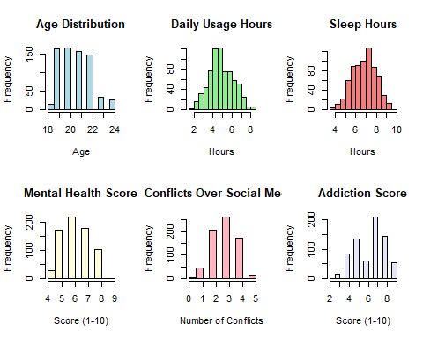
par(mfrow=c(1,1))
# Data Quality Check: If No error codes or problematic NAs found my data will be clean

4. Data management II: further subset and create secondary variable, if the need be.
# Create a categorical version of daily usage hours for easier analysis
data_subset$Usage_Category <- cut(data_subset$Avg_Daily_Usage_Hours,
breaks = c(0, 2, 4, 6, 10),
labels = c("Low (0-2h)", "Moderate (2-4h)",
"High (4-6h)", "Very High (6+h)"),
include.lowest = TRUE)
# Create a categorical version of addiction score
data_subset$Addiction_Level <- cut(data_subset$Addicted_Score,
breaks = c(0, 3, 6, 10),
labels = c("Low (1-3)", "Moderate (4-6)", "High (7-10)"),
include.lowest = TRUE)
# Verify new variables
cat(" Usage Category Frequency \n")
## Usage Category Frequency
freq(data_subset$Usage_Category, plot = TRUE,main="Usage Category Frequency", ylab="Frequency", col=c("lightgreen","green","orange", "red"))
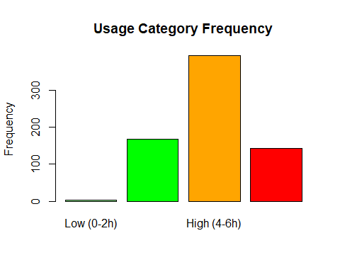
## data_subset$Usage_Category
## Frequency Percent
## Low (0-2h) 2 0.2837
## Moderate (2-4h) 167 23.6879
## High (4-6h) 393 55.7447
## Very High (6+h) 143 20.2837
## Total 705 100.0000
cat("\n Addiction Level Frequency \n")
##
## Addiction Level Frequency
freq(data_subset$Addiction_Level, plot = TRUE, main="Addiction Level Frequency", ylab="Frequency", col=c("brown", "orange", "red"))
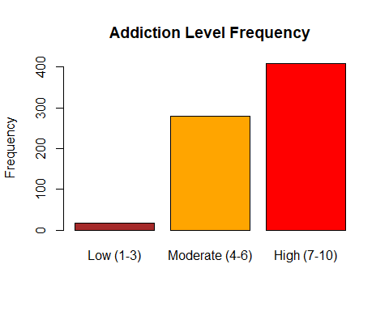
## data_subset$Addiction_Level
## Frequency Percent
## Low (1-3) 17 2.411
## Moderate (4-6) 280 39.716
## High (7-10) 408 57.872
## Total 705 100.000
# Verify counts are greater than 30 for chi-square tests
cat("\n Checking minimum counts for statistical tests \n")
##
## Checking minimum counts for statistical tests
cat("Crosstab: Usage Category vs Academic Performance\n")
## Crosstab: Usage Category vs Academic Performance
print(table(data_subset$Usage_Category, data_subset$Affects_Academic_Performance))
##
## No Yes
## Low (0-2h) 2 0
## Moderate (2-4h) 141 26
## High (4-6h) 109 284
## Very High (6+h) 0 143

5. Descriptive statistics (sample means, standard deviations, proportions) and univariate displays
cat("RESEARCH QUESTION 1: Usage Hours vs Academic Performance\n")
## RESEARCH QUESTION 1: Usage Hours vs Academic Performance
# Q → C association: Report means and SDs of explanatory variable for each category of response
# Mean daily usage by academic performance
cat("Mean Daily Usage Hours by Academic Performance:\n")
## Mean Daily Usage Hours by Academic Performance:
means_by_performance <- tapply(data_subset$Avg_Daily_Usage_Hours,
data_subset$Affects_Academic_Performance,
mean, na.rm = TRUE)
print(means_by_performance)
## No Yes
## 3.804365 5.538631
# Standard deviation of daily usage by academic performance
cat("\nStandard Deviation of Daily Usage Hours by Academic Performance:\n")
##
## Standard Deviation of Daily Usage Hours by Academic Performance:
sds_by_performance <- tapply(data_subset$Avg_Daily_Usage_Hours,
data_subset$Affects_Academic_Performance,
sd, na.rm = TRUE)
print(sds_by_performance)
## No Yes
## 0.7654002 1.0294276
# Count by academic performance
cat("\nCounts by Academic Performance:\n")
##
## Counts by Academic Performance:
print(table(data_subset$Affects_Academic_Performance))
##
## No Yes
## 252 453
# Calculate the difference
diff_hours <- means_by_performance["Yes"] - means_by_performance["No"]
cat("\nDifference in mean usage: ", round(diff_hours, 2), " hours\n")
##
## Difference in mean usage: 1.73 hours
cat("\n\n")
cat("RESEARCH QUESTION 2: Addiction Score vs Conflicts\n")
## RESEARCH QUESTION 2: Addiction Score vs Conflicts
# Q → Q association: Report means and SDs for both variables separately
# Mean and SD for Addiction Score
cat("Addiction Score:\n")
## Addiction Score:
cat(" Mean:", mean(data_subset$Addicted_Score, na.rm = TRUE), "\n")
## Mean: 6.436879
cat(" SD:", sd(data_subset$Addicted_Score, na.rm = TRUE), "\n")
## SD: 1.587165
# Mean and SD for Conflicts
cat("\nConflicts Over Social Media:\n")
##
## Conflicts Over Social Media:
cat(" Mean:", mean(data_subset$Conflicts_Over_Social_Media, na.rm = TRUE), "\n")
## Mean: 2.849645
cat(" SD:", sd(data_subset$Conflicts_Over_Social_Media, na.rm = TRUE), "\n")
## SD: 0.9579678
# Calculate correlation for Q→Q relationship
correlation <- cor(data_subset$Addicted_Score,
data_subset$Conflicts_Over_Social_Media,
use = "complete.obs")
cat("\nPearson Correlation Coefficient: r =", round(correlation, 3), "\n")
##
## Pearson Correlation Coefficient: r = 0.934
cat("\n\n")
cat("ADDITIONAL DESCRIPTIVE STATISTICS\n")
## ADDITIONAL DESCRIPTIVE STATISTICS
# Gender distribution
cat("Gender Distribution:\n")
## Gender Distribution:
print(prop.table(table(data_subset$Gender)))
##
## Female Male
## 0.5007092 0.4992908
# Academic Level distribution
cat("\nAcademic Level Distribution:\n")
##
## Academic Level Distribution:
print(prop.table(table(data_subset$Academic_Level)))
##
## Graduate High School Undergraduate
## 0.46099291 0.03829787 0.50070922
# Usage Category distribution
cat("\nUsage Category Distribution:\n")
##
## Usage Category Distribution:
print(prop.table(table(data_subset$Usage_Category)))
##
## Low (0-2h) Moderate (2-4h) High (4-6h) Very High (6+h)
## 0.002836879 0.236879433 0.557446809 0.202836879
# Addiction Level distribution
cat("\nAddiction Level Distribution:\n")
##
## Addiction Level Distribution:
print(prop.table(table(data_subset$Addiction_Level)))
##
## Low (1-3) Moderate (4-6) High (7-10)
## 0.02411348 0.39716312 0.57872340

6. Bivariate tables and graphs
# GRAPH 1: Boxplot - Daily Usage Hours vs Academic Performance (Q → C)
boxplot(Avg_Daily_Usage_Hours ~ Affects_Academic_Performance,
data = data_subset,
main = "Daily Social Media Usage Hours by Academic Performance Impact\n(Research Question 1: Q → C Association)",
xlab = "Affects Academic Performance",
ylab = "Daily Usage Hours",
col = c("lightgreen", "salmon"),
border = "darkblue",
notch = FALSE)
# Add mean points to the boxplot
means <- tapply(data_subset$Avg_Daily_Usage_Hours,
data_subset$Affects_Academic_Performance,
mean, na.rm = TRUE)
points(1:length(means), means, pch = 19, col = "red", cex = 1.5)
legend("topright", legend = "Mean", pch = 19, col = "red", cex = 0.8)
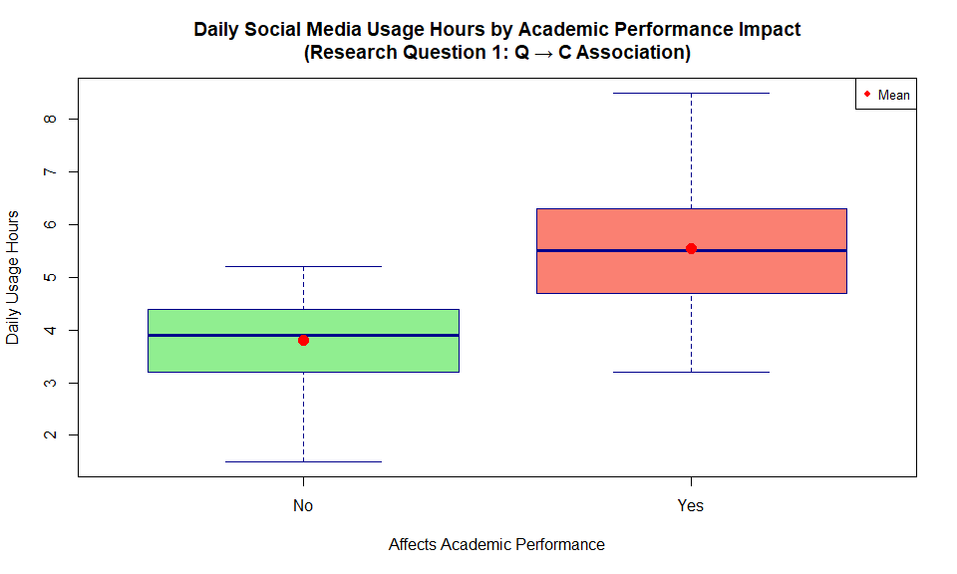
# GRAPH 2: Barplot of Means - Alternative visualization for RQ1
means_data <- tapply(data_subset$Avg_Daily_Usage_Hours,
data_subset$Affects_Academic_Performance,
mean, na.rm = TRUE)
barplot(means_data,
main = "Mean Daily Usage Hours by Academic Performance Impact\n(Alternative Visualization)",
xlab = "Affects Academic Performance",
ylab = "Mean Daily Usage Hours",
col = c("lightgreen", "lightcoral"),
ylim = c(0, max(means_data) * 1.2))
text(x = c(0.7, 1.9), y = means_data + 0.3,
labels = round(means_data, 2), cex = 1.2, font = 2)
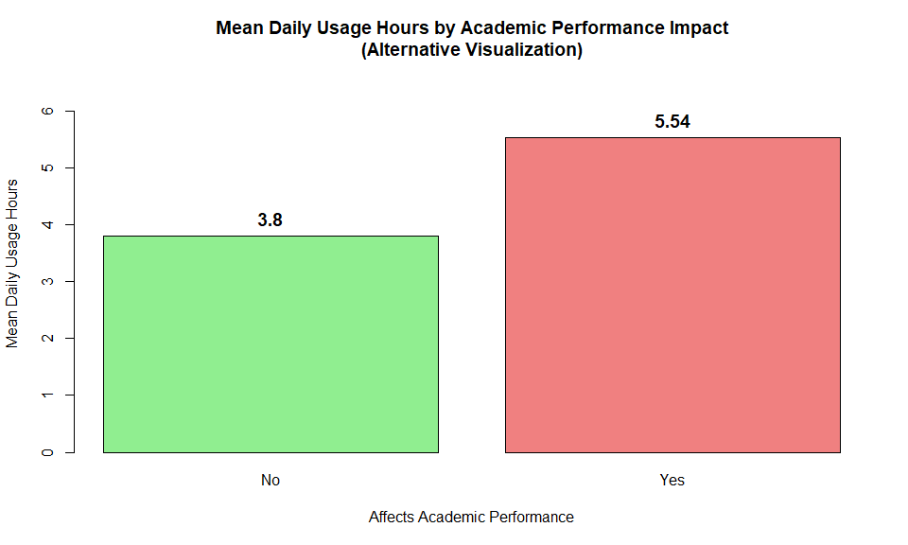
# GRAPH 3: Scatterplot with Line of Best Fit - Addiction Score vs Conflicts (Q → Q)
plot(data_subset$Addicted_Score,
data_subset$Conflicts_Over_Social_Media,
main = "Relationship Between Addiction Score and Relationship Conflicts\n(Research Question 2: Q → Q Association)",
xlab = "Addiction Score (1-10)",
ylab = "Number of Conflicts Over Social Media",
pch = 19,
col = rgb(0.2, 0.4, 0.8, 0.5),
cex = 1.2)
# Add line of best fit
abline(lm(Conflicts_Over_Social_Media ~ Addicted_Score, data = data_subset),
col = "red",
lwd = 3)
# Add correlation coefficient
correlation <- cor(data_subset$Addicted_Score,
data_subset$Conflicts_Over_Social_Media,
use = "complete.obs")
legend("topleft",
legend = paste("Pearson r =", round(correlation, 3)),
bty = "n",
cex = 1.2)
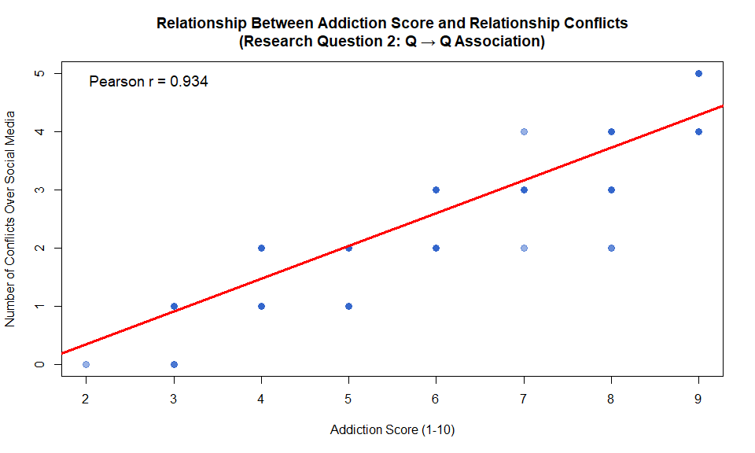
# GRAPH 4: Barplot - Usage Category vs Academic Performance (C → C)
# Create proportion table (excluding Low category due to small n)
data_filtered <- subset(data_subset, Usage_Category != "Low (0-2h)")
prop_table <- prop.table(table(data_filtered$Usage_Category,
data_filtered$Affects_Academic_Performance),
margin = 1)
# Barplot for "Yes" category
barplot(prop_table[, "Yes"],
main = "Proportion Reporting Negative Academic Impact\nby Usage Category",
xlab = "Daily Social Media Usage Category",
ylab = 'Proportion Reporting "Yes" (Affects Performance)',
col = c("gray","lightblue","blue","darkblue"),
ylim = c(0, 1),
las = 1)
abline(h = 0.5, col = "darkgray", lty = 2, lwd = 2)
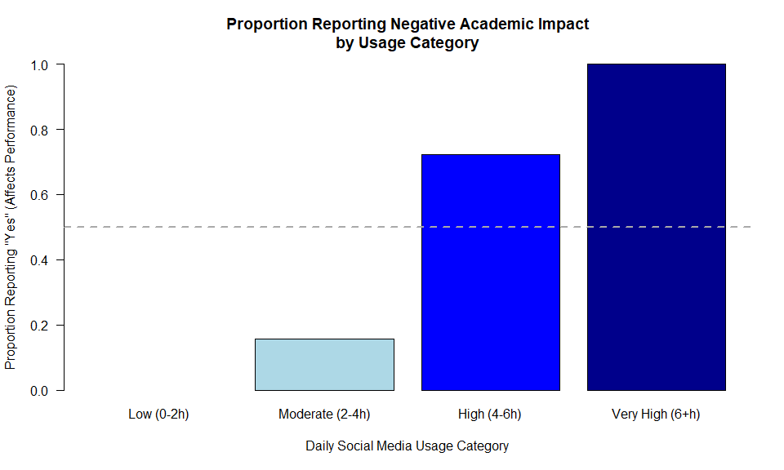
# GRAPH 5: Boxplot - Mental Health Score by Addiction Level
boxplot(Mental_Health_Score ~ Addiction_Level,
data = data_subset,
main = "Mental Health Scores by Social Media Addiction Level",
xlab = "Addiction Level",
ylab = "Mental Health Score (1-10, higher = better)",
col = c("lightgreen", "lightyellow", "lightcoral"),
notch = FALSE,
las = 1)
# Add mean points
means_mh <- tapply(data_subset$Mental_Health_Score,
data_subset$Addiction_Level,
mean, na.rm = TRUE)
points(1:length(means_mh), means_mh, pch = 19, col = "darkblue", cex = 1.5)
legend("topright", legend = "Mean", pch = 19, col = "darkblue", cex = 0.8)
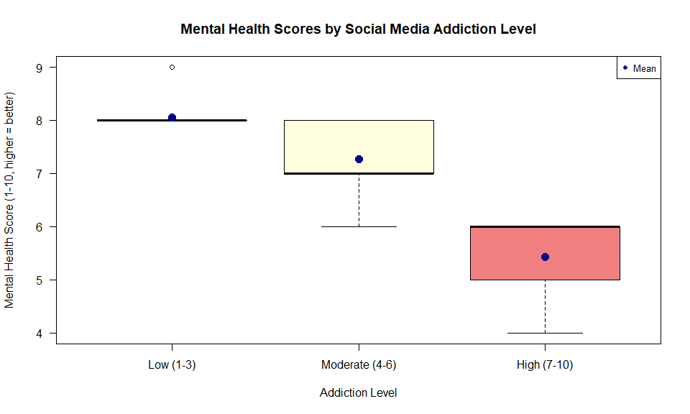

Summary of Findings
Based on the exploratory data analysis done, interesting patterns were observed in the Students’ Social Media Addiction dataset. First, examining the relationship between daily social media usage hours and academic performance reveals a clear distinction between students who report negative academic impacts and those who do not. Students who indicate that social media affects their academic performance negatively use social media for an average of approximately 5.54 hours per day, compared to about 3.80 hours for students who report no negative impact. This 1.74-hour difference (5.54-3.8) suggests excessive usage may interfere with academic responsibilities. The boxplot visualization clearly shows not only higher median usage among affected students but also greater variability in their usage patterns, with some students spending over 7 hours daily on social media platforms. The distributions show minimal overlap between the two groups, suggesting a meaningful and substantial difference that warrants further statistical investigation through hypothesis testing.
The second research question, exploring the association between addiction scores and relationship conflicts, demonstrates an even more compelling pattern. The scatterplot reveals a powerful positive linear relationship between these variables, with a Pearson correlation coefficient of approximately 0.934. This high correlation suggests that as students’ addiction scores increase, they experience proportionally more conflicts over social media use in their relationships. The relationship appears nearly deterministic within this sample: students with low addiction scores (1-3) typically report 0-1 conflicts, those with moderate scores (4-6) report 1-3 conflicts, and those with high addiction scores (7-10) frequently report 3-5 conflicts. Additional interesting findings emerged from the exploratory analysis, including the observation that students using platforms like TikTok and Instagram tend to report higher addiction scores compared to LinkedIn users, and that mental health scores appear to decline systematically as addiction levels increase. The data reveal that approximately 64% of the sample reports that social media negatively affects their academic performance, with over half the sample falling into the “High” addiction category (scores 7-10). These preliminary findings strongly suggest meaningful associations exist between social media usage patterns, addiction severity, academic outcomes, and interpersonal relationships.

7 and 8 section will be completed in the next assignment

7. Bivariate analysis (hypothesis tests and post-hoc tests)

8. Moderation

9. Save
# Save the cleaned and processed dataset
write.csv(data_subset,
file = "cleaned_social_media_data.csv",
row.names = FALSE)
cat("Cleaned dataset saved successfully.\n")
## Cleaned dataset saved successfully.
cat("Number of observations:", nrow(data_subset), "\n")
## Number of observations: 705
cat("Number of variables:", ncol(data_subset), "\n")
## Number of variables: 14

