Burky @ EuroBillTracker

<https://www.eurobilltracker.com/?referer=32954>

Burky

# About

EuroBillTracker (EBT) is an international non-profit volunteer team dedicated to tracking Euro notes around the world. Each user enters the serial numbers and location information for each note they obtain into EuroBillTracker. From this information, the site extracts:

* Diffusion information: Each Euro country has its own range of note serial numbers and from this information we can generate diffusion graphs that tell us how the notes travel to other countries. See the Diffusion section for more information.
* Tracking information: When a note is re-entered, the users who previously entered it are notified via email. These hits can be seen in the statistics section.
* Statistics and rankings: Who enters the most notes, which are the best countries? Where are the notes currently situated?

# User: Burky

## General

Active contribution to EBT was recorded on **6,603 days** between 2004-08-04 and 2022-09-01. Bills were entered on 6,576 days (= 99.59 %) and hits occurred on 3,820 days (= 57.85 %).  
**887,150 bills** (134.36 /day) were entered with a total value of **24,831,760 Euro** (mean = 27.99); **8,840 hits** (= 1.34 /day) occurred (hit-ratio = 1 : 100.36).  
Bills were entered in **1,614** different **locations**.

## Active Periods

Active periods are consecutive days with at least one bill entered. The three longest such periods were:

| From | To | Days | Bills | Value | Hits | BpD | Avg | HitRt |
| --- | --- | --- | --- | --- | --- | --- | --- | --- |
| 2012-03-25 | 2022-09-01 | 3,813 | 631,071 | 15,708,805 | 6,116 | 165.5 | 24.89 | 103.18 |
| 2008-06-22 | 2012-03-06 | 1,354 | 201,195 | 7,546,085 | 2,303 | 148.6 | 37.51 | 87.36 |
| 2006-03-16 | 2007-06-18 | 460 | 15,470 | 489,570 | 87 | 33.6 | 31.65 | 177.82 |

The **three longest periods** cover **5,627 days** (= 85.22%), **847,736 bills** (= 95.56%), a total value of **23,744,460 Euro** (= 95.62%) and **8,506 hits** (= 96.22%).

## Yearly Activity

Active contribution to EBT was recorded in 19 different years. Cumulative entries throughout the recent years look like:

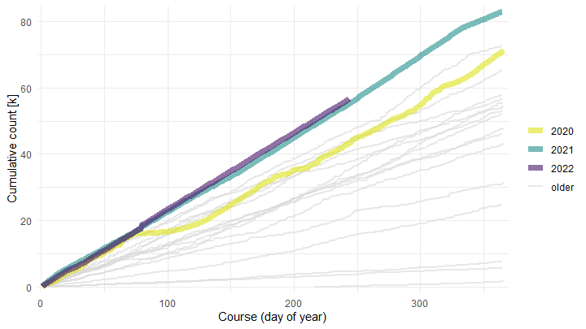

## Monthly Activity

Active contribution to EBT was recorded in 218 different months.  
The seven month with most entered bills were:

| Month | Days | Bills | Value | Hits | BpD | Avg | HitRt |
| --- | --- | --- | --- | --- | --- | --- | --- |
| 2014-10 | 31 | 9,105 | 280,100 | 49 | 293.7 | 30.76 | 185.82 |
| 2020-12 | 31 | 8,324 | 228,720 | 72 | 268.5 | 27.48 | 115.61 |
| 2021-10 | 31 | 7,916 | 147,350 | 102 | 255.4 | 18.61 | 77.61 |
| 2022-03 | 31 | 7,874 | 147,505 | 125 | 254.0 | 18.73 | 62.99 |
| 2021-01 | 31 | 7,790 | 158,610 | 97 | 251.3 | 20.36 | 80.31 |
| 2021-11 | 30 | 7,615 | 144,690 | 101 | 253.8 | 19.00 | 75.40 |
| 2021-09 | 30 | 7,601 | 131,785 | 90 | 253.4 | 17.34 | 84.46 |

The seven months with least entered bills were:

| Month | Days | Bills | Value | Hits | BpD | Avg | HitRt |
| --- | --- | --- | --- | --- | --- | --- | --- |
| 2006-09 | 30 | 377 | 8,960 | 4 | 12.6 | 23.77 | 94.25 |
| 2004-11 | 30 | 341 | 7,755 | 0 | 11.4 | 22.74 | Inf |
| 2004-09 | 30 | 308 | 6,370 | 0 | 10.3 | 20.68 | Inf |
| 2006-03 | 31 | 257 | 6,590 | 3 | 8.3 | 25.64 | 85.67 |
| 2004-10 | 31 | 252 | 7,870 | 1 | 8.1 | 31.23 | 252.00 |
| 2004-08 | 28 | 250 | 5,205 | 0 | 8.9 | 20.82 | Inf |
| 2022-09 | 1 | 225 | 4,150 | 5 | 225.0 | 18.44 | 45.00 |

Graphical representation of the monthly variation:

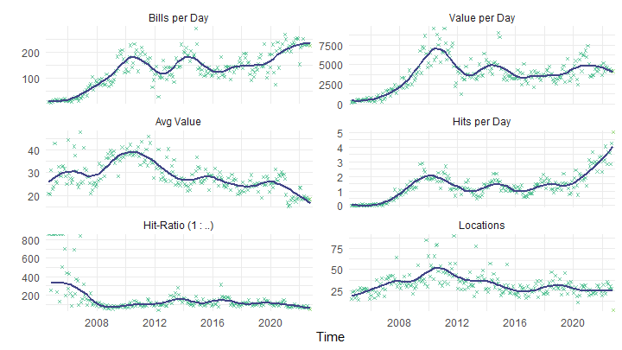

## Denomination

Distribution of entered bills by denomination:

| Denom | Count | C_Pct | Value | V_Pct |
| --- | --- | --- | --- | --- |
| € 5 | 262,238 | 29.56 | 1,311,190 | 5.28 |
| € 10 | 233,162 | 26.28 | 2,331,620 | 9.39 |
| € 20 | 181,960 | 20.51 | 3,639,200 | 14.66 |
| € 50 | 131,077 | 14.78 | 6,553,850 | 26.39 |
| € 100 | 63,355 | 7.14 | 6,335,500 | 25.51 |
| € 200 | 10,062 | 1.13 | 2,012,400 | 8.10 |
| € 500 | 5,296 | 0.60 | 2,648,000 | 10.66 |

Distribution of denominations by year:

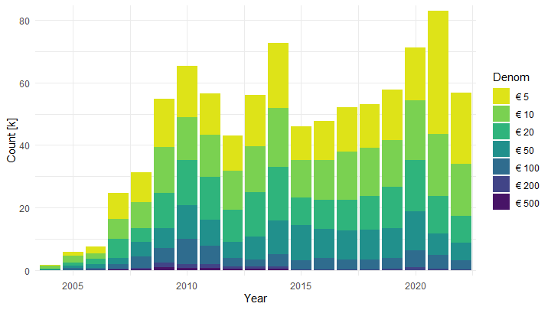

## Hits

The five longest hit streaks were:

| # | From | To | Days | Bills | Value | Hits | BpD | Avg | HitRt |
| --- | --- | --- | --- | --- | --- | --- | --- | --- | --- |
|  | 2021-09-20 | 2021-11-25 | 67 | 17,051 | 316,840 | 233 | 254.5 | 18.58 | 73.18 |
|  | 2021-05-28 | 2021-07-30 | 64 | 14,925 | 292,245 | 188 | 233.2 | 19.58 | 79.39 |
| a | 2022-05-11 | 2022-06-16 | 37 | 8,623 | 159,765 | 135 | 233.1 | 18.53 | 63.87 |
| b | 2022-02-18 | 2022-03-25 | 36 | 8,972 | 162,955 | 158 | 249.2 | 18.16 | 56.78 |
|  | 2021-04-03 | 2021-05-08 | 36 | 7,987 | 128,570 | 131 | 221.9 | 16.10 | 60.97 |
| c | 2022-06-18 | 2022-07-17 | 30 | 6,901 | 135,065 | 93 | 230.0 | 19.57 | 74.20 |

Plot of the 15 most recent hit streaks:

