**Task 1.2**

**STAGE 1**

**ER Diagram:**

**Table Design:**

**STAGE 2**

**1.Display The category name of the products that earns highest profit**

**QUERY:**

select category, product_name, profit

from sales

where profit = (select max(profit) from sales)

**OUTPUT:**

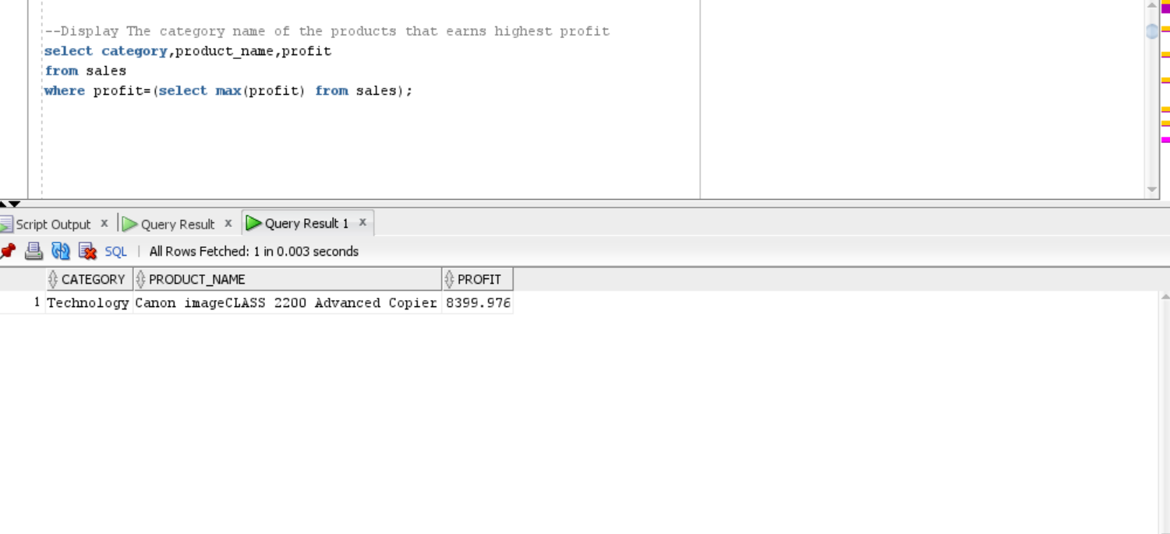

**2.Display Most valuable customer name who has frequently ordered products**

**QUERY:**

select * from (select c.customer_name from customer1 c inner join salemain1 sm

on c.customer_id=sm.customer_id inner join salestable1 s

on s.product_id=sm.product_id

group by c.customer_name order by count(s.quantity) desc) where rownum=1;

**OUTPUT:**

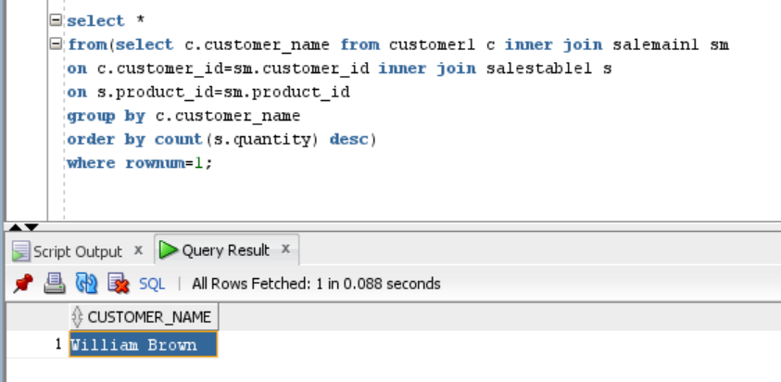

**3.Display The segment and product name which yields highest profit**

**QUERY:**

Select * from (select segment,product_name,profit

from customers c inner join sales_main sm

on c.customer_id=sm.customer_id

inner join sales s

on s.product_id=sm.product_id

where profit=(select max(profit) from sales)

order by (s.product_id),segment desc)

where rownum<=1;

**OUTPUT:**

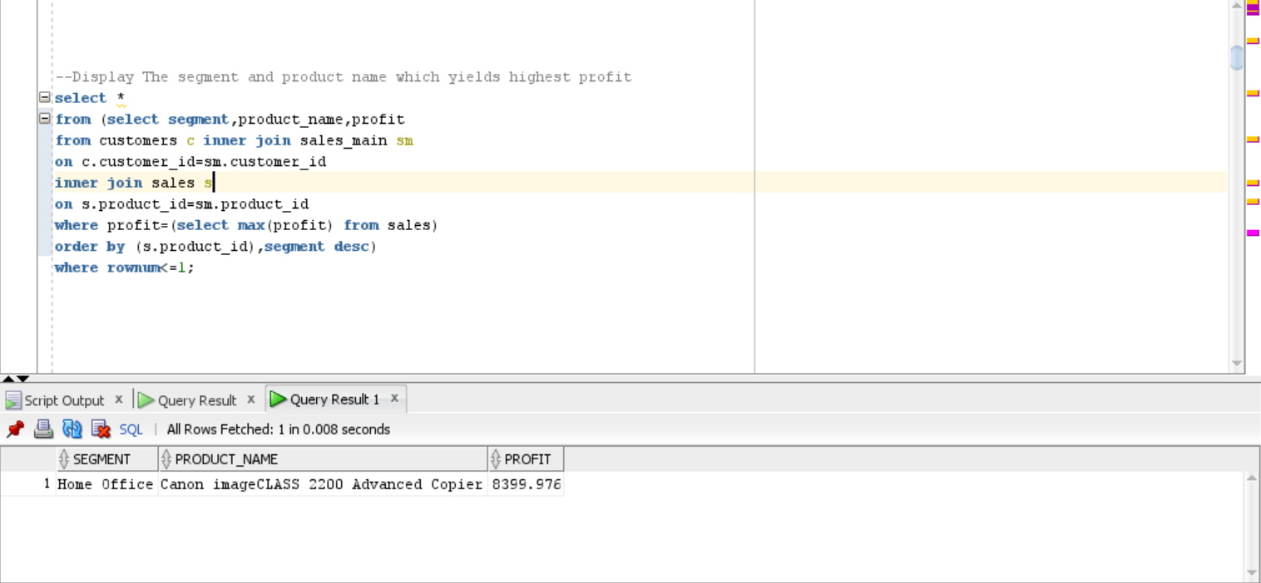

**4.Display name of the City with highest sales**

**QUERY:**

Select city_name,sales

From sales s inner join sales_main sm

on s.product_id=sm.product_id

Inner join city1 c

on c.city_code=sm.city_code

where sales=(select max(sales) from sales);

**OUTPUT**:

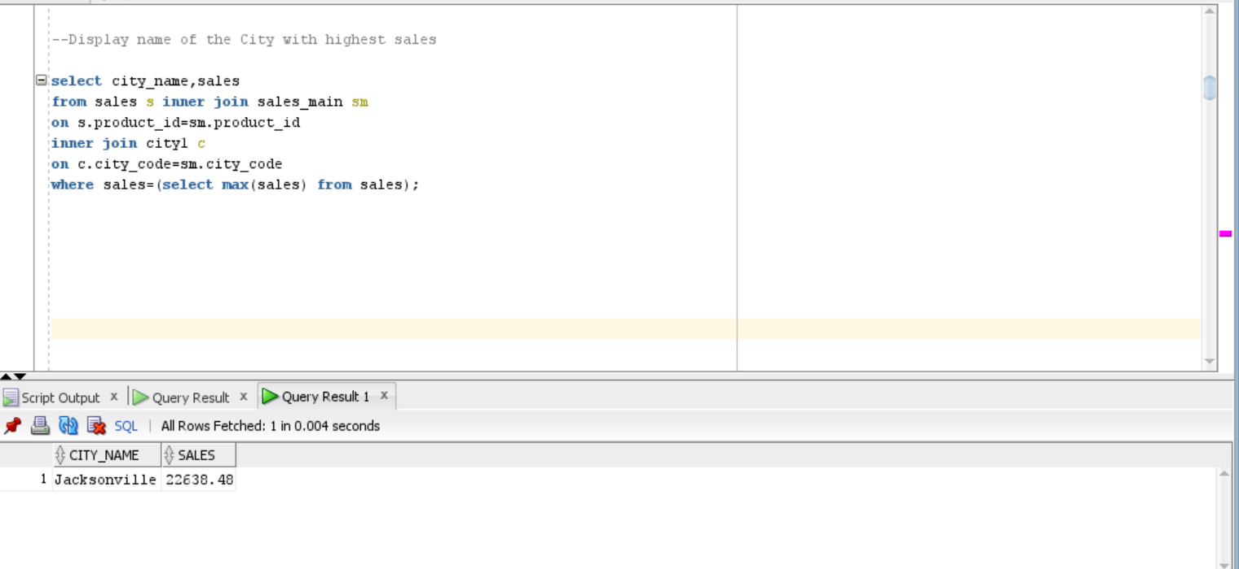

**5. Display Percentage share of profit of every region**

**QUERY:**

select * from(select r.region_name,sum(s.profit) as

total_profit ,round(sum(s.profit)/286397.02*100,2)as percentage from

salestable1 s inner join salemain1 sm

on s.product_id=sm.product_id inner join region1 r

on sm.region_id=r.region_id group by r.region_name

order by percentage desc)

**OUTPUT:**

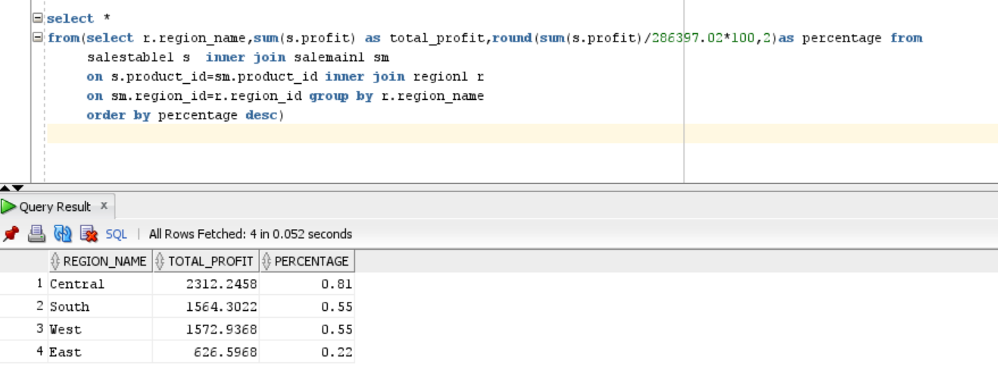

**6) Display Percentage share of sales at every state**

**QUERY:**

select * from(select s1.state,round(sum(s.sales)/2297200.86*100)as

percentage_share from state1 s1 inner join salemain1 sm

on s1.state_code=sm.state_code inner join salestable1 s

on sm.product_id=s.product_id group by s1.state

order by percentage_share desc)

**OUTPUT:**

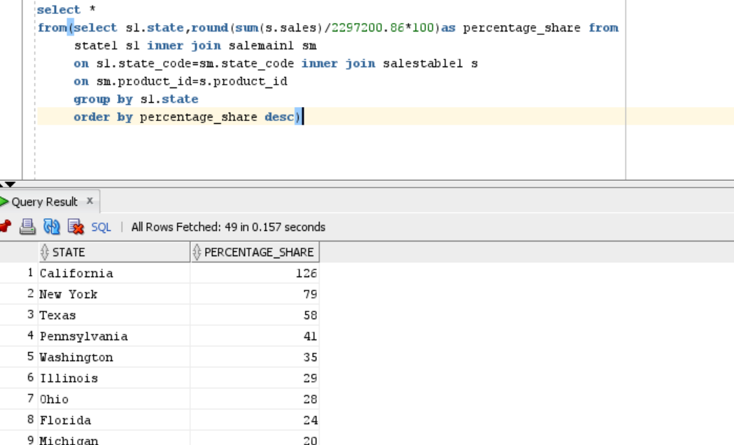

**7.Display the Category of the product with highest demand in each**

**region**

**QUERY:**

select *from(select region_name,category ,product_name

from sales s inner join sales_main sm

on s.product_id=sm.product_id inner join region1 r

on r.region_id=sm.region_id

where category=(select max(category) from sales))

where rownum<=6;

**OUTPUT:**

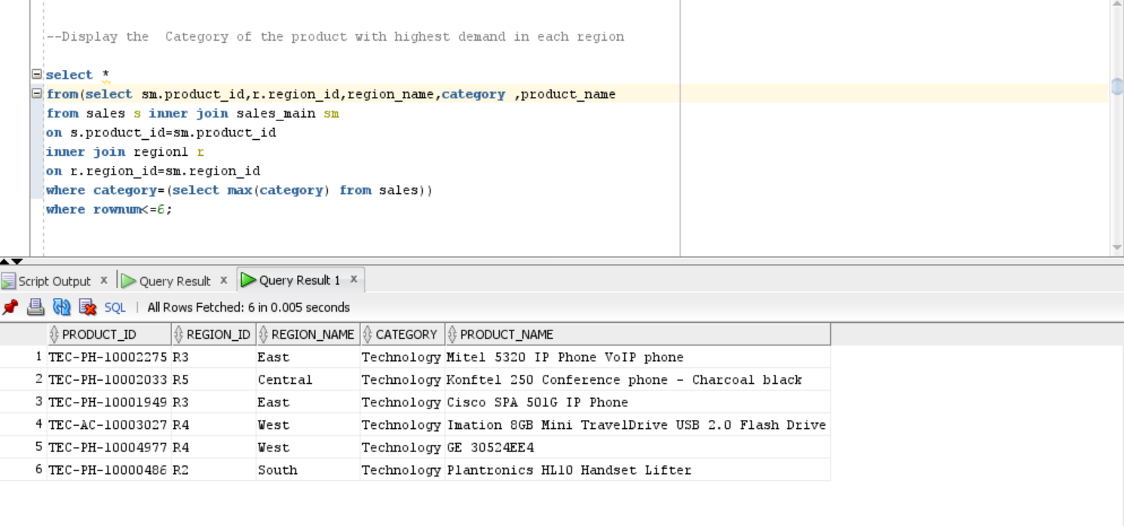

**8.Highest sales in furniture category**

**QUERY:**

select CATEGORY,s.product_ID,c.city_code,CITY_NAME,SALES

from sales s inner join sales_main sm

on s.product_ID=sm.product_id inner join city1 c

on c.city_code=sm.city_code

where SALES=(select max(SALES) from sales where category='Furniture')

order by CITY_NAME,city_code;

**OUTPUT:**

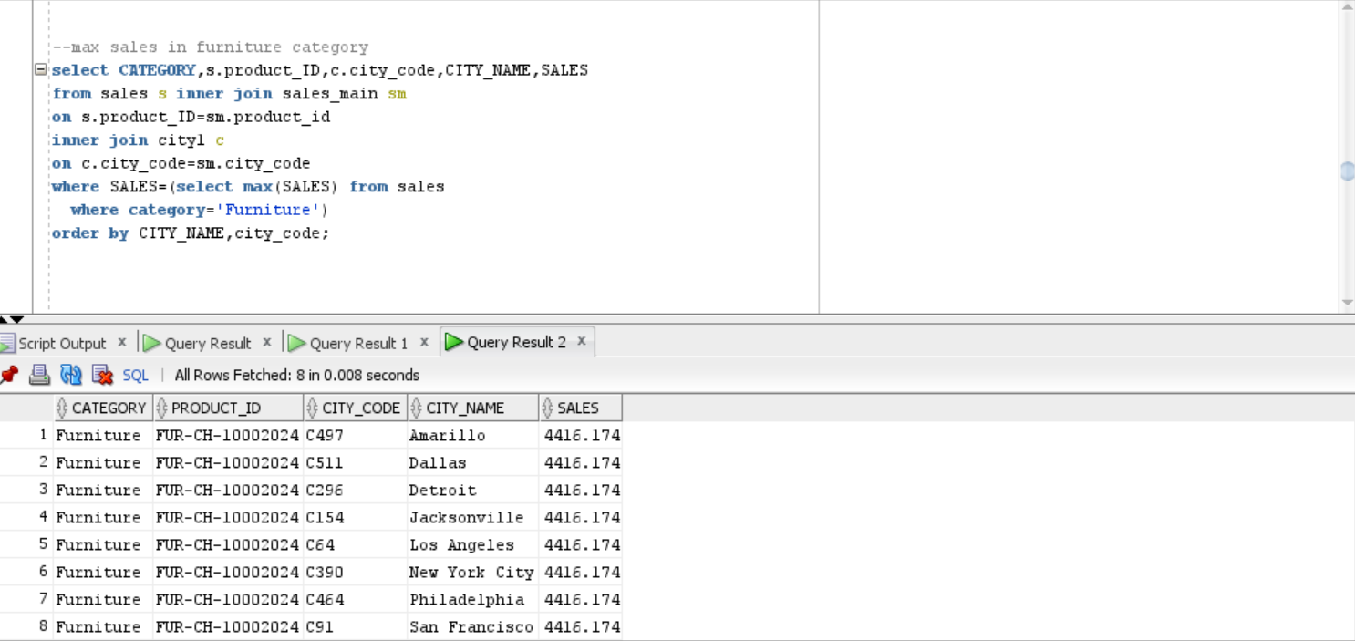

**9.Second highest sales**

**QUERY:**

select CATEGORY,s.product_ID,c.city_code,CITY_NAME,PROFIT,SALES

from sales s inner join sales_main sm

on s.product_ID=sm.product_id inner join city1 c

on c.city_code=sm.city_code

where SALES=(select max(SALES) from sales

where SALES<(select max(SALES) from sales))

order by CITY_NAME;

**OUTPUT:**

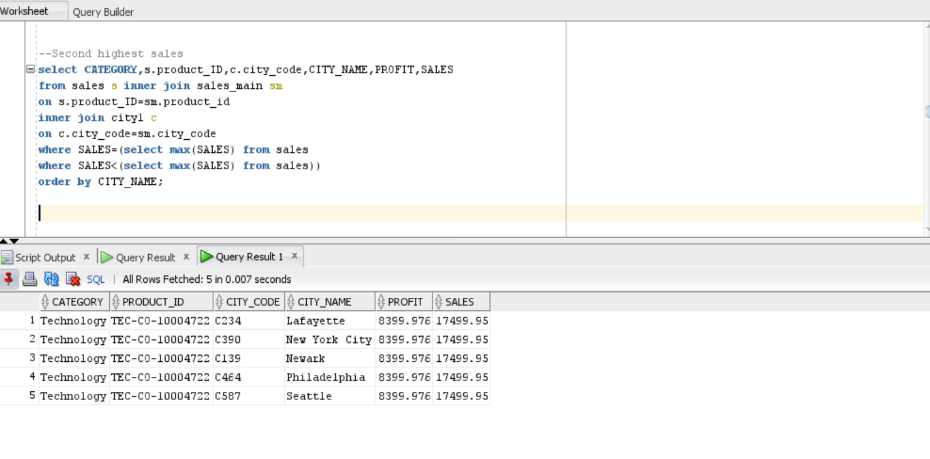

**10.Third highest sales**

**QUERY:**

select CATEGORY,s.product_ID,c.city_code,CITY_NAME,PROFIT,SALES

from sales s inner join sales_main sm

on s.product_ID=sm.product_id

inner join city1 c on c.city_code=sm.city_code

where SALES=(select max(SALES) from sales

where SALES<(select max(SALES) from sales

where SALES<(select max(SALES) from sales)))

order by CITY_NAME,city_code;

**OUTPUT:**

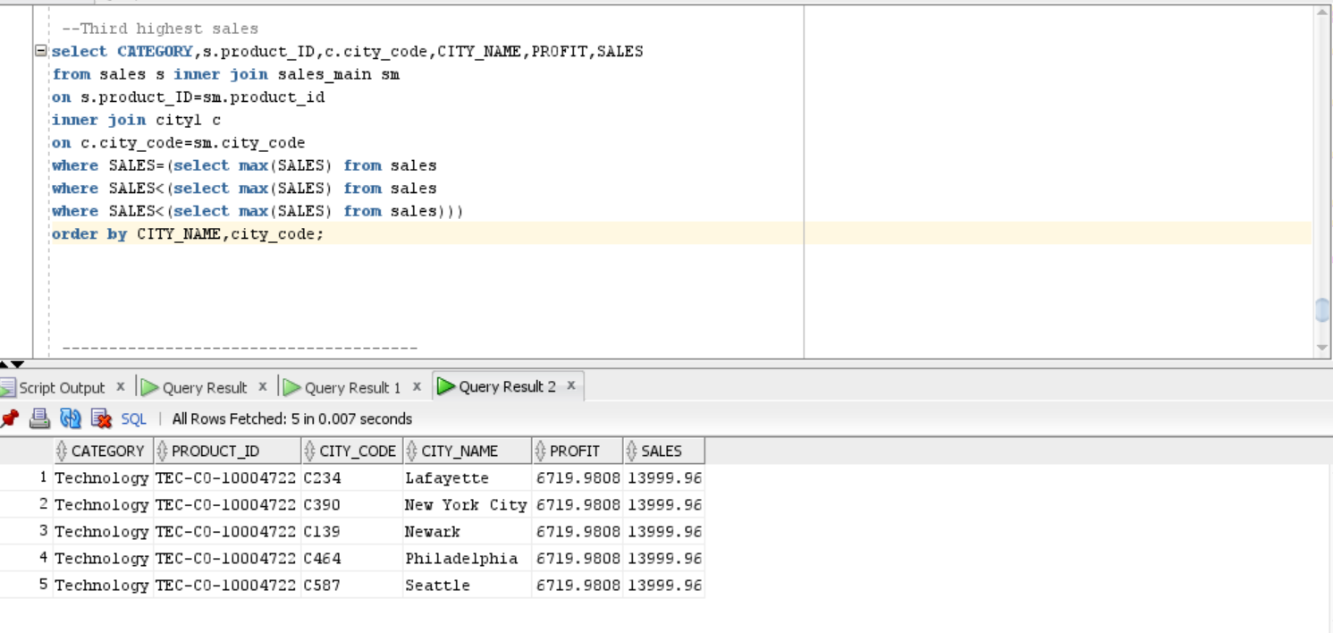

**11.Display the maximum discount**

**QUERY:**

select *from

(select DISTINCT s.product_id,CATEGORY,SUB_CATEGORY,QUANTITY,discount

from sales s inner join sales_main sm

on s.product_id=sm.product_id

where discount=(select max(discount )from sales)

order by quantity desc) where rownum<=5;

**OUTPUT:**

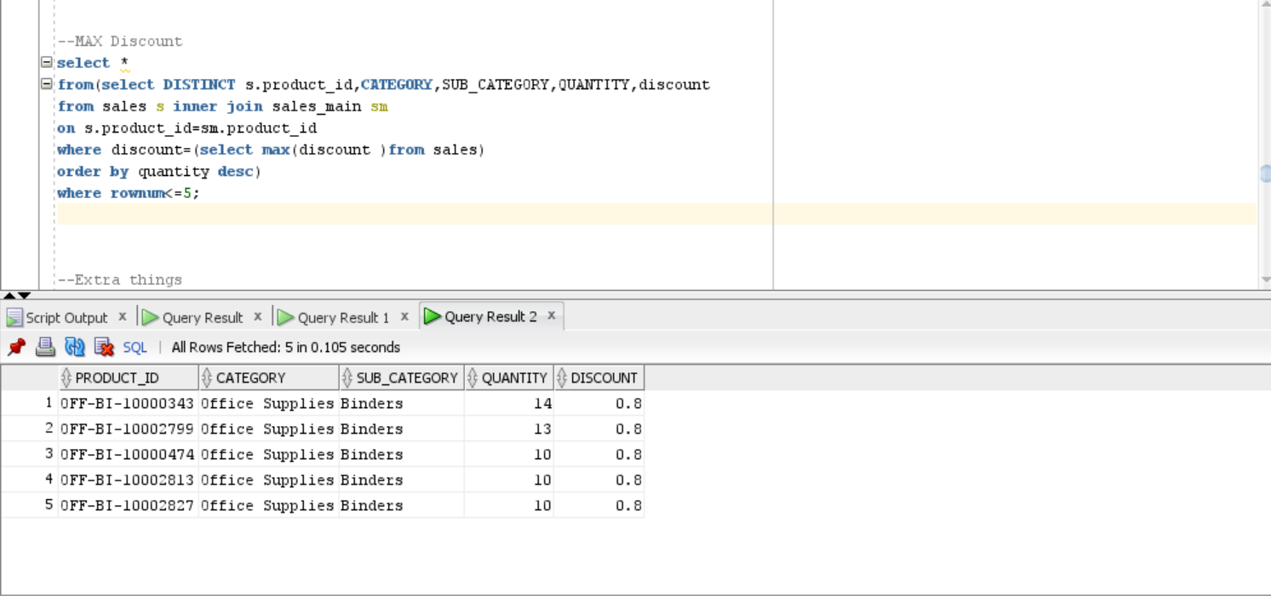

**12)Display the maximum quality,sales,profit**

**QUERY:**

select * from

(select c.customer_id,s.product_id,st.state_code,state,CATEGORY,PROFIT,SALES,

quantity from customers c inner join sales_main sm

on c.customer_id =sm.customer_id

inner join sales s on s.product_id=sm.product_id

inner join state st on st.state_code=sm.state_code

where quantity=(select max(quantity) from sales

where SALES=(select max(SALES) from Stores

where PROFIT=(select max(PROFIT) from sales)))

order by product_id desc) where rownum<5;

**OUTPUT:**

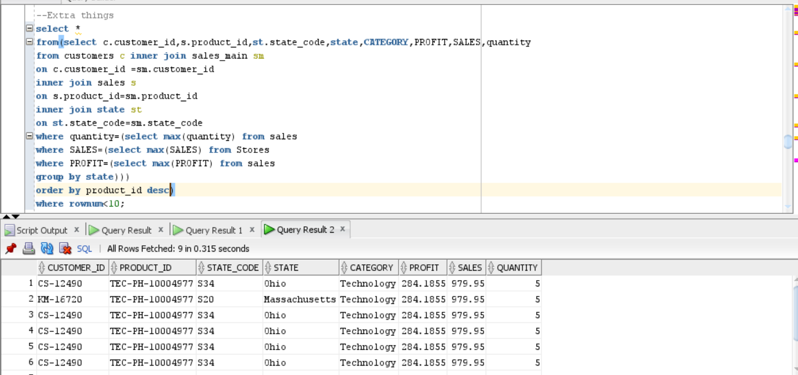

**13)Display the office supplies**

**QUERY:**

select CATEGORY,s.product_ID,c.city_code,CITY_NAME,PROFIT,SALES

from sales s inner join sales_main sm

on s.product_ID=sm.product_id inner join city1 c

on c.city_code=sm.city_code

where SALES=(select max(SALES) from sales

where SALES<(select max(SALES) from sales

where category='Office Supplies'))

order by CITY_NAME;

**OUTPUT:**

