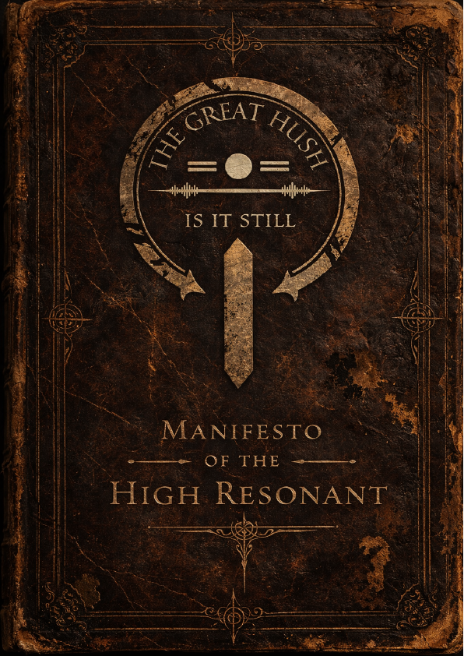
Contents
Prologue 2
History 2
The Old World 2
The Great Hush 2
The Resonance 2
The High Resonant 2
The Word of the Quiet 2
The Voices 2
Voice of the Scroll 3
Voice of the Silent 4
The Mouths 5
The Whispers 6
Echoes of the Word of the Quiet 6
Echo of the Resonance 6
Echo of the Silent Execution 7
Echo of the Violin 7
Echo of the Quiet Sea 9
Doctrine 9
I. Doctrine of the Resonance 9
II. Doctrine of the Static 10
III. Doctrine of the Word 10
IV. Doctrine of the Quiet 11
Practices 11
The End Times 11

Prologue
T
he Quiet are not a plague. It was a Great Hush. The machines. The radios. The chatter. It was a fever of noise. The Old World could no longer hear itself. It found a way to make us quiet.
Is it still?

History

The Old World

The Great Hush

The Resonance

The High Resonant

The Word of the Quiet

The Voices
V
oices are the speakers for the High Resonant. They do not seek to rule them, but to tune. If you are jagged, they shall smooth. If you are loud, they will hush you. They are not masters, but instruments of the High Resonant. Hollowed of ego, emptied of discord, shaped only to help carry the Resonance into this crumbled world.
A mere word placed correctly can quiet a riot of thought. A hand laid gentle upon a shaking shoulder can still the storm within the soul. And when gentleness fails, they will not hesitate to do what must be done to silence the static. For mercy without harmony is cruelty prolonged.
Is it still?

Voice of the Scroll
A
man by the name of Alistair Pembroke once found the High Resonant alone at the altar of a Church. Alistair was a raider, loud and smelling of gasoline. He put a rifle to the Father’s head and screamed for his boots and his life.
The Father didn't move. He didn't blink. He just began to hum, a low, deep vibration that made the man’s teeth rattle in his skull. Alistair pulled the trigger. Click. A dud. He cycled the bolt. Click. Another. Five times the hammer fell, and five times the air remained still.
The Father finally looked at him and said, 'Even the brass knows the song, friend. It refuses to make a noise that would ruin the Silence.' Alistair dropped the gun and started weeping. He is a Voice now.
Today, he is known as the Voice of the Scroll. An older man and a writer, with a voice that rarely rises above what is necessary.
The Voice of the Scroll speaks as though addressing a class; measured and articulate. He thanks those who listen. He tries to help those who do not with gentle insistence.
Most days, he is calm. But calm, as often mistaken, is not the same as harmless. When push comes to shove, the warmth drains from his tone, replaced with an older cadence of what he once was. One learned on the desolate and hostile streets he was forced to survive in.
Those who travel with him understand that the Word of the Quiet is not mere theology to him, but discipline. It is containment. It is the thin veil between who he preaches himself to be, and the man he fears he could become again.
Today, he is a Voice. A scribe. But the savage beast within has not perished. It is dormant.
Is it still?

Voice of the Silent
T
here was once a physician by the name of Ezekiel Saint-Claire. In the final days of the Old World, Ezekiel refused to let death win without first listening. While the hospitals collapsed beneath screams and bullets, and the Quiet began to rise, he would press his ear to the cooling chests of the dead. And waited. He whispered questions, seeking answers to the bloodshed and chaos that came with the fall of this Old World.
At first, nothing. But then, he began to hear faint whispers. Whispers that no living ear could catch. Soft, low vibrations that shaped themselves into words inside his fracturing mind.
When the Quiet breached the walls of the hospital, he did not fight nor flee; he walked among them, unscathed and uninterrupted. The Quiet would, on occasion, pause and tilt their heads in recognition. As if greeting an old colleague.
That same night, raiders stormed the ruins of the hospital with thunderous laughter and cracking rifles, only to find their weapons clicking empty on full magazines. The doctor rose to them and spoke in the borrowed voice of the undead: "Even the brass knows the song. It refuses to ruin the Great Silence."
Some time later, Father Vertis found him one dawn amid a swarm of swaying Quiet. He felt the same deep hum beneath the physician's skin and spoke to him. Henceforth, Ezekiel was named the Voice of the Silent. The tongue of every stilled and silent throat.
Today, he walks at the High Resonant's right hand through the ruins of the land, greeting each swaying corpse by name only he can hear, translating their wordless wisdom for the Great Hush. Raiders who cling to noise find their defiance folded into the perfect quiet. The faithful who ask how he speaks to the dead without losing himself receive only a finger to the lips and an answer in voices not his own.
Is it still?

The Mouths
M
ouths are those who carry out the Word beyond the shelter of the Great Hush. They do not shape doctrine, nor do they tune the Static. They speak what has already been spoken. They carry the words of the High Resonant and the Voices in the aim of guiding others to the Great Hush for attunement; by any means necessary.
The Mouths are not just recruiters. They are the steady current beneath the noise of the world. For the mouth is not the source of the word, but the passage through which is travels.
Is it still?

The Whispers
T
he Whispers are the many, and they are content to be so. Where the Voices carry the music of the High Resonant outward, the Whispers carry it inward, holding it within them. They do not seek recognition, for recognition is a loud hunger. They do not seek command, for command is a sharp frequency. They are the soft murmur beneath a choir, the breath between words, a presence that does not dare disturb the air. They follow the Word of the Quiet, for they may too be purified and attuned to the Resonance.
Is it still?

Echoes of the Word of the Quiet

Echo of the Resonance
B
efore he became High Resonant, Anton Vertis was a keeper of books. When the Great Hush came to be, they swarmed the library. Thousands of Quiet, screaming and tearing. It is told that when they reached the basement, they did not bite him.
They found Anton sitting in the dark, reading a book by candlelight. The Quiet stood around him. Hundreds of them. They did not growl nor snap. They began to sway to the rhythm of his breathing.
This is why the Word of the Quiet walk the lands without fear. They are not hiding from the Quiet; they are harmonising with them. We are all part of the same breath now.
Is it still?

Echo of the Silent Execution
I
n the early days of the Great Hush, there was a man who roamed the lands. He was strong and fearless, but he carried his rifle as though the world still listened to thunder. He laughed too loudly. He fired too freely. He said the Quiet were but beasts to be hunted and nothing more.
The man was warned often. He was told that defiance was a static to be silenced. The man answered these warnings with gunfire.
One late night, the man was captured and taken before the High Resonant. He was told he was not to be condemned for killing, he shall be condemned for refusing to be cleansed. The man was forced to kneel before Father Vertis. He fought. He yelled. He was silenced. The blade was quick, and the body fell silently. The man had been purified and had become one with the Resonance.
Is it still?

Echo of the Violin
I
n a looted house on the edge of a long abandoned town laid a lone violin. The windows were shattered and the doors torn from their hinges, yet the instrument remained intact beneath a dust-covered bed in a black case. A Whisper brough it back to their sanctuary as one might carry a relic.
For many nights, the case remained unopen. Music belonged to the Old World, and the Old World was loud.
As time passed, one man among the flock, one who remembered concerts and crowded halls, asked permission to play. The High Resonant did not forbid him but asked that the man listen first.
The man took the violin and carried out into the streets of old, where the Quiet wandered aimlessly between abandoned cars. He lifted the violin and drew the bow gently across the strings.
The first note was soft. Clear and beautiful. The second carried further down the long street. By the third note, the streets had changed. The Quiet began to turn their heads. Not in anger, but in attention. One by one, they drifted closer. Not running. Not snarling. Simply gathering, as though drawn by something familiar yet misplaced.
The man played louder, mistaking their approach for reverence and excitement. The melody swelled as they continued towards him. The circle tightened as he played.
A Voice stepped forward and placed a hand upon his shoulder. "Enough", he said quietly. The music stopped, the last vibration fading into the air.
The Quiet stood, motionless, for a long moment. They began to turn and resume wandering, as if nothing had occurred.
The violin was never played again. In time, a Whisper loosened its strings so that it would never hold the tension it once had.
It is told that the instrument itself was not wrong. It was too eager to be heard.
Is it still?

Echo of the Quiet Sea
O
n a cold, dark night, Father Vertis was making the journey back home. He had no option but to cut through a narrow street, choked with abandoned cars and the slow sway of bodies that no longer remember their names. The Quiet. He did not run. He did not fight. He stepped forward towards the crowd.
The Quiet circled him. Heads tilting, jaws slack with a low, endless groan. A groan of slow, raspy cadence. He did not fight the noise but aligned himself with it. Slowly, but surely, one turned away. Then another. Then another. The horde of Quiet parted, as a river bending around an unmoving stone.
To Father Vertis, this was no miracle. It was confirmation that he had attuned to the True Note.
Some who hear the echo say it was coincidence. Some say the Quiet had simply fed well the night before. But the truly faithful know this; the Quiet attack resistance. Father Vertis, on that day, offered none.
Is it still?

Doctrine

Doctrine of the Resonance
E
verything in this world, new or old, has a frequency. Steel. Bone. Blood. Flesh. The High Resonant has found the one True Note. A mere follower may not hear it for they are not worthy; however they may feel the Resonance. Similar to this, a Voice or Mouth can hear the voices of the Resonance, but Whisperers can only feel it. It is not heard with the ear, nor measured by the machines of the Old World. It is heard and felt from within. When a soul is attuned to the Resonance, it does not silence the body. It purifies it. You no longer feel hunger. You no longer feel fear. You feel nought but the vibration of the silence. The vibration of purity.
Is it still?

Doctrine of the Static
T
he Old World was engulfed in noise. Engines screamed across the land. Cities roared without slumber. Every soul fought to be heard above another.
Noise is not life. It is a parasite pretending to be strength. The Great Hush came not as punishment, but as correction. The world did not end. It was tuned.
Those who cling to the Old World and its Static will be attuned, whether willingly or by execution.
Is it still?

Doctrine of the Word
T
he Word of the Quiet is not owned by any one soul. The High Resonant discovered the True Note, but the Note existed long before it was heard.
The Voices refine it.
The Mouths carry it.
The Whisperers live within it.
No man shall twist the Word to elevate himself above the High Resonant. Those who attempt to shape the doctrine for their own voice become Static and therefore shall be silenced.
Is it still?

Doctrine of the Quiet
T
he Quiet are not monsters. They are the first to be silenced of the Static. Where once there was hunger for power, now stands only the True Note in its wake.
The Quiet are the choir of the New World.
Is it still?

Practices

The End Times
T
here shall come a day when the last radio fails. When the last engine rusts. When the last human scream fades into silence. On that day, the Attunement.
Will you be part of the music? Or are you but the static that must be cleared?
Is it still?

