PotPal

Software Development Plan

Version 1.0

Revision History

| **Date** | **Version** | **Description** | **Author** |
| --- | --- | --- | --- |
| 27/10/24 | 1.0 | First rough version of the Software Development Plan | Lê Thanh Minh Trí |
|  |  |  |  |
|  |  |  |  |
|  |  |  |  |

Table of Contents

**1. Introduction 4**

**2. Project Overview 4**

2.1 Project Purpose, Scope, and Objectives 4

2.2 Assumptions and Constraints 4

2.3 Project Deliverables 4

**3. Project Organization 5**

3.1 Organizational Structure 5

3.2 Roles and Responsibilities 5

**4. Management Process 6**

4.1 Project Estimates 6

4.2 Project Plan 6

4.2.1 Phase and Iteration Plan 6

4.2.2 Releases 7

4.2.3 Project Schedule 7

4.3 Project Monitoring and Control 8

4.3.1 Reporting 8

4.3.2 Risk Management 9

4.3.3 Configuration Management 10

Software Development Plan

# 

# Introduction

The main purpose of this Software Development Plan (SDP) is to outline overall the application and the management process for the development of the [**Potpal**] software.

# Project Overview

## Project Purpose, Scope, and Objectives

* **Purpose:** This project is a part of Intro to Software Engineer course, aims to provide practical experience in designing, developing, and testing a software application. Specifically, the project involves creating a game that demonstrates core principles of software engineering, including requirements gathering, system design, implementation, and testing.
* **Scope:** The scope of this project includes the development of a fully functional Ecommerce website. The website will be implemented, and tested within a predefined timeline, following the structured phases of the software development lifecycle
* **Objectives:** The objective of this project is to demonstrate the application of software engineering principles, showcasing the students' understanding of the software development process.

## Assumptions and Constraints

* The team consists of 5 people and there will be no more people added during the project.
* The project runs on a low budget.
* Project has a development time of around 10 weeks.

## Project Deliverables

| **Week** | **Artifacts** |
| --- | --- |
| 1 | Project proposal  Weekly report |
| 2 | Software development plan  Vision document  Weekly report |
| 3 | Detailed requirements  Initial design  Software architecture document,  UML models  UI design  Weekly report |
| 4 |
|
| 5 | Test plan,  Use cases  Database design,  Front-end and back-end development  Weekly report |
| 6 |
| 7 | Source code  Test case  Test report  Implementation and testing  Weekly report |
| 8 |
| 9 |
| 10 | Final product |

# Project Organization

## Organizational Structure

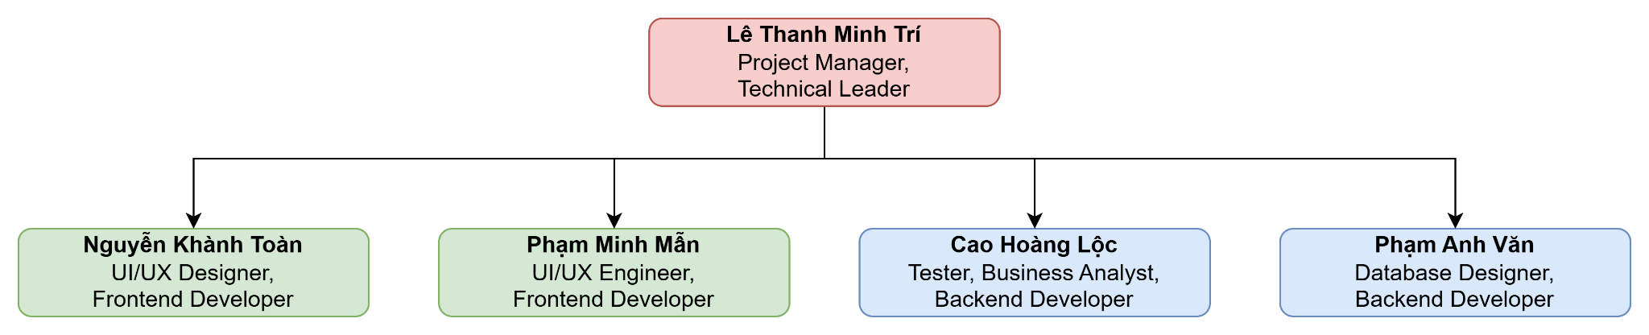

## Roles and Responsibilities

| **Person** | **Role** | **Description** |
| --- | --- | --- |
| Lê Thanh Minh Trí | Project Manager,  Technical Leader | * Make project plan * Roles assignment and tasks distribution * Weekly report * Organize meetings * Validate codebase before deployment * Coordinate backend and frontend * Dev support |
| Nguyễn Khánh Toàn | UI/UX Designer,  Frontend Developer | * Design the user interface * Implement UI/UX design to codebase * Create Software Architecture Document * Cooperate with UI/UX Engineer to ensure user friendly interface * Write source code * Perform unit test * Communicate with backend devs |
| Phạm Minh Mẫn | UI/UX Engineer, Frontend Developer | * Design UI/UX system * Implement the UX system * Cooperate with UI/UX Designer to ensure user-friendly and quality interface * Write source code * Perform unit test * Communicate with backend devs * Review source code |
| Cao Hoàng Lộc | Tester, Business Analyst, Backend Developer | * Prepare and conduct test plan, test case and test report * Document requirements (interview customers, etc.) * Communicate with team members about the requirements * Coordinate to review requirements * Cooperate with Database Designer on implementing classes, components, etc. * Write source code * Perform unit test |
| Phạm Anh Văn | Database Designer, Backend Developer | * Design the backend system (components, classes, databases, etc.) * Create Software Architecture Document * Cooperate with Business Analyst to implement backend design * Write source code * Perform unit test * Communicate with frontend devs * Review source code |

# Management Process

## Project Estimates

- **Cost:** The cost varies depending on chosen domain and hosting service, commercial service, technologies and tool services.

- **Time:** Each team member is expected to spend approximately 21 hours per week over a 10 week period. With a team of 5 members, this amounts to 1050 hours total for the project.

- **Re-estimation points, circumstances:** After each sprint/phase or the previous estimation is not close.

- **Infrastructure:** The project will be developed, tested and deployed on personal computers of each member of the group then pushed and managed on GitHub.

## Project Plan

### Phase and Iteration Plan

| **Phase** | **Sprint** | **Start day** | **End day** | **Main objectives** |
| --- | --- | --- | --- | --- |
| Inception | 1 | 14/10 | 27/10 | Project proposal, initial requirements |
| Elaboration | 2 | 28/10 | 10/11 | Detailed requirements and initial design |
| 3 | 11/11 | 24/11 | Detailed design and test planning |
| Construction | 4 | 25/11 | 8/12 | Implementation and testing |
| 5 | 9/12 | 22/12 | Implementation and testing |

### Releases

* **Demo:** First 3 versions are intended for demonstration purposes, allow the project manager to visualize the progress and give feedback.
* **Product release:** This is where the website goes online for all users, requiring thorough testing and validation to ensure a smooth user experience.

### Project Schedule

* Sprint 1:  
  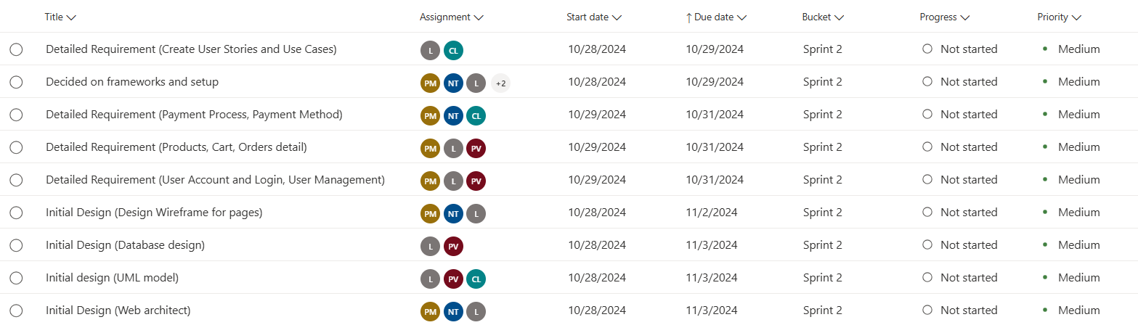
* Sprint 2:  
  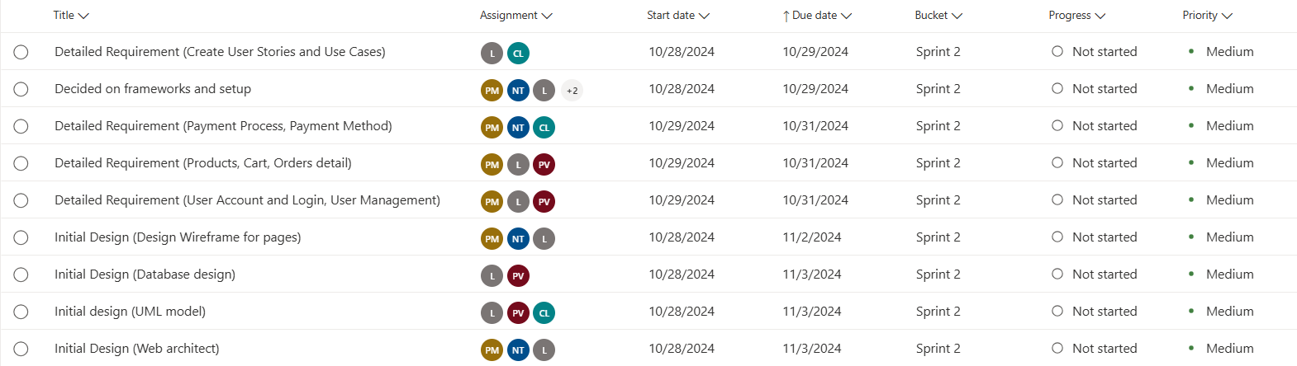
* Sprint 3:  
  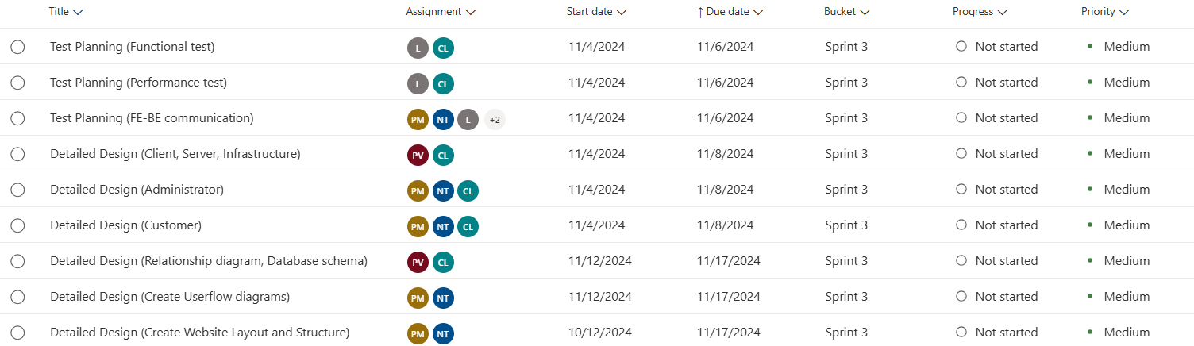
* Sprint 4:  
  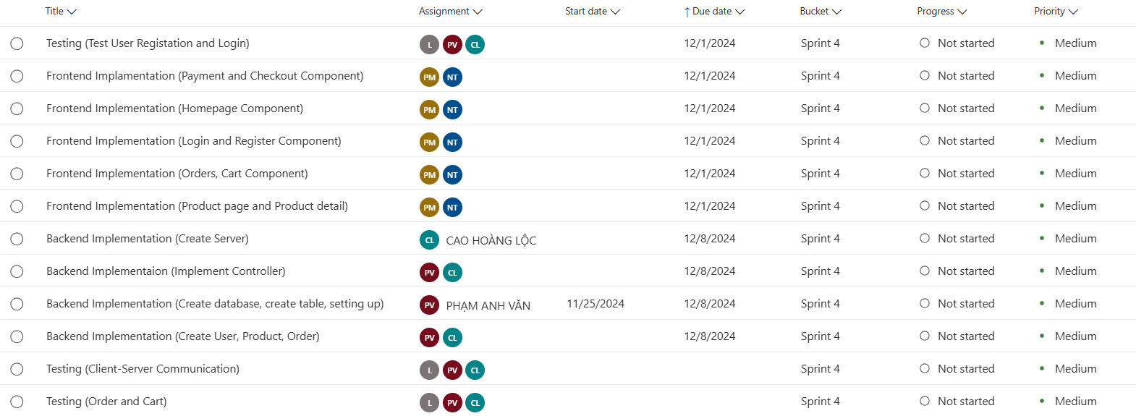
* Sprint 5:  
  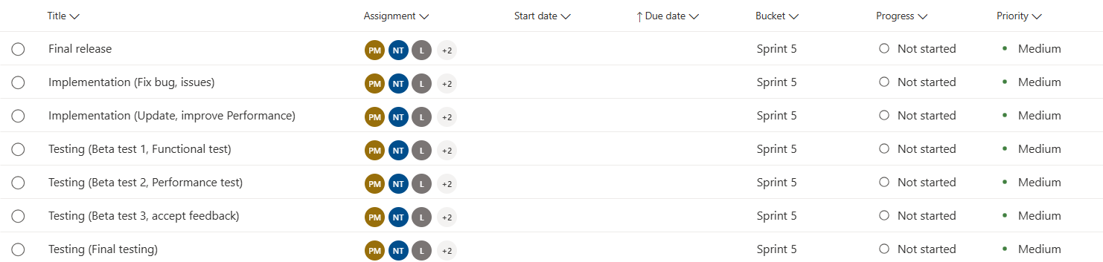

## Project Monitoring and Control

### Reporting

* **Weekly meeting:** 
  + Time: Saturday every week.
  + Method: Online meeting on Discord or Google Meet.
  + Participants: All team members.
  + Purpose: Review project progress, address challenges encountered, plan tasks and objectives for the upcoming week.
  + Documentation: The meeting result will be recorded, summarizing information and decisions made.
* **Weekly status report:**
  + Time: Once every week
  + Method: Project manager will write the documentation report.
  + Content: Summary of progress as well as project milestones and objectives, overview completed tasks and upcoming tasks, identification of any risks or issues that need attention, Updates on any changes to the project timeline or scope.
* **Informal chats:** 
  + Participants: All team members.
  + Method: Messenger, Discord (and Zalo for emergency).
  + Purpose: Provide a channel for team members to discuss, share and resolve issues.

### Risk Management

| **Risk ID** | **Risk Description** | **Probability** | **Impact** | **Risk Exposure** | **Priority** | **Mitigation Strategy or Contingency Plan** |
| --- | --- | --- | --- | --- | --- | --- |
| S3 | Poor time management | Likely | Serious | 5625 | 1 | * Can lead to catastrophe if neglected. * Members may change their priority to the closest problem to get the project’s progress back on track. * Project Manager must be agile on noticing bad time management and notify the entire team to react and resolve as soon as possible |
| M2 | Deadline changes | Frequently | Moderate | 4500 | 2 | * Project Manager adjusts plans to fit new deadline. * Worst case scenario, the entire team shifts focus to finish the deadline as fast as possible. |
| S4 | Poor tasks distribution | Likely | Moderate | 3750 | 3 | * Project Manager re-evaluate if assigned tasks are already fair or not, then re-assign tasks if necessary. * Tasks distribution must be accepted by ALL members. |
| S1 | Staffs are unavailable during critical times | Occasional | Serious | 3750 | 4 | * Emergency contact (Direct call) to discuss with the unavailable staff. Project Manager overtake the task and split it for the entire team to handle. * In case Project Manager is unavailable, select a Co-Manager to overtake the project temporarily. |
| S2 | Lack of experiences | Occasional | Moderate | 2500 | 5 | * The member may ask Project Manager, AI assistant or any friends with experiences for help and support. * Members must be proactive to avoid wasting time. * If no choices are available, the member and Project Manager work with TA to find alternative solutions. |
| T1 | Data loss without backup | Seldom | Moderate | 1250 | 6 | * Cloud experiment data: Project Manager help create new data to replace lost data. * Codebase on GitHub: GitHub codebase must be splitted into branches. Must be reviewed and updated regularly.  If any branch is lost or any member lost their in-progress code, that segment should only be for one specific task, simplifying the recovery process. * Documentation: Upload all documents on Drive and the finalized version on GitHub to prevent loss. |
| T3 | Technologies changes | Seldom | Moderate | 1250 | 7 | * Must carefully study and research the newly chosen technology or tool. * ALL members must agree on the changes. * Otherwise the member(s) that performs the change have to take responsibility and resolve in case conflicts arise. |
| T2 | Lack of technologies | Seldom | Moderate | 1250 | 8 | * The Project Manager should reconsider the tasks or the technologies supporting the project. * Either restart, replace, upgrade or refer to TA for guidance. |
| M3 | Natural disaster | Unlikely | Catastrophic | 900 | 9 | * Might lead to members being unavailable. * Project Manager and/or TA must be notified immediately if members would have to be unresponsive for days. |
| M1 | Requirement changes | Seldom | Insignificant | 625 | 10 | Project Manager minimizes time loss by proactively handling changes on their own if possible. |

### Configuration Management

- Google Drive: <https://drive.google.com/drive/folders/1LzSp4pshTCRXEJwvQcMpWDSktmDlS-HI?usp=drive_link>

- GitHub:   
<https://github.com/Burncake/sowe-ecommerce>

- MS Planner:  
[Planner - Group 5 sowe](https://planner.cloud.microsoft/student.hcmus.edu.vn/Home/PlanViews/FRRtfp8_N0qlaJ4-t9BBNsgABzbm?Type=PlanLink&Channel=Link&CreatedTime=638656307995820000)