**Tools Setup Report**

Group ID: **Group 5**

Project Name: **PotPal**

Prepared by: **Lê Thanh Minh Trí**

Team members:

22127422 - **Lê Thanh Minh Trí** *Project Manager - Technical Leader*  
22127234 - **Cao Hoàng Lộc** *Tester - Business Analyst - Backend Developer*

22127257 - **Phạm Minh Mẫn** *UI/UX Engineer - Front End Developer*

22127418 - **Nguyễn Khánh Toàn** *UI/UX Designer - Frontend Developer*

22127450 - **Phạm Anh Văn** *Database Designer - Backend Developer*

# Google Drive

Using Google Drive to store documents and working collaboration  
Link: <https://drive.google.com/drive/folders/1LzSp4pshTCRXEJwvQcMpWDSktmDlS-HI?usp=drive_link>  
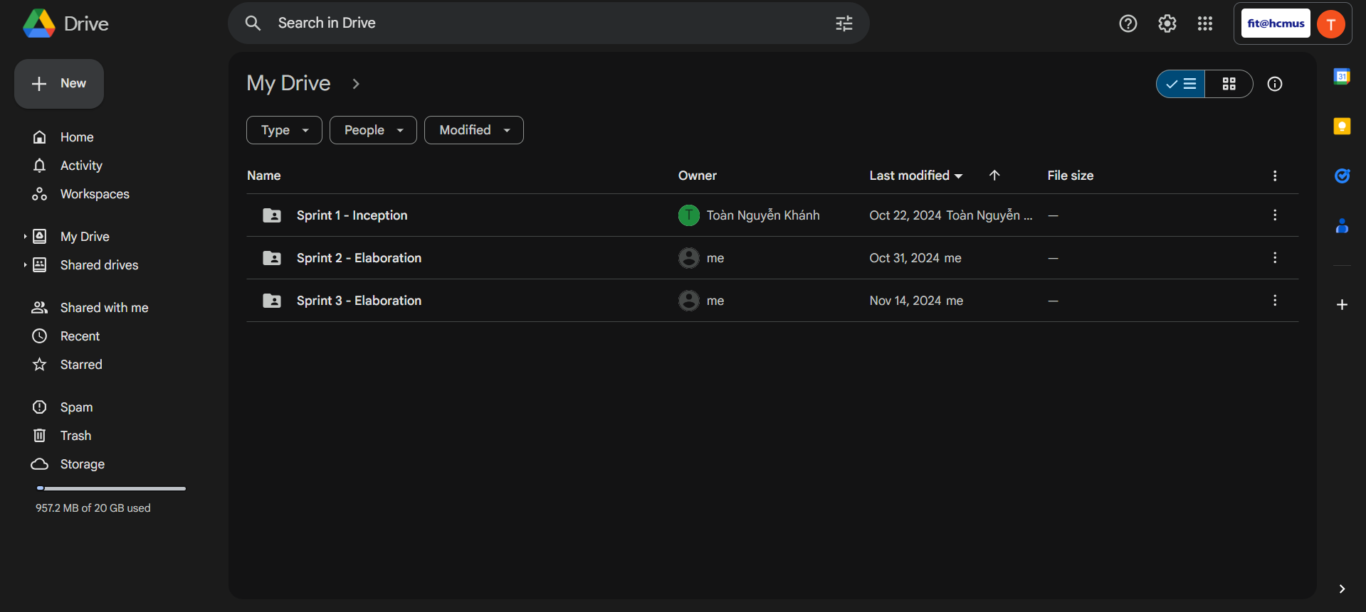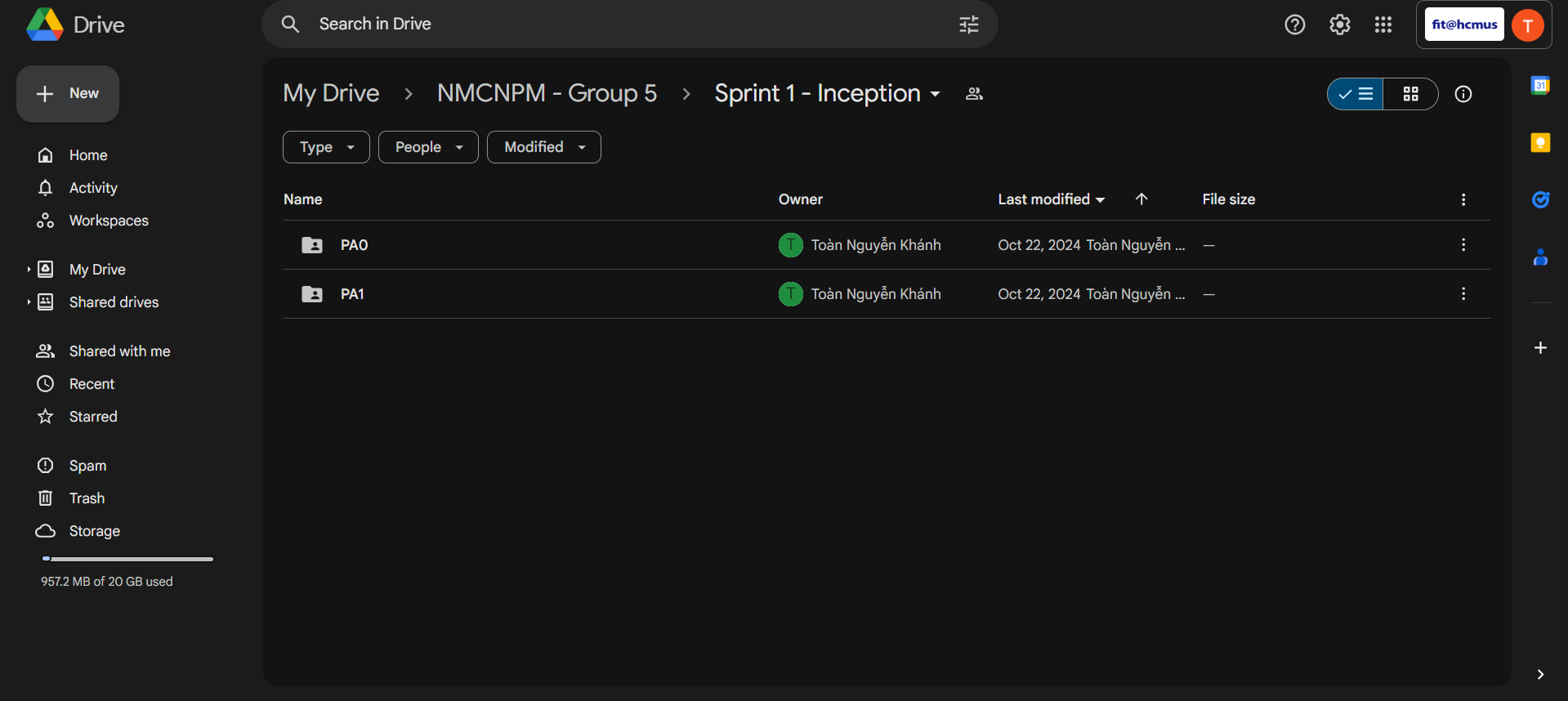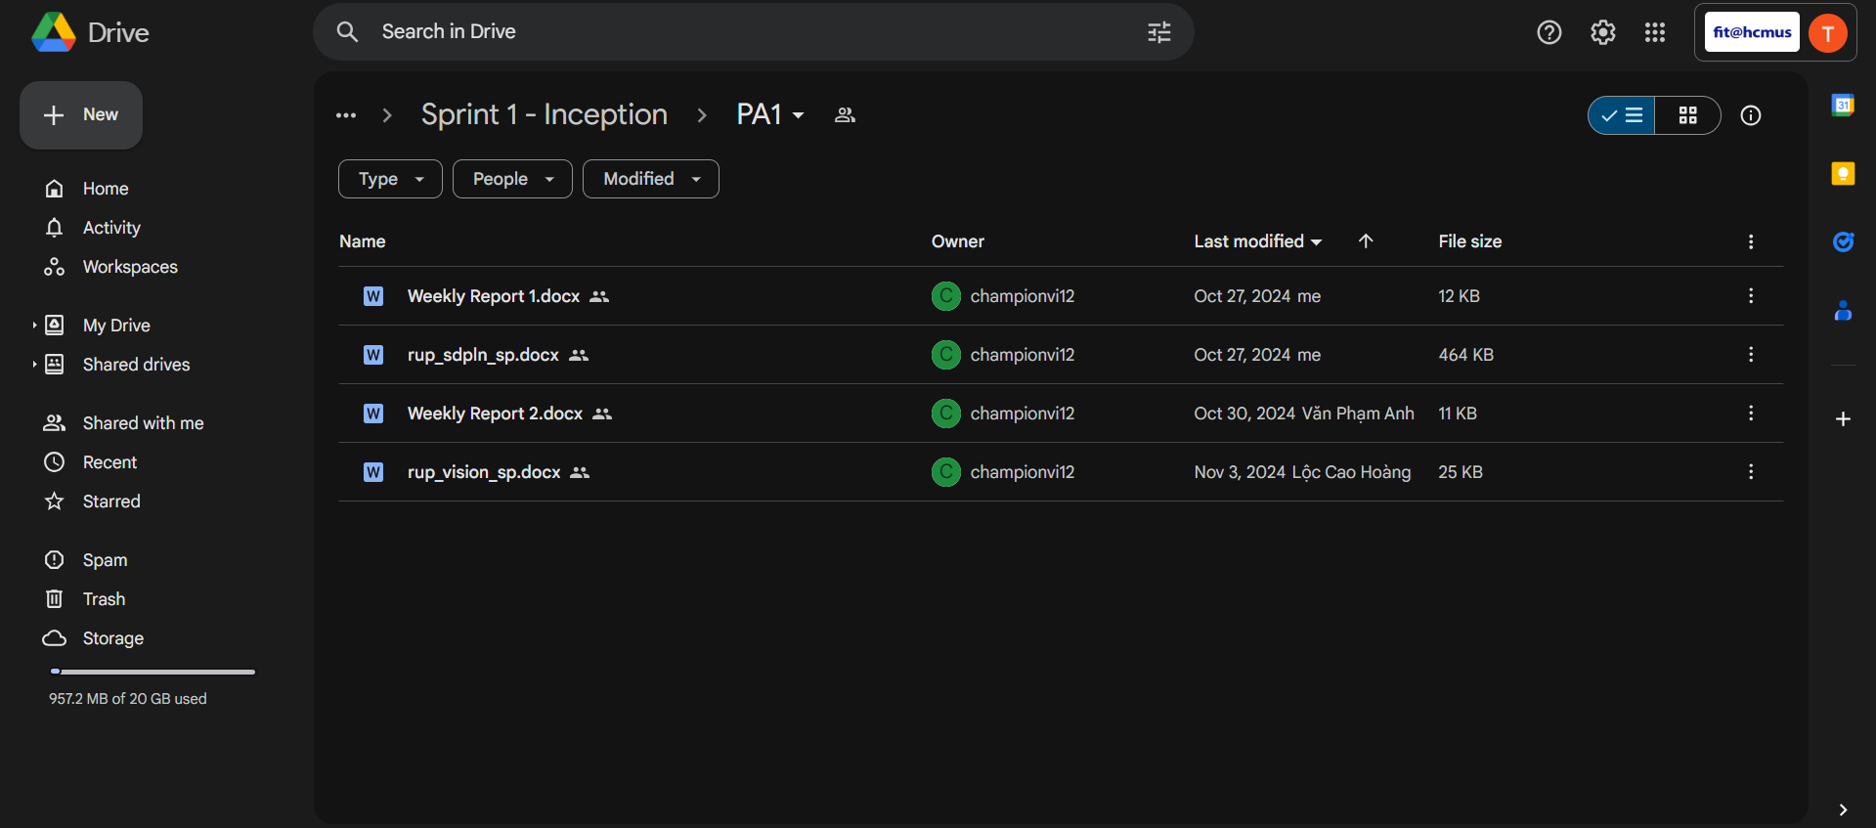

1. **GitHub**

GitHub for coding storage, collaboration and finished documentation storage.  
Link: <https://github.com/Burncake/sowe-ecommerce>  
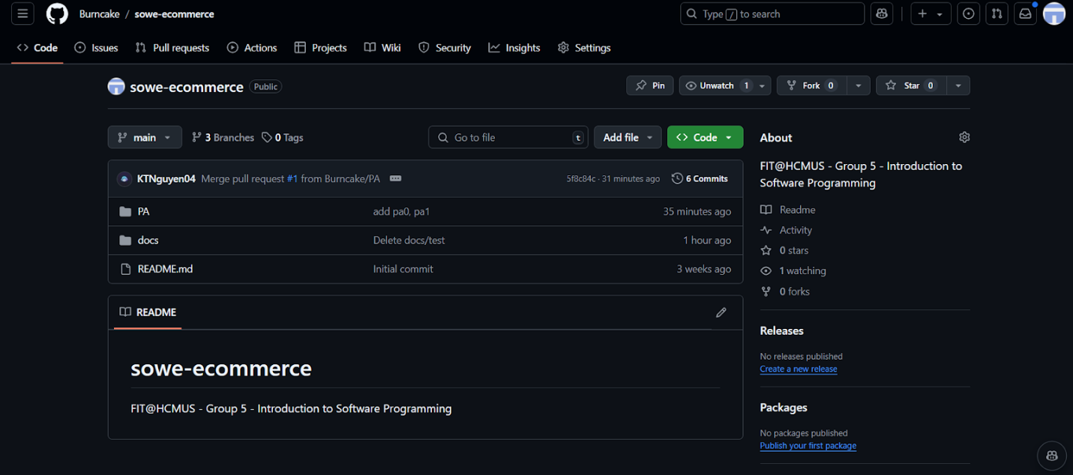

1. **Discord**

Chat, discuss and meeting about the project will be taking place in the Discord server.  
Link: <https://discord.gg/YGfAcv2pkw>  
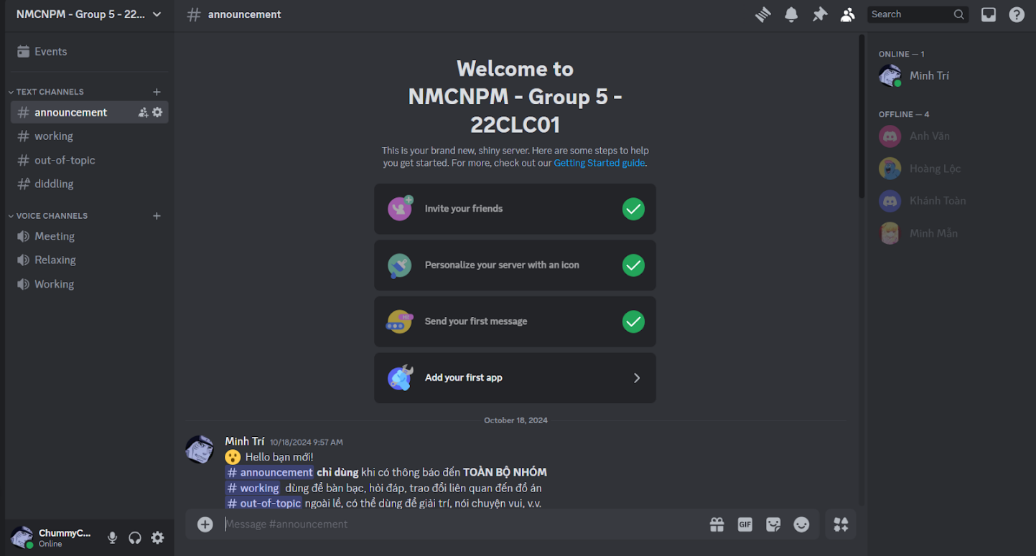  
  
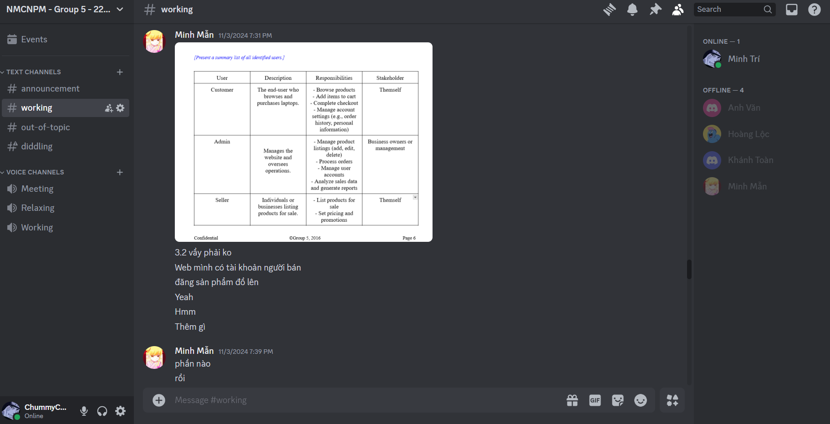

1. **Jira**

Using Jira to schedule and record backlogs  
Link: <https://intro-to-se-potpal-22clc01.atlassian.net/jira/software/projects/SCRUM/boards/1/backlog?atlOrigin=eyJpIjoiZTJkMjFhZTJhZGFkNDE2Y2E2ZTY4NWY3MjIwNGYxNTIiLCJwIjoiaiJ9>  
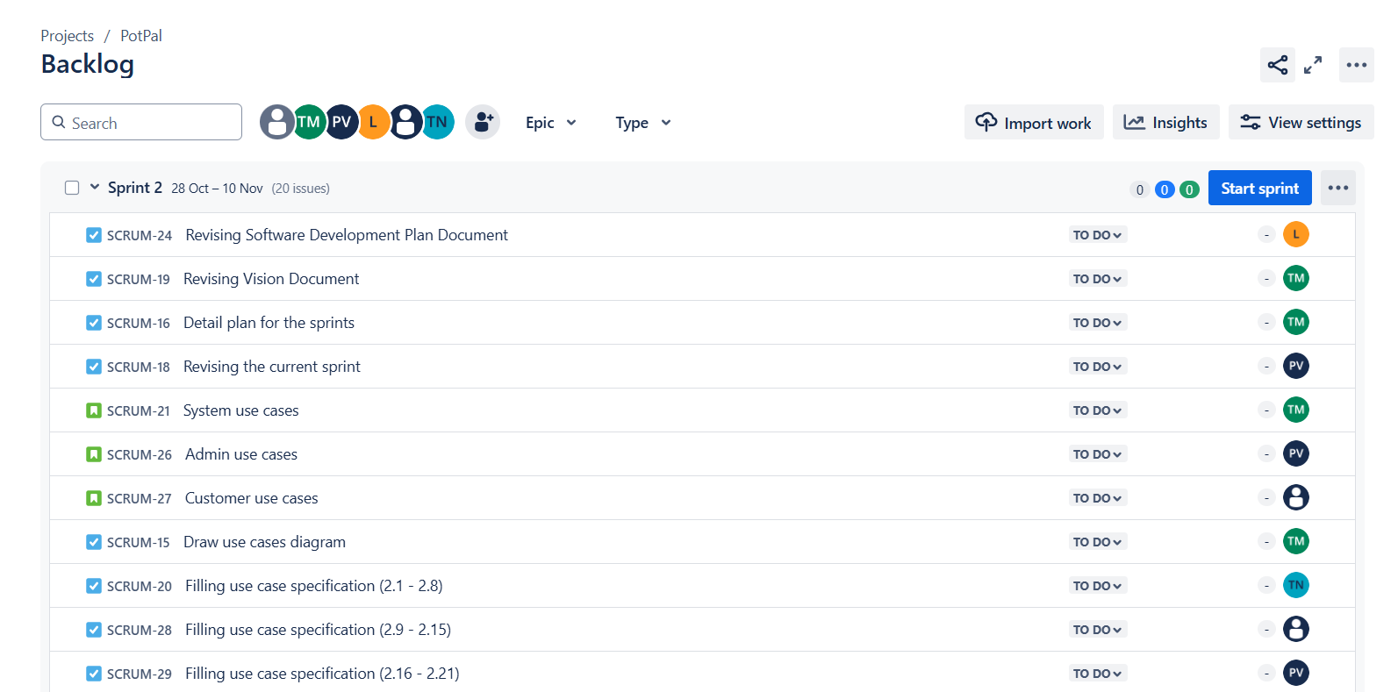

1. **Microsoft Planner**

Microsoft Planner is used for task planning and tracking.  
Link: <https://planner.cloud.microsoft/student.hcmus.edu.vn/Home/PlanViews/FRRtfp8_N0qlaJ4-t9BBNsgABzbm?Type=PlanLink&Channel=Link&CreatedTime=638656307995820000>  
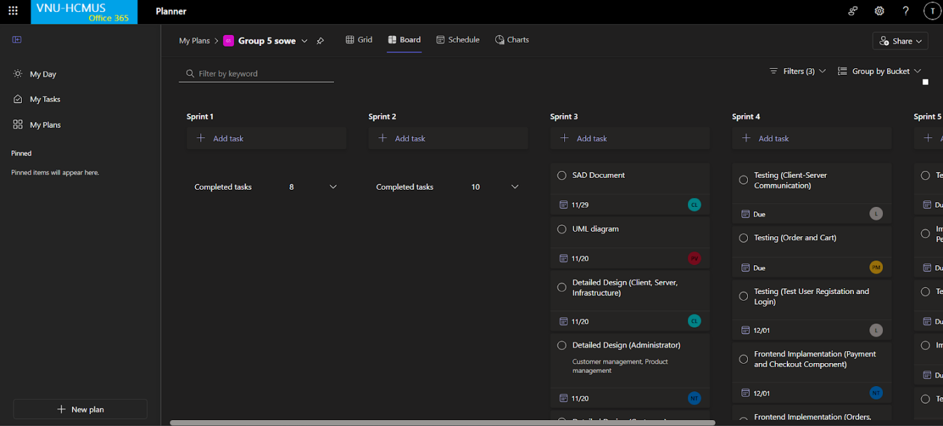 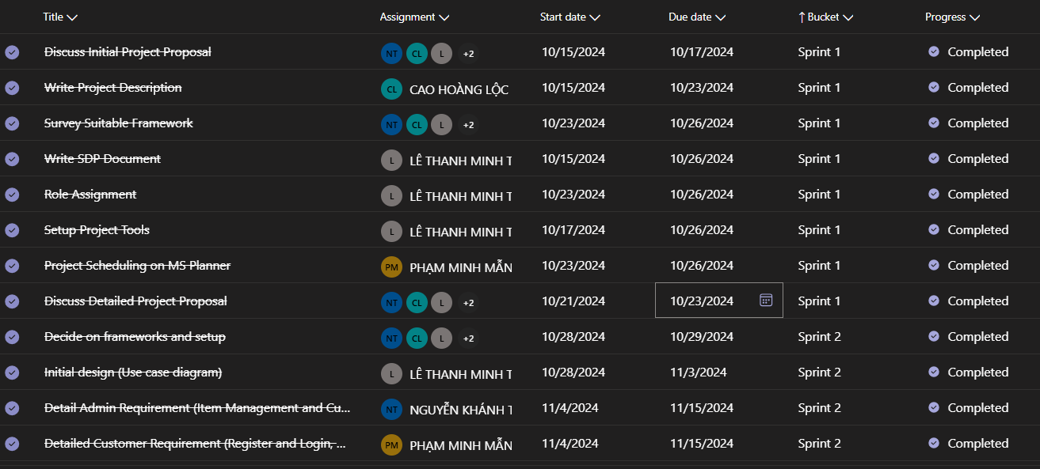

1. **Messenger**

