**PotPal**

Automated Testing

Version 1.0

Revision History

| **Date** | **Version** | **Description** | **Author** |
| --- | --- | --- | --- |
| 02/01/25 | 0.1 | Added Introduction | Lê Thanh Minh Trí |
| 02/01/25 | 0.2 | Added Test Scripts | Lê Thanh Minh Trí |
| 02/01/25 | 0.3 | Added Test Results | Lê Thanh Minh Trí |
| 02/01/25 | 0.3 | Added Test Evidences | Lê Thanh Minh Trí |
| 02/01/25 | 1.0 | First version | Lê Thanh Minh Trí |

Table of Contents

**1. Introduction 4**

**2. Test Script as Plain Text 4**

○ Search with text + Filter by price 4

○ Add new item to cart + Change quantity of items in cart + Remove item from cart 5

○ Add new product + Edit product 6

**3. Test Script as Record View 8**

○ Search with text + Filter by price 8

○ Add new item to cart + Change quantity of items in cart + Remove item from cart 8

○ Add new product + Edit product 9

**4. Test Results 9**

○ Search with text 9

○ Filter by price 9

○ Add new item to cart 9

○ Change quantity of items in cart 9

○ Remove item from cart 9

○ Add new product 9

○ Edit product 9

**UI Prototype**

# Introduction

* This document provides the records of the **PotPal** website automated testing.
* Tool used: Katalon Studio v10
* Test cases chosen:
  + Search with text
  + Filter by price
  + Add new item to cart
  + Change quantity of items in cart
  + Remove item from cart
  + Add new product
  + Edit product

# Test Script as Plain Text

## Search with text + Filter by price

import static com.kms.katalon.core.checkpoint.CheckpointFactory.findCheckpoint

import static com.kms.katalon.core.testcase.TestCaseFactory.findTestCase

import static com.kms.katalon.core.testdata.TestDataFactory.findTestData

import static com.kms.katalon.core.testobject.ObjectRepository.findTestObject

import static com.kms.katalon.core.testobject.ObjectRepository.findWindowsObject

import com.kms.katalon.core.checkpoint.Checkpoint as Checkpoint

import com.kms.katalon.core.cucumber.keyword.CucumberBuiltinKeywords as CucumberKW

import com.kms.katalon.core.mobile.keyword.MobileBuiltInKeywords as Mobile

import com.kms.katalon.core.model.FailureHandling as FailureHandling

import com.kms.katalon.core.testcase.TestCase as TestCase

import com.kms.katalon.core.testdata.TestData as TestData

import com.kms.katalon.core.testng.keyword.TestNGBuiltinKeywords as TestNGKW

import com.kms.katalon.core.testobject.TestObject as TestObject

import com.kms.katalon.core.webservice.keyword.WSBuiltInKeywords as WS

import com.kms.katalon.core.webui.keyword.WebUiBuiltInKeywords as WebUI

import com.kms.katalon.core.windows.keyword.WindowsBuiltinKeywords as Windows

import internal.GlobalVariable as GlobalVariable

import org.openqa.selenium.Keys as Keys

WebUI.openBrowser('')

WebUI.navigateToUrl('https://pot-pal.vercel.app/')

WebUI.setText(findTestObject('Object Repository/Page_PotPal/input_PotPal_form-control me-2'), 'ecn')

WebUI.click(findTestObject('Object Repository/Page_PotPal/button_Search'))

WebUI.selectOptionByValue(findTestObject('Object Repository/Page_PotPal/select_All Prices0 - 10001000 - 20002000 - _b754be'),

'0-1000', true)

WebUI.click(findTestObject('Object Repository/Page_PotPal/a_Tecno Megabook T6 Laptop'))

## Add new item to cart + Change quantity of items in cart + Remove item from cart

import static com.kms.katalon.core.checkpoint.CheckpointFactory.findCheckpoint

import static com.kms.katalon.core.testcase.TestCaseFactory.findTestCase

import static com.kms.katalon.core.testdata.TestDataFactory.findTestData

import static com.kms.katalon.core.testobject.ObjectRepository.findTestObject

import static com.kms.katalon.core.testobject.ObjectRepository.findWindowsObject

import com.kms.katalon.core.checkpoint.Checkpoint as Checkpoint

import com.kms.katalon.core.cucumber.keyword.CucumberBuiltinKeywords as CucumberKW

import com.kms.katalon.core.mobile.keyword.MobileBuiltInKeywords as Mobile

import com.kms.katalon.core.model.FailureHandling as FailureHandling

import com.kms.katalon.core.testcase.TestCase as TestCase

import com.kms.katalon.core.testdata.TestData as TestData

import com.kms.katalon.core.testng.keyword.TestNGBuiltinKeywords as TestNGKW

import com.kms.katalon.core.testobject.TestObject as TestObject

import com.kms.katalon.core.webservice.keyword.WSBuiltInKeywords as WS

import com.kms.katalon.core.webui.keyword.WebUiBuiltInKeywords as WebUI

import com.kms.katalon.core.windows.keyword.WindowsBuiltinKeywords as Windows

import internal.GlobalVariable as GlobalVariable

import org.openqa.selenium.Keys as Keys

WebUI.openBrowser('')

WebUI.navigateToUrl('https://pot-pal.vercel.app/')

WebUI.click(findTestObject('Object Repository/Page_PotPal/a_Login'))

WebUI.setText(findTestObject('Object Repository/Page_PotPal/input_Username_Username'), 'tf2_scout')

WebUI.setEncryptedText(findTestObject('Object Repository/Page_PotPal/input_Password_Password'), 'tzH6RvlfSTg=')

WebUI.click(findTestObject('Object Repository/Page_PotPal/button_Sign in'))

WebUI.click(findTestObject('Object Repository/Page_PotPal/a_Cart'))

WebUI.click(findTestObject('Object Repository/Page_PotPal/a_Continue Shopping'))

WebUI.click(findTestObject('Object Repository/Page_PotPal/button_Search'))

WebUI.click(findTestObject('Object Repository/Page_PotPal/a_Tecno Megabook T3 Laptop'))

WebUI.click(findTestObject('Object Repository/Page_PotPal/button_Add to Cart'))

WebUI.click(findTestObject('Object Repository/Page_PotPal/a_PotPal'))

WebUI.click(findTestObject('Object Repository/Page_PotPal/button_Search'))

WebUI.click(findTestObject('Object Repository/Page_PotPal/a_Tecno Megabook T4 Laptop'))

WebUI.click(findTestObject('Object Repository/Page_PotPal/button_Add to Cart'))

WebUI.click(findTestObject('Object Repository/Page_PotPal/a_Cart'))

WebUI.doubleClick(findTestObject('Object Repository/Page_PotPal/button_'))

WebUI.click(findTestObject('Object Repository/Page_PotPal/button__1'))

WebUI.click(findTestObject('Object Repository/Page_PotPal/button__1_2'))

WebUI.click(findTestObject('Object Repository/Page_PotPal/button__1_2_3'))

WebUI.click(findTestObject('Object Repository/Page_PotPal/i_Remove_fa fa-trash'))

WebUI.click(findTestObject('Object Repository/Page_PotPal/i_Remove_fa fa-trash'))

WebUI.click(findTestObject('Object Repository/Page_PotPal/a_Continue Shopping'))

## Add new product + Edit product

import static com.kms.katalon.core.checkpoint.CheckpointFactory.findCheckpoint

import static com.kms.katalon.core.testcase.TestCaseFactory.findTestCase

import static com.kms.katalon.core.testdata.TestDataFactory.findTestData

import static com.kms.katalon.core.testobject.ObjectRepository.findTestObject

import static com.kms.katalon.core.testobject.ObjectRepository.findWindowsObject

import com.kms.katalon.core.checkpoint.Checkpoint as Checkpoint

import com.kms.katalon.core.cucumber.keyword.CucumberBuiltinKeywords as CucumberKW

import com.kms.katalon.core.mobile.keyword.MobileBuiltInKeywords as Mobile

import com.kms.katalon.core.model.FailureHandling as FailureHandling

import com.kms.katalon.core.testcase.TestCase as TestCase

import com.kms.katalon.core.testdata.TestData as TestData

import com.kms.katalon.core.testng.keyword.TestNGBuiltinKeywords as TestNGKW

import com.kms.katalon.core.testobject.TestObject as TestObject

import com.kms.katalon.core.webservice.keyword.WSBuiltInKeywords as WS

import com.kms.katalon.core.webui.keyword.WebUiBuiltInKeywords as WebUI

import com.kms.katalon.core.windows.keyword.WindowsBuiltinKeywords as Windows

import internal.GlobalVariable as GlobalVariable

import org.openqa.selenium.Keys as Keys

WebUI.openBrowser('')

WebUI.navigateToUrl('https://pot-pal.vercel.app/admin/products')

WebUI.click(findTestObject('Object Repository/Page_PotPal/button_Add Product'))

WebUI.setText(findTestObject('Object Repository/Page_PotPal/input_Product Name_prodName'), 'Testing Product')

WebUI.setText(findTestObject('Object Repository/Page_PotPal/input_Price_price'), '1000')

WebUI.setText(findTestObject('Object Repository/Page_PotPal/input_Stock_stock'), '10')

WebUI.setText(findTestObject('Object Repository/Page_PotPal/textarea_Description_description'), 'A demo product. Delete this if seen.')

WebUI.selectOptionByValue(findTestObject('Object Repository/Page_PotPal/select_Select a categoryTecnoHPDellAppleLen_f62ab7'),

'00002', true)

WebUI.setText(findTestObject('Object Repository/Page_PotPal/input_Processor_processor'), 'Intel i7')

WebUI.setText(findTestObject('Object Repository/Page_PotPal/input_RAM_ram'), '32GB')

WebUI.setText(findTestObject('Object Repository/Page_PotPal/input_Storage_storage'), '')

WebUI.doubleClick(findTestObject('Object Repository/Page_PotPal/input_Storage_storage'))

WebUI.setText(findTestObject('Object Repository/Page_PotPal/input_Storage_storage'), '1TB SSD')

WebUI.setText(findTestObject('Object Repository/Page_PotPal/input_Image URL_mainImage'), 'https://i1.sndcdn.com/artworks-Trq9r5fQZ1uEtV51-AjhIPw-t500x500.jpg')

WebUI.click(findTestObject('Object Repository/Page_PotPal/button_Add Product_1'))

WebUI.click(findTestObject('Object Repository/Page_PotPal/button_Available_admin-action-button text-blue-600'))

WebUI.click(findTestObject('Object Repository/Page_PotPal/input_Unavailable_admin-radio-input'))

WebUI.click(findTestObject('Object Repository/Page_PotPal/button_Update Product'))

# Test Script as Record View

## Search with text + Filter by price

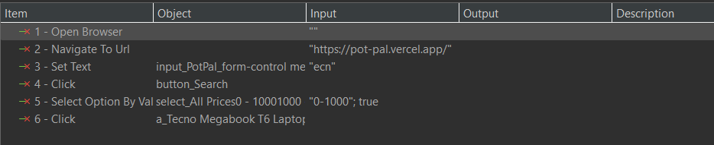

## Add new item to cart + Change quantity of items in cart + Remove item from cart

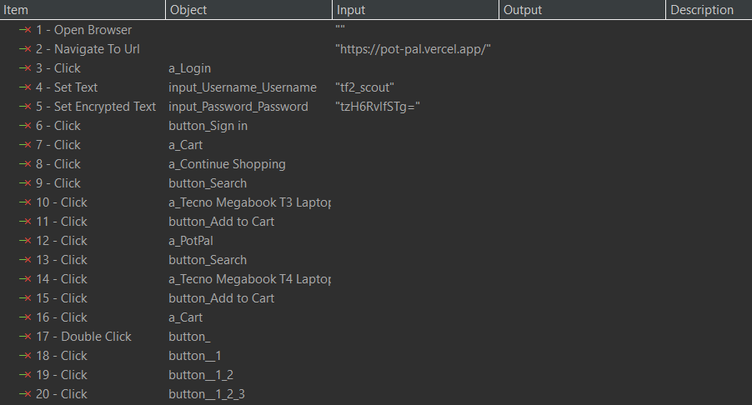  


## Add new product + Edit product

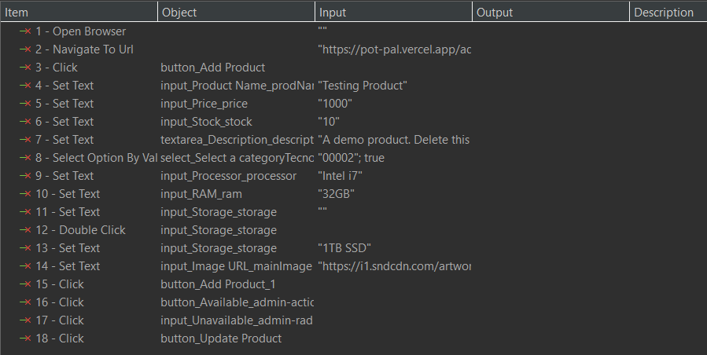

# Test Results

## Search with text

* + Passed 3 times with no defect.

## Filter by price

* + Passed 3 times with no defect.

## Add new item to cart

* + Passed 3 times with no defect.

## Change quantity of items in cart

* + Passed 3 times with no defect.

## Remove item from cart

* + Passed 3 times with no defect.

## Add new product

* + Passed 3 times with no defect.

## Edit product

* + Passed 3 times with no defect.

# Test Evidences

