Jacob Hayes

21 May 2023

Directory listing results:

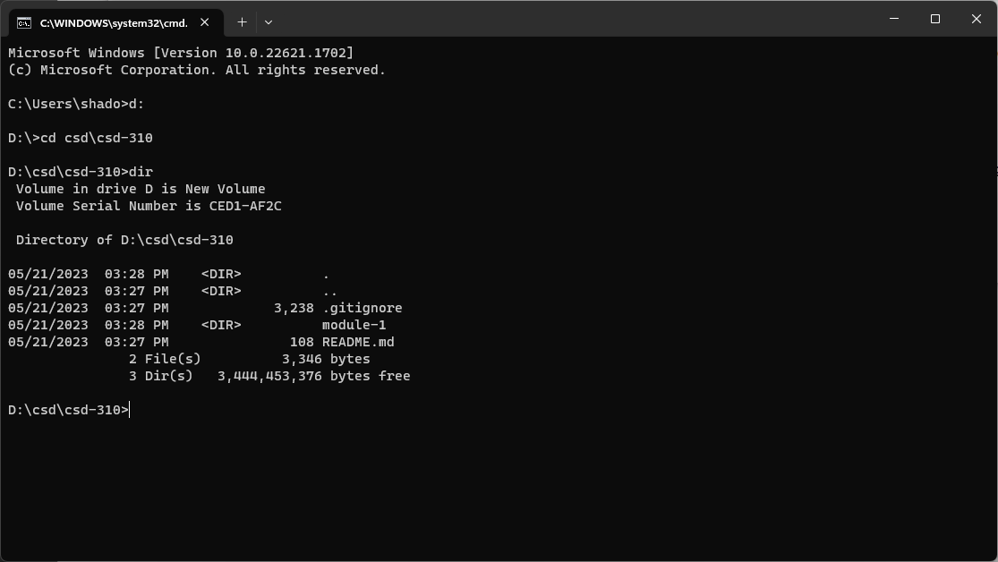

<https://github.com/Burndown9/csd-310>