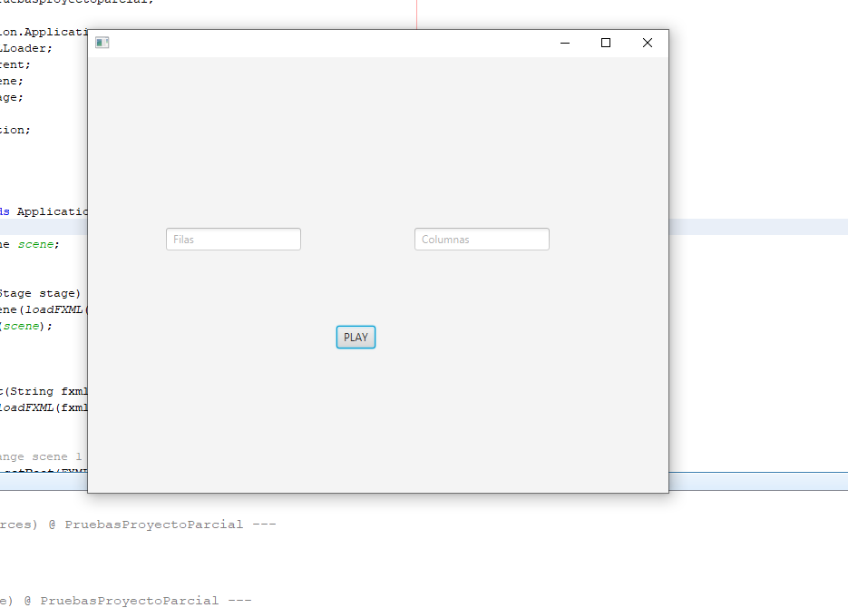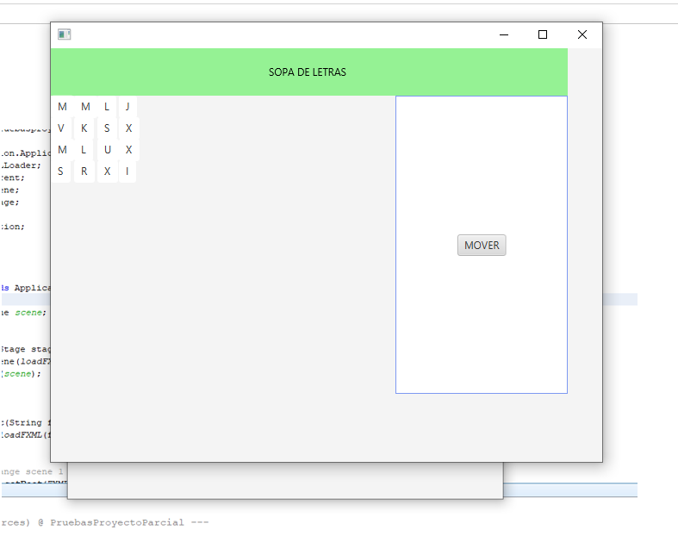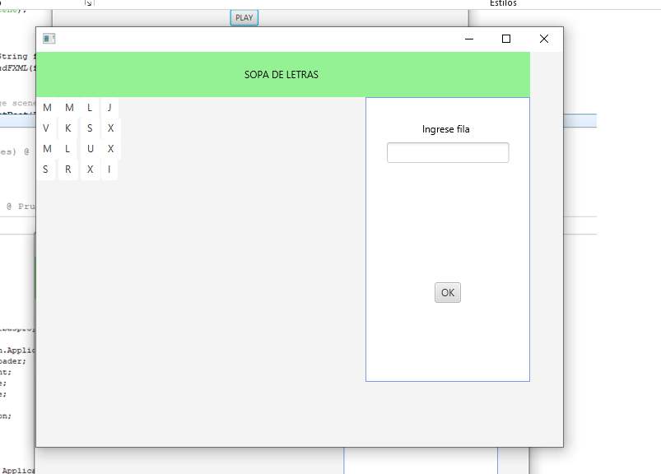

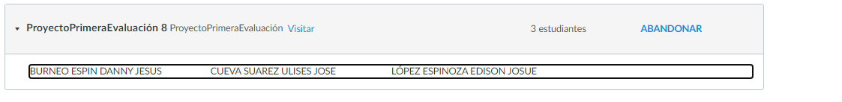

CUEVA SUAREZ ULISES = 0

LOPEZ ESPINOZA EDISON JOSUE = 0