**CMSC 411 Final Project – Presentation Outline/General Things to Discuss**

Highlighted = someone add to this

**Approach**

The project calls for an implementation of the CORDIC (Coordinate Rotation Digital) algorithm using hyperbolic sin and cos functions as well as the exponential function (ex). In order to implement the CORDIC algorithm we first had to learn how it works.

From the Documentation, we know that...

> The CORDIC algorithm involves a series of rotations of increasingly smaller pre-determined angles, in order to approximate a target angle.

AND

> In the hyperbolic implementation, those angles are arctanh(0.5i), where i is the rotation number which goes from 1 to the maximum number of rotations.

SO

1) For each rotation, new x and y values are calculated using the formulas:

x’ = x + d * y/2i

y’ = y + d * x/2i

Note: Explain what each variable means

2) For the hyperbolic implementation of the CORDIC algorithm:

y starts at 0

x starts at 1.207534

Note: Make sure to explain why x starts at 1.207534

3) When all of the rotations are done...

x is approximately the value of cosh(t)

y is approximately the value of sinh(t)

We can get et by adding cosh(t) and sinh(t)

4) With the above things in mind, we began the implementation.

Should we tell Chi that we started the implementation in C and then translated to assembly?

**Code**

Explain the most important steps as to how the code works:

[Mention general logic/idea for each step?]

When discussing the code, explain magic numbers (what is the purpose of those weird numbers in the code with no immediate context) and how the numbers are stored and modified during the calculations and why they are stored modified the way that they are.

Examples:

> **Show where we enter the input and what the input represents**

> Why does x start at 1.207534? (It is multiplied by k which is found to be 1.207534? What is k? Mention that this is to prevent multiplication?)

> Explain how we avoid multiplying during the CORDIC calculations? See above.

> Explain what the arctanh table is used for (fixed predetermined angles)

> Maybe mention that we used Floating-Point Instructions to store/manipulate numbers for sinh, cosh, and ex. Values for sinh, cosh, and ex are in VFP registers s3, s4, and s5 as 32 bit floats.

> All numbers are multiplied by 216 before doing the calculations, and divided by 216 after calculations, explain why this is.

**Issues**

Code Related Issues (From Documentation):

“The hardest part about this project was completing the Assembly code because the algorithm was only documented well for sin and cos online. There was very little information about how to change the Cordic algorithm to compute cosh, sinh, and ex .”

Solution – How did we find out how to implement the hyperbolic sin and cos function?

Once we have hyperbolic sin and cos, we can get ex because ex = sinh(x) + cosh(x).

Proof:

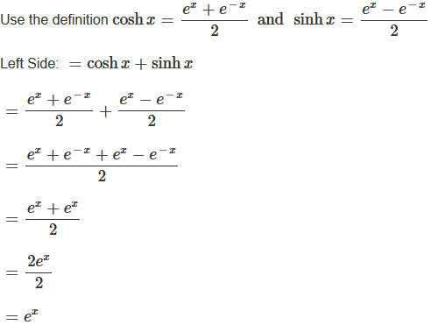

Non-code Related Issues:

Understanding how to calculate CPI – within the group, several members were confused about how CPI was calculated.

**Results**

Present clock speed results:

The most important thing is to state how we calculated each stat...

CPI = Clock Cycles per Second / Average Instructions per Second

Total Computer Cycles = CPI * Total Instructions

Total Processing Time = Total Computer Cycles / Clock Cycles per Second

|  |  |  |  |
| --- | --- | --- | --- |
| **Statistic** | **32kHz clock** | **1MHz clock** | **1GHz clock** |
| CPI | $$\frac{32,000 cycles/sec}{6135.2 instructions/sec} =5.215 CPI$$ | $$\frac{1,000,000 cycles/sec}{6135.2 instructions/sec}=162.99 CPI$$ | $$\frac{1,000,000,000 cycles/sec}{6135.2 instructions/sec}=162,993.87 CPI$$ |
| Total computer cycles | $$5.215\frac{cycles}{instruction} × 574 instructions = 2,993 cycles$$ | $$162.99\frac{cycles}{instruction}× 574 instructions = 93,556 cycles$$ | $$162,993.87\frac{cycles}{instruction}× 574 instructions = 93,558,481 cycles$$ |
| Total processing time | $$2,993 cycles ×\frac{1 second}{32,000 cycles}= 0.0935 seconds$$ | $$93, 556 cycles ×\frac{1 second}{1,000,00 cycles}= 0.0936 seconds$$ | $$93,558,481 cycles ×\frac{1 second}{1,000,000,000 cycles}= 0.0936 seconds$$ |

Present sample test data:

**Note: Chi may ignore our sample numbers and ask to input his numbers**

Our numbers...

|  |  |  |  |
| --- | --- | --- | --- |
| **x** | **cosh(x)** | **sinh(x)** | **ex** |
| 0 | 1.003 | 0.04332 | 1.046 |
| 0.88 | 1.416 | 1 | 2.416 |
| π/4 | 1.327 | 0.870 | 2.198 |
| - π/4 | 1.327 | -0.8704 | 0.4568 |
| -1 | 1.546 | -1.178 | 0.3688 |