**CSCI 3000 Homework 2**

Write a program that can be used by a small theater to sell tickets for performances. The theater’s auditorium has 15 rows of seats, with 30 seats in each row. The program should display a screen that shows which seats are available and which are taken. For example, the following screen shows a chart depicting each seat in the theater. Seats that are taken are represented by a # symbol, and seats that are available are represented by a - symbol:

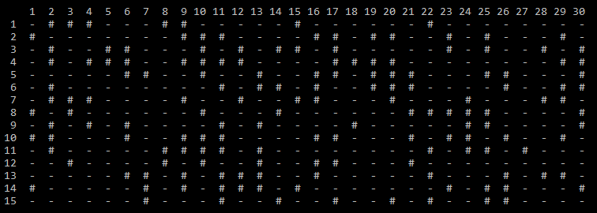

You will read the input file “tickets.txt” to read the initial condition of the theater. In the file, each line will represent one seat by a row and column number. For instance, if the file content is as follows:

10 15

5 20

8 13

This means three tickets were sold. And the seat location of the first ticket is 10th row and 15th column. The location of the second seat is 5th row and 20th column. And the location of the third seat is 8th row and 13th column.

Your program starts with showing a menu to the user. In the menu there will be 5 options as follows:

1. View Current Seats
   1. This menu will show the current seat conditions as shown in the above figure.
2. Sell Ticket
   1. Program will ask user the row and column number of the seat. And it will mark that seat as sold. (Also, provide a warning message if the seat was already sold)
3. Refund Ticket
   1. It will ask user to enter row and column number. If the seat was sold, it will mark it unsold. (Also, provide a warning message if the selected seat was not sold yet)
4. Save Data File
   1. It will save the current seat conditions back into the “tickets.txt” file using the same format. This way the same file can be used again for another run of the program.
5. Exit Program
   1. Exits the program

--> Please use functions for each option in the menu. Your code must be structured and easily readable.

++++++++++++++++++++++++++++++++++++++++++++++++++++++++++++++++++++++++++++++

On the top of your source code, please add your name and number, Course ID, HW number and the date using a comment block. Please see the example below,

/*

Semih Dinc – MY_STUDENT_NUMBER

CSCI 2000, HW-X

(Due Date)

*/

Please do not copy your code from someone else’s program. The instructor may use a code comparison program that automatically checks the similarity between different programs. And do not hesitate to contact me if you are having trouble with the homework. I will be more than happy to help you to solve your problem.