**CSCI 3000 Homework 4**

In this homework, you will manage the car data of a dealer. You will design a C++ class called **Car.** A single Car variable (object) have five member variables (attributes): **VIN, make, model, year,** and **price**.

Car class attributes should be private, and set/get functions should be implemented to access and update the values. Also, you should have at least two constructor functions to initialize Car objects. Finally a print() function should be implemented to print single Car data on the screen.

Class description is given below:

|  |  |
| --- | --- |
| **Car** | |
| *Type* | *Member Variables* |
| string | VIN |
| string | make |
| string | model |
| int | year |
| int | price |
|  | |
| *Return Type* | *Member Function* |
| (constructor) | **Car**() //default constructor |
| (constructor) | **Car**(string newVIN, string newMake, string newModel, int newYear, int newPrice) |
| void | **setVIN**(string newVIN) |
| void | **setMake**(string newMake) |
| void | **setModel**(string newModel) |
| void | **setYear**(int newYear) |
| void | **setPrice**(int newPrice) |
| string | **getVIN()** |
| string | **getMake()** |
| string | **getModel()** |
| int | **getYear()** |
| int | **getPrice()** |
| void | **print**() |

Once your class is ready, you will read the “cardata.txt” file, which includes all 250 cars in the dealer. A sample view of the file is given below:

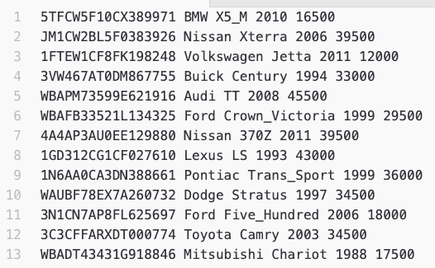

…

Before you read file, you will create an array of cars having size of 250. This number is always 250 and does not change. In the file, each line contains a single car, for which attributes are separated by space character. So, you can read one line using a simple while loop such as:

While(inputFile >> VIN >> make >> model >> year >> price){

//create new car and send it to the corresponding array index

...

}

Once your car array is ready, you will provide following operations to the user in a menu.

1. **Print All Cars:** Print all information of all Cars
2. **Print by Make:** Get the model name from user and print all cars only in that model.
3. **Print by Price:** Get a price input from the user and print all cars that have less than given input.
4. **Exit:** Exit from the program

On the top of your source code, please add your name and number, Course ID, HW number and the date using a comment block. Please see the example below,

/*MY_NAME – MY_STUDENT_NUMBER

CSCI 3000, HW-X

(Due Date)*/

Please do not copy your code from someone else’s program. The instructor may use a code comparison program that automatically checks the similarity between different programs. And do not hesitate to contact me if you are having trouble with the homework. I will be more than happy to help you to solve your problem.