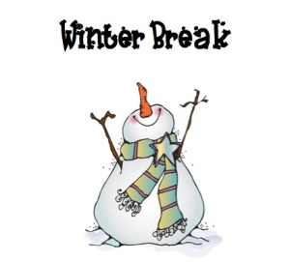**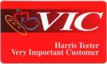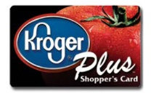**********

**Happy Holidays**

**from the PTO!**

We wish each family love and joy during the holiday season. Please check your students’ backpacks for a special gift from the PTO for each little Bobcat!

Follow us by visiting [facebook.com /**Burnley-Moran Elementary School PTO**](http://www.facebook.com/JackieRobinsonFamilyYMCA)

Be sure to find and click the LIKE and FOLLOW button at the top of the page.

**GO PAPERLESS**

**If you prefer an e-version of the PTO newsletter, email us @** [**burnleymoranpto@gmail.com**](mailto:burnleymoranpto@gmail.com)

**Community Corner**

**Winter Concert**

**Thursday Dec 15th (6:30-7:30 pm)**

2nd & 3rd grade proudly will present a collection of songs to bring holiday and winter cheer to our school community! Performers should be dropped off in the cafeteria by 6:15pm.

**Teacher Appreciation Lunch**

**Friday Dec 16th**

Let's make sure our fabulous teachers and staff knows how grateful we are for them at the holidays. **Bring a baked good to the teacher luncheon.** For more info contact Bekah at rimenning@gmail.com

**Supplies for the Art Room**

Mr. Trott is in need of flattened boxes in good condition that can be repurposed for art projects. Please send this to school with your Bobcat if you have any on hand.

**Barnes and Noble**

**Book Fair**

**Sat. Dec 10th (9-1pm)**

This is going to be a fun event with seasonal story times and crafts, caroling and an art exhibit. The BME PTO will earn 20% of all sales from 9am-1pm that day (**and online that week**). Please help spread the word!!!!!

***Mrs Stipe & BME students will be singing @11:30am.***

***Wear a BME shirt if you have one!***

**Fabio Pizza Night**

**Dec 14th**

The BME PTO will receive 10% of sales for the evening for families who bring the Bobcat Ticket.

***\*\* Raised money will help fund field trips and special projects at the school \*\****

Other Easy ways to help raise funds:

Fundraiser Events

**Upcoming Events**

* Jan 16th**:No School –MLK Day**
* Jan 17th**:PTO Meeting**
* Jan23th**: No School – Teacher Work Day**

**December’s School Events**

* Dec 10th**: Barnes&Noble Book Fair (9am -1pm)**
* Dec 13th**:PTO Meeting**
* Dec 14th**:Fabio Pizza Night**
* Dec 15th: **Winter Concert**
* Dec 16th: **Teacher Appreciation Lunch**
* Dec 19- Jan 2nd**:NO School - Winter Break**
* **GET A BME T-SHIRTS ($10)**
* **DIRECT DONATIONS TO BME PTO**
* **BOX-TOPS FOR EDUCATION**

For every Box Top you clip, the school will receive 10 cents.

* **LINK – SHOP – EARN**

**NEXT TIME** you are at the store give the BME School ID.

**ID: 90856 ID: 4880 ID: 02783**

Volunteer Corner

* Thank you to all of our volunteers for the wonderful help we’ve received all semester. Our school is great because of your involvement and energy. Thanks!!
* **Barnes&Noble Book Fair:** help make this first time event extra exciting!

**Questions? Comments? Ideas?**

**Contact our Co-Chairs Kristin Clarens & Keshia Washington @**[burnleymoranpto@gmail.com](mailto:burnleymoranpto@gmail.com)

The BME PTO is a volunteer group of parents/caregivers and teachers that work together for the benefit of the school and the students.

**BME PTO December**

**Newsletter!** 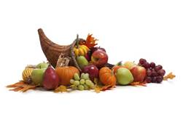

**PTO meeting**

**Tuesday Dec 13th**

**6-7pm**

**in the BME Library.**

**ALL ARE WELCOME!!**

**Up Coming Events**

* Nov 4th**:Walk to School Day**
* Nov 8th**:No School (Prof.Learn.Day )**
* Nov 10th:**Sock Hop**
* Nov15th**:PTO Meeting**
* Nov16th**: Fabio Pizza Night**
* Nov 23-25th**:Thanksgiving Break**

**October’s Events**

* Oct 7nd**:Walk to School Day**
* Oct 13th**:Community Potluck**
* Oct18th**:PTO Meeting**
* Oct19st**: Fabio Pizza Night**(1551 East High St.) Bring the Bobcat Ticket
* Oct286h**:NO School (Teacher Work Day)**