****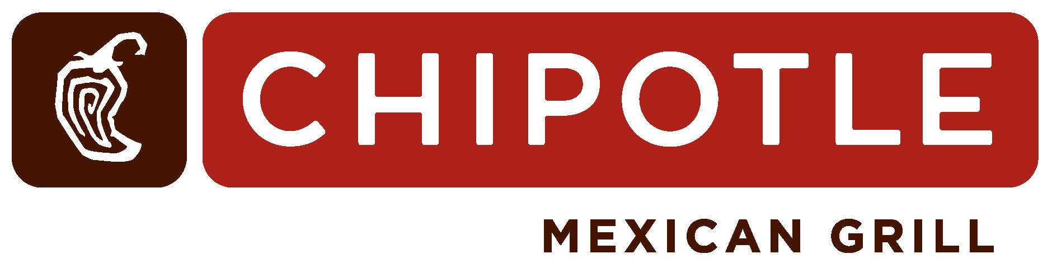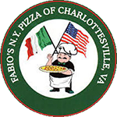 ********

Fundraiser Events

**Community Corner**

**COMMUNITY POTLUCK**

**Thur Oct 13, 5-7**

Join the Bobcat community and bring a dish to share at this teacher-sponsored community event**!**

Volunteer Corner

* **Walk-a-Thon:** Volunteers are still needed for this awesomely fun event!Contact **Beth B**. @ bethbaluarte@gmail.com for more details.
* **Tailgate at CHS**
* **Donations for SOCK HOP raffle baskets needed.** Themes are: arts and crafts, movie night, and cooking. Please donate small items related to one of the themes. Teachers will collect the donations for the PTO

**The BME PTO is a volunteer group of parents/caregivers and teachers that work together for the benefit of the school and the students. Contact our Co-Chairs Kristin Clarens and Keshia Washington us @** [burnleymoranpto@gmail.com](mailto:burnleymoranpto@gmail.com)

**if you have any questions or comments.**

**October’s School Events**

* Oct 7nd**:** **Walk to School Day**
* Oct 13th**:** **Community Potluck**
* Oct 286h**:** **NO School-Teacher Work Day**

Follow us by visiting [facebook.com /**Burnley-Moran Elementary School PTO**](http://www.facebook.com/JackieRobinsonFamilyYMCA)

Be sure to find and click the LIKE and FOLLOW button at the top of the page.

**Up Coming Events**

* Nov 4th**:** **Walk to School Day**
* Nov 4th**:** **Tailgate at CHS**
* Nov 8th**: No School-Prof.Learn. Day**
* Nov 10th:**Sock Hop**
* Nov 15th**:** **PTO Meeting**
* Nov 23-25th**: Thanksgiving Break**

**GO PAPERLESS**

**If you prefer an e-version of the PTO newsletter, email us @** [**burnleymoranpto@gmail.com**](mailto:burnleymoranpto@gmail.com)

**PTO meeting**

**Tuesday Oct 18th**

**6-7pm**

**in the BME Library.**

**ALL ARE WELCOME!!**

Other Easy ways to help raise funds:

* **GET A BME T-SHIRTS ($10)**
* **DIRECT DONATIONS TO BME PTO**
* **BOX-TOPS FOR EDUCATION**

For every Box Top you clip, the school will receive 10 cents.

* **LINK – SHOP – EARN**

**NEXT TIME** you are at the store give the BME School ID.

**ID: 90856**  **ID: 4880** **ID: 02783**

**Ninja Night**

**Oct 8th (4-9pm)**

Bring your Bobcat to Mountain Kim Martial Arts and enjoy a parents’ night out! Your child gets a Taekwondolesson, pizza, and more for just $20; proceeds benefit the PTO. Spots are limited; visit

<http://burnleymoran-pto-mtkim.eventbrite.com>

**Friday, Oct 21th**

This super fun event helps support the PTO programs and events throughout the ENTIRE school year. ***Pledges are due October 20th***. Please ask your friends, family, and neighbors to help support your effort and your school.

**Restaurant Month**

For the next month, **Chipotle, Fabio’s Pizza, Guadalajara and Mc Donald’s** will donate a portion of their profit to the PTO. Join your friends for a fun and fundraising meal. Supporting BME has never been easier!

* **Oct10th: Chipotle**
* **Oct 19th: Fabio’s Pizza**
* **Oct 29th: Guadalajara**
* **Nov 2nd: Mc Donald**

**Up Coming Events**

* Nov 4th**:** **Walk to School Day**
* Nov 8th**:No School (Prof.Learn.Day )**
* Nov 10th:**Sock Hop**
* Nov 15th**:** **PTO Meeting**
* Nov 16th**: Fabio Pizza Night**
* Nov 23-25th**: Thanksgiving Break**

**October’s Events**

* Oct 7nd**:** **Walk to School Day**
* Oct 13th**:** **Community Potluck**
* Oct 18th**:** **PTO Meeting**
* Oct19st**: Fabio Pizza Night** (1551 East High St.) Bring the Bobcat Ticket
* Oct 286h**:** **NO School (Teacher Work Day)**

**BME PTO October**

**Newsletter!**