******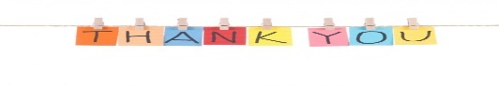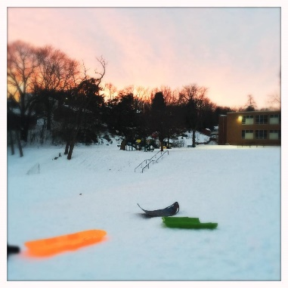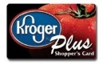******Image result for dollar signImage result for dollar sign****

**Community Corner**

**BME Community Night**

**Friday Jan 20th**

Keep your eyes peeled for more information on BME Community Night at the Main Street Ice Arena!

**Sledding on the BME Hill**

**Next snow day**

There are only a few things more fun than gliding down a snow-covered hill in a plastic sled or inner tube. Next snow day, come spend time with friends and family at BME playground!!!!

Volunteer Corner

* **Multicultural Night Hosts!!** Volunteers NEEDED to host a classroom country! **This could be a country that represents your heritage, somewhere you have visited, or somewhere you would like to visit**! Volunteers could share pictures, traditional clothing, a craft, a game, a song, a video, or teach students words from another language.
* **Spring Fling!** We are looking for *Games, Food and Raffle Coordinators* for one of the PTO’s biggest celebration of the year! Spring Fling is quickly approaching. Please join us brainstorm and organized this fun event!
* **Playground Project**! We are looking for volunteers for the Playground Improvement Committee to help make the BME an even better playground.

**Questions? Comments? Ideas?**

**Contact our Co-Chairs Kristin Clarens & Keshia Washington @**[burnleymoranpto@gmail.com](mailto:burnleymoranpto@gmail.com)

The BME PTO is a volunteer group of parents/caregivers and teachers that work together for the benefit of the school and the students.

**GO PAPERLESS**

**If you prefer an e-version of the PTO newsletter, email us @** [**burnleymoranpto@gmail.com**](mailto:burnleymoranpto@gmail.com)

Follow us by visiting [facebook.com /**Burnley-Moran Elementary School PTO**](http://www.facebook.com/JackieRobinsonFamilyYMCA)

Be sure to find and click the LIKE and FOLLOW button at the top of the page.

**Sunset** **on the BME Hill.**

**Fast & Fun!**

**Upcoming Events**

* **Feb 4th: Ninja Night**
* Feb 10th**:Teacher Appreciation**
* Feb 16th**: Multicultural Night (5:30-7:30pm)**
* **Feb 20th: No School – Teacher Professional learning**
* Feb 21st**:PTO Meeting**
* Feb 22th**: Fabio Pizza Night**

**January’s School Events**

* Jan 16th**: NO School – In honor of MLK**
* Jan 17th**:PTO Meeting**
* Jan 18th**:Fabio Pizza Night**
* Jan 20th: **Ice skating BME Community Night**
* Jan 23rd: **NO School –Teacher Workday**

Other Easy ways to help raise funds:

**Fabio Pizza Night**

**Jan 18th**

The BME PTO will receive 10% of sales for the evening for families who bring the Bobcat Ticket.

***\*\* Raised money will help fund field trips and special proje* *cts at the school \*\****

**Ninja Night**

**Feb 4th (4-9pm)**

Parents, are you in need of a night off? Let your kids unleash their inner ninjas while you take the evening off! Ninja night is great fun and much much more!! . Spots are limited; visit

<http://burnleymoran-pto-mtkim.eventbrite.com>

* **GET A BME T-SHIRTS ($10)**
* **DIRECT DONATIONS TO BME PTO**
* **BOX-TOPS FOR EDUCATION**

For every Box Top you clip, the school will receive 10 cents.

* **LINK – SHOP – EARN**

**NEXT TIME** you are at the store give the BME School ID.

**ID: 90856 ID: 4880 ID: 02783**

Fundraiser Events

**BME PTO January**

**Newsletter!** 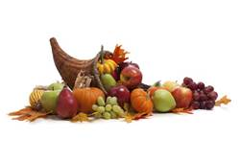

**PTO meeting**

**Tuesday Jan 17th**

**6-7pm**

**in the BME Library.**

**ALL ARE WELCOME!!**

**Up Coming Events**

* Nov 4th**:Walk to School Day**
* Nov 8th**:No School (Prof.Learn.Day )**
* Nov 10th:**Sock Hop**
* Nov15th**:PTO Meeting**
* Nov16th**: Fabio Pizza Night**
* Nov 23-25th**:Thanksgiving Break**

**October’s Events**

* Oct 7nd**:Walk to School Day**
* Oct 13th**:Community Potluck**
* Oct18th**:PTO Meeting**
* Oct19st**: Fabio Pizza Night**(1551 East High St.) Bring the Bobcat Ticket
* Oct286h**:NO School (Teacher Work Day)**