Lab 1

MATLAB is a powerful tool to solve complex differential equations and do near-instant parallel calculations for simulations. In this lab we learned and reviewed the functionality of simulating a mass spring system through a system of ODE’s, the state space method, and finding a transfer function for the system. We then apply what we use in these problems to simulate an inverted pendulum-cart system. To simulate the pole-cart system we implemented the equations of motion in the state space form, assuming various parameters like weight of the cart and length of the pendulum and using a piecewise function to apply an external force to the cart. The straightforward state-space matrices and the lsim() function make simulating the pole-cart system simple, which allows us to understand how to get the state space equations and external functions in the first place.

% State-space matrices

A = [0 1 0 0; 0 0 -((mp\*g)/mc) 0; 0 0 0 1; 0 0 (g\*(mp + mc)/(L\*mc)) 0];

B = [0; (1/mc); 0; -(1/(L\*mc))];

C = [1 0 0 0];

D = 0;

% Time span for the simulation

tspan = 0:0.01:10;

% Define input function (external force F)

u = arrayfun(F, tspan); % Evaluate F(t) over the time span

% Initial state

x0 = [0; 0; 0.523599; 0]; % Initial displacement and velocity

% Simulate the state-space system using lsim

sys = ss(A, B, C, D); % Create the state-space system

[y, t, x] = lsim(sys, u, tspan, x0); % Simulate the response

Figure 1: Our code modified from the example code

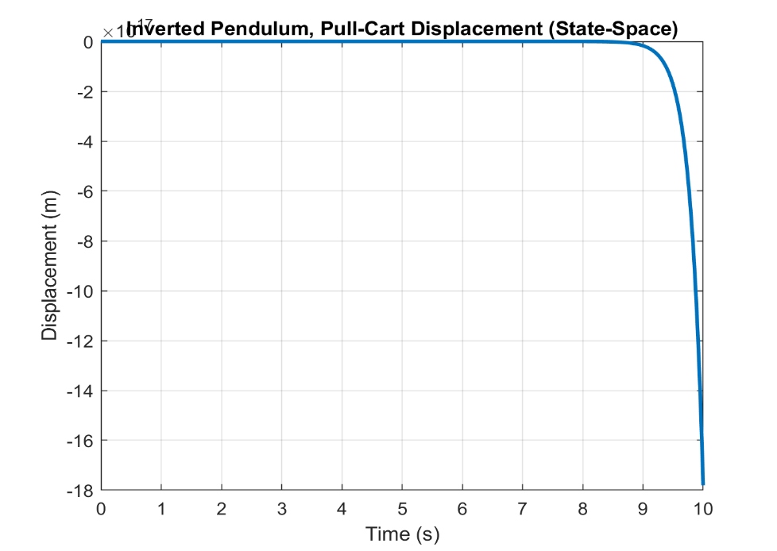

Figure 2: State-space graph of the pole-cart system

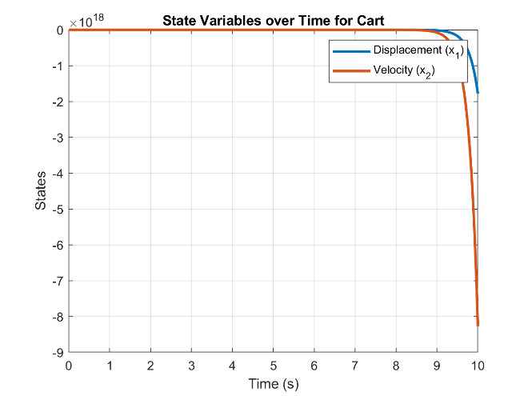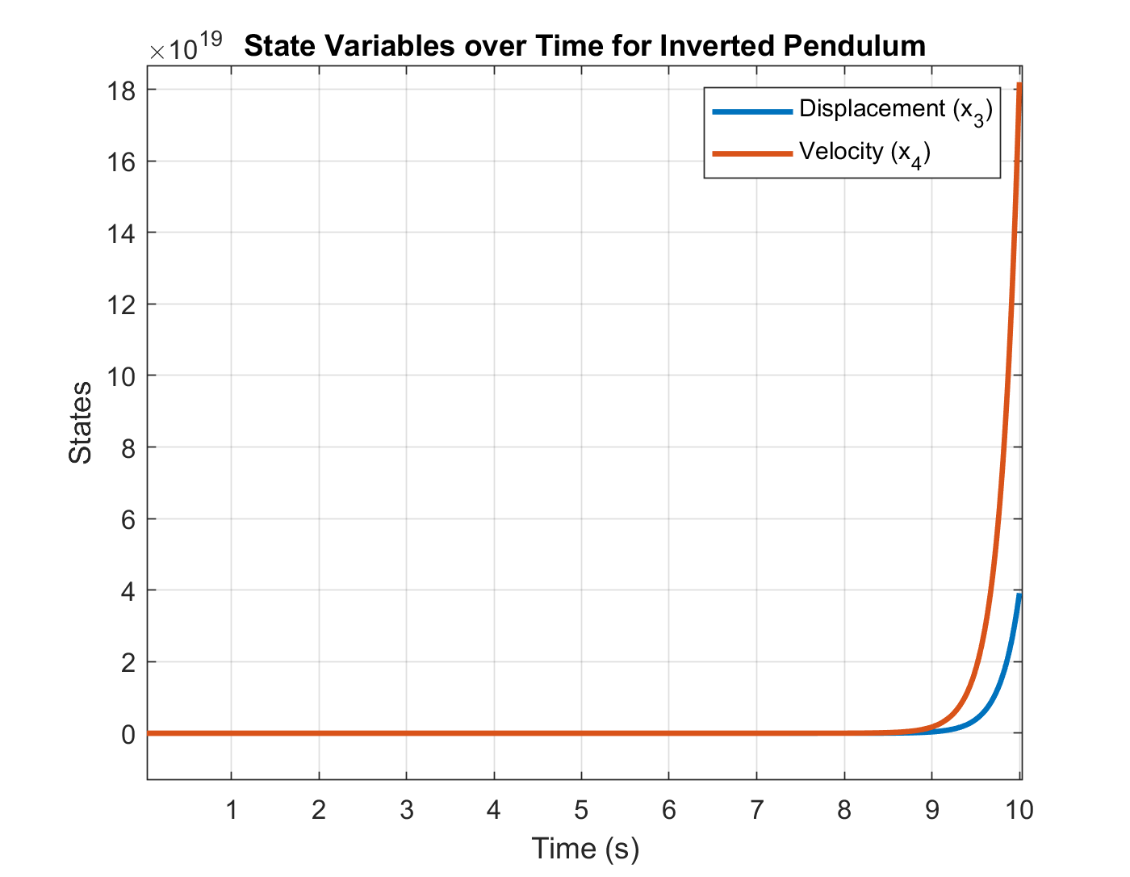

Figures 3 and 4: Graphs of the states of the cart and inverted pendulum respectively

After analyzing the resulting graphs from our system we conclude that they are not expected and representative of the system. The main point we find an issue with is the cart's displacement concerning time. The cart is a 1kg mass with an additional .1kg mass attached. The force applied on the cart is 1N which has the units kg\*m/s^2. Given that our system is slightly over 1kg we would expect to see our cart begin accelerating linearly around 1 second in, however, the cart's displacement remains static until the last few fractions of a second. This leads us to believe that this system has been incorrectly modeled.

Conclusion

In general we learned that these system settings can be volatile, in the sense that a small change can impact the resulting simulation greatly. Although the resulting plots were “correct” we concluded the results were mostly “theoretical” and these might not be the exact results in a real-life testing apparatus.