AI Assisted Coding-15.4
Name: B.Akshara
Ht.no:2303A51279
Batch.no:05
Task 1– Real-Time Application: Online Food Ordering API
Prompt:
Create a simple REST API for an Online Food Ordering System using Node.js and Express.
Include endpoints:
- GET /menu → list food items
- POST /order → create order
- GET /order/:id → get order status • PUT /order/:id → update order
- DELETE /order/:id → cancel order
Use in-memory storage, UUID for IDs, proper status codes, and return clean JSON responses. Provide complete working code in one file (server.js) with run instructions. Also suggest improvements like authentication and pagination.
Output :
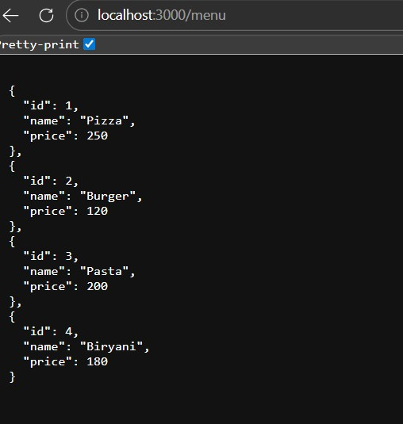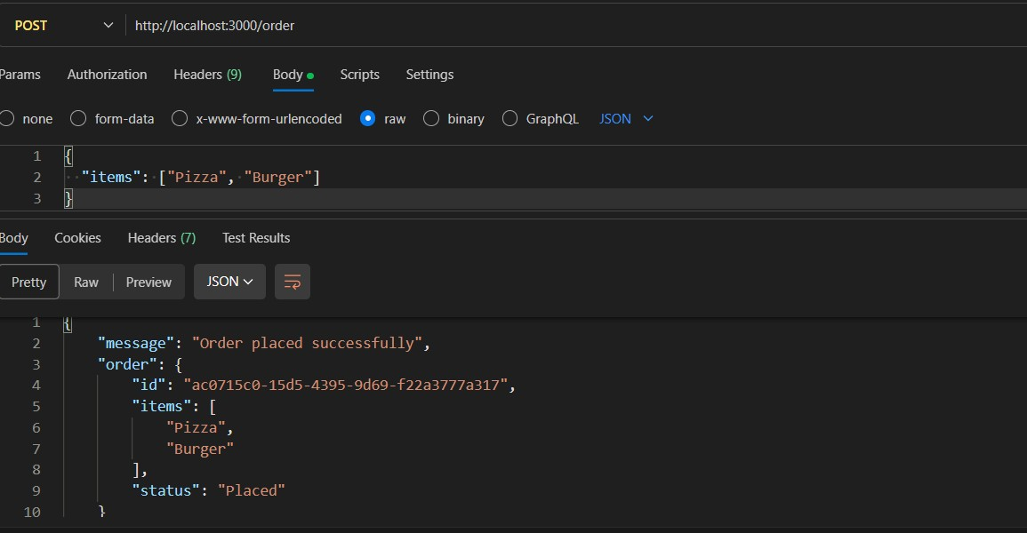
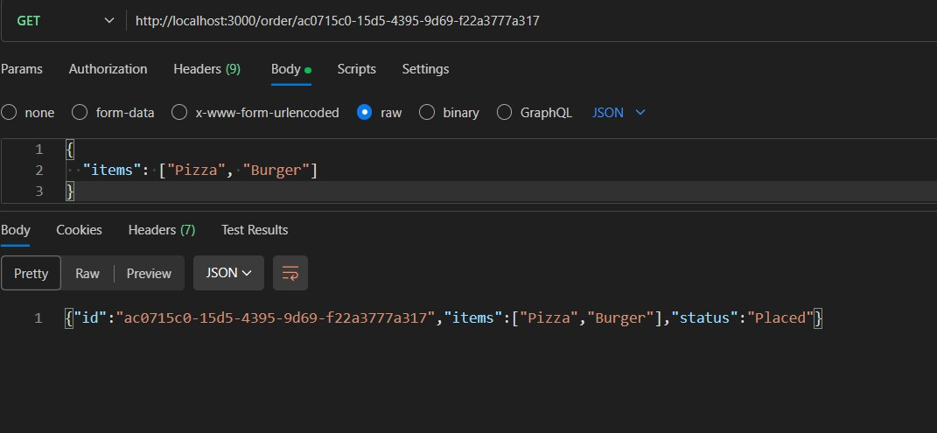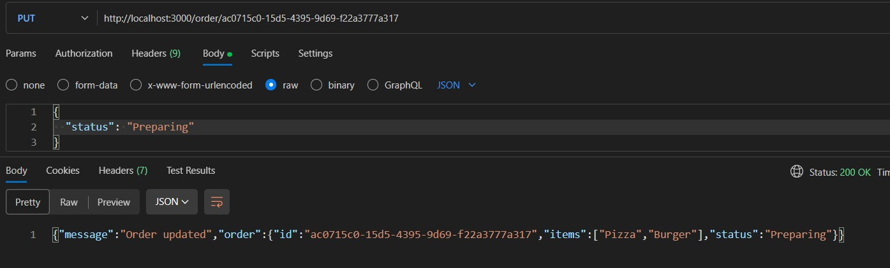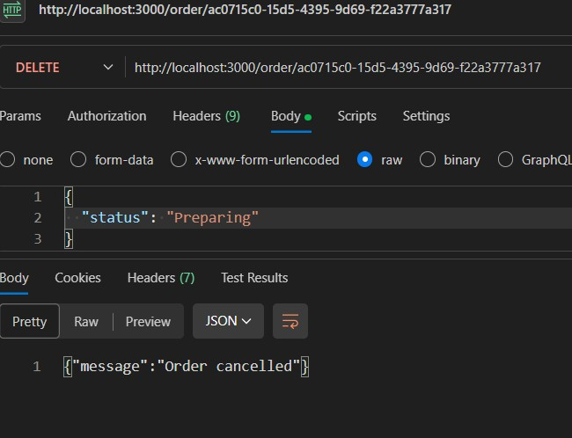

Explanation : This code implements a simple API for an online food ordering system using Flask. It allows users to view the menu, place orders, track orders, update existing orders, and cancel orders. The menu and orders are stored in dictionaries, and the API handles various HTTP methods to perform the necessary operations on the orders.

Task 2 – Employee Payroll API
Prompt:
Create a REST API for an Employee Payroll System using Node.js and Express.
Include endpoints:
- GET /employees → list all employees
- POST /employees → add employee with salary details
- PUT /employees/:id/salary → update employee salary
- DELETE /employees/:id → remove employee
Use in-memory storage, unique IDs, input validation, and proper HTTP status codes. Suggest a clear data model structure (employee id, name, role, salary). Add comments/docstrings for each endpoint. Provide complete working code in one file and basic API documentation. Also ensure secure and structured data handling.
Output:
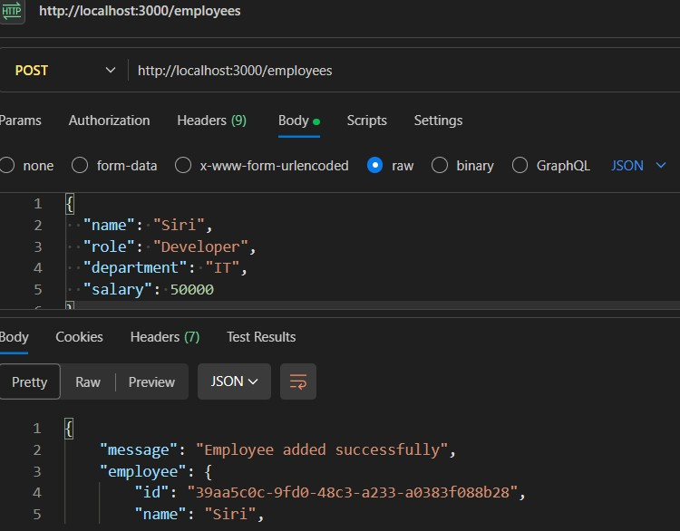
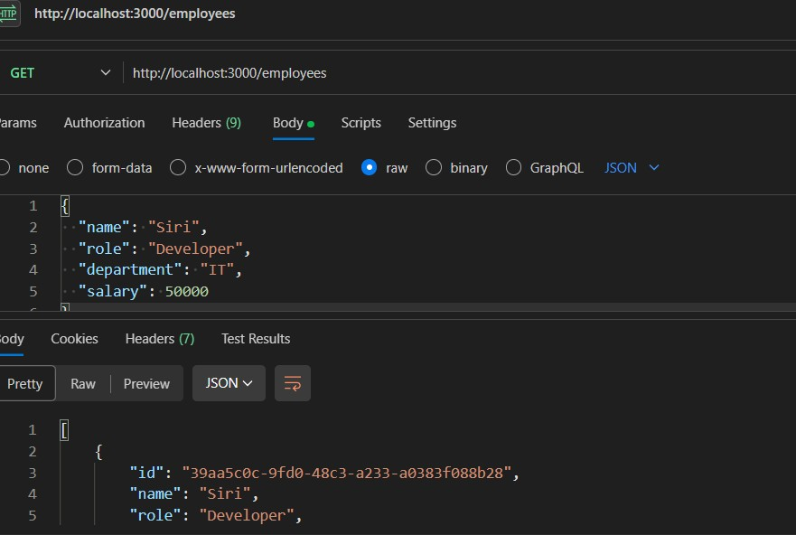
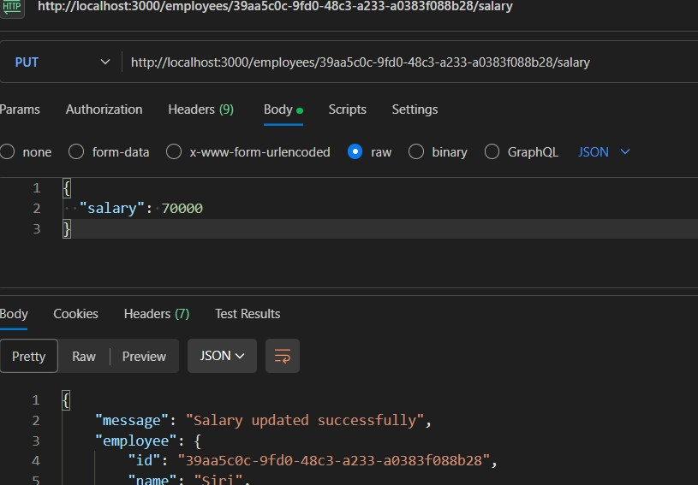
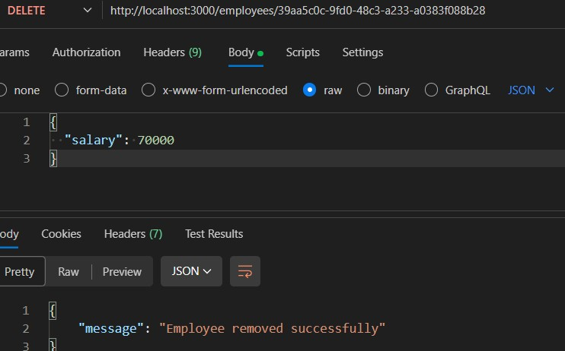
Explanation : The Employee Payroll API built using Flask manages employee data through REST endpoints.
It allows users to list employees, add new employees, update employee salary, and delete employees using GET, POST, PUT, and DELETE methods. Employee information is stored in an in-memory list and returned in JSON format.
Task 3: Student Information REST API
Prompt:
Create a Student Management REST API using Node.js and Express.
Features:
- Add student (name, rollNumber, course, year)
- Get all students
- Get student by ID
- Update student
- Delete student
Use:
- In-memory storage
- UUID for IDs
- Input validation - Proper status codes
Output:
- Complete server.js with comments Output:
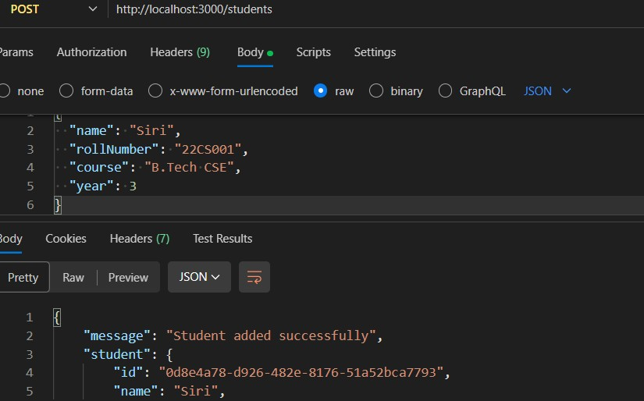
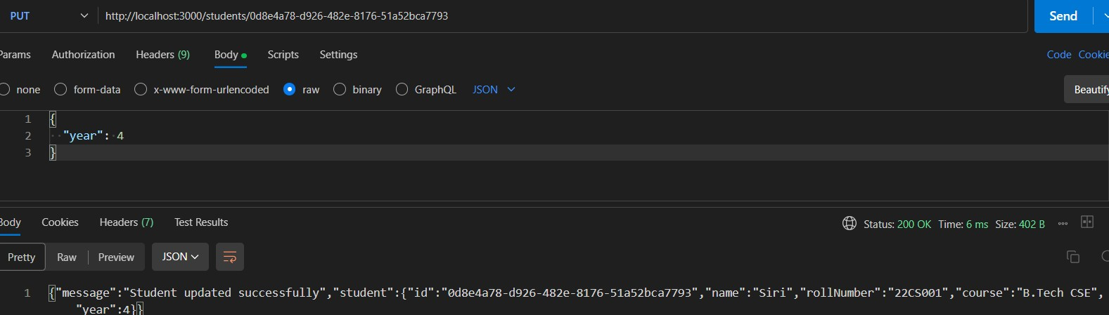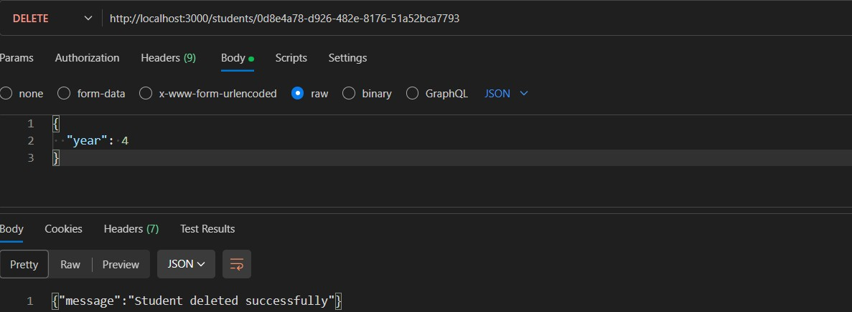
Explanation : This code is a simple API for a Student Information System built using the Flask framework. It allows users to perform CRUD (Create, Read, Update, Delete) operations on student data. The API has endpoints to list all students, add a new student, update an existing student's information, and delete a student based on their ID. The student data is stored in a list called `students`.
Task 4: Weather Information API Integration
Prompt:
Create a Weather API using Node.js and Express.
Endpoints:
- GET /weather/current/:city → current weather
- GET /weather/forecast/:city → 5-day forecast
Use OpenWeatherMap API with axios.
Return temperature, humidity, and weather condition in JSON.
Include error handling and clean code.
Output:
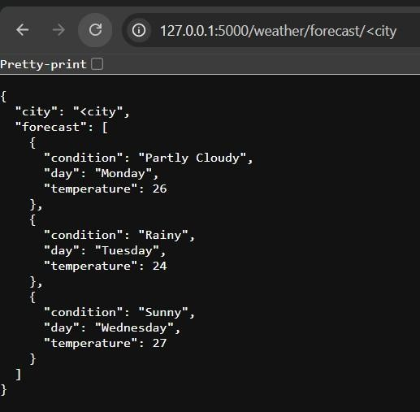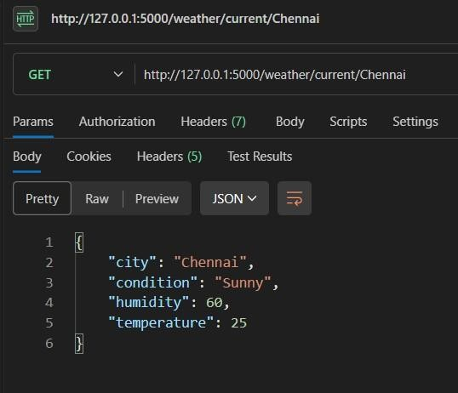

Explanation : This code creates a simple Flask REST API with two endpoints: /weather/current/<city> and /weather/forecast/<city>. The first endpoint returns mock current weather data for the specified city, while the second endpoint returns a mock weather forecast for the next few days. In a real implementation, you would replace the mock data with actual data fetched from the OpenWeatherMap API.
TASK – 05
Prompt : Create a Python **Flask REST API endpoint to delete an item from a list using the DELETE method. The endpoint should be /items/<int:index>. If the index is invalid, return a JSON error message "Item not found" with status code 404. If successful, remove the item and return a JSON response with "message": "Item deleted" and the deleted item.
Output:

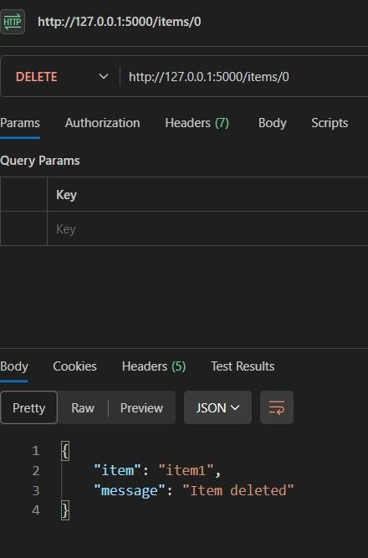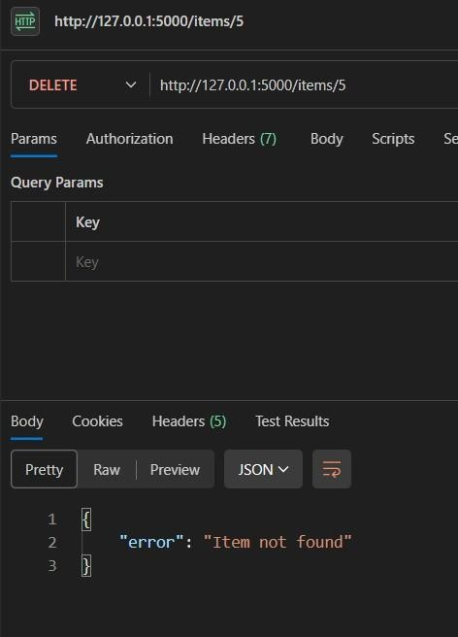

Explanation :
This code creates a simple Flask REST API with an endpoint to delete an item from a list. The endpoint is defined as `/items/<int:index>`, where `<int:index>` is a placeholder for the index of the item to be deleted.
When a DELETE request is made to this endpoint, the function `delete_item` is called with the index as an argument. The function checks if the index is valid (i.e., within the bounds of the list). If it is valid, it removes the item from the list using `pop()` and returns a JSON response indicating that the item was deleted, along with the deleted item itself.

