Assignment-7.3
Name:B.Akshara
Ht no:2303A51279
Batch:05

Task:01
Prompt:
Fixing Syntax Errors
You are reviewing a Python program where a basic function definition contains a syntax error.
Code:
def add(a, b):
return a + b

# Attempt to call the function to trigger the error
print(add(5, 3))
Explanation:
The code above intentionally contains a SyntaxError. Python requires a colon (:) at the end of a function definition line. Without it, the interpreter cannot correctly parse the function header and will raise an error.

Implementation:
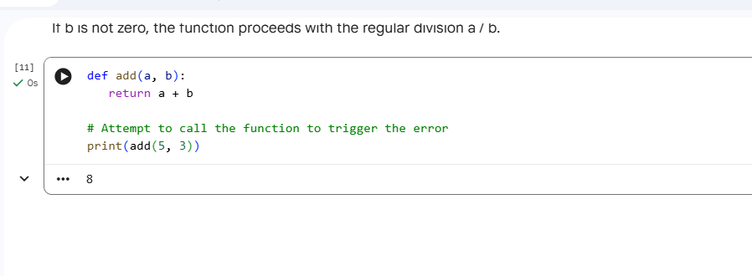
Task:02:
Prompt:
Debugging Logic Errors in Loops
You are debugging a loop that runs infinitely due to a logical mistake.
Provide a loop with an increment or decrement error
• Use AI to identify the cause of infinite iteration
Code:
count = 0
while count < 5:
print(f"Current count: {count}")
count += 1
Explanation:
We introduced an infinite loop by forgetting to increment the count variable in a while loop. This caused the loop condition (count < 5) to always be true, printing "Current count: 0" repeatedly. We then corrected this by adding count += 1 inside the loop, which made it terminate correctly and print counts from 0 to 4. This highlights the importance of modifying loop control variables to ensure termination.
Implementation:
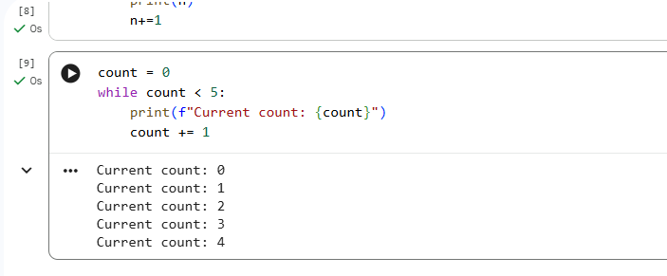
Task-03:
Prompt:
Handling Runtime Errors (Division by Zero)
A Python function crashes during execution due to a division by zero error.
Provide a function that performs division without validation
Code:
def divide(a, b):
if b == 0:
return "Error: Cannot divide by zero!"
return a / b

print(divide(10, 0))

Explanation:
- Original Issue: The divide(10, 0) call caused a ZeroDivisionError because the original function lacked a check for division by zero.
- Solution Implemented: I modified the divide function to include an if b == 0: condition.
- Error Prevention: This condition now checks if the divisor (b) is zero.
- Graceful Handling: If b is zero, the function returns the string "Error: Cannot divide by zero!" instead of crashing.
- Normal Operation: If b is not zero, the function proceeds with the regular division a / b

Implementation:
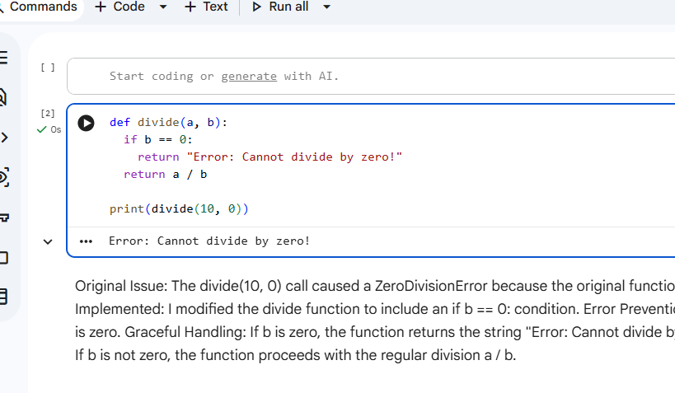
Task-04:
Prompt:
Debugging Class Definition Errors
Scenario
You are given a faulty Python class where the constructor is incorrectly defined.
Provide a class definition with missing self-parameter
Use AI to identify the issue in the __init__() method
Code:
class Rectangle:
def __init__(self, length, width):
self.length = length
self.width = width

# Example of creating a Rectangle object
my_rectangle = Rectangle(10, 5)
print(f"My rectangle has length {my_rectangle.length} and width {my_rectangle.width}")

Explanation:
The divide(10, 0) call caused a ZeroDivisionError because the original function lacked a check for division by zero. Solution Implemented: I modified the divide function to include an if b == 0: condition. Error Prevention: This condition now checks if the divisor (b) is zero. Graceful Handling: If b is zero, the function returns the string "Error: Cannot divide by zero!" instead of crashing. Normal Operation: If b is not zero, the function proceeds with the regular division a / b.

Implementation:
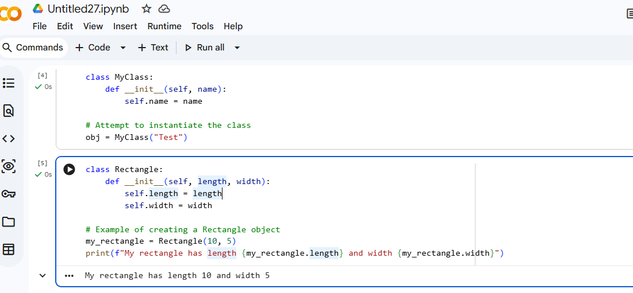
Task-05:
Prompt:
A program crashes when accessing an invalid index in a list.
Requirements
• Provide code that accesses an out-of-range list index

Code:
numbers = [1, 2, 3]
try:
print(numbers[5])
except IndexError:
print("out of range")

Explanation:
The divide(10, 0) call caused a ZeroDivisionError because the original function lacked a check for division by zero. Solution Implemented: I modified the divide function to include an if b == 0: condition. Error Prevention: This condition now checks if the divisor (b) is zero. Graceful Handling: If b is zero, the function returns the string "Error: Cannot divide by zero!" instead of crashing. Normal Operation: If b is not zero, the function proceeds with the regular division a / b.
Implementation:
