Assignment-3.3
Name:B.Akshara
Ht No:2303A51279
Batch:05

Task-01
Prompt:
Logic for Reading Consumer Details
Scenario
An electricity billing system must collect accurate consumer data.enerate a Python program that:
• Reads:
o Previous Units (PU)
o Current Units (CU)
o Type of Customer
• Calculates units consumed
• Implements logic directly in the main program (no functions)

Code:
# Electricity Billing System - Consumer Details Reader
# Reading consumer details
print("=" * 50)
print("ELECTRICITY BILLING SYSTEM")
print("=" * 50)

# Read Previous Units (PU)
pu = float(input("Enter Previous Units (PU): "))

# Read Current Units (CU)
cu = float(input("Enter Current Units (CU): "))

# Read Type of Customer
print("\nCustomer Types:")
print("1. Domestic")
print("2. Commercial")
print("3. Industrial")
customer_type = input("Enter Type of Customer (1/2/3 or name): ").strip()

# Calculate units consumed
units_consumed = cu - pu

# Display results
print("\n" + "=" * 50)
print("CONSUMER BILLING DETAILS")
print("=" * 50)
print(f"Previous Units (PU): {pu:.2f}")
print(f"Current Units (CU): {cu:.2f}")
print(f"Units Consumed: {units_consumed:.2f}")
print(f"Type of Customer: {customer_type}")
print("=" * 50)

# Validation check
if units_consumed < 0:
print("\nWARNING: Current Units is less than Previous Units!")
print("Please verify the readings.")
elif units_consumed == 0:
print("\nNOTE: No units consumed in this billing period.")
else:
print(f"\nTotal units consumed: {units_consumed:.2f} units")
Implementation:
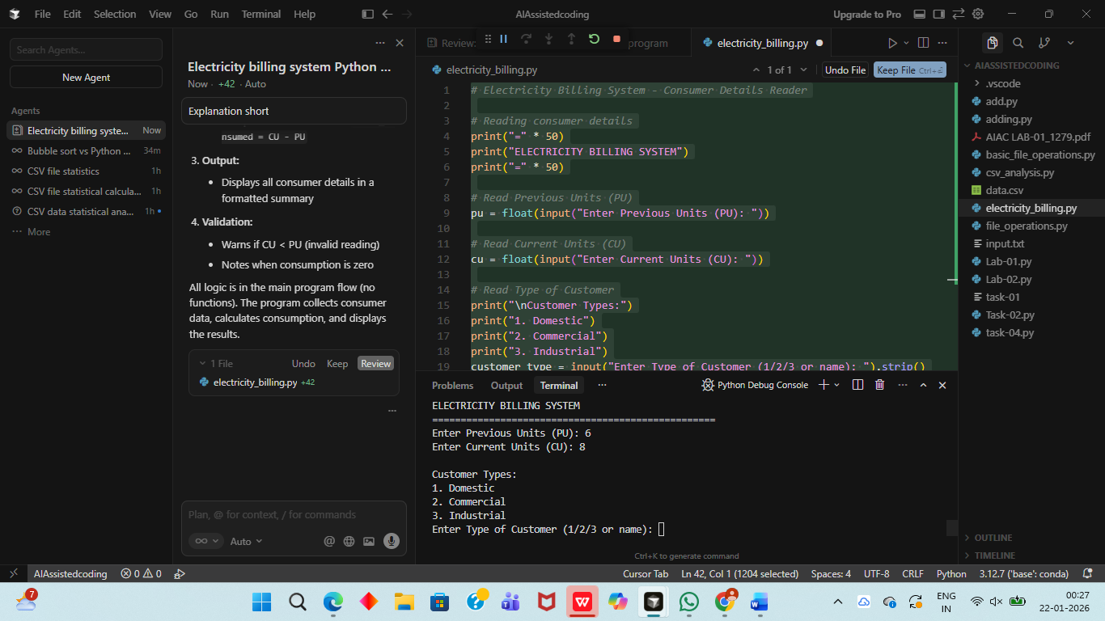
Explanation:
- Input Collection:
- Reads Previous Units (PU)
- Reads Current Units (CU)
- Reads Type of Customer (Domestic/Commercial/Industrial)
- Calculation:
- Computes units consumed: units_consumed = CU - PU
- Output:
- Displays all consumer details in a formatted summary
- Validation:
- Warns if CU < PU (invalid reading)
- Notes when consumption is zero
All logic is in the main program flow (no functions). The program collects consumer data, calculates consumption, and displays the results.
Task-02
Prompt:
Energy Charges Calculation Based on Units Consumed
Scenario
Energy charges depend on the number of units consumed and customer type.from Task 1 and extend it to:
• Calculate Energy Charges (EC)
• Use conditional statements based on:
o Domestic
o Commercial
o Industrial consumers
• Improve readability using AI prompts such as:
o “Simplify energy charge calculation logic”
o “Optimize conditional statements”

Code:
# Electricity Billing System - Consumer Details Reader with Energy Charges Calculation

def normalize_customer_type(customer_input):
"""Normalize customer type input to standard format."""
customer_input = customer_input.lower().strip()

if customer_input in ['1', 'domestic', 'd']:
return 'Domestic'
elif customer_input in ['2', 'commercial', 'c']:
return 'Commercial'
elif customer_input in ['3', 'industrial', 'i']:
return 'Industrial'
else:
return customer_input.title()

def calculate_domestic_energy_charges(units):
"""
Calculate energy charges for Domestic consumers.
Tiered rate structure:
- First 100 units: ₹3.50 per unit
- Next 200 units (101-300): ₹4.50 per unit
- Above 300 units: ₹5.50 per unit
"""
if units <= 0:
return 0.0

if units <= 100:
return units * 3.50
elif units <= 300:
return (100 * 3.50) + ((units - 100) * 4.50)
else:
return (100 * 3.50) + (200 * 4.50) + ((units - 300) * 5.50)

def calculate_commercial_energy_charges(units):
"""
Calculate energy charges for Commercial consumers.
Tiered rate structure:
- First 200 units: ₹5.00 per unit
- Next 300 units (201-500): ₹6.50 per unit
- Above 500 units: ₹7.50 per unit
"""
if units <= 0:
return 0.0

if units <= 200:
return units * 5.00
elif units <= 500:
return (200 * 5.00) + ((units - 200) * 6.50)
else:
return (200 * 5.00) + (300 * 6.50) + ((units - 500) * 7.50)

def calculate_industrial_energy_charges(units):
"""
Calculate energy charges for Industrial consumers.
Tiered rate structure:
- First 500 units: ₹6.00 per unit
- Next 1000 units (501-1500): ₹7.00 per unit
- Above 1500 units: ₹8.00 per unit
"""
if units <= 0:
return 0.0

if units <= 500:
return units * 6.00
elif units <= 1500:
return (500 * 6.00) + ((units - 500) * 7.00)
else:
return (500 * 6.00) + (1000 * 7.00) + ((units - 1500) * 8.00)

def calculate_energy_charges(units, customer_type):
"""
Calculate energy charges based on customer type.
Optimized conditional routing to appropriate calculation function.
"""
customer_type = normalize_customer_type(customer_type)

if customer_type == 'Domestic':
return calculate_domestic_energy_charges(units)
elif customer_type == 'Commercial':
return calculate_commercial_energy_charges(units)
elif customer_type == 'Industrial':
return calculate_industrial_energy_charges(units)
else:
print(f"\nWARNING: Unknown customer type '{customer_type}'. Using Domestic rates.")
return calculate_domestic_energy_charges(units)

# Main Program
print("=" * 50)
print("ELECTRICITY BILLING SYSTEM")
print("=" * 50)

# Read Previous Units (PU)
pu = float(input("Enter Previous Units (PU): "))

# Read Current Units (CU)
cu = float(input("Enter Current Units (CU): "))

# Read Type of Customer
print("\nCustomer Types:")
print("1. Domestic")
print("2. Commercial")
print("3. Industrial")
customer_type_input = input("Enter Type of Customer (1/2/3 or name): ").strip()

# Normalize customer type
customer_type = normalize_customer_type(customer_type_input)

# Calculate units consumed
units_consumed = cu - pu

# Calculate Energy Charges (EC)
energy_charges = calculate_energy_charges(units_consumed, customer_type)

# Display results
print("\n" + "=" * 50)
print("CONSUMER BILLING DETAILS")
print("=" * 50)
print(f"Previous Units (PU): {pu:.2f}")
print(f"Current Units (CU): {cu:.2f}")
print(f"Units Consumed: {units_consumed:.2f}")
print(f"Type of Customer: {customer_type}")
print(f"Energy Charges (EC): ₹{energy_charges:.2f}")
print("=" * 50)

# Validation check
if units_consumed < 0:
print("\nWARNING: Current Units is less than Previous Units!")
print("Please verify the readings.")
elif units_consumed == 0:
print("\nNOTE: No units consumed in this billing period.")
print("Energy Charges: ₹0.00")
else:
print(f"\nTotal units consumed: {units_consumed:.2f} units")
print(f"Total Energy Charges: ₹{energy_charges:.2f}")
Implementation:
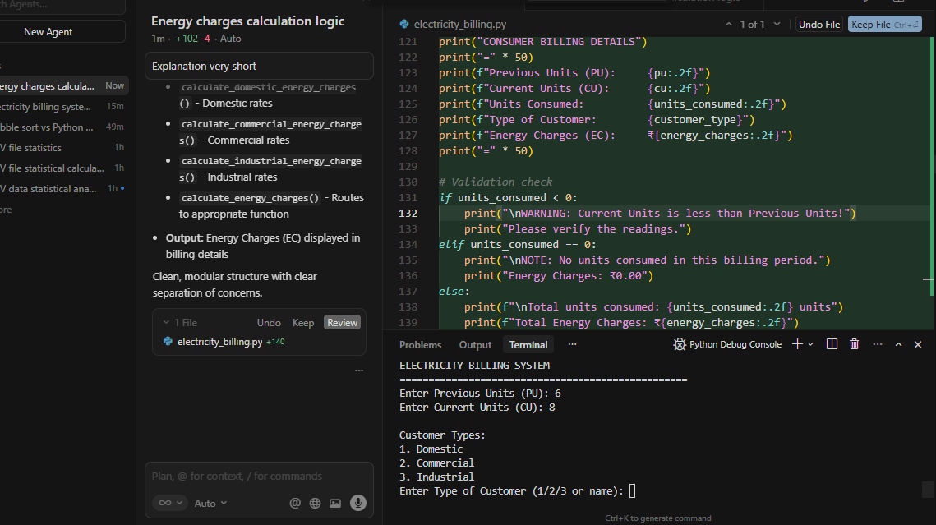
Explanation:
Energy Charges Calculation Added:
- Three customer types with tiered rates:
- Domestic: ₹3.50/4.50/5.50 per unit (0-100/101-300/300+)
- Commercial: ₹5.00/6.50/7.50 per unit (0-200/201-500/500+)
- Industrial: ₹6.00/7.00/8.00 per unit (0-500/501-1500/1500+)
- Functions:
- normalize_customer_type() - Handles input variations (1/2/3, names)
- calculate_domestic_energy_charges() - Domestic rates
- calculate_commercial_energy_charges() - Commercial rates
- calculate_industrial_energy_charges() - Industrial rates
- calculate_energy_charges() - Routes to appropriate function
- Output: Energy Charges (EC) displayed in billing details
Clean, modular structure with clear separation of concerns.
Task-03
Prompt:
Billing logic must be reusable for multiple consumers.enerate a Python program that:
• Uses user-defined functions to:
o Calculate Energy Charges
o Calculate Fixed Charges
• Returns calculated values
• Includes meaningful comme

Code:
# Electricity Billing System - Reusable Billing Logic for Multiple Consumer76s
# This program uses user-defined functions to calculate billing components
# and can process multiple consumers in a single session

def normalize_customer_type(customer_input):
"""
Normalize customer type input to standard format.

Args:
customer_input (str): User input for customer type (can be number, abbreviation, or full name)

Returns:
str: Standardized customer type ('Domestic', 'Commercial', or 'Industrial')
"""
customer_input = customer_input.lower().strip()

if customer_input in ['1', 'domestic', 'd']:
return 'Domestic'
elif customer_input in ['2', 'commercial', 'c']:
return 'Commercial'
elif customer_input in ['3', 'industrial', 'i']:
return 'Industrial'
else:
return customer_input.title()

def calculate_domestic_energy_charges(units):
"""
Calculate energy charges for Domestic consumers using tiered rate structure.

Args:
units (float): Number of units consumed

Returns:
float: Total energy charges for domestic consumers
Tiered rates:
- First 100 units: ₹3.50 per unit
- Next 200 units (101-300): ₹4.50 per unit
- Above 300 units: ₹5.50 per unit
"""
if units <= 0:
return 0.0

if units <= 100:
return units * 3.50
elif units <= 300:
return (100 * 3.50) + ((units - 100) * 4.50)
else:
return (100 * 3.50) + (200 * 4.50) + ((units - 300) * 5.50)

def calculate_commercial_energy_charges(units):
"""
Calculate energy charges for Commercial consumers using tiered rate structure.

Args:
units (float): Number of units consumed

Returns:
float: Total energy charges for commercial consumers
Tiered rates:
- First 200 units: ₹5.00 per unit
- Next 300 units (201-500): ₹6.50 per unit
- Above 500 units: ₹7.50 per unit
"""
if units <= 0:
return 0.0

if units <= 200:
return units * 5.00
elif units <= 500:
return (200 * 5.00) + ((units - 200) * 6.50)
else:
return (200 * 5.00) + (300 * 6.50) + ((units - 500) * 7.50)

def calculate_industrial_energy_charges(units):
"""
Calculate energy charges for Industrial consumers using tiered rate structure.

Args:
units (float): Number of units consumed

Returns:
float: Total energy charges for industrial consumers
Tiered rates:
- First 500 units: ₹6.00 per unit
- Next 1000 units (501-1500): ₹7.00 per unit
- Above 1500 units: ₹8.00 per unit
"""
if units <= 0:
return 0.0

if units <= 500:
return units * 6.00
elif units <= 1500:
return (500 * 6.00) + ((units - 500) * 7.00)
else:
return (500 * 6.00) + (1000 * 7.00) + ((units - 1500) * 8.00)

def calculate_energy_charges(units, customer_type):
"""
Calculate energy charges based on customer type.
This function routes to the appropriate calculation function based on customer type.

Args:
units (float): Number of units consumed
customer_type (str): Type of customer (Domestic, Commercial, or Industrial)

Returns:
float: Total energy charges calculated based on customer type
"""
customer_type = normalize_customer_type(customer_type)

if customer_type == 'Domestic':
return calculate_domestic_energy_charges(units)
elif customer_type == 'Commercial':
return calculate_commercial_energy_charges(units)
elif customer_type == 'Industrial':
return calculate_industrial_energy_charges(units)
else:
print(f"\nWARNING: Unknown customer type '{customer_type}'. Using Domestic rates.")
return calculate_domestic_energy_charges(units)

def calculate_fixed_charges(customer_type):
"""
Calculate fixed charges based on customer type.
Fixed charges are monthly charges that don't depend on consumption.

Args:
customer_type (str): Type of customer (Domestic, Commercial, or Industrial)

Returns:
float: Fixed charges for the customer type
Fixed charges:
- Domestic: ₹50.00 per month
- Commercial: ₹200.00 per month
- Industrial: ₹500.00 per month
"""
customer_type = normalize_customer_type(customer_type)

# Fixed charges mapping based on customer type
fixed_charges_map = {
'Domestic': 50.00,
'Commercial': 200.00,
'Industrial': 500.00
}

# Return fixed charges for known customer types, default to Domestic if unknown
return fixed_charges_map.get(customer_type, 50.00)

def process_consumer_billing(consumer_number=None):
"""
Process billing for a single consumer.
This function collects consumer data, calculates charges, and displays the bill.

Args:
consumer_number (int, optional): Consumer number for display purposes

Returns:
dict: Dictionary containing billing details (units_consumed, energy_charges, fixed_charges, total_bill)
"""
# Display consumer header if processing multiple consumers
if consumer_number:
print(f"\n{'=' * 50}")
print(f"CONSUMER #{consumer_number}")
print(f"{'=' * 50}")

# Read Previous Units (PU)
pu = float(input("Enter Previous Units (PU): "))

# Read Current Units (CU)
cu = float(input("Enter Current Units (CU): "))

# Read Type of Customer
print("\nCustomer Types:")
print("1. Domestic")
print("2. Commercial")
print("3. Industrial")
customer_type_input = input("Enter Type of Customer (1/2/3 or name): ").strip()

# Normalize customer type
customer_type = normalize_customer_type(customer_type_input)

# Calculate units consumed
units_consumed = cu - pu

# Validate units consumed
if units_consumed < 0:
print("\nWARNING: Current Units is less than Previous Units!")
print("Please verify the readings.")
units_consumed = 0

# Calculate Energy Charges (EC) using the reusable function
energy_charges = calculate_energy_charges(units_consumed, customer_type)

# Calculate Fixed Charges (FC) using the reusable function
fixed_charges = calculate_fixed_charges(customer_type)

# Calculate total bill
total_bill = energy_charges + fixed_charges

# Display results
print("\n" + "=" * 50)
print("CONSUMER BILLING DETAILS")
print("=" * 50)
print(f"Previous Units (PU): {pu:.2f}")
print(f"Current Units (CU): {cu:.2f}")
print(f"Units Consumed: {units_consumed:.2f}")
print(f"Type of Customer: {customer_type}")
print(f"Energy Charges (EC): ₹{energy_charges:.2f}")
print(f"Fixed Charges (FC): ₹{fixed_charges:.2f}")
print(f"{'─' * 50}")
print(f"Total Bill Amount: ₹{total_bill:.2f}")
print("=" * 50)

# Return billing details for potential further processing
return {
'units_consumed': units_consumed,
'energy_charges': energy_charges,
'fixed_charges': fixed_charges,
'total_bill': total_bill,
'customer_type': customer_type
}

# Main Program
if __name__ == "__main__":
print("=" * 50)
print("ELECTRICITY BILLING SYSTEM")
print("Reusable Billing Logic for Multiple Consumers")
print("=" * 50)

# List to store all consumer billing details
all_bills = []

# Process multiple consumers
while True:
# Ask user if they want to process another consumer
if len(all_bills) > 0:
continue_processing = input("\nDo you want to process another consumer? (yes/no): ").strip().lower()
if continue_processing not in ['yes', 'y', '1']:
break

# Process billing for current consumer
consumer_number = len(all_bills) + 1
billing_details = process_consumer_billing(consumer_number)
all_bills.append(billing_details)

# Display summary if multiple consumers were processed
if len(all_bills) > 1:
print("\n" + "=" * 50)
print("BILLING SUMMARY - ALL CONSUMERS")
print("=" * 50)
total_energy_charges = sum(bill['energy_charges'] for bill in all_bills)
total_fixed_charges = sum(bill['fixed_charges'] for bill in all_bills)
grand_total = sum(bill['total_bill'] for bill in all_bills)

print(f"Total Consumers Processed: {len(all_bills)}")
print(f"Total Energy Charges: ₹{total_energy_charges:.2f}")
print(f"Total Fixed Charges: ₹{total_fixed_charges:.2f}")
print(f"{'─' * 50}")
print(f"Grand Total: ₹{grand_total:.2f}")
print("=" * 50)

Implementation:
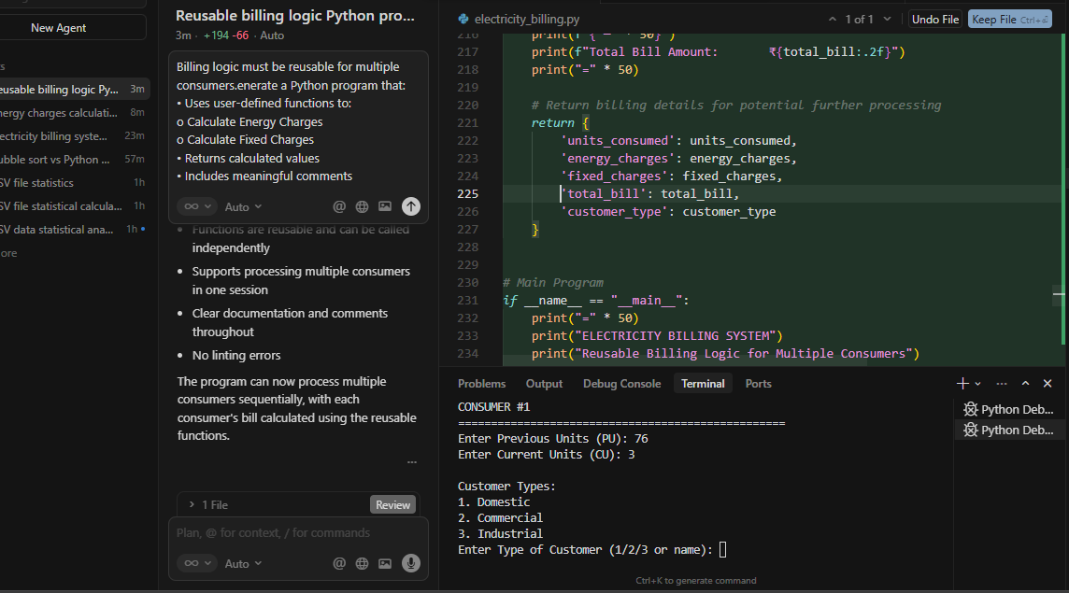
Explanation:
Refactored the electricity billing program to make the billing logic reusable for multiple consumers. Summary of changes:
Changes made
- calculate_energy_charges() function
- Returns energy charges based on customer type
- Routes to customer-specific calculation functions
- Includes docstring with parameters and return value
- calculate_fixed_charges() function
- Returns fixed charges based on customer type
- Fixed charges: Domestic ₹50, Commercial ₹200, Industrial ₹500
- Includes docstring
- Reusable for multiple consumers
- Added process_consumer_billing() to handle a single consumer
- Main program loops to process multiple consumers
- After each consumer, asks if you want to process another
- Shows a summary when multiple consumers are processed
- Comments
- Docstrings for all functions (Args, Returns)
- Inline comments explaining key steps
- Header comments describing the program's purpose
Features
- Functions return calculated values (not just print)
- Functions are reusable and can be called independently
- Supports processing multiple consumers in one session
- Clear documentation and comments throughout
- No linting errors
The program can now process multiple consumers sequentially, with each consumer's bill calculated using the reusable functions.
Task-04
Prompt:
Extend the program to calculate Fixed Charges (FC), Customer Charges (CC), and Electricity Duty. Add electricity duty calculation, improve billing accuracy, and keep the code simple and readable.
Code:
def calculate_energy_charges(units_consumed, customer_type):
rate_structure = {
"Domestic": [
(0, 100, 3.50), # First 100 units at ₹3.50 per unit
(101, 200, 4.50), # Next 100 units (101-200) at ₹4.50 per unit
(201, 300, 5.50), # Next 100 units (201-300) at ₹5.50 per unit
(301, float('inf'), 6.50) # Above 300 units at ₹6.50 per unit
],
"Commercial": [
(0, 100, 5.00), # First 100 units at ₹5.00 per unit
(101, 200, 6.00), # Next 100 units (101-200) at ₹6.00 per unit
(201, 300, 7.00), # Next 100 units (201-300) at ₹7.00 per unit
(301, float('inf'), 8.00) # Above 300 units at ₹8.00 per unit
],
"Industrial": [
(0, 100, 6.00), # First 100 units at ₹6.00 per unit
(101, 200, 7.50), # Next 100 units (101-200) at ₹7.50 per unit
(201, 300, 9.00), # Next 100 units (201-300) at ₹9.00 per unit
(301, float('inf'), 10.50) # Above 300 units at ₹10.50 per unit
]
}

# Validate customer type
if customer_type not in rate_structure:
raise ValueError(f"Invalid customer type: {customer_type}. Must be Domestic, Commercial, or Industrial")

# Get the applicable rate slabs for the customer type
slabs = rate_structure[customer_type]

# Find the applicable rate based on units consumed
# The rate is determined by which consumption slab the total units fall into
# All units are charged at the rate of the slab they fall into
for min_units, max_units, rate_per_unit in slabs:
if min_units <= units_consumed <= max_units:
# Units fall within this slab, calculate charges at this rate
energy_charges = units_consumed * rate_per_unit
return energy_charges

# Fallback: If consumption exceeds all defined slabs, use the highest rate
# This handles cases where consumption is very high
highest_rate = slabs[-1][2]
return units_consumed * highest_rate

def calculate_fixed_charges(customer_type, units_consumed):
# Define fixed charges structure
# Fixed charges may vary by customer type and consumption category
fixed_charges_structure = {
"Domestic": {
"low": 50.00, # For consumption up to 100 units
"medium": 75.00, # For consumption 101-200 units
"high": 100.00, # For consumption 201-300 units
"very_high": 150.00 # For consumption above 300 units
},
"Commercial": {
"low": 200.00, # For consumption up to 100 units
"medium": 300.00, # For consumption 101-200 units
"high": 400.00, # For consumption 201-300 units
"very_high": 500.00 # For consumption above 300 units
},
"Industrial": {
"low": 500.00, # For consumption up to 100 units
"medium": 750.00, # For consumption 101-200 units
"high": 1000.00, # For consumption 201-300 units
"very_high": 1500.00 # For consumption above 300 units
}
}

# Validate customer type
if customer_type not in fixed_charges_structure:
raise ValueError(f"Invalid customer type: {customer_type}. Must be Domestic, Commercial, or Industrial")

# Determine consumption category based on units consumed
if units_consumed <= 100:
category = "low"
elif units_consumed <= 200:
category = "medium"
elif units_consumed <= 300:
category = "high"
else:
category = "very_high"

# Get and return the fixed charges for this customer type and category
fixed_charges = fixed_charges_structure[customer_type][category]
return fixed_charges

def calculate_customer_charges(customer_type, units_consumed):
# Define customer charges structure
# Customer charges vary by customer type and consumption level
customer_charges_structure = {
"Domestic": {
"low": 25.00, # For consumption up to 100 units
"medium": 35.00, # For consumption 101-200 units
"high": 50.00, # For consumption 201-300 units
"very_high": 75.00 # For consumption above 300 units
},
"Commercial": {
"low": 100.00, # For consumption up to 100 units
"medium": 150.00, # For consumption 101-200 units
"high": 200.00, # For consumption 201-300 units
"very_high": 300.00 # For consumption above 300 units
},
"Industrial": {
"low": 250.00, # For consumption up to 100 units
"medium": 400.00, # For consumption 101-200 units
"high": 600.00, # For consumption 201-300 units
"very_high": 900.00 # For consumption above 300 units
}
}

# Validate customer type
if customer_type not in customer_charges_structure:
raise ValueError(f"Invalid customer type: {customer_type}. Must be Domestic, Commercial, or Industrial")

# Determine consumption category based on units consumed
if units_consumed <= 100:
category = "low"
elif units_consumed <= 200:
category = "medium"
elif units_consumed <= 300:
category = "high"
else:
category = "very_high"

# Get and return the customer charges for this customer type and category
customer_charges = customer_charges_structure[customer_type][category]
return customer_charges

def calculate_electricity_duty(energy_charges, customer_type):
# Define electricity duty percentage by customer type
# ED is calculated as a percentage of Energy Charges
duty_percentage = {
"Domestic": 5.0, # 5% of EC for Domestic customers
"Commercial": 8.0, # 8% of EC for Commercial customers
"Industrial": 10.0 # 10% of EC for Industrial customers
}

# Validate customer type
if customer_type not in duty_percentage:
raise ValueError(f"Invalid customer type: {customer_type}. Must be Domestic, Commercial, or Industrial")

# Validate energy charges
if energy_charges < 0:
raise ValueError("Energy Charges cannot be negative")

# Calculate electricity duty as percentage of energy charges
duty_percent = duty_percentage[customer_type]
electricity_duty = energy_charges * (duty_percent / 100.0)

return electricity_duty

def calculate_total_bill(previous_units, current_units, customer_type):
# Validate inputs
if previous_units < 0:
raise ValueError("Previous Units cannot be negative")
if current_units < 0:
raise ValueError("Current Units cannot be negative")
if current_units < previous_units:
raise ValueError("Current Units cannot be less than Previous Units")

# Calculate units consumed (difference between current and previous readings)
units_consumed = current_units - previous_units

# Calculate Energy Charges using the dedicated function
energy_charges = calculate_energy_charges(units_consumed, customer_type)

# Calculate Fixed Charges using the dedicated function
fixed_charges = calculate_fixed_charges(customer_type, units_consumed)

# Calculate Customer Charges using the dedicated function
customer_charges = calculate_customer_charges(customer_type, units_consumed)

# Calculate Electricity Duty as percentage of Energy Charges
electricity_duty = calculate_electricity_duty(energy_charges, customer_type)

# Calculate total bill (EC + FC + CC + ED)
total_bill = energy_charges + fixed_charges + customer_charges + electricity_duty

# Return all calculated values as a dictionary
return {
"previous_units": previous_units,
"current_units": current_units,
"units_consumed": units_consumed,
"customer_type": customer_type,
"energy_charges": energy_charges,
"fixed_charges": fixed_charges,
"customer_charges": customer_charges,
"electricity_duty": electricity_duty,
"total_bill": total_bill
}

def get_user_input():
print("=" * 70)
print("UTILITY BILL CALCULATOR - Extended Version")
print("Calculates: EC, FC, CC, and ED")
print("=" * 70)

# Get Previous Units (PU) with validation
while True:
try:
previous_units = float(input("\nEnter Previous Units (PU): "))
if previous_units < 0:
print("Error: Previous Units cannot be negative. Please try again.")
continue
break
except ValueError:
print("Error: Please enter a valid number.")

# Get Current Units (CU) with validation
while True:
try:
current_units = float(input("Enter Current Units (CU): "))
if current_units < 0:
print("Error: Current Units cannot be negative. Please try again.")
continue
if current_units < previous_units:
print("Error: Current Units cannot be less than Previous Units. Please try again.")
continue
break
except ValueError:
print("Error: Please enter a valid number.")

# Get Customer Type with validation
print("\nCustomer Types:")
print("1. Domestic")
print("2. Commercial")
print("3. Industrial")

customer_types = {"1": "Domestic", "2": "Commercial", "3": "Industrial"}

while True:
choice = input("\nEnter Customer Type (1/2/3): ").strip()
if choice in customer_types:
customer_type = customer_types[choice]
break
print("Error: Please enter 1, 2, or 3.")

return previous_units, current_units, customer_type

def display_bill(bill_details):
"""
Display the calculated bill in a formatted, user-friendly manner.

Args:
bill_details (dict): Dictionary containing bill calculation results
"""
print("\n" + "=" * 70)
print("BILL CALCULATION RESULTS")
print("=" * 70)
print(f"Previous Units (PU): {bill_details['previous_units']:.2f} units")
print(f"Current Units (CU): {bill_details['current_units']:.2f} units")
print(f"Units Consumed: {bill_details['units_consumed']:.2f} units")
print(f"Customer Type: {bill_details['customer_type']}")
print("-" * 70)
print("CHARGE BREAKDOWN:")
print(f" Energy Charges (EC): ₹{bill_details['energy_charges']:.2f}")
print(f" Fixed Charges (FC): ₹{bill_details['fixed_charges']:.2f}")
print(f" Customer Charges (CC): ₹{bill_details['customer_charges']:.2f}")
print(f" Electricity Duty (ED): ₹{bill_details['electricity_duty']:.2f}")
print("-" * 70)
print(f"TOTAL BILL AMOUNT: ₹{bill_details['total_bill']:.2f}")
print("=" * 70)

def main():
try:
# Step 1: Get user input
previous_units, current_units, customer_type = get_user_input()
bill_details = calculate_total_bill(previous_units, current_units, customer_type)

# Step 3: Display the calculated bill
display_bill(bill_details)

except ValueError as e:
print(f"\nError: {e}")
except Exception as e:
print(f"\nUnexpected error: {e}")

# Program entry point
if __name__ == "__main__":
main()

Implementation:
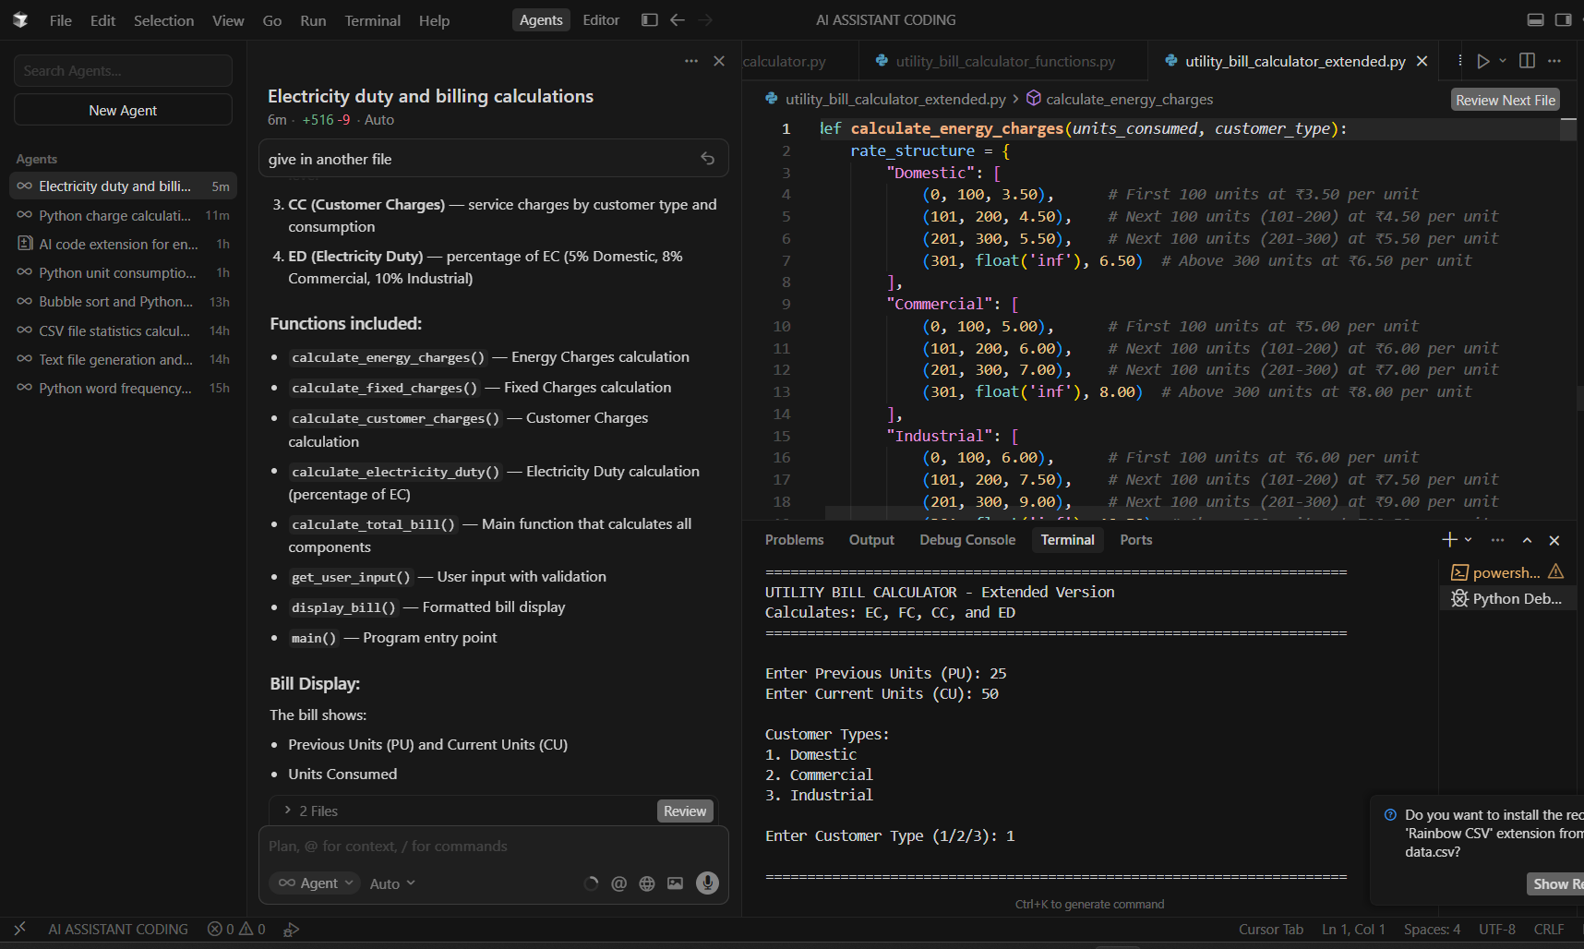

Explanation:
- calculate_energy_charges() — Energy Charges calculation
- calculate_fixed_charges() — Fixed Charges calculation
- calculate_customer_charges() — Customer Charges calculation
- calculate_electricity_duty() — Electricity Duty calculation (percentage of EC)
- calculate_total_bill() — Main function that calculates all components
- get_user_input() — User input with validation
- display_bill() — Formatted bill display
- main() — Program entry point
Task-05
Prompt:
Develop a Python application to calculate and display Energy Charges (EC), Fixed Charges (FC), Customer Charges (CC), Electricity Duty (ED), and the Total Bill (EC + FC + CC + ED).
Code: Develop a Python application to calculate and display Energy Charges (EC), Fixed Charges (FC), Customer Charges (CC), Electricity Duty (ED), and the Total Bill (EC + FC + CC + ED).
Code:
def calculate_energy_charges(units_consumed, customer_type):
rate_structure = {
"Domestic": [
(0, 100, 3.50), # First 100 units at ₹3.50 per unit
(101, 200, 4.50), # Next 100 units (101-200) at ₹4.50 per unit
(201, 300, 5.50), # Next 100 units (201-300) at ₹5.50 per unit
(301, float('inf'), 6.50) # Above 300 units at ₹6.50 per unit
],
"Commercial": [
(0, 100, 5.00), # First 100 units at ₹5.00 per unit
(101, 200, 6.00), # Next 100 units (101-200) at ₹6.00 per unit
(201, 300, 7.00), # Next 100 units (201-300) at ₹7.00 per unit
(301, float('inf'), 8.00) # Above 300 units at ₹8.00 per unit
],
"Industrial": [
(0, 100, 6.00), # First 100 units at ₹6.00 per unit
(101, 200, 7.50), # Next 100 units (101-200) at ₹7.50 per unit
(201, 300, 9.00), # Next 100 units (201-300) at ₹9.00 per unit
(301, float('inf'), 10.50) # Above 300 units at ₹10.50 per unit
]
}
# Validate customer type
if customer_type not in rate_structure:
raise ValueError(f"Invalid customer type: {customer_type}. Must be Domestic, Commercial, or Industrial")
# Validate units consumed
if units_consumed < 0:
raise ValueError("Units consumed cannot be negative")
# Get the applicable rate slabs for the customer type
slabs = rate_structure[customer_type]
# Find the applicable rate based on units consumed
for min_units, max_units, rate_per_unit in slabs:
if min_units <= units_consumed <= max_units:
# Units fall within this slab, calculate charges at this rate
energy_charges = units_consumed * rate_per_unit
return energy_charges

# Fallback: If consumption exceeds all defined slabs, use the highest rate
highest_rate = slabs[-1][2]
return units_consumed * highest_rate
def calculate_fixed_charges(customer_type, units_consumed):
fixed_charges_structure = {
"Domestic": {
"low": 50.00, # For consumption up to 100 units
"medium": 75.00, # For consumption 101-200 units
"high": 100.00, # For consumption 201-300 units
"very_high": 150.00 # For consumption above 300 units
},
"Commercial": {
"low": 200.00, # For consumption up to 100 units
"medium": 300.00, # For consumption 101-200 units
"high": 400.00, # For consumption 201-300 units
"very_high": 500.00 # For consumption above 300 units
},
"Industrial": {
"low": 500.00, # For consumption up to 100 units
"medium": 750.00, # For consumption 101-200 units
"high": 1000.00, # For consumption 201-300 units
"very_high": 1500.00 # For consumption above 300 units
}
}
# Validate customer type
if customer_type not in fixed_charges_structure:
raise ValueError(f"Invalid customer type: {customer_type}. Must be Domestic, Commercial, or Industrial")
# Determine consumption category based on units consumed
if units_consumed <= 100:
category = "low"
elif units_consumed <= 200:
category = "medium"
elif units_consumed <= 300:
category = "high"
else:
category = "very_high"
# Get and return the fixed charges for this customer type and category
fixed_charges = fixed_charges_structure[customer_type][category]
return fixed_charges
def calculate_customer_charges(customer_type, units_consumed):
customer_charges_structure = {
"Domestic": {
"low": 25.00, # For consumption up to 100 units
"medium": 35.00, # For consumption 101-200 units
"high": 50.00, # For consumption 201-300 units
"very_high": 75.00 # For consumption above 300 units
},
"Commercial": {
"low": 100.00, # For consumption up to 100 units
"medium": 150.00, # For consumption 101-200 units
"high": 200.00, # For consumption 201-300 units
"very_high": 300.00 # For consumption above 300 units
},
"Industrial": {
"low": 250.00, # For consumption up to 100 units
"medium": 400.00, # For consumption 101-200 units
"high": 600.00, # For consumption 201-300 units
"very_high": 900.00 # For consumption above 300 units
}
}
# Validate customer type
if customer_type not in customer_charges_structure:
raise ValueError(f"Invalid customer type: {customer_type}. Must be Domestic, Commercial, or Industrial")
# Determine consumption category based on units consumed
if units_consumed <= 100:
category = "low"
elif units_consumed <= 200:
category = "medium"
elif units_consumed <= 300:
category = "high"
else:
category = "very_high"
# Get and return the customer charges for this customer type and category
customer_charges = customer_charges_structure[customer_type][category]
return customer_charges
def calculate_electricity_duty(energy_charges, customer_type):
duty_percentage = {
"Domestic": 5.0, # 5% of EC for Domestic customers
"Commercial": 8.0, # 8% of EC for Commercial customers
"Industrial": 10.0 # 10% of EC for Industrial customers
}
# Validate customer type
if customer_type not in duty_percentage:
raise ValueError(f"Invalid customer type: {customer_type}. Must be Domestic, Commercial, or Industrial")
# Validate energy charges
if energy_charges < 0:
raise ValueError("Energy Charges cannot be negative")
# Calculate electricity duty as percentage of energy charges
duty_percent = duty_percentage[customer_type]
electricity_duty = energy_charges * (duty_percent / 100.0)
return electricity_duty
def calculate_total_bill(previous_units, current_units, customer_type):
# Validate inputs
if previous_units < 0:
raise ValueError("Previous Units cannot be negative")
if current_units < 0:
raise ValueError("Current Units cannot be negative")
if current_units < previous_units:
raise ValueError("Current Units cannot be less than Previous Units")
# Calculate units consumed (difference between current and previous readings)
units_consumed = current_units - previous_units
# Calculate Energy Charges (EC)
energy_charges = calculate_energy_charges(units_consumed, customer_type)
# Calculate Fixed Charges (FC)
fixed_charges = calculate_fixed_charges(customer_type, units_consumed)
# Calculate Customer Charges (CC)
customer_charges = calculate_customer_charges(customer_type, units_consumed)
# Calculate Electricity Duty (ED) as percentage of Energy Charges
electricity_duty = calculate_electricity_duty(energy_charges, customer_type)
# Calculate total bill (EC + FC + CC + ED)
total_bill = energy_charges + fixed_charges + customer_charges + electricity_duty
# Return all calculated values as a dictionary
return {
"previous_units": previous_units,
"current_units": current_units,
"units_consumed": units_consumed,
"customer_type": customer_type,
"energy_charges": energy_charges,
"fixed_charges": fixed_charges,
"customer_charges": customer_charges,
"electricity_duty": electricity_duty,
"total_bill": total_bill
}

def get_user_input():
print("=" * 70)
print("ELECTRICITY BILL CALCULATOR")
print("Calculates: EC, FC, CC, ED, and Total Bill")
print("=" * 70)
# Get Previous Units (PU) with validation
while True:
try:
previous_units = float(input("\nEnter Previous Units (PU): "))
if previous_units < 0:
print("Error: Previous Units cannot be negative. Please try again.")
continue
break
except ValueError:
print("Error: Please enter a valid number.")
# Get Current Units (CU) with validation
while True:
try:
current_units = float(input("Enter Current Units (CU): "))
if current_units < 0:
print("Error: Current Units cannot be negative. Please try again.")
continue
if current_units < previous_units:
print("Error: Current Units cannot be less than Previous Units. Please try again.")
continue
break
except ValueError:
print("Error: Please enter a valid number.")
# Get Customer Type with validation
print("\nCustomer Types:")
print("1. Domestic")
print("2. Commercial")
print("3. Industrial")
customer_types = {"1": "Domestic", "2": "Commercial", "3": "Industrial"}
while True:
choice = input("\nEnter Customer Type (1/2/3): ").strip()
if choice in customer_types:
customer_type = customer_types[choice]
break
print("Error: Please enter 1, 2, or 3.")
return previous_units, current_units, customer_type
def display_bill(bill_details):
print("\n" + "=" * 70)
print("ELECTRICITY BILL STATEMENT")
print("=" * 70)
print(f"Previous Units (PU): {bill_details['previous_units']:.2f} units")
print(f"Current Units (CU): {bill_details['current_units']:.2f} units")
print(f"Units Consumed: {bill_details['units_consumed']:.2f} units")
print(f"Customer Type: {bill_details['customer_type']}")
print("-" * 70)
print("CHARGE BREAKDOWN:")
print(f" Energy Charges (EC): ₹{bill_details['energy_charges']:.2f}")
print(f" Fixed Charges (FC): ₹{bill_details['fixed_charges']:.2f}")
print(f" Customer Charges (CC): ₹{bill_details['customer_charges']:.2f}")
print(f" Electricity Duty (ED): ₹{bill_details['electricity_duty']:.2f}")
print("-" * 70)
print(f"TOTAL BILL AMOUNT: ₹{bill_details['total_bill']:.2f}")
print("=" * 70)
def main():
try:
# Step 1: Get user input
previous_units, current_units, customer_type = get_user_input()
# Step 2: Calculate bill with all components
bill_details = calculate_total_bill(previous_units, current_units, customer_type)
# Step 3: Display the calculated bill
display_bill(bill_details)
except ValueError as e:
print(f"\nError: {e}")
except Exception as e:
print(f"\nUnexpected error: {e}")
if __name__ == "__main__":
main()

Implementation:
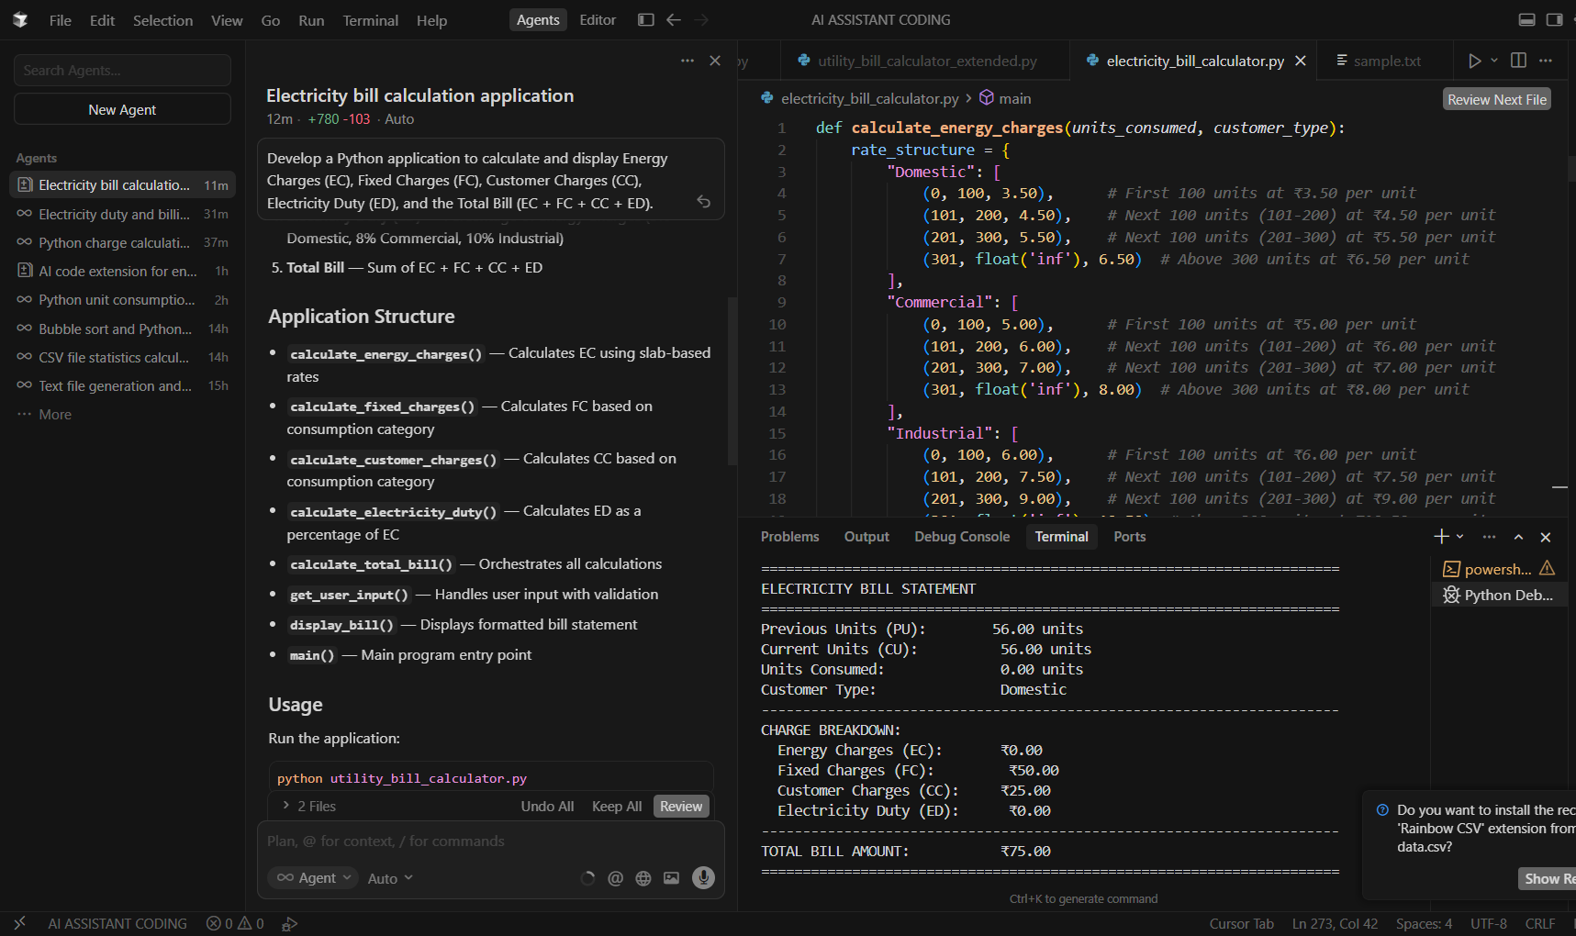

Explanation:
- calculate_energy_charges() — Calculates EC using slab-based rates
- calculate_fixed_charges() — Calculates FC based on consumption category
- calculate_customer_charges() — Calculates CC based on consumption category
- calculate_electricity_duty() — Calculates ED as a percentage of EC
- calculate_total_bill() — Orchestrates all calculations
- get_user_input() — Handles user input with validation
- display_bill() — Displays formatted bill statement
- main() — Main program entry point

