Assignment-10.4

NAME:B.Akshara
HT NO:2303A51279
BATCH:05

TASK-01:
PROMPT:
You are given a Python script containing:
• Syntax errors
• Indentation issues
• Incorrect variable names
• Faulty function calls
Identify all syntactic and structural errors
• Correct them systematically
• Generate an explanation of each fix made
CODE:
ERROR CODE:
def calculateTotal(a,b)
result = a + b
return result
def print_result(reslt):
print("The total is" reslt)
x = 10
y = "20"
total = calculate_total(x,y)
print_result(total)
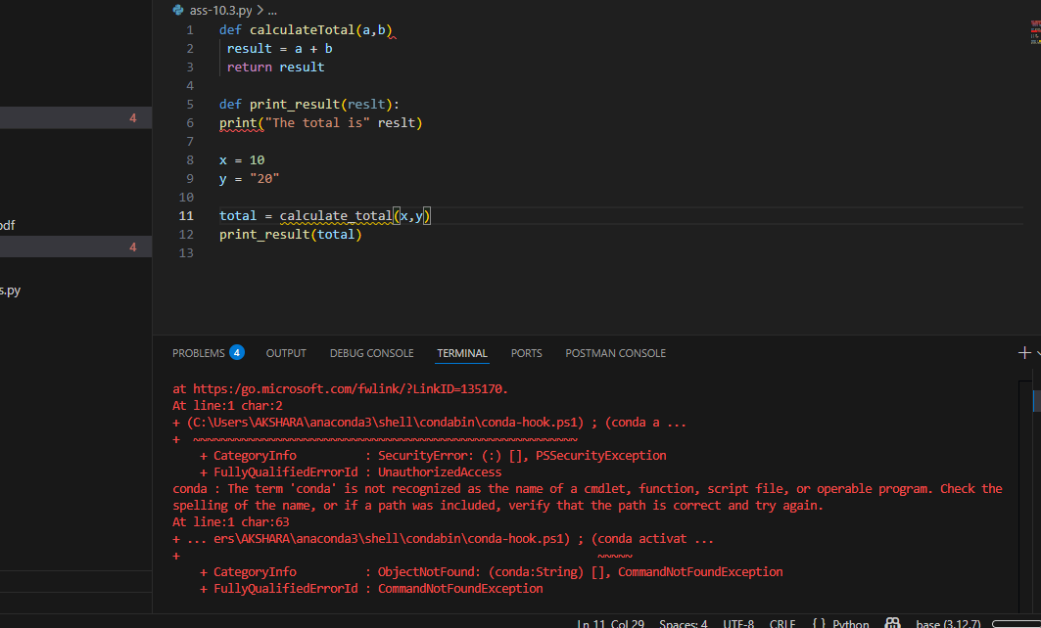
CORRECTED CODE:
def calculate_total(a, b):
"""
Calculates the sum of two numbers.
Parameters:
a (int or float): First number
b (int or float): Second number
Returns:
int or float: Sum of a and b
"""
result = a + b
return result
def print_result(result):
"""
Prints the calculated result.
Parameters:
result (int or float): The value to print
"""
print("The total is:", result)
x = 10
y = 20
total = calculate_total(x, y)
print_result(total)
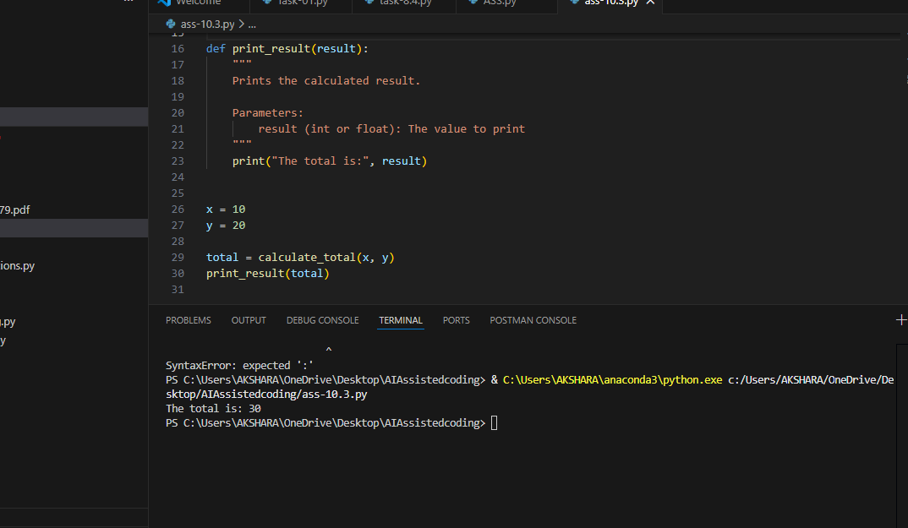
TASK-02
PROMPT:
You are given a poorly structured Python function with:
• Cryptic function names
• Poor indentation
• Unclear variable naming
• No documentation
• Refactor the code for clarity
• Apply PEP 8 formatting standards
• Improve naming conventions
• Add meaningful documentation

CODE:
def find_duplicates_bruteforce(arr):
duplicates = []
n = len(arr)
for i in range(n):
for j in range(i + 1, n):
if arr[i] == arr[j] and arr[i] not in duplicates:
duplicates.append(arr[i])
return duplicates
data = [1, 2, 3, 2, 4, 5, 1, 6]
# Function call
result = find_duplicates_bruteforce(data)
# Output
print("Input list:", data)
print("Duplicate values:", result)
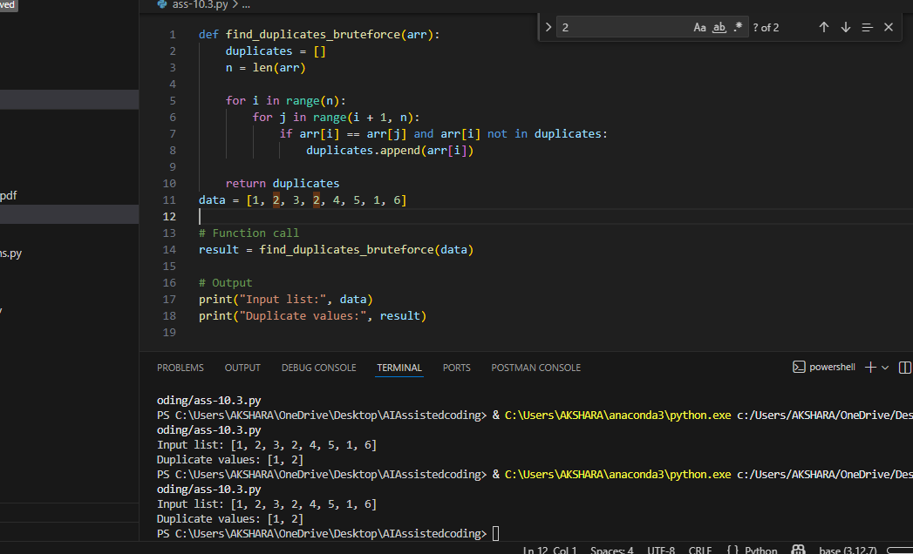
OPTIMIZED CODE:
ef find_duplicates_optimized(arr):
seen = set()
duplicates = set()
for num in arr:
if num in seen:
duplicates.add(num)
else:
seen.add(num)
return list(duplicates)
data = [1, 2, 3, 2, 4, 5, 1, 6]
# Function call
result = find_duplicates_optimized(data)
# Output
print("Input list:", data)
print("Duplicate values:", result)
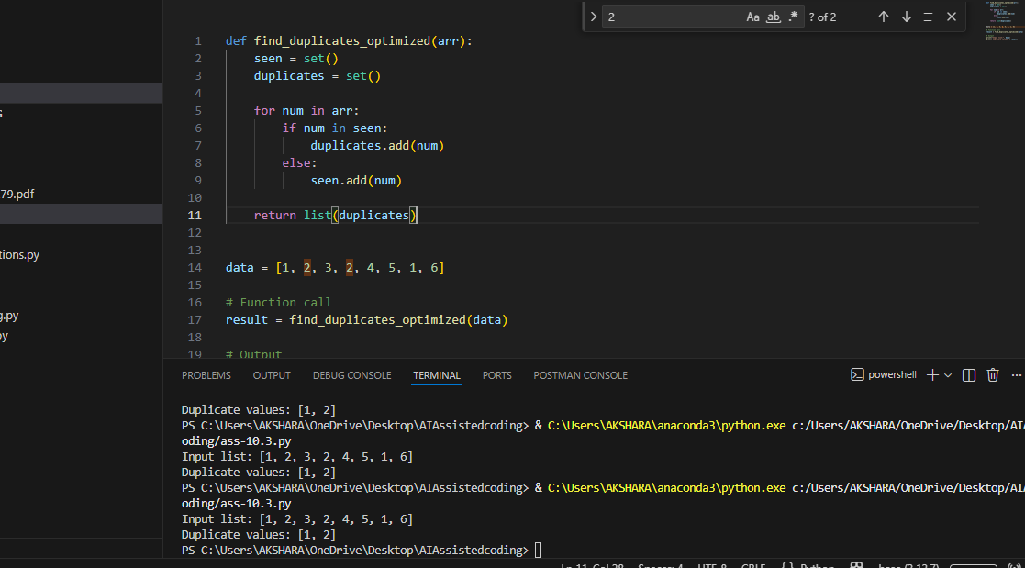
TASK-03:
PROMPT:
You are given a poorly structured Python function with:
• Cryptic function names
• Poor indentation
• Unclear variable naming
• No documentation
• Refactor the code for clarity
• Apply PEP 8 formatting standards
• Improve naming conventions
• Add meaningful documentation
Expected Outcome
• Clean, well-structured code
• Descriptive function and variable names
• Proper indentation and formatting
• Docstrings explaining the function purpose
• AI explanation of readability improvements
CODE:
POORLY STRUCTURED FUNCTION:
def f(x):
s=0
for i in range(len(x)):
if x[i]%2==0:
s=s+x[i]
return s
REFACTORED,CLEAN AND MAINTANABLE VERSION:
def calculate_sum_of_even_numbers(numbers):
"""
Calculates the sum of all even numbers in a given list.
Parameters:
numbers (list of int): A list of integers.
Returns:
int: The sum of all even numbers in the list.
"""
total_sum = 0
for number in numbers:
if number % 2 == 0:
total_sum += number
return total_sum
PROPER INDENTATION:
BEFORE:
for i in range(len(x)):
if x[i]%2==0:
s=s+x[i]
AFTER:
for number in numbers:
if number % 2 == 0:
total_sum += number
FINAL CODE:
def calculate_sum_of_even_numbers(numbers):
"""
Calculates the sum of all even numbers in a given list.
Parameters:
numbers (list of int): A list of integers.
Returns:
int: The sum of all even numbers in the list.
"""
total_sum = 0
for number in numbers:
if number % 2 == 0:
total_sum += number
return total_sum
data = [1, 2, 3, 4, 5, 6]
# Function call
result = calculate_sum_of_even_numbers(data)

# Output
print("Input list:", data)
print("Sum of even numbers:", result)

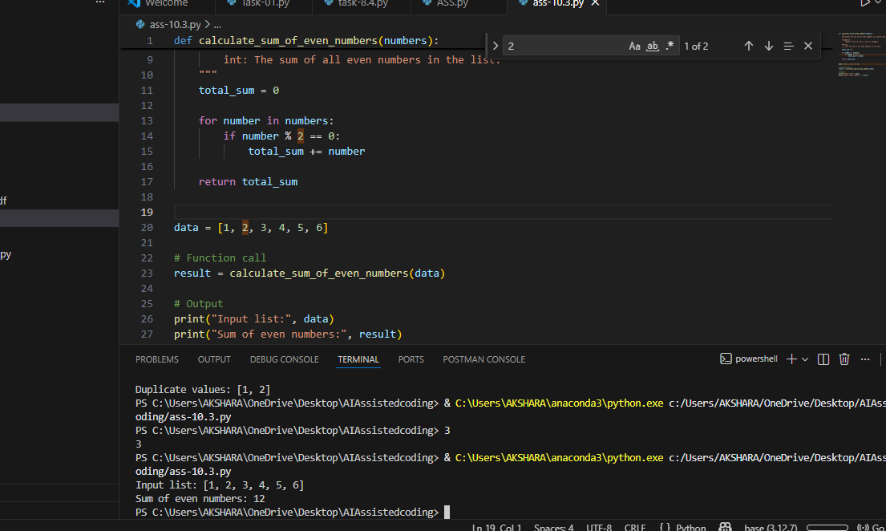
TASK-04:
PROMPT:
Task Description
You are given a Python script that:
• Uses unsafe SQL query construction
• Has no input validation
• Lacks exception handling
• Identify security vulnerabilities
• Refactor the code using safe coding practices
• Add proper exception handling
• Improve robustness and reliability
Expected Outcome
• Secure SQL queries using parameterized statements
• Input validation logic
• Try-except blocks for runtime safety
• AI-generated explanation of security improvements
• Production-ready code structure
Unsafe Script:
import sqlite3
def get_user(username):
conn = sqlite3.connect("users.db")
cursor = conn.cursor()
query = "SELECT * FROM users WHERE username = '" + username + "'"
cursor.execute(query)
return cursor.fetchall()
Security Issues Identified
• SQL Injection vulnerability.
• No input validation.
• No exception handling.
• Connection not closed.
Production-Ready Secure Version:
import sqlite3
def get_user(username):
"""
Retrieve user details safely from the database.
"""
if not isinstance(username, str) or not username.strip():
raise ValueError("Invalid username provided.")
try:
with sqlite3.connect("users.db") as conn:
cursor = conn.cursor()

cursor.execute(
"SELECT * FROM users WHERE username = ?",
(username,)
)
return cursor.fetchall()
except sqlite3.Error as error:
print(f"Database error occurred: {error}")
return None
Security Improvements Explained:
Parameterized Queries
Prevents SQL injection.
Input Validation
Stops malicious or empty input.
Exception Handling
Avoids runtime crashes.
Context Manager
Auto-closes database connection.
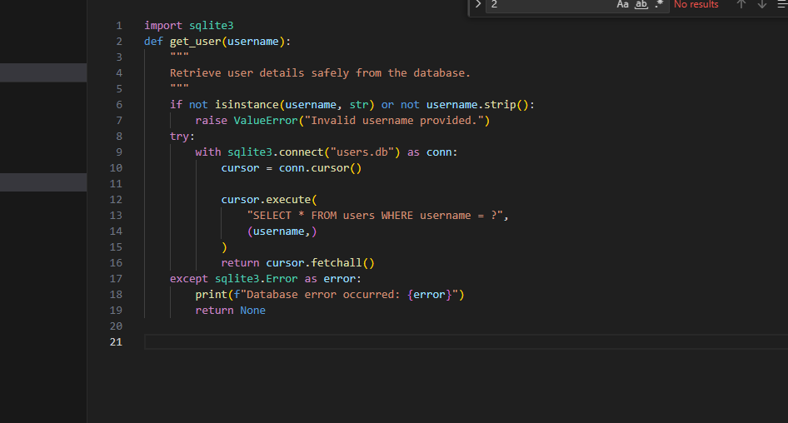

TASK-05:
PROMPT:
AI-Based Automated Code Review Report
Scenario
Your team uses AI tools to perform automated preliminary code reviews
before human review, to improve code quality and consistency across
projects.
Task Description
You are provided with a poorly written Python script.
Using AI-assisted review:
* Generate a structured code review report that evaluates:
o Code readability
o Naming conventions
o Formatting and style consistency
o Error handling
o Documentation quality
o Maintainability
The task is not just to fix the code, but to analyze and report on quality
issues.
Poor Script for Review
def d(a,b):return a/b

x=10
y=0
print(d(x,y))
AI Code Review Report
Readability
Issue: Cryptic function name d.
Risk: Hard for teams to understand.
Naming Conventions
Not following PEP 8.
Examples:
• a, b
• d
Use descriptive names.
Formatting & Style
• One-line function reduces readability.
• No spacing.
Error Handling
• Critical Risk
• Division by zero causes crash.
Documentation Quality
• None present.

Maintainability
• Low — unclear intent and unsafe execution
Code Smells Detected
• Magic values
• Poor naming
• Missing error handling
• Lack of documentation
Demonstration of AI as Code Reviewer
This review showcased how AI can:
Detect syntax errors, Improve performance, Refactor for readability, Harden security
& Generate structured review reports.
