ASSIGNMENT-9.3

NAME:B.Akshara
HT NO:2303A51279
BATCH:05

TASK-01
PROMPT:
#Basic Docstring Generation
#Scenario
#You are developing a utility function that processes numerical lists and must be properly
#documented for future maintenance.
#Requirements
#• Write a Python function to return the sum of even numbers and sum of odd numbers in a
#given list
#• Manually add a Google Style docstring to the function
#• Use an AI-assisted tool (Copilot / Cursor AI) to generate a function-level docstring
#• Compare the AI-generated docstring with the manually written docstring
#• Analyze clarity, correctness, and completeness
CODE:
Manual:
def sum_even_odd(numbers):
"""
Computes the sum of even and odd numbers in a list of integers.
Args:
numbers (list of int): A list containing integer values.
Returns:
tuple: A tuple of two integers where:
- The first value is the sum of all even numbers.
- The second value is the sum of all odd numbers.
Example:
>>> sum_even_odd([1, 2, 3, 4, 5])
(6, 9)
"""
even_sum = 0
odd_sum = 0

for num in numbers:
if num % 2 == 0:
even_sum += num
else:
odd_sum += num
return even_sum, odd_sum
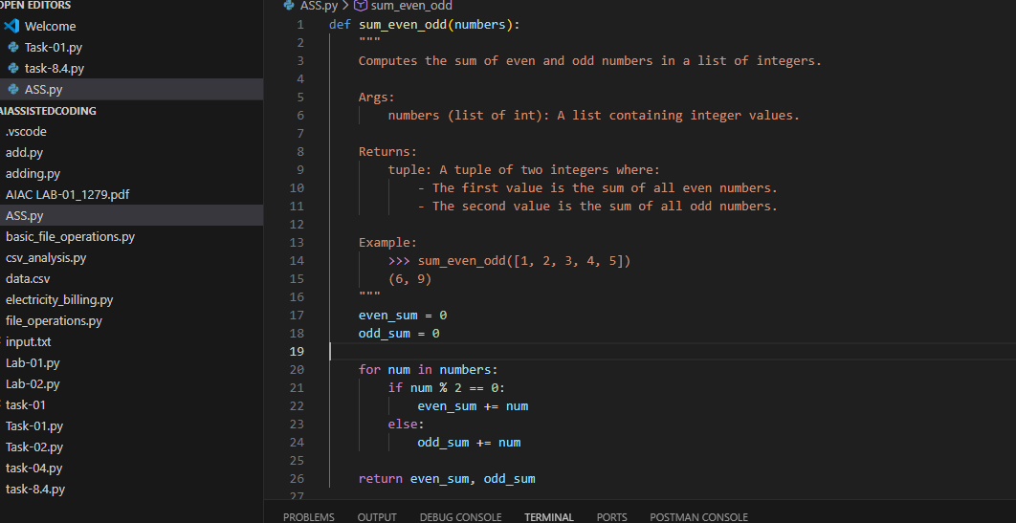
AI Generated:
def sum_even_odd(numbers):
"""
Returns the sums of even and odd numbers in the provided list.
Parameters:
numbers (list[int]): List of integers to be processed.

Returns:
(int, int): A tuple containing the sum of even numbers and the sum of odd numbers.
even_sum = sum(num for num in numbers if num % 2 == 0)
odd_sum = sum(num for num in numbers if num % 2 != 0)
"""
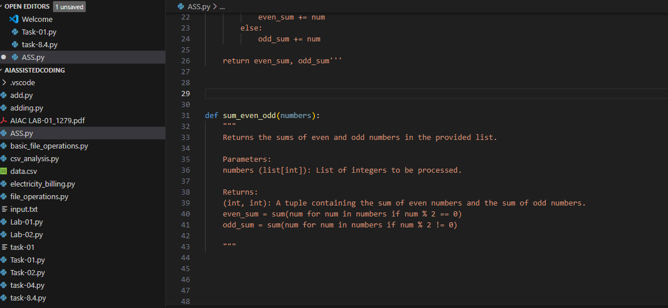
EXPlANATION:
Comparison: Manual vs. AI-Generated Docstring
Aspect | Manual Docstring | AI-Generated Docstring
Clarity | Very clear and descriptive | Clear but more concise
Detail Level | More detailed (explains what each return value means) | Less detailed (just states it returns sums)
Structure | Fully follows Google style with Args, Returns, and Example | Partially follows Google style but misses Example section
Usefulness for Maintenance | Better for future developers due to examples and explanations | Good, but may require additional clarification
Correctness | Fully correct | Fully correct
Completeness | More complete | Slightly incomplete (no example, less explanation)

TASK-02
PROMPT:
You are developing a student management module that must be easy to understand for new
developers.
Requirements
• Write a Python program for an sru_student class with the following:
– Attributes: name, roll_no, hostel_status
– Methods: fee_update() and display_details()
• Manually write inline comments for each line or logical block
• Use an AI-assisted tool to automatically add inline comments
• Compare manual comments with AI-generated comments
• Identify missing, redundant, or incorrect AI comments
CODE:
Manual :
# Defining the student class for SRU
class sru_student:
# Constructor method to initialize student details
def __init__(self, name, roll_no, hostel_status):
# Assigning student name to the object
self.name = name
# Assigning roll number to the object
self.roll_no = roll_no
# Assigning hostel status (True/False) to the object
self.hostel_status = hostel_status

# Method to update hostel fee based on hostel status
def fee_update(self):
# Checking if the student is staying in hostel
if self.hostel_status:
# If yes, hostel fee is applicable
self.fee = 50000
else:
# If not, hostel fee is not applicable
self.fee = 0

# Method to display student details
def display_details(self):
# Printing student name
print("Name:", self.name)
# Printing student roll number
print("Roll No:", self.roll_no)
# Printing hostel status
print("Hostel Status:", self.hostel_status)
# Printing updated fee
print("Fee:", self.fee)
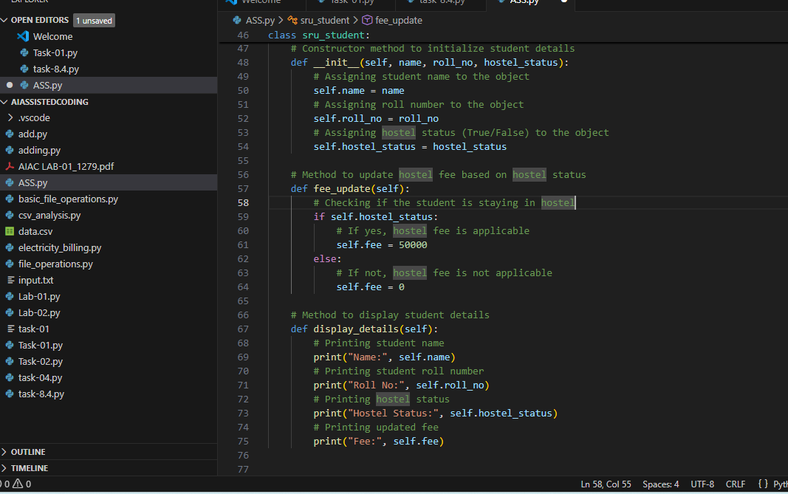
AI Generated:
# Class to represent an SRU student
class sru_student:
# Initializes the student object
def __init__(self, name, roll_no, hostel_status):
# Stores the student's name
self.name = name
# Stores the student's roll number
self.roll_no = roll_no
# Stores whether the student is in hostel
self.hostel_status = hostel_status

# Updates the student's fee
def fee_update(self):
# Checks hostel status
if self.hostel_status:
# Assigns hostel fee
self.fee = 50000
else:
# Assigns zero fee
self.fee = 0

# Displays student details
def display_details(self):
# Prints name
print("Name:", self.name)
# Prints roll number
print("Roll No:", self.roll_no)
# Prints hostel status
print("Hostel Status:", self.hostel_status)
# Prints fee
print("Fee:", self.fee)
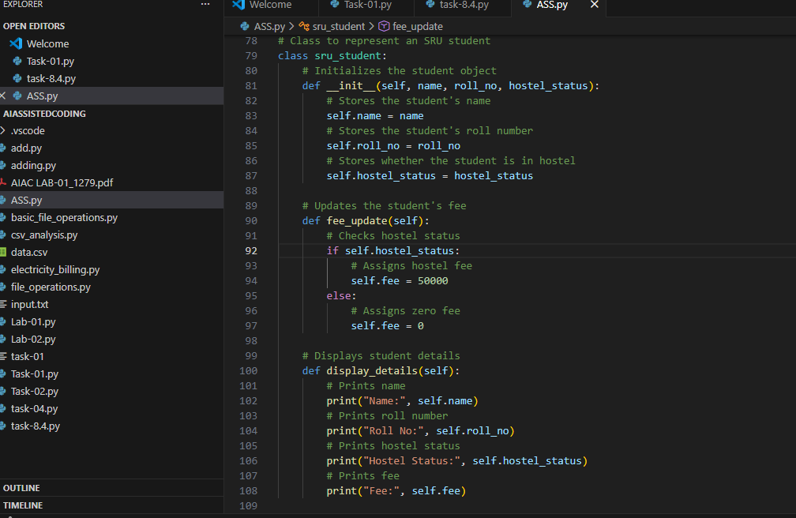
EXPLANATION: Comparative Analysis: Manual vs AI Comments
Aspect | Manual Comments | AI-Generated Comments
Clarity | Very clear, beginner-friendly | Clear but slightly generic
Detail Level | More explanatory | More concise
Use of Domain Terms | Mentions “student”, “hostel”, “SRU” | More generic wording
Helpfulness for New Developers | High | Moderate
Redundancy | Minimal | Some repetition (e.g., “prints”)
Context Awareness | Better understanding of system | More surface-level

TASK-03:
PROMPT:
Module-Level and Function-Level Documentation
Scenario
You are building a small calculator module that will be shared across multiple projects and
requires structured documentation.
Requirements
• Write a Python script containing 3–4 functions (e.g., add, subtract, multiply, divide)
• Manually write NumPy Style docstrings for each function
• Use AI assistance to generate:
– A module-level docstring
– Individual function-level docstrings
• Compare AI-generated docstrings with manually written ones
• Evaluate documentation structure, accuracy, and readability
CODE:
Manual:
"""
calculator_manual.py
A simple calculator module that provides basic arithmetic operations.
"""
def add(a, b):
"""
Add two numbers.
Parameters
----------
a : int or float
First number.
b : int or float
Second number.
Returns
-------
int or float
Sum of a and b.
"""
return a + b
def subtract(a, b):
"""
Subtract second number from the first.
Parameter
a : int or float
First number.
b : int or float
Second number.
Returns
-------
int or float
Result of a - b.
"""
return a - b
def multiply(a, b):
"""
Multiply two numbers.
Parameters
----------
a : int or float
First number.
b : int or float
Second number.
Returns
-------
int or float
Product of a and b.
"""
return a * b
def divide(a, b):
"""
Divide first number by the second.
Parameters
----------
a : int or float
Numerator.
b : int or float
Denominator (must not be zero).
Returns
-------
float
Result of a / b.
Raises
------
ZeroDivisionError
If b is zero.
"""
if b == 0:
raise ZeroDivisionError("Cannot divide by zero")
return a / b
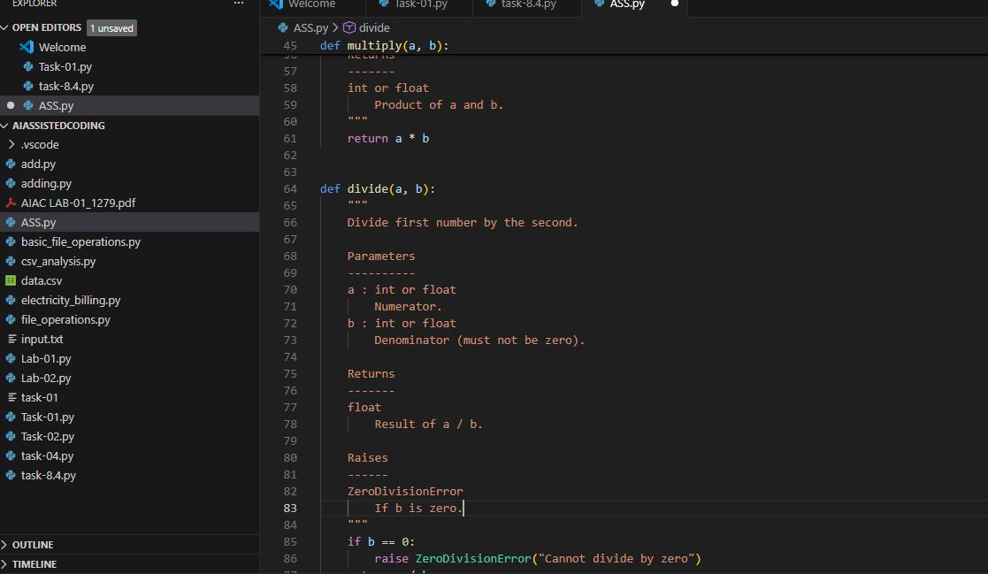
AI Generated:
def add(a, b):
"""
Returns the sum of two numbers.
Parameters
----------
a : int or float
b : int or float
Returns
-------
int or float
"""
return a + b
def subtract(a, b):
"""
Returns the difference between two numbers.

Parameters
----------
a : int or float
b : int or float
Returns
-------
int or float
"""
return a - b
def multiply(a, b):
"""
Returns the product of two numbers.
Parameters
----------
a : int or float
b : int or float

Returns
-------
int or float
"""
return a * b
def multiply(a, b):
"""
Returns the product of two numbers.
Parameters
----------
a : int or float
b : int or float
Returns
-------
int or float
"""
return a * b
def divide(a, b):
"""
Divides one number by another.
Parameters
----------
a : int or float
b : int or float
Returns
-------
float
"""
if b == 0:
raise ZeroDivisionError("Cannot divide by zero")
return a / b
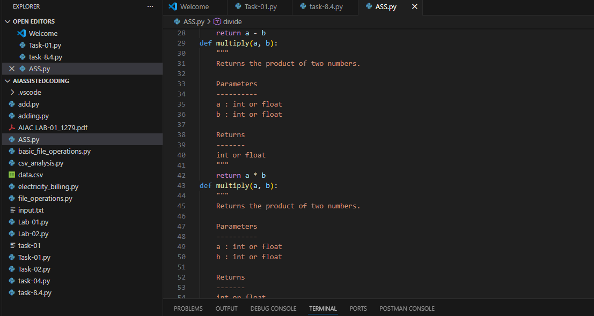

EXPLANATION: Manual vs AI Documentation
Module-Level Docstring Comparison
Aspect | Manual | AI-Generated
Purpose | Brief description | More structured and reusable
Audience | General | Clearly states multi-project use
Readability | Simple | More polished
Detail | Minimal | Slightly better

