Assignment-2.3

Name:B.Akshara
Ht No:2303A5129
Batch:05

Task-01
Prompt:
Word Frequency from Text Filegenerate Python code that reads a text file and counts word
Code:
from collections import Counter
import re

def count_words(filename: str) -> Counter:
with open(filename, "r", encoding="utf-8") as f:
text = f.read().lower()

words = re.findall(r"[a-z0-9]+(?:'[a-z0-9]+)?", text)
return Counter(words)

if __name__ == "__main__":
filename = "input.txt" # put your text file name here
counts = count_words(filename)

for word, freq in counts.most_common():
print(f"{word}: {freq}")
Implementation:
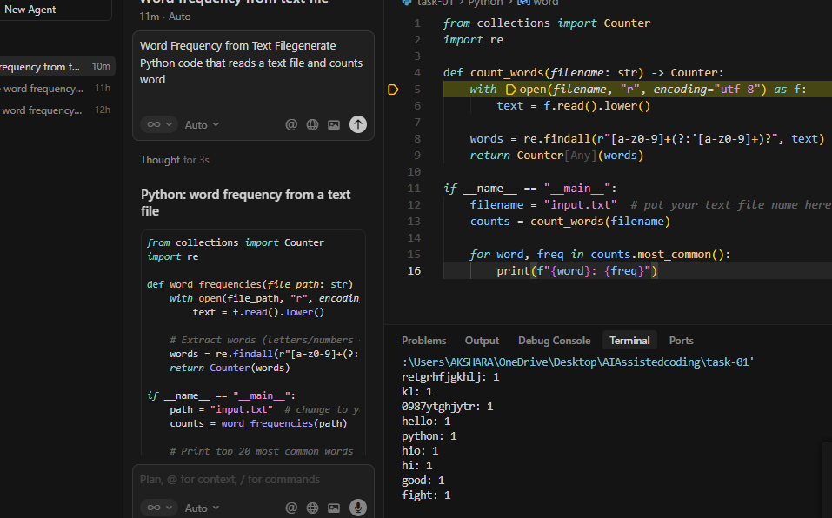

Explanation:
What it does: Counts how many times each word appears in a text file.How it works:
- Reads the file → Opens input.txt and reads all text
- Converts to lowercase → Makes counting case-insensitive
- Extracts words → Uses regex to find words (handles contractions like "don't")
- Counts words → Uses Counter to count occurrences
- Prints results → Shows each word with its frequency, sorted from most to least common
Example: If file has "hello python hello", output:
hello: 2
python: 1
Key components:
- Counter - counts word frequencies
- re.findall() - extracts words from text
- most_common() - sorts by frequency
Task-02:
Prompt:
automating basic file operations.generate a program that:
➢ Creates a text file
➢ Writes sample text
➢ Reads and displays the content
Code:
from collections import Counter
import re

def count_words(filename: str) -> Counter:
with open(filename, "r", encoding="utf-8") as f:
text = f.read().lower()

words = re.findall(r"[a-z0-9]+(?:'[a-z0-9]+)?", text)
return Counter(words)

if __name__ == "__main__":
filename = "input.txt" # put your text file name here
counts = count_words(filename)

for word, freq in counts.most_common():
print(f"{word}: {freq}")

Implementation:
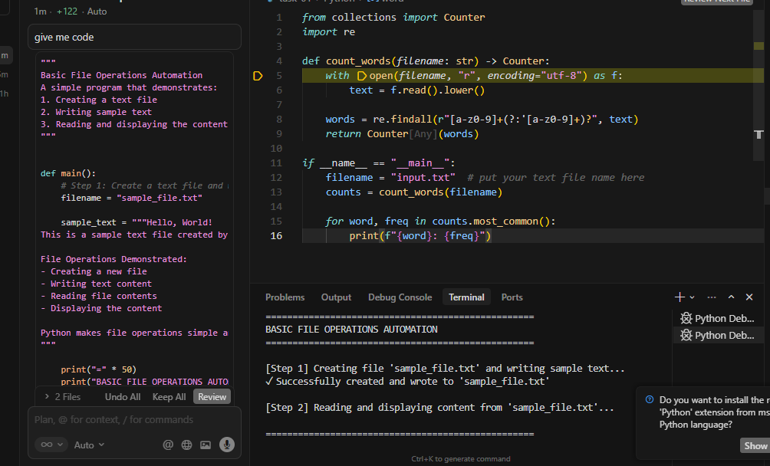
Explanation:
- Creates a file (sample_file.txt)
- Writes sample text to it
- Reads and displays the content
Key parts:
- open(filename, 'w') — creates/overwrites file for writing
- file.write() — writes text to the file
- open(filename, 'r') — opens file for reading
- file.read() — reads entire file content
- with statement — automatically closes the file
- try-except — handles errors
Flow: Create → Write → Read → DisplaySimple file I/O with error handling.
Task:03
Prompt:
Read a CSV file and calculate mean, min, and max.
Code:
import csv
import statistics
from typing import Dict, List, Any

def read_csv_file(filename: str) -> List[Dict[str, Any]]:
"""Read a CSV file and return a list of dictionaries."""
data = []
try:
with open(filename, 'r', encoding='utf-8') as file:
csv_reader = csv.DictReader(file)
for row in csv_reader:
data.append(row)
print(f"Successfully read {len(data)} rows from '{filename}'")
return data
except FileNotFoundError:
print(f"Error: File '{filename}' not found.")
return []
except Exception as e:
print(f"Error reading CSV file: {e}")
return []

def convert_to_numeric(value: str) -> float:
"""Convert a string value to float, handling errors gracefully."""
try:
return float(value)
except (ValueError, TypeError):
return None

def calculate_statistics(data: List[Dict[str, Any]]) -> Dict[str, Dict[str, float]]:
"""Calculate mean, min, and max for all numeric columns in the CSV."""
if not data:
print("No data to process.")
return {}

# Get all column names from the first row
columns = list(data[0].keys())

# Dictionary to store statistics for each numeric column
stats = {}

for column in columns:
# Extract values for this column
values = [row[column] for row in data]

# Convert to numeric values, filtering out None values
numeric_values = [convert_to_numeric(val) for val in values]
numeric_values = [val for val in numeric_values if val is not None]

# Only calculate statistics if we have numeric values
if numeric_values:
stats[column] = {
'mean': statistics.mean(numeric_values),
'min': min(numeric_values),
'max': max(numeric_values),
'count': len(numeric_values)
}
return stats

def display_statistics(stats: Dict[str, Dict[str, float]]) -> None:
"""Display the calculated statistics in a formatted way."""
if not stats:
print("No numeric columns found in the CSV file.")
return

print("\n" + "="*70)
print("STATISTICS SUMMARY")
print("="*70)

for column, values in stats.items():
print(f"\nColumn: {column}")
print(f" Count: {values['count']}")
print(f" Mean: {values['mean']:.2f}")
print(f" Min: {values['min']:.2f}")
print(f" Max: {values['max']:.2f}")

print("="*70 + "\n")

def main():
# CSV filename - change this to your CSV file name
csv_filename = "data.csv"

print(f"Reading CSV file: {csv_filename}")
print("-" * 70)

# Step 1: Read the CSV file
data = read_csv_file(csv_filename)

if not data:
print("\nNo data was read. Please check if the file exists and is valid.")
return

# Step 2: Calculate statistics
print("\nCalculating statistics...")
stats = calculate_statistics(data)

# Step 3: Display the results
display_statistics(stats)

if __name__ == "__main__":
main()

Implementation:
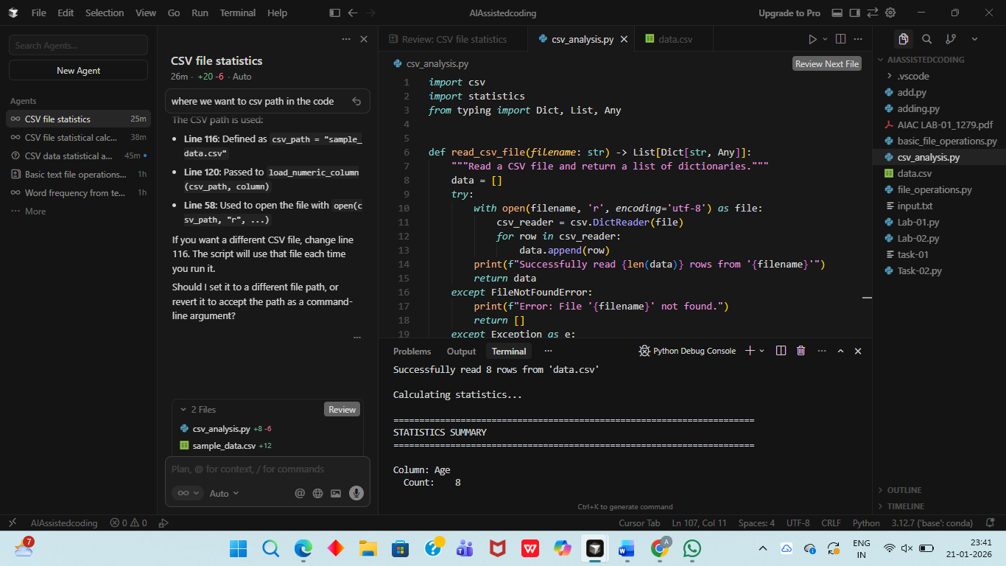
Explanation:
Reads a CSV and computes mean, min, and max for numeric columns.
Key Functions:
- read_csv_file() - Opens CSV, reads rows as dictionaries
- convert_to_numeric() - Converts strings to numbers (returns None if invalid)
- calculate_statistics() - For each column:
- Extracts values → converts to numbers → filters out None
- Calculates mean, min, max, count (only for numeric columns)
- display_statistics() - Prints formatted results
- main() - Runs: read → calculate → display
How it works:
- Uses csv.DictReader to read CSV rows as dictionaries
- Automatically detects numeric columns (skips text columns like "Name")
- Uses statistics.mean() for mean, min()/max() for min/max
- Handles errors gracefully (missing files, invalid data)
Result: Shows mean, min, max, and count for each numeric column in the CSV.

Task-04
Prompt:
To generate:1)Bubble sort,2) Python’s built-in sort(),3)Compare both implementations
Code:
import time
import random
from typing import List

def bubble_sort(arr: List[int]) -> List[int]:
"""
Implement bubble sort algorithm.

Bubble sort repeatedly steps through the list, compares adjacent elements
and swaps them if they are in the wrong order. The pass through the list
is repeated until the list is sorted.

Time Complexity: O(n²)
Space Complexity: O(1)
"""
# Create a copy to avoid modifying the original list
arr = arr.copy()
n = len(arr)

# Traverse through all array elements
for i in range(n):
# Flag to optimize: if no swaps occur, array is already sorted
swapped = False

# Last i elements are already in place
for j in range(0, n - i - 1):
# Traverse the array from 0 to n-i-1
# Swap if the element found is greater than the next element
if arr[j] > arr[j + 1]:
arr[j], arr[j + 1] = arr[j + 1], arr[j]
swapped = True

# If no two elements were swapped by inner loop, then break
if not swapped:
break

return arr

def python_builtin_sort(arr: List[int]) -> List[int]:
"""
Use Python's built-in sort() method.

Python's built-in sort uses Timsort algorithm, which is a hybrid
stable sorting algorithm derived from merge sort and insertion sort.

Time Complexity: O(n log n) average case
Space Complexity: O(n)
"""
# Create a copy to avoid modifying the original list
arr = arr.copy()
arr.sort()
return arr
def compare_sorting_algorithms(arr: List[int]) -> None:
"""
Compare bubble sort and Python's built-in sort() in terms of:
1. Correctness (both should produce the same result)
2. Performance (execution time)
"""
print("=" * 70)
print("SORTING ALGORITHM COMPARISON")
print("=" * 70)
print(f"\nArray size: {len(arr)} elements")
print(f"Original array (first 20 elements): {arr[:20]}")
if len(arr) > 20:
print(f"Original array (last 10 elements): ...{arr[-10:]}")
# Test Bubble Sort (run multiple times for accuracy)
print("\n" + "-" * 70)
print("BUBBLE SORT")
print("-" * 70)
iterations = 10 if len(arr) < 1000 else 3
start_time = time.time()
for _ in range(iterations):
bubble_sorted = bubble_sort(arr)
bubble_time = (time.time() - start_time) / iterations
print(f"Time taken: {bubble_time:.6f} seconds")
print(f"Sorted array (first 20 elements): {bubble_sorted[:20]}")
if len(bubble_sorted) > 20:
print(f"Sorted array (last 10 elements): ...{bubble_sorted[-10:]}")
# Test Python's Built-in Sort (run multiple times for accuracy)
print("\n" + "-" * 70)
print("PYTHON'S BUILT-IN SORT()")
print("-" * 70)
iterations = 10 if len(arr) < 1000 else 3
start_time = time.time()
for _ in range(iterations):
builtin_sorted = python_builtin_sort(arr)
builtin_time = (time.time() - start_time) / iterations
print(f"Time taken: {builtin_time:.6f} seconds")
print(f"Sorted array (first 20 elements): {builtin_sorted[:20]}")
if len(builtin_sorted) > 20:
print(f"Sorted array (last 10 elements): ...{builtin_sorted[-10:]}")
# Verify correctness
print("\n" + "-" * 70)
print("CORRECTNESS CHECK")
print("-" * 70)
is_correct = bubble_sorted == builtin_sorted
print(f"Both algorithms produce the same result: {is_correct}")
if is_correct:
print("[OK] Both sorting algorithms are correct!")
else:
print("[ERROR] Results don't match!")
# Performance comparison
print("\n" + "-" * 70)
print("PERFORMANCE COMPARISON")
print("-" * 70)
print(f"Bubble Sort time: {bubble_time:.6f} seconds (average over {iterations} runs)")
print(f"Built-in Sort time: {builtin_time:.6f} seconds (average over {iterations} runs)")
if builtin_time > 0:
speedup = bubble_time / builtin_time
print(f"Speedup factor: {speedup:.2f}x")
if speedup > 1:
print(f"\n-> Built-in sort() is {speedup:.2f}x faster than Bubble Sort")
else:
print(f"\n-> Bubble Sort is {1/speedup:.2f}x faster than built-in sort()")
else:
print("\n-> Built-in sort() is extremely fast (time too small to measure accurately)")
print("\n" + "=" * 70)
def main():
"""Main function to demonstrate and compare sorting algorithms."""
# Test with different array sizes
test_sizes = [100, 500, 1000]
for size in test_sizes:
# Generate random array
random_arr = [random.randint(1, 1000) for _ in range(size)]
print(f"\n\n{'#' * 70}")
print(f"TEST CASE: Random array of {size} elements")
print(f"{'#' * 70}")
compare_sorting_algorithms(random_arr)
# Test with already sorted array
print(f"\n\n{'#' * 70}")
print("TEST CASE: Already sorted array (1000 elements)")
print(f"{'#' * 70}")
sorted_arr = list(range(1, 1001))
compare_sorting_algorithms(sorted_arr)
# Test with reverse sorted array
print(f"\n\n{'#' * 70}")
print("TEST CASE: Reverse sorted array (1000 elements)")
print(f"{'#' * 70}")
reverse_arr = list(range(1000, 0, -1))
compare_sorting_algorithms(reverse_arr)
# Summary
print("\n\n" + "=" * 70)
print("SUMMARY")
print("=" * 70)
if __name__ == "__main__":
main()

Implementation:
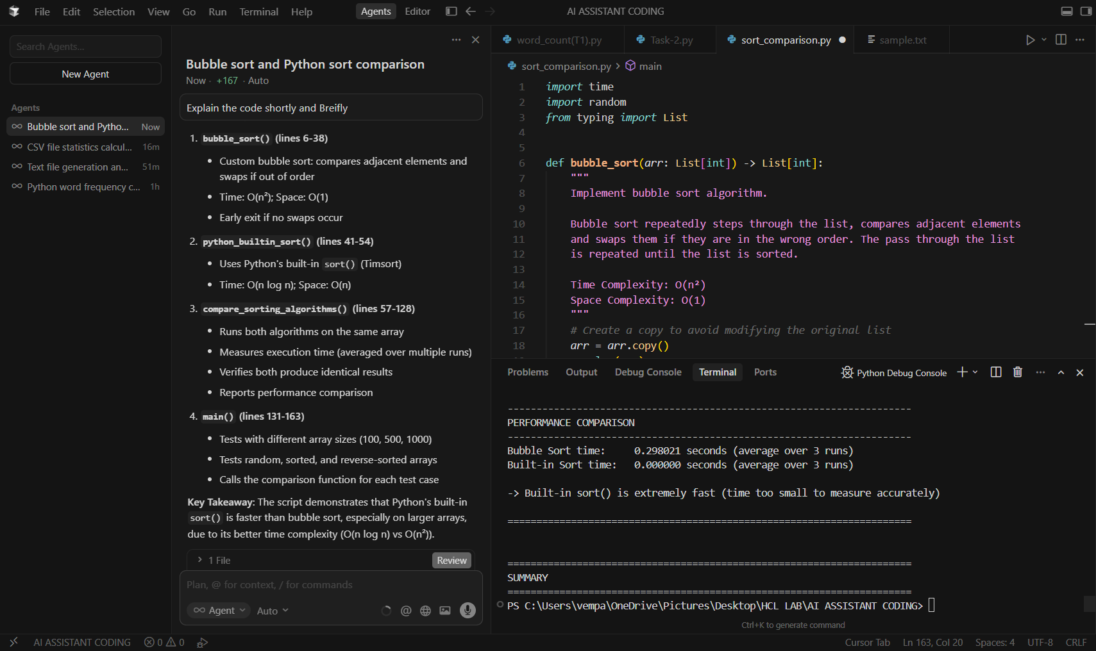
Explanation:
Compares Bubble Sort with Python's built-in sort().
Main Components:
- bubble_sort() (lines 6-38)
- Custom bubble sort: compares adjacent elements and swaps if out of order
- Time: O(n²); Space: O(1)
- Early exit if no swaps occur
- python_builtin_sort() (lines 41-54)
- Uses Python's built-in sort() (Timsort)
- Time: O(n log n); Space: O(n)
- compare_sorting_algorithms() (lines 57-128)
- Runs both algorithms on the same array
- Measures execution time (averaged over multiple runs)
- Verifies both produce identical results
- Reports performance comparison
- main() (lines 131-163)
- Tests with different array sizes (100, 500, 1000)
- Tests random, sorted, and reverse-sorted arrays
- Calls the comparison function for each test case
Key Takeaway: The script demonstrates that Python's built-in sort() is faster than bubble sort, especially on larger arrays, due to its better time complexity (O(n log n) vs O(n²)).

