LAB ASSIGNMENT-8.4

NAME:B.Akshara
HT NO:2303A51279
BATCH:05

TASK-01:
PROMPT:
#Developing a Utility Function Using TDD
#Scenario
#You are working on a small utility library for a larger software system. One of
#the required functions should calculate the square of a given number, and
#correctness is critical because other modules depend on it.
#Task Description
#Following the Test Driven Development (TDD) approach:
#1. First, write unit test cases to verify that a function correctly returns the
#square of a number for multiple inputs.

#2. After defining the test cases, use GitHub Copilot or Cursor AI to
#generate the function implementation so that all tests pass.
#Ensure that the function is written only after the tests are created.
#3. Finally, run the tests to confirm that the implementation is correct and
#meets the specified requirements.
#Unit Test Cases for the square function

CODE:
import unittest

def square(n):
return n * n
class TestSquareFunction(unittest.TestCase):

def test_square_of_positive_integer(self):
self.assertEqual(square(4), 16)
self.assertEqual(square(10), 100)

def test_square_of_negative_integer(self):
self.assertEqual(square(-3), 9)
self.assertEqual(square(-7), 49)

def test_square_of_zero(self):
self.assertEqual(square(0), 0)

def test_square_of_float(self):
self.assertAlmostEqual(square(2.5), 6.25)
self.assertAlmostEqual(square(-1.5), 2.25)
if __name__ == '__main__':
unittest.main()
# Function Implementation
def square(n):
return n * n

EXPLANATION:
This code defines a square(n) function and uses Python’s unittest framework to test it.
The tests check that the function works correctly for positive numbers, negative numbers, zero, and floats.
unitTest.main() runs all the tests automatically.
The function is defined twice, which is unnecessary

IMPLEMENTATION:
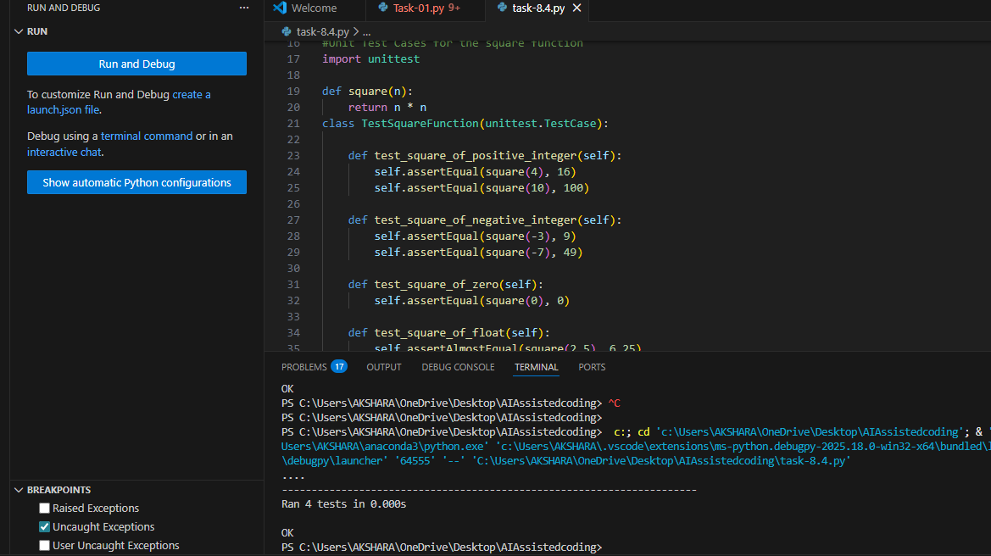
TASK-02:
PROMPT:
#Email Validation for a User Registration System
#Scenario
#You are developing the backend of a user registration system. One
#requirement is to validate user email addresses before storing them in the
#database.
#Task Description
#Apply Test Driven Development by:
#1. Writing unit test cases that define valid and invalid email formats (e.g.,
#missing @, missing domain, incorrect structure).
#2. Using AI assistance to implement the validate_email() function based
#strictly on the behavior described by the test cases.
#The implementation should be driven entirely by the test expectations.
CODE:
import unittest
import re
def validate_email(email):
pattern = r'^[a-zA-Z0-9._%+-]+@[a-zA-Z0-9.-]+\.[a-zA-Z]{2,}$'
return re.match(pattern, email) is not None
class TestValidateEmailFunction(unittest.TestCase):
def test_valid_email(self):
self.assertTrue(validate_email("test@example.com"))
self.assertTrue(validate_email("user.name@domain.co.uk"))
self.assertTrue(validate_email("user+tag@example.org"))

def test_invalid_email(self):
self.assertFalse(validate_email("invalid.email"))
self.assertFalse(validate_email("@example.com"))
self.assertFalse(validate_email("test@"))
self.assertFalse(validate_email("test@example"))
self.assertFalse(validate_email("test@.com"))
self.assertFalse(validate_email("test@com."))
self.assertFalse(validate_email("test@exam_ple.com"))
if __name__ == '__main__':
unittest.main()

EXPLANATION:
- validate_email() uses a regular expression to check if an email format is valid.
- It returns True for valid emails and False for invalid ones.
- test_valid_email checks emails that should pass validation.
- test_invalid_email checks emails that should fail validation.
- unittest.main() runs all the tests automatically.

IMPLEMENTATION:
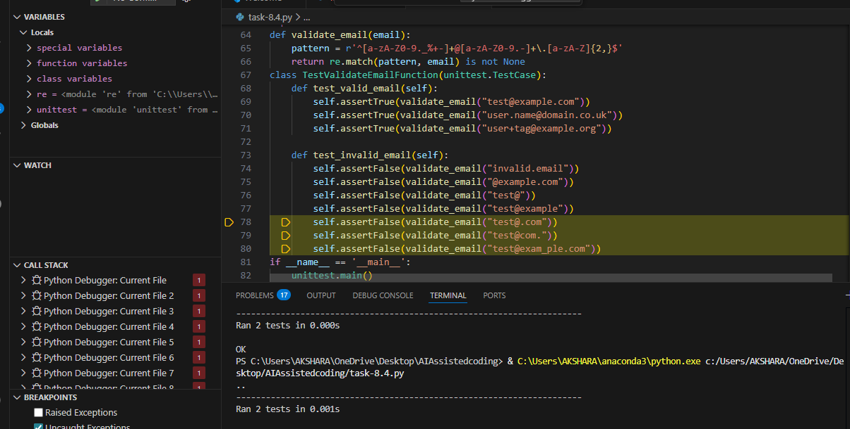
TASK-03:
PROMPT:
#In a grading or evaluation module, a function is required to determine the
#maximum value among three inputs. Accuracy is essential, as incorrect results
#could affect downstream decision logic.
#Using the TDD methodology:
#1. Write test cases that describe the expected output for different
#combinations of three numbers.
# 2. After defining the tests, implement the function to find the maximum
# value among the three inputs, ensuring that all tests pass.

CODE:
import unittest
def max_of_three(a, b, c):
return max(a, b, c)
class TestMaxOfThreeFunction(unittest.TestCase):
def test_first_is_max(self):
self.assertEqual(max_of_three(10, 5, 3), 10)

def test_second_is_max(self):
self.assertEqual(max_of_three(4, 8, 2), 8)

def test_third_is_max(self):
self.assertEqual(max_of_three(1, 3, 7), 7)

def test_all_equal(self):
self.assertEqual(max_of_three(5, 5, 5), 5)

def test_negative_numbers(self):
self.assertEqual(max_of_three(-1, -5, -3), -1)

def test_mixed_numbers(self):
self.assertEqual(max_of_three(-2, 0, 2), 2)
if __name__ == '__main__':
unittest.main()
EXPLANATION:
- max_of_three(a, b, c) returns the largest value among three numbers using Python’s max() function.
- The test class uses unittest to verify the function’s correctness.
- Separate tests check when the first, second, or third number is the maximum.
- Additional tests handle equal values, negative numbers, and mixed numbers.
- unittest.main() runs all test cases automatically.
IMPLEMENTATION:
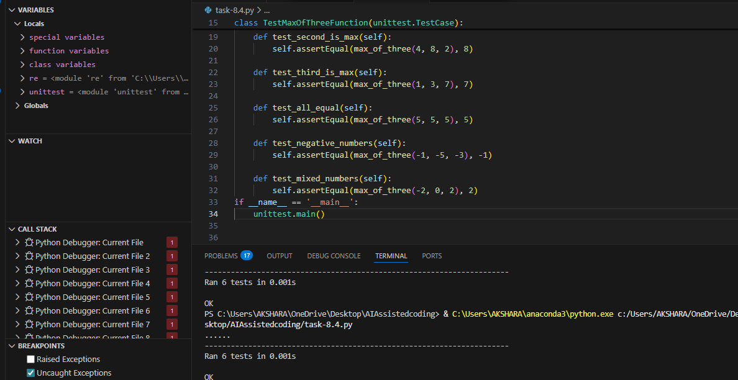
TASK-04:
PROMPT:
#You are building a simple shopping cart module for an e-commerce
#application. The cart must support adding items, removing items, and
#calculating the total price accurately.
#1. Write unit tests for each required behavior:
# Adding an item
# Removing an item
# Calculating the total price
#2. After defining all tests, use AI tools to generate the ShoppingCart class
#and its methods so that the tests pass.

CODE:
import unittest
class ShoppingCart:
def __init__(self):
self.items = []

def add_item(self, item, price):
self.items.append((item, price))

def remove_item(self, item):
self.items = [i for i in self.items if i[0] != item]

def total_price(self):
return sum(price for item, price in self.items)
class TestShoppingCart(unittest.TestCase):
def setUp(self):
self.cart = ShoppingCart()

def test_add_item(self):
self.cart.add_item("Apple", 1.0)
self.assertEqual(len(self.cart.items), 1)
self.assertEqual(self.cart.items[0], ("Apple", 1.0))

def test_remove_item(self):
self.cart.add_item("Banana", 0.5)
self.cart.add_item("Orange", 0.75)
self.cart.remove_item("Banana")
self.assertEqual(len(self.cart.items), 1)
self.assertEqual(self.cart.items[0], ("Orange", 0.75))

def test_total_price(self):
self.cart.add_item("Milk", 2.0)
self.cart.add_item("Bread", 1.5)
self.assertEqual(self.cart.total_price(), 3.5)

def test_total_price_empty_cart(self):
self.assertEqual(self.cart.total_price(), 0)

def test_remove_nonexistent_item(self):
self.cart.add_item("Eggs", 3.0)
self.cart.remove_item("Cheese") # Removing item not in cart
self.assertEqual(len(self.cart.items), 1)
self.assertEqual(self.cart.items[0], ("Eggs", 3.0))
if __name__ == '__main__':
unittest.main()

EXPLANATION:
1. ShoppingCart stores items with their prices and supports adding, removing, and calculating total cost.
2. setUp() creates a fresh cart before each test.
3 . Tests verify that items are added and removed correctly.
4. Total price is checked for both non-empty and empty carts.
5. unittest.main() runs all tests to ensure the cart works properly.

IMPLEMENTATION:
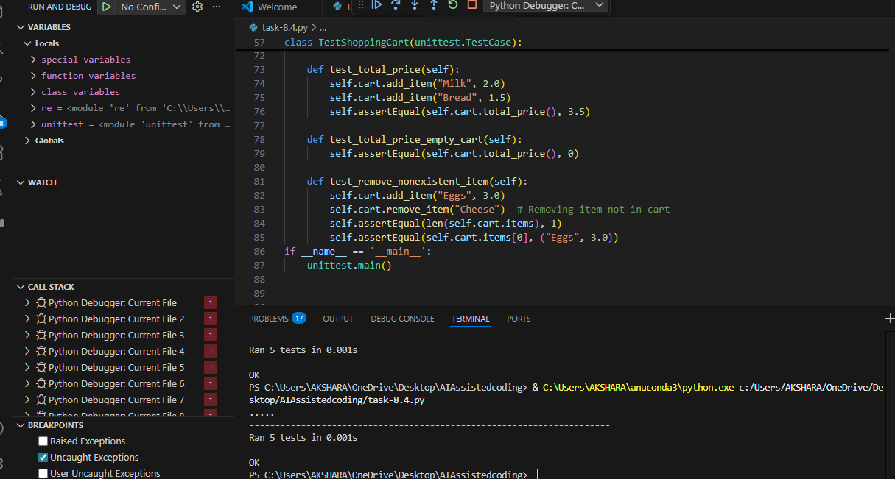

TASK-05:
PROMPT:
#You are working on a text-processing module where a function is required to
#identify whether a given string is a palindrome. The function must handle
#different cases and inputs reliably.
#1. Write test cases for a palindrome checker covering:
# Simple palindromes
# Non-palindromes
# Case variations
#generate the is_palindrome()
#function based on the test case expectations
CODE:
import unittest
import re
def is_palindrome(s):
# Remove all non-alphanumeric characters and convert to lowercase
s = re.sub(r'[^a-zA-Z0-9]', '', s).lower()
return s == s[::-1]
class TestPalindromeChecker(unittest.TestCase):
def test_simple_palindrome(self):
self.assertTrue(is_palindrome("madam"))
def test_non_palindrome(self):
self.assertFalse(is_palindrome("hello"))
def test_case_variation(self):
self.assertTrue(is_palindrome("Racecar"))
def test_palindrome_with_spaces(self):
self.assertTrue(is_palindrome("A man a plan a canal Panama"))

def test_palindrome_with_punctuation(self):
self.assertTrue(is_palindrome("No 'x' in Nixon."))

def test_empty_string(self):
self.assertTrue(is_palindrome(""))
def test_single_character(self):
self.assertTrue(is_palindrome("a"))
if __name__ == '__main__':
unittest.main()
EXPLANATION:
The is_palindrome() function first removes all non-alphanumeric characters using a regular expression and converts the string to lowercase.
This ensures that spaces, punctuation, and letter case do not affect the comparison.
The cleaned string is then compared with its reverse to check if it reads the same backward.
The test class uses unittest to verify the function with simple, complex, and edge-case inputs.
If all tests pass, it confirms the palindrome checker works correctly in all scenarios.

IMPLEMENTATION:
