Project Proposal Report
Hull Tactical - Market Prediction
Single-index daily tactical allocation forecasting
(LightGBM + Deep Time-Series Models + Ensemble)
Date: 2026-01-15
Prepared for: Kaggle Featured Code Competition

1. Executive Summary
This proposal outlines a structured research and engineering plan to build a robust prediction-and-allocation pipeline for the Hull Tactical Market Prediction competition. The dataset is a single time series indexed by date_id, with grouped feature families (Market dynamics/technical, macro, rates, valuation, volatility, sentiment, momentum, and binary features) and a training-only target forward_returns. We will retain the existing LightGBM baseline as a strong tabular anchor, add two sequence models (PatchTST and Temporal Fusion Transformer) to capture longer-horizon dynamics and conditional regime effects, and combine models via blending and optional stacking using strict time-based out-of-fold (OOF) validation.

Key outcomes
- A reproducible end-to-end pipeline: data → features/windows → model training → OOF evaluation → ensemble → API-compatible inference.
- Three primary model families: LightGBM (baseline), PatchTST, TFT; optional N-BEATS as a controlled ablation.
- Ensembling strategy prioritized for robustness: blending first, stacking second, validated via OOF stability checks.

2. Problem Statement and Data
Goal: predict next-day S&P 500 forward returns (forward_returns) or an equivalent allocation signal under a time-series API constraint (no forward peeking). The dataset is a single daily time series. Early history includes extensive missing values, which must be handled carefully to avoid leakage.

2.1 Dataset fields (high level)
- date_id: unique identifier for each trading day.
- Feature families: M* (market dynamics/technical), E* (macro), I* (interest rates), P* (price/valuation), V* (volatility), S* (sentiment), MOM* (momentum), D* (binary/dummy).
- forward_returns: next-day returns of buying S&P 500 and selling a day later (train only).
- risk_free_rate and market_forward_excess_returns: additional train-only fields (may be used cautiously as targets/auxiliary signals).

3. Current Baseline (Existing Work)
The current baseline uses engineered features (lags/rolling statistics and domain-inspired ratios) with a LightGBM regressor, evaluated using rank-based correlation (IC) on a time-ordered validation split. An API-compatible predict() wrapper constrains outputs and applies consistent preprocessing (e.g., scaling and clipping).

3.1 Strengths of the baseline
- Strong performance on tabular factor-style features; robust to missingness and non-linear feature interactions.
- Fast iteration cycle for feature testing, importance analysis, and ablation studies.
- Suitable as an anchor model in ensembles (stable OOF predictions).

3.2 Baseline limitations (why add deep models)
- Temporal structure is only captured through manually engineered lag/rolling features.
- Harder to learn longer-horizon dependencies and regime shifts end-to-end.
- Potential performance ceiling when the signal requires sequence-level pattern recognition.

4. Proposed Workflow and System Architecture
Figure 1 shows the end-to-end modeling workflow. Figure 2 shows the proposed modular architecture.
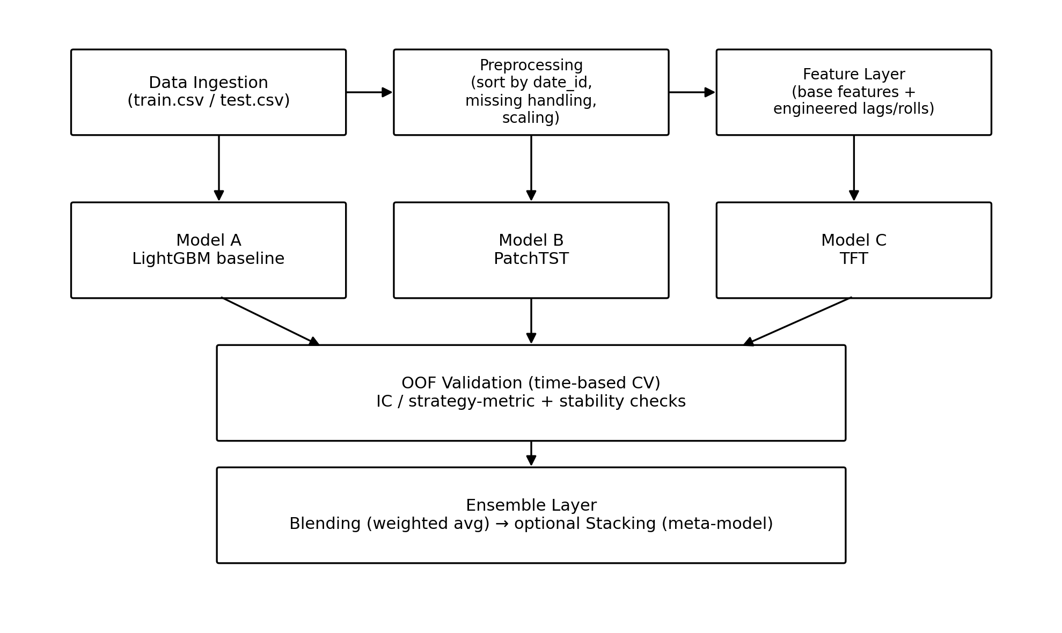
Figure 1. End-to-end workflow (data → features → models → OOF validation → ensemble).
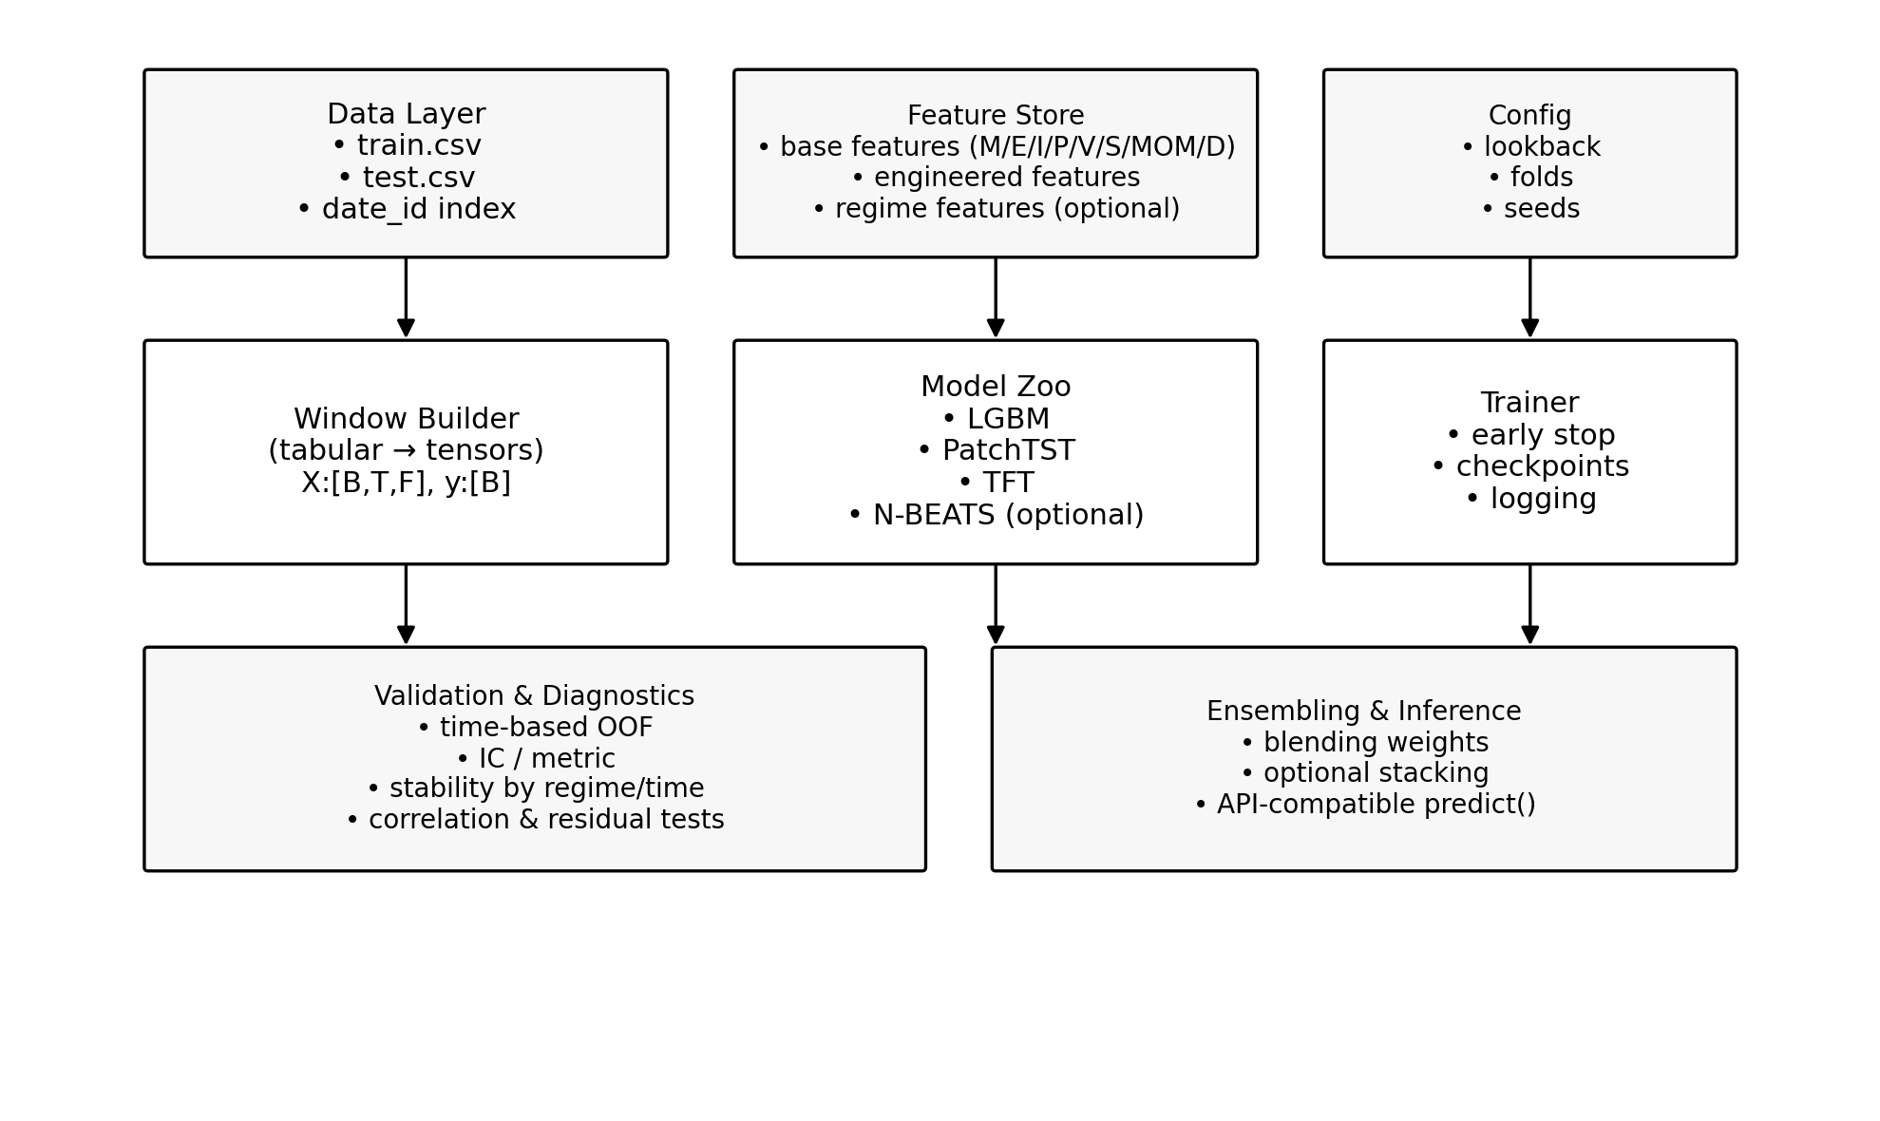
Figure 2. Project architecture (data/feature store, window builder, model zoo, trainer, validation, ensemble, inference).

5. Model Plan and Comparative Analysis
We will train three primary model families and evaluate them under a shared time-based OOF protocol. The emphasis is on complementary information capture and stable generalization, rather than single-split gains.

5.1 Model comparison (for this dataset)
Model | What it captures | Pros | Cons / risks | Role in ensemble
LightGBM (baseline) | Nonlinear factor interactions in tabular features | Fast, robust, strong baseline; handles missingness well | Limited long-horizon sequence learning; relies on engineered lags | Anchor / main component
PatchTST | Long-range multivariate temporal patterns via patching | Strong long-horizon modeling; simpler than TFT; often good generalization | Requires windowing + scaling; sensitive to lookback choice | Complementary time-structure model
Temporal Fusion Transformer (TFT) | Conditional feature importance + regime effects with attention | Powerful covariate modeling; interpretable attention/feature gates | Heavy training; overfit risk; pipeline complexity | High-upside component, small-to-medium weight
N-BEATS (optional) | Trend/seasonal decomposition on target/history | Simple training; good as ablation/sanity baseline | Weak covariate use; may add little on noisy returns | Optional auxiliary model

6. Validation Strategy and Leakage Controls
Because the task is time-series with an API that prevents forward peeking, validation must mirror the deployment setting. We will use time-based splits and generate out-of-fold predictions for all models before ensembling.

6.1 Recommended OOF protocol
- Primary: rolling or expanding window CV with non-overlapping validation blocks.
- OOF storage: save per-day predictions for each model and each fold.
- Metrics: Spearman IC; plus stability diagnostics by time block and by regime (e.g., volatility quantiles).

6.2 Leakage safeguards
- All feature engineering uses only information available up to date_id (strict causality).
- Scaling/normalization is fit on training portion only within each fold, then applied to validation.
- Any regime model (e.g., clustering) is trained within fold boundaries to avoid peeking.

7. Ensembling Plan (Blending and Stacking)
Ensembling will be performed only on OOF predictions to prevent optimistic bias. We prioritize blending for robustness, and use stacking only if it shows stable improvements across folds.

7.1 Blending (first choice)
- Compute weights on OOF predictions (grid search or constrained regression).
- Keep weights stable by using regularization and by checking sensitivity across folds.
- Optionally use regime-dependent weights (e.g., separate weights for high/low volatility regimes) if validated.

7.2 Stacking (optional, second stage)
- Train a simple meta-model (Ridge or small LightGBM) on OOF predictions.
- Strictly train meta-model on OOF only; final fit uses full training after meta-weights are fixed.
- Use conservative regularization to avoid overfitting to OOF noise.

8. Implementation Plan and Repository Structure

8.1 Suggested repository layout
A modular structure keeps experimentation fast while ensuring reproducibility:
project/
data/ # raw train/test (not committed if large)
features/ # feature definitions + cached feature store
models/
lgbm.py # baseline training/inference
patchtst.py # PatchTST model + training
tft.py # TFT model + training
nbeats.py # optional
validation/
splits.py # time-based CV
metrics.py # IC + diagnostics
ensemble/
blend.py
stack.py
inference/
api_predict.py # Kaggle API wrapper
notebooks/ # EDA and experiments
configs/ # YAML/JSON configs
reports/ # this proposal + experiment logs

8.2 Engineering requirements
- Unified window builder so PatchTST/TFT share identical inputs and leakage controls.
- Deterministic seeds, experiment logging (params, folds, scores), and model artifact versioning.
- Inference latency control (cache rolling window state; avoid heavy per-step recomputation).

9. Milestones, Timeline, and Deliverables
A pragmatic 4-phase plan (adjustable based on compute budget and results):
Phase | Scope | Deliverables
Phase 1 (1-2 weeks) | Validation hardening + OOF pipeline | Time-based CV module; OOF store; baseline LGBM score & stability report
Phase 2 (1-2 weeks) | PatchTST implementation + tuning | PatchTST training/inference; OOF predictions; LGBM+PatchTST blending
Phase 3 (2-3 weeks) | TFT implementation + careful regularization | TFT OOF; diagnostics; tri-model blending; optional regime-weighting
Phase 4 (ongoing) | Finalize ensemble + runtime optimization | Final submission candidates; ablation report; reproducible inference notebook

10. Risks and Mitigations
- Risk: time-series leakage inflates CV → Mitigation: fold-local scaling, strict causal features, OOF-only ensemble training.
- Risk: TFT overfitting / unstable gains → Mitigation: conservative model size, early stopping, strong regularization, blending with small weight.
- Risk: runtime limits in code competition → Mitigation: prioritize LGBM + PatchTST for speed; cache rolling windows; prune heavy features.
- Risk: marginal returns from extra models → Mitigation: use complementarity tests (prediction correlation, residual correlation, segmented IC) before adding complexity.

11. References (selected)
- Oreshkin et al. (2019). N-BEATS: Neural basis expansion analysis for interpretable time series forecasting.
- Lim et al. (2021). Temporal Fusion Transformers for interpretable multi-horizon time series forecasting.
- Nie et al. (2023). PatchTST: Long-term time series forecasting with patch-based transformers.
- Lopez de Prado (2018). Advances in Financial Machine Learning (validation and leakage controls).

