**COEN 240 MACHINE LEARNING**

**HOMEWROK THREE**

**NAME: BOSEN YANG STUDENT ID: 1589880**

**PROBLEM ONE**

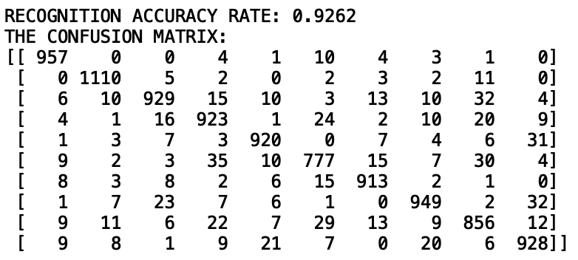

**PROBLEM TWO:**

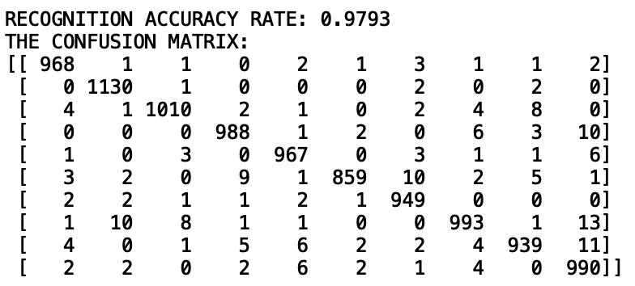

**PROBLEM THREE**

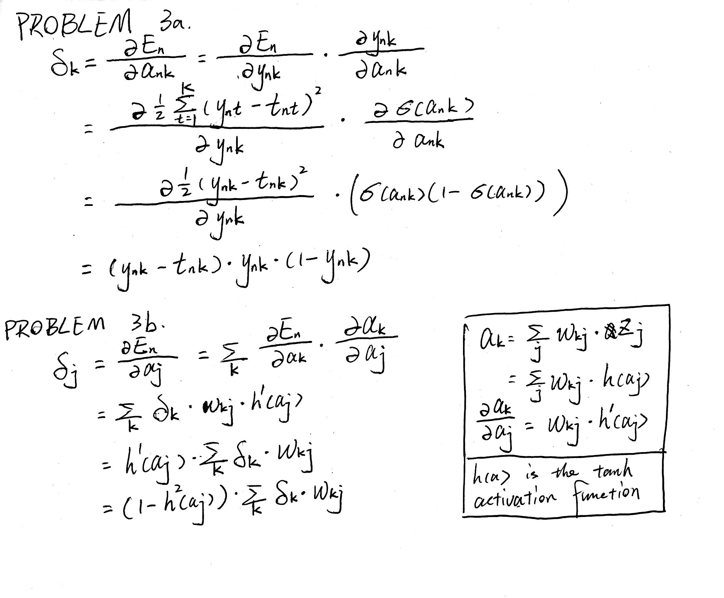

**ATTACHMENTS**

**PROBLEM ONE CODE**

"""

Created on Sun Jan 26 17:12:27 2020

@author: burson

"""

import tensorflow as tf

import numpy as np

import time

from sklearn.linear_model import LogisticRegression

from sklearn.metrics import confusion_matrix

mnist = tf.keras.datasets.mnist

# DATASET ACQUISITION

(x_traino, y_train),(x_testo, y_test) = mnist.load_data()

x_train = np.reshape(x_traino,(60000,28*28))

x_test = np.reshape(x_testo,(10000,28*28))

x_train, x_test = x_train / 255.0, x_test / 255.0

# MODEL CREATION

logreg = LogisticRegression(solver='saga', multi_class='multinomial', max_iter = 100, verbose=2)

# DATA CHECKING

#import matplotlib.pyplot as plt

#plt.figure(figsize=(20,4))

#for index, (image, label) in enumerate(zip(x_train[30:35], y_train[30:35])):

# plt.subplot(1, 5, index + 1)

# plt.imshow(np.reshape(image, (28,28)), cmap=plt.cm.gray)

# plt.title('Training: %i\n' % label, fontsize = 20)

# MODEL FITTING

logreg.fit(x_train, y_train)

# MODEL EVALUATION

time.sleep(0.2)

predictions = logreg.predict(x_test).reshape(-1, 1)

y_test = y_test.reshape(-1, 1)

num_test = x_test.shape[0]

num_match = np.count_nonzero(np.equal(predictions, y_test))

score = num_match/num_test

print("\n\nRECOGNITION ACCURACY RATE: %.4f" % (score))

print("THE CONFUSION MATRIX: ")

cm = confusion_matrix(y_test, predictions)

print(cm)

**PROBLEM TWO CODE**

"""

Created on Sun Jan 26 17:41:40 2020

@author: Burson

"""

import numpy as np

import tensorflow as tf

from keras.models import Sequential

from keras.layers import Dense

from sklearn.metrics import confusion_matrix

mnist = tf.keras.datasets.mnist

# DATASET ACQUISITION

(x_train, y_train),(x_test, y_test) = mnist.load_data()

x_train = x_train.reshape((60000, 28*28))

x_test = x_test.reshape((10000, 28*28))

x_train, x_test = x_train / 255.0, x_test / 255.0

# MODEL CREATION

model = Sequential()

model.add(Dense(512, activation="relu", input_dim=28*28))

model.add(Dense(10, activation="softmax"))

model.summary()

# MODEL COMPILATION

model.compile(optimizer="adam",

loss="sparse_categorical_crossentropy",

metrics=["accuracy"])

# MODEL FITTING

model.fit(x_train, y_train, epochs=5, batch_size=50, verbose=2)

test_loss, test_acc = model.evaluate(x_train, y_train)

print("\n\nTRAINING SET ACCURACY RATE: %.4f" % (test_acc))

# MODEL EVALUATION

predictions_mat = model.predict(x_test)

predictions = np.argmax(predictions_mat, axis=1)

num_test = x_test.shape[0]

num_match = np.count_nonzero(np.equal(predictions, y_test))

score = num_match/num_test

print("\n\nRECOGNITION ACCURACY RATE: %.4f" % (score))

print("THE CONFUSION MATRIX: ")

cm = confusion_matrix(y_test, predictions)

print(cm)