**COEN 240 MACHINE LEARNING**

**HOMEWROK THREE**

**NAME: BOSEN YANG STUDENT ID: 1589880**

**PROBLEM ONE**

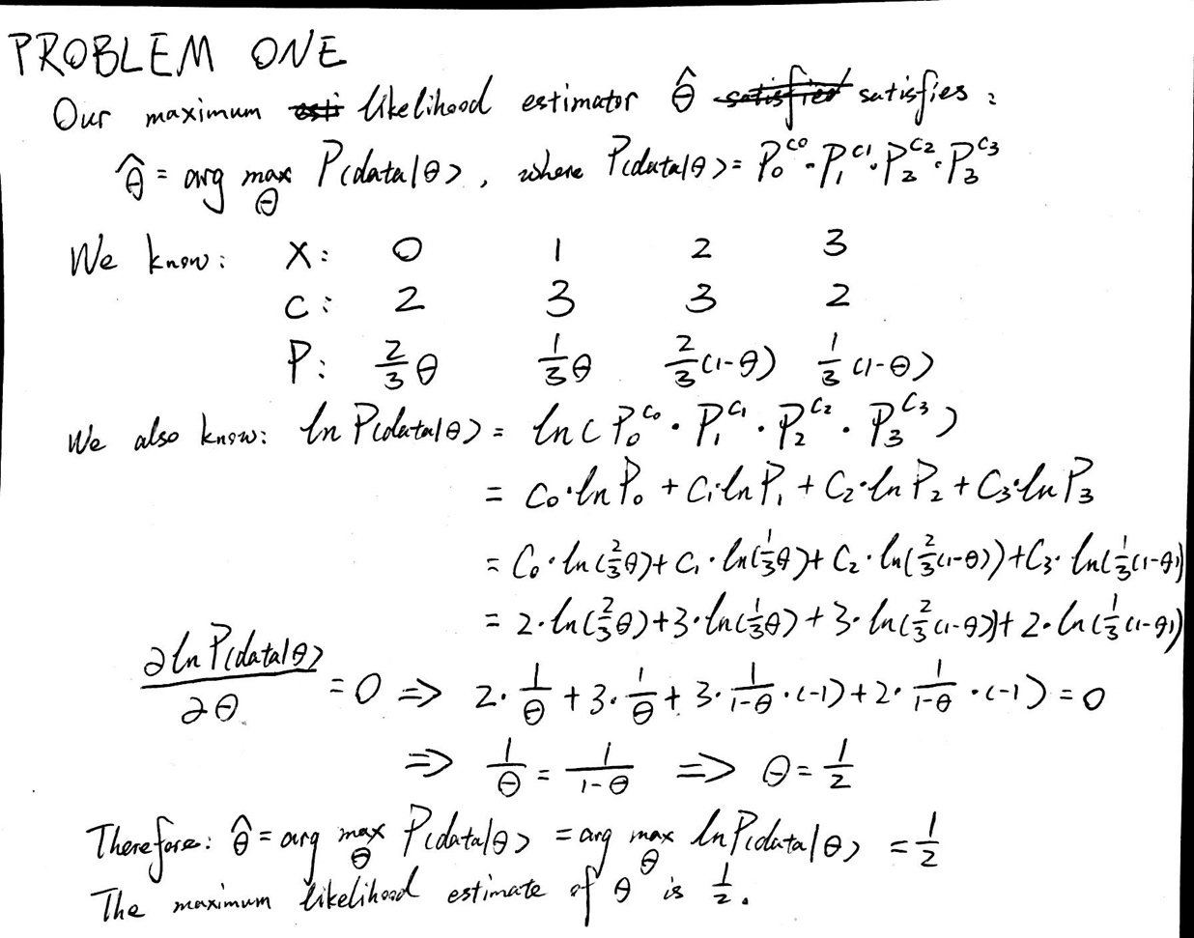

**PROBLEM TWO:**

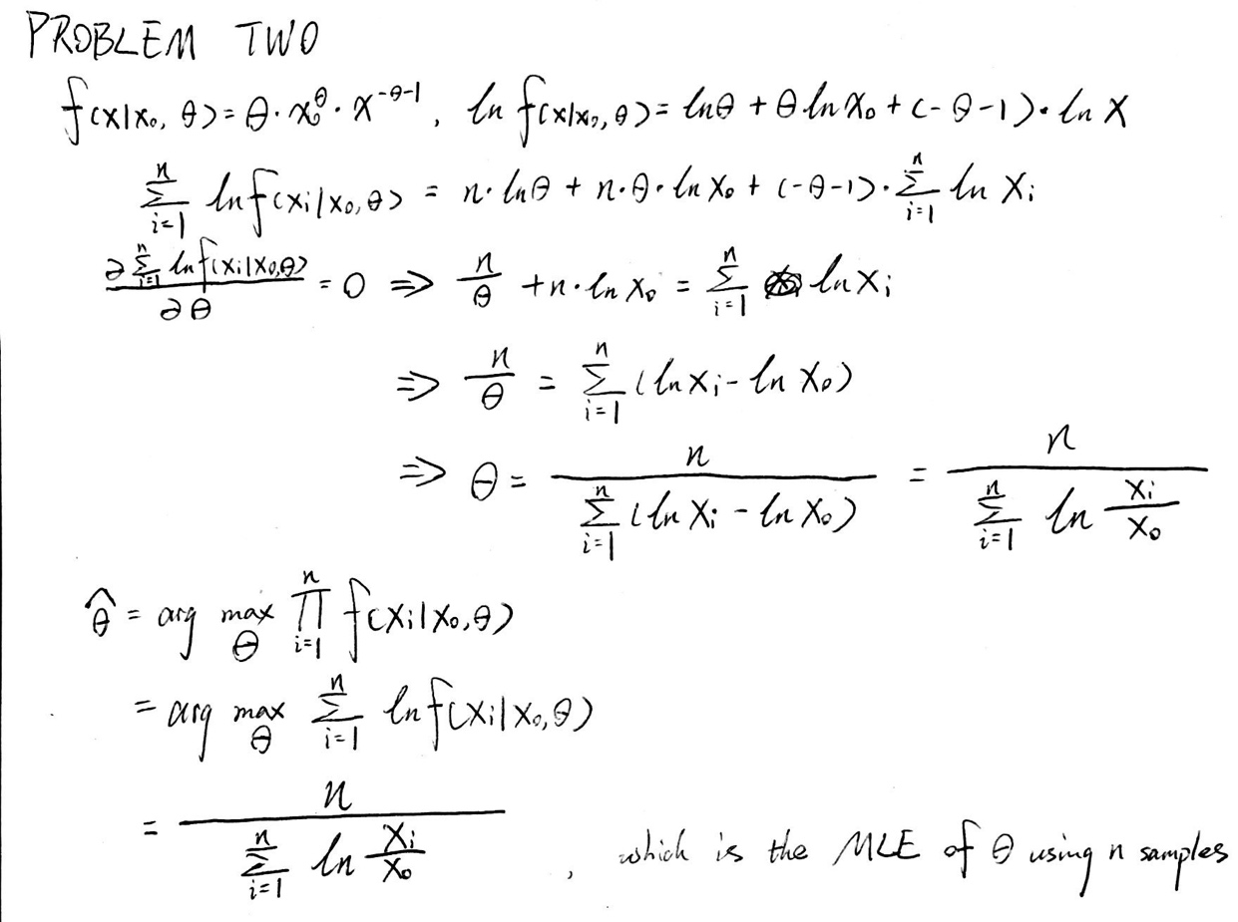

**PROBLEM THREE:**

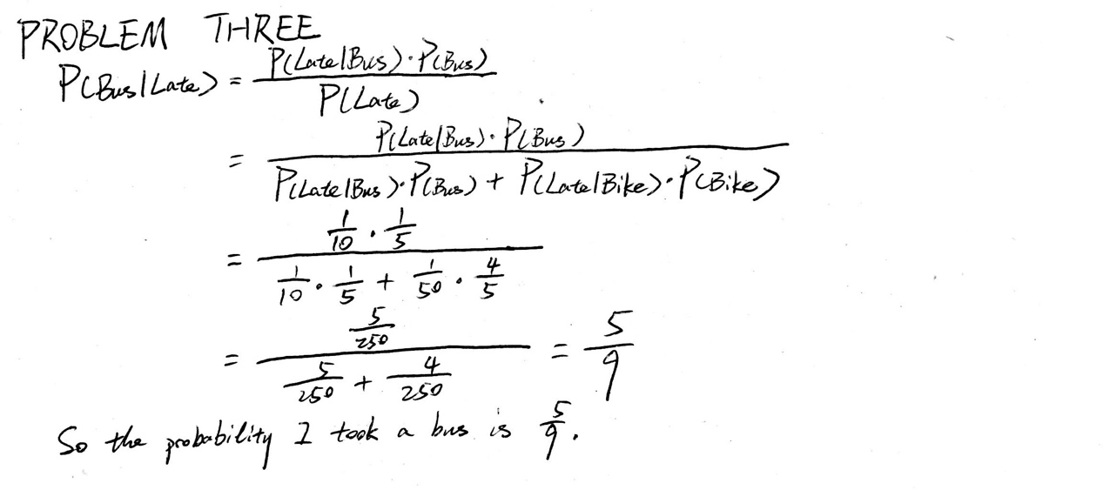

**PROBLEM FOUR**

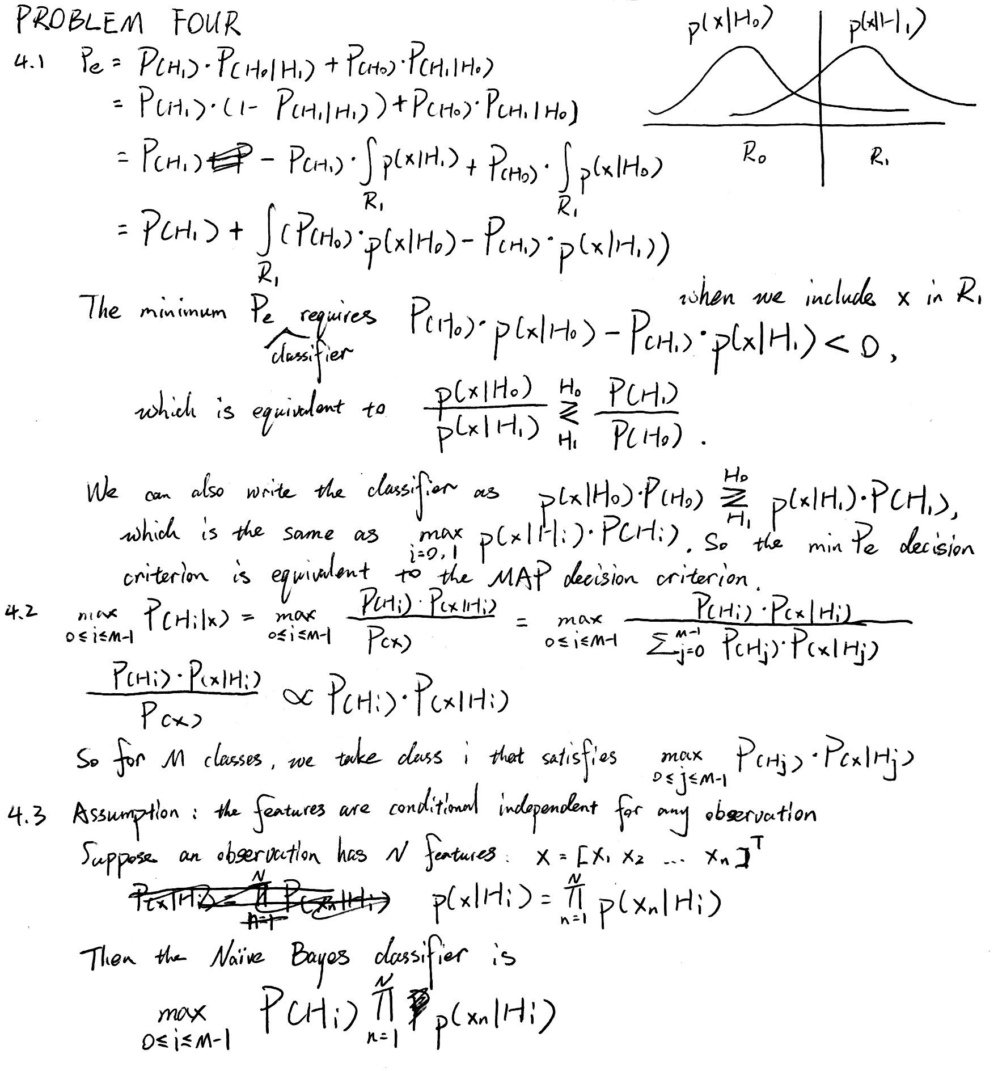

**PROBLEM FIVE**

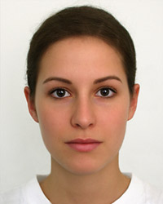 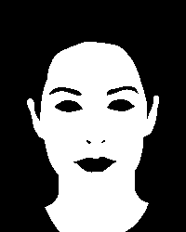 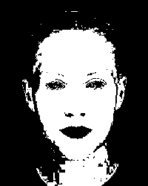

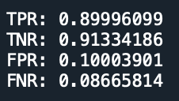

**ATTACHMENTS**

**PROBLEM ONE CODE**

"""

Created on Sun Jan 26 17:12:27 2020

@author: burson

"""

﻿#!/usr/bin/env python3

# -*- coding: utf-8 -*-

"""

Created on Mon Feb 24 08:42:29 2020

@author: Burson

"""

import math

import numpy as np

from PIL import Image

from matplotlib.pyplot import imread

# INPUT READING ------------------------------------------

train_image = imread("family.jpg")

train_truth = imread("family.png")

test_image = imread("portrait.jpg")

test_truth = imread("portrait.png")

# INPUT PROCESSING ------------------------------------------

# color code extraction AND scale invariant transformation

train_shape = train_image.shape

train_image_flat = train_image.reshape((train_shape[0]*train_shape[1], train_shape[2]))

train_image_base = np.sum(train_image_flat, axis=1) + 0.000000000000000001 # deal with 0's

train_image_flat_trans = np.transpose(train_image_flat)

train_r = np.divide(train_image_flat_trans[0], train_image_base)

train_g = np.divide(train_image_flat_trans[1], train_image_base)

# deal with 0 elements

pos_zero = np.argwhere(np.sum(train_image_flat, axis=1) == 0)

for i in pos_zero:

train_r[int(i[0])] = 1/3

train_g[int(i[0])] = 1/3

del(train_image, train_image_base, train_image_flat_trans, pos_zero)

# skin background split

train_label_s = train_truth.reshape((train_shape[0]*train_shape[1], train_shape[2]+1)).transpose()[1]

train_label_b = 1-train_label_s

train_r_s = train_r[np.argwhere(np.multiply(train_r, train_label_s))]

train_r_b = train_r[np.argwhere(np.multiply(train_r, train_label_b))]

train_g_s = train_g[np.argwhere(np.multiply(train_g, train_label_s))]

train_g_b = train_g[np.argwhere(np.multiply(train_g, train_label_b))]

# prior probability calculation

pp_s = np.count_nonzero(train_label_s)/train_image_flat.shape[0]

pp_b = np.count_nonzero(train_label_b)/train_image_flat.shape[0]

del(train_label_s, train_label_b)

# color code extraction AND scale invariant transformation

test_shape = test_image.shape

test_image_flat = test_image.reshape((test_shape[0]*test_shape[1], test_shape[2]))

test_image_base = np.sum(test_image_flat, axis=1) + 0.000000000000000001

test_image_flat_trans = np.transpose(test_image_flat)

test_r = np.divide(test_image_flat_trans[0], test_image_base)

test_g = np.divide(test_image_flat_trans[1], test_image_base)

# deal with 0 elements

pos_zero = np.argwhere(np.sum(test_image_flat, axis=1) == 0)

for i in pos_zero:

test_r[int(i[0])] = 1/3

test_g[int(i[0])] = 1/3

test_label_s = test_truth.reshape((test_shape[0]*test_shape[1], test_shape[2]+1)).transpose()[1]

del(test_image, test_image_base, test_image_flat_trans)

del(train_truth, test_truth)

# MODEL TRAINING ------------------------------------------

# use the closed-form solution we derived

miu_r_s = train_r_s.mean()

miu_g_s = train_g_s.mean()

var_r_s = train_r_s.var()

var_g_s = train_g_s.var()

miu_r_b = train_r_b.mean()

miu_g_b = train_g_b.mean()

var_r_b = train_r_b.var()

var_g_b = train_g_b.var()

# OUTPUT GENERATION ------------------------------------------

# calculate p(x|Hs) for skin

power_s_r = -np.square(test_r - miu_r_s)/(2*var_r_s)

power_s_g = -np.square(test_g - miu_g_s)/(2*var_g_s)

p_Hs_r = np.exp(power_s_r) / (math.sqrt(2*np.pi*var_r_s))

p_Hs_g = np.exp(power_s_g) / (math.sqrt(2*np.pi*var_g_s))

p_Hs = np.multiply(p_Hs_r, p_Hs_g)

# calculate p(x|Hb) for background

power_b_r = -np.square(test_r - miu_r_b)/(2*var_r_b)

power_b_g = -np.square(test_g - miu_g_b)/(2*var_g_b)

p_Hb_r = np.exp(power_b_r) / (math.sqrt(2*np.pi*var_r_b))

p_Hb_g = np.exp(power_b_g) / (math.sqrt(2*np.pi*var_g_b))

p_Hb = np.multiply(p_Hb_r, p_Hb_g)

del(test_r, test_g)

del(power_s_r, power_s_g, power_b_r, power_b_g, p_Hs_r, p_Hs_g, p_Hb_r, p_Hb_g)

# result generation applying MAP criterion

result_s = (pp_s*p_Hs - pp_b*p_Hb) > 0

# ditected binary mask generation

ones = 255*np.multiply(np.ones(test_image_flat.shape[0]), result_s)

result_array = []

for i in range(3):

result_array.append(ones)

result_array = np.array(result_array).transpose().reshape((test_shape[0], test_shape[1], test_shape[2]))

result_array = result_array.astype(np.uint8)

result_image = Image.fromarray(result_array)

result_image.save("result.png")

del(i, ones, result_image, result_array)

# OUTPUT EVALUATION ------------------------------------------

num_positive = np.count_nonzero(result_s)

num_negative = test_image_flat.shape[0] - num_positive

true_match_s = np.count_nonzero(np.multiply(test_label_s, result_s))

true_match_b = np.count_nonzero(np.multiply(1-test_label_s, 1-result_s))

false_match_s = np.count_nonzero(np.multiply(1-test_label_s, result_s))

false_match_b = np.count_nonzero(np.multiply(test_label_s, 1-result_s))

tpr = true_match_s / num_positive

tnr = true_match_b / num_negative

fpr = false_match_s / num_positive

fnr = false_match_b / num_negative

print("\n\n")

print("TPR: %.8f\nTNR: %.8f" % (tpr, tnr))

print("FPR: %.8f\nFNR: %.8f" % (fpr, fnr))

print("\n\n")