**COEN 240 MACHINE LEARNING**

**HOMEWROK SIX**

**NAME: BOSEN YANG STUDENT ID: 1589880**

**PROBLEM ONE**

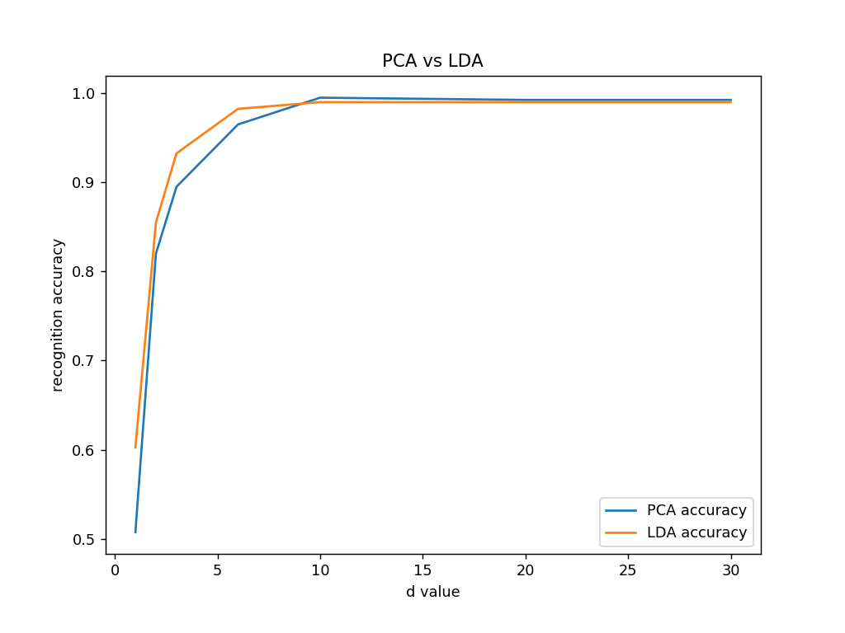

We can see the curve converges faster for LDA, because of its nature of supervised learning. So when we want to reduce the dimension a lot, or when we have small d values, LDA model is a better choice.

However, this advantage comes at a cost, which can also be observed on the graph. Though LDA converges faster, the curve becomes flat after some point. That’s because LDA has constraints on it maximum dimensions, which equals to rank of the within class covariance matrix. In our case, the maximum dimension of LDA model is 9. It means even if we increase d more than 9, we will not be able to change the result. On the other hand, PCA don’t have such constraint on the subspace dimension.

**ATTACHMENTS**

SEE CODE IN THE ZIP FILE.