<https://www.oracle.com/technetwork/java/javase/downloads/jre8-downloads-2133155.html>  
  
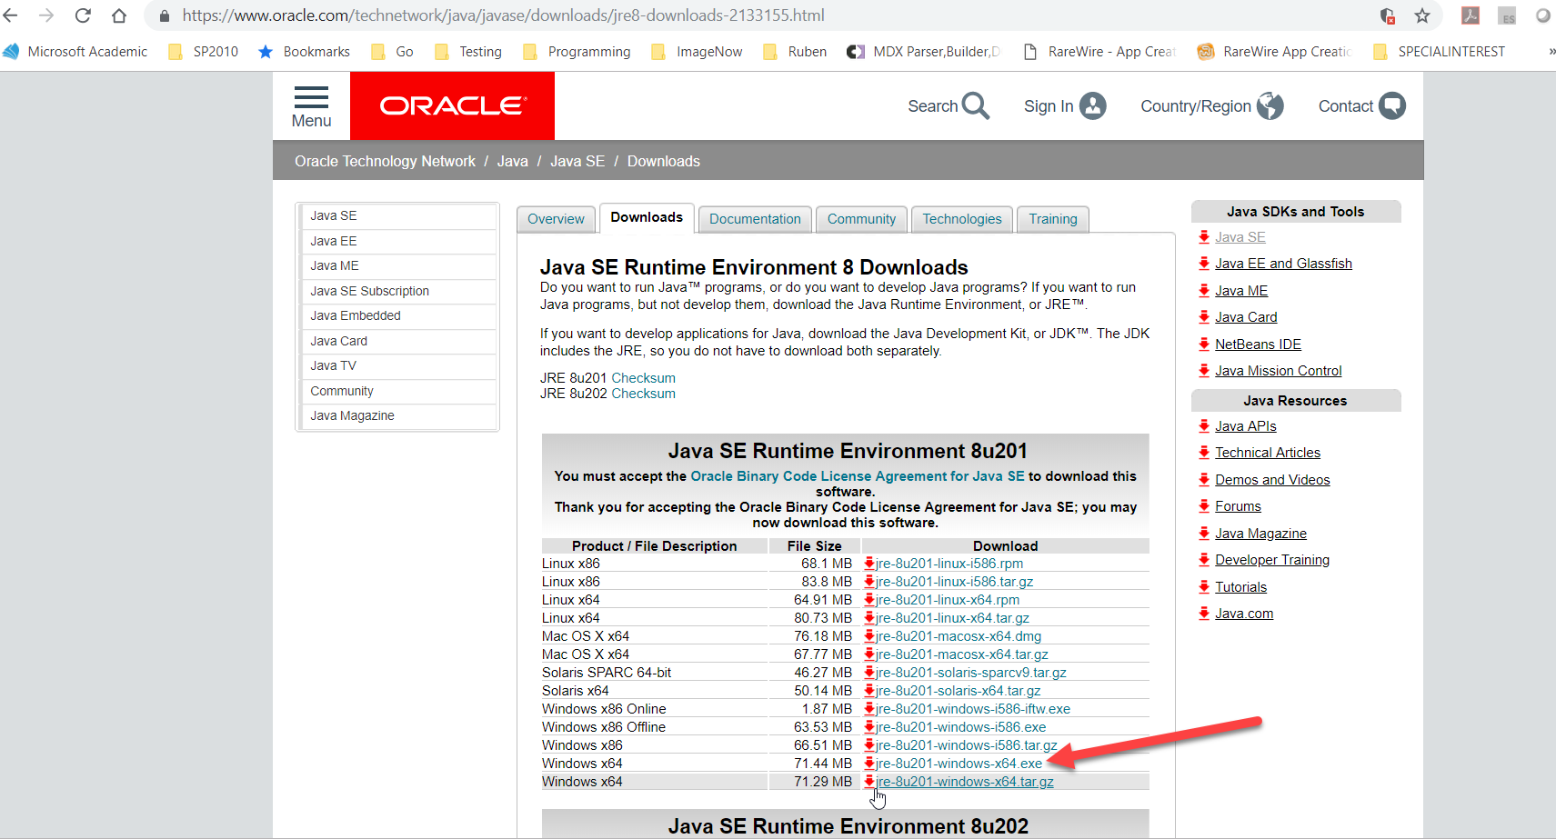

|  |  |  |
| --- | --- | --- |
| Windows x64 | 71.44 MB | [jre-8u201-windows-x64.exe](https://download.oracle.com/otn-pub/java/jdk/8u201-b09/42970487e3af4f5aa5bca3f542482c60/jre-8u201-windows-x64.exe) |

C:\Program Files\Java\jre1.8.0_201\bin

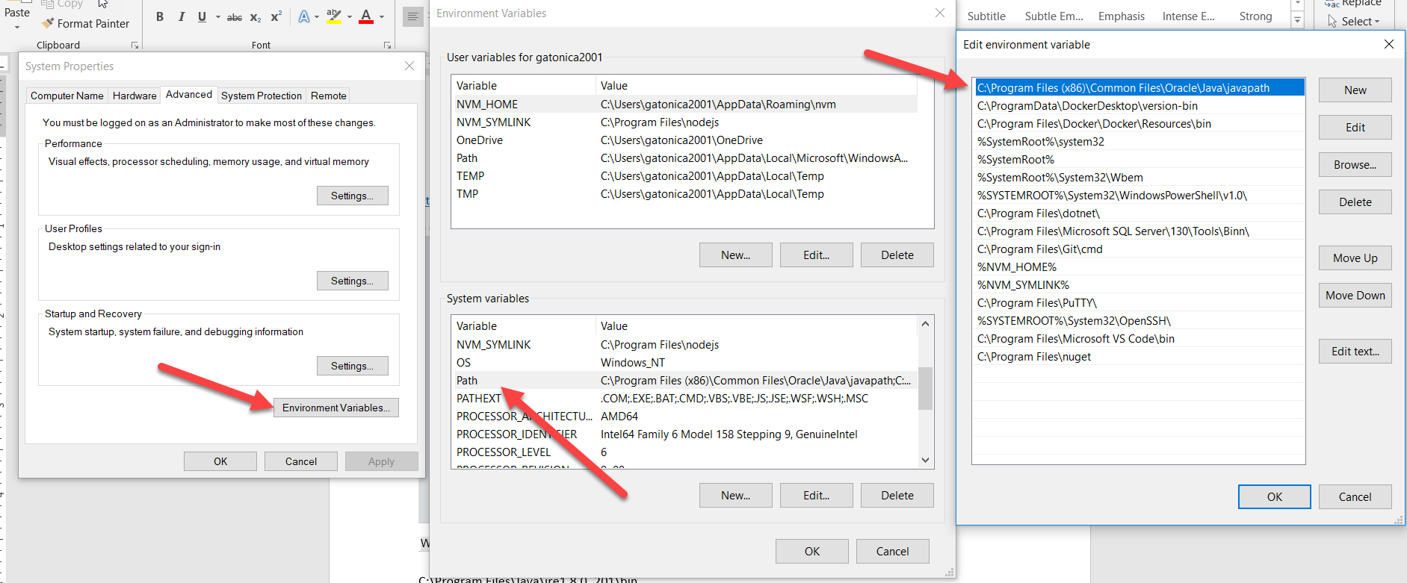

Edit path variable to include JRE path for WinRdbi can find it.

Got to https://github.com/dtechcoach/cop4703/tree/spring2019U02/Setup to download WinRDBI.zip and unzip in development folder. (if you can’t access uri above, please use the ASU official site to create an account and download, https://winrdbi.asu.edu/download.html)

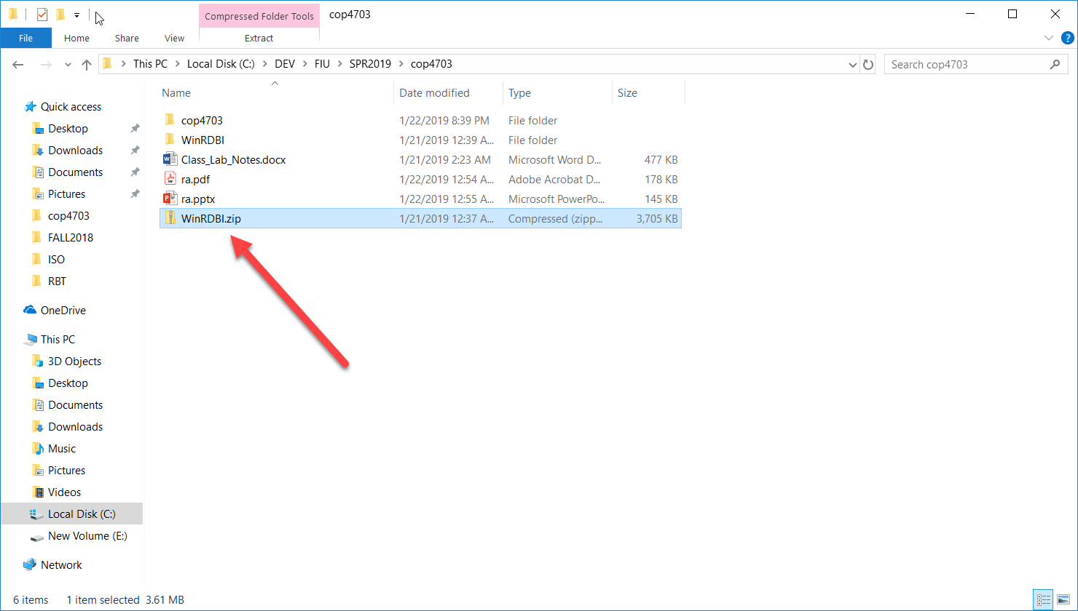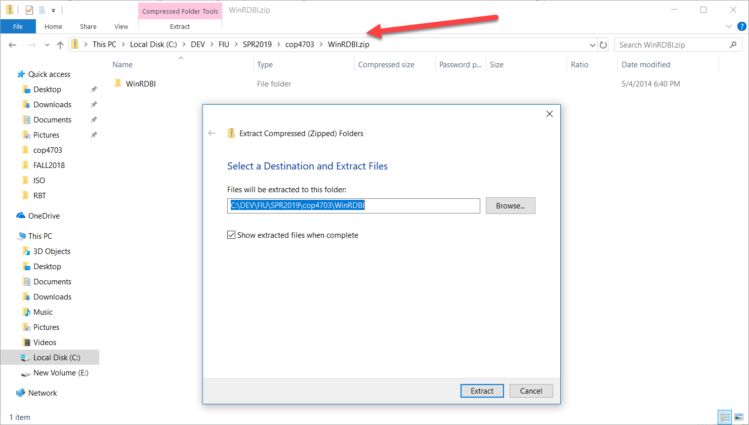

Navigate to the corresponding 32bit or 64 bit folder…

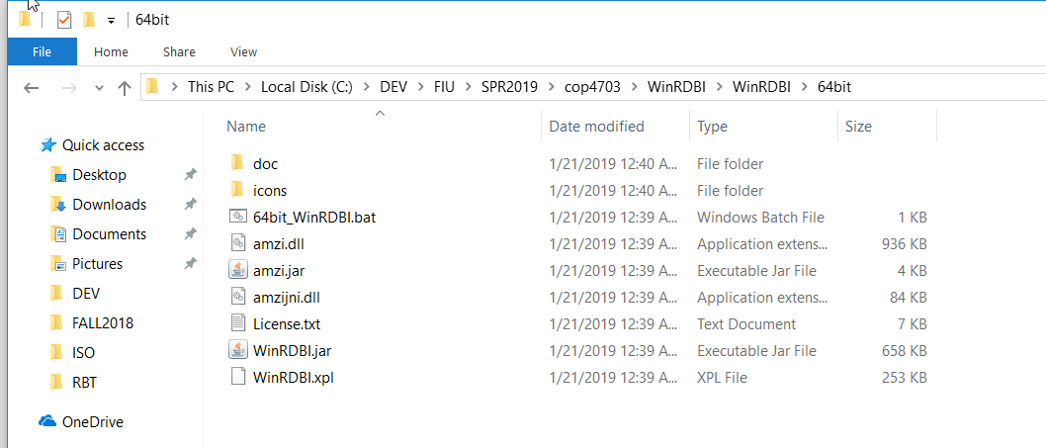

Navigate to folder where you downloaded WinRDBI : EX. C:\DEV\FIU\SPR2019\cop4703\WinRDBI\WinRDBI\64bit

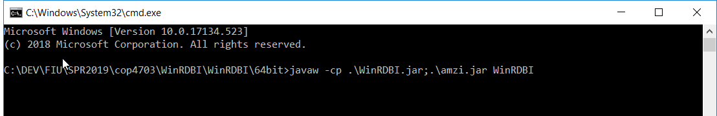

Open command line in this location and run javaw -cp .\WinRDBI.jar;.\amzi.jar WinRDBI

