# Requirements

## Domain Analysis

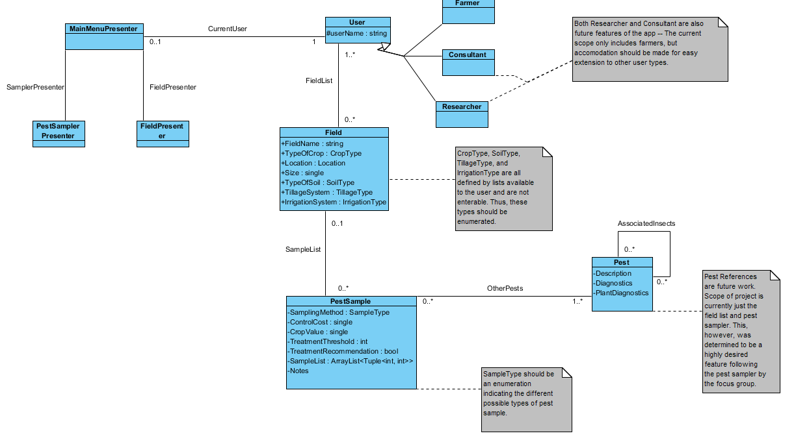

## Domain Analysis Description

This app must be designed for ease of maintainability and ease of extension, as this is a project intended to stretch out many years into the future. To that extent, it makes sense for each area of the app to have a separate handler for each function of the app. FieldPresenter and PestSampler presenter handle each of the current intended functions of the app – to be able to add, view, and edit field information, and to create pest samples to link to a field. MainMenuPresenter is intended to act as an interface between the functional handlers and the data on the back end (e.g. the fields and pest samples). By this design, the system acts as a Model-View-Presenter system. The functional handlers act as the view, the MainMenuPresenter acts as the main controller, and the field, user, and pest sample objects act as the data. This design allows for ease of extension of the system; to add a new function, all that is necessary is to add a new Presenter on the front end, and any additional data on the back end. The MainMenuPresenter acts as an interface in between the two systems, gathering and collecting the necessary data from the Model and passing it to the View.