Project Report

My project represents simple card game called «AZI». Two players get by 3 card and have a trump. One by one players make their move. After each move player whose card is bigger earn 1 point. At the end of the game player with lots of points win.

To realize this game on Windows I’ve used «Winsock» for socket connection and rewrite threads and mutexes, adapted them to Windows. The main difference of Winsock from Unix sockets it’s their type: «SOCKET». In other they act the same: **socket()** - to initialize, **bind()** - to bind address, **listen()** - to listen for incoming sockets, **accept()** - to accept connection, **connect()** - to connect to server socket, **send()** - to send message, **recv()** to receive the message.  
Threads and mutexes are the same too. To create a new thread we need two variable: **HANDLE** for thread and **DWORD** for its ID. Then, by the **createThread()** function we create thread as in Unix. To wait for created thread we use **WaitForSingleObject** or **WaitForMultipleObjects** functions. Also, thread function should return **DWORD WINAPI.**Mutexes has type of **HANDLE.** To lock it we use **WaitForSingleObject,** which returns **WAIT_OBJECT_0** if resource is free. To unlock resource we just **ReleaseMutex.**

**Server:**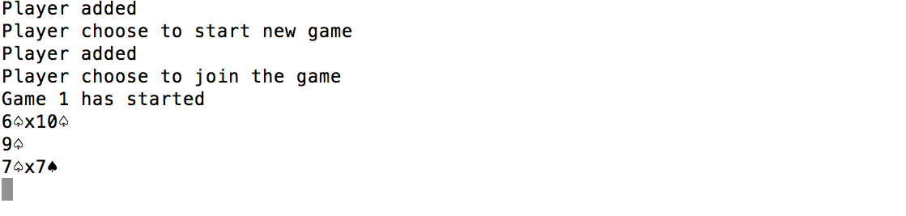

**Client 1:**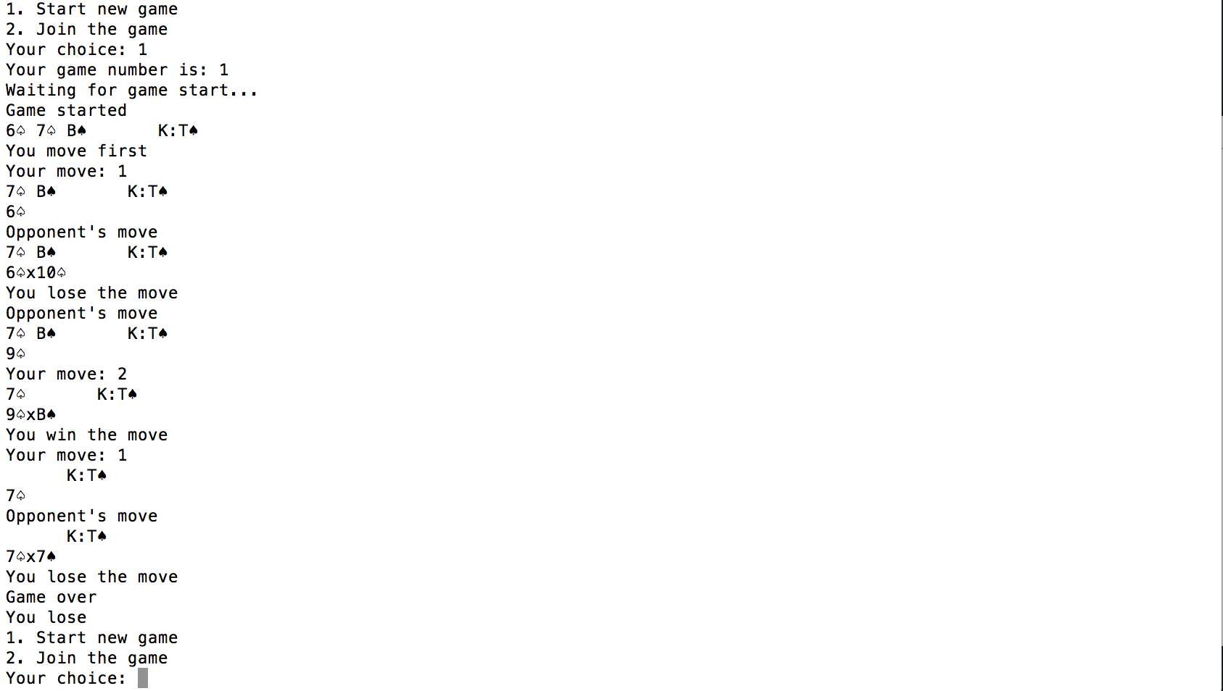

**Client 2:**