Base Classifiers:

Classifier: Decision Tree

Classification Report

precision recall f1-score support

0 0.82 0.84 0.83 12768

1 0.78 0.78 0.78 12769

2 0.71 0.70 0.70 12768

accuracy 0.77 38305

macro avg 0.77 0.77 0.77 38305

weighted avg 0.77 0.77 0.77 38305

---------------------------------------------

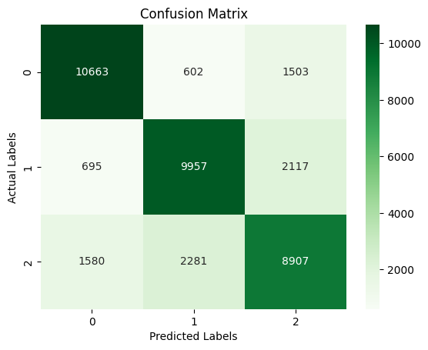

-----------------------

Classifier: KNN

Classification Report

precision recall f1-score support

0 0.81 0.98 0.88 12768

1 0.82 0.91 0.87 12769

2 0.91 0.62 0.73 12768

accuracy 0.84 38305

macro avg 0.85 0.84 0.83 38305

weighted avg 0.85 0.84 0.83 38305

---------------------------------------------

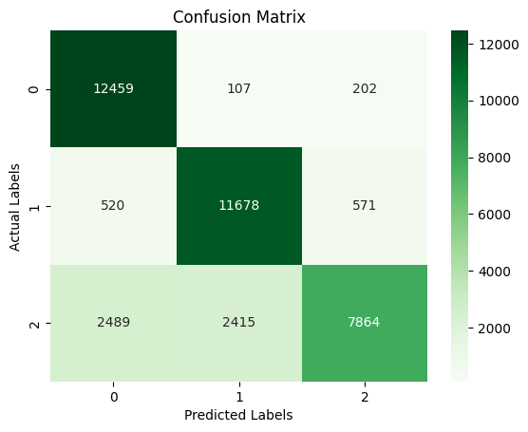

-----------------------

Classifier: Gaussian NB

Classification Report

precision recall f1-score support

0 0.62 0.87 0.72 12768

1 0.73 0.73 0.73 12769

2 0.69 0.41 0.51 12768

accuracy 0.67 38305

macro avg 0.68 0.67 0.65 38305

weighted avg 0.68 0.67 0.65 38305

---------------------------------------------

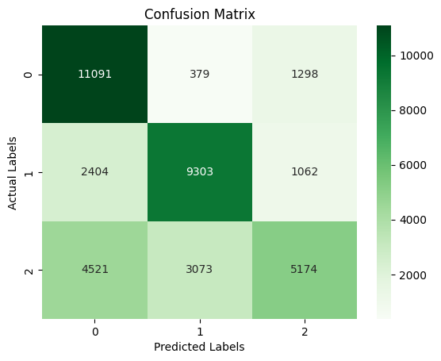

-----------------------

Classifier: Logistic Regression

/usr/local/lib/python3.10/dist-packages/sklearn/linear_model/_logistic.py:458: ConvergenceWarning: lbfgs failed to converge (status=1):

STOP: TOTAL NO. of ITERATIONS REACHED LIMIT.

Increase the number of iterations (max_iter) or scale the data as shown in:

<https://scikit-learn.org/stable/modules/preprocessing.html>

Please also refer to the documentation for alternative solver options:

<https://scikit-learn.org/stable/modules/linear_model.html#logistic-regression>

n_iter_i = _check_optimize_result(

Classification Report

precision recall f1-score support

0 0.67 0.80 0.73 12768

1 0.73 0.68 0.70 12769

2 0.61 0.54 0.57 12768

accuracy 0.67 38305

macro avg 0.67 0.67 0.67 38305

weighted avg 0.67 0.67 0.67 38305

---------------------------------------------

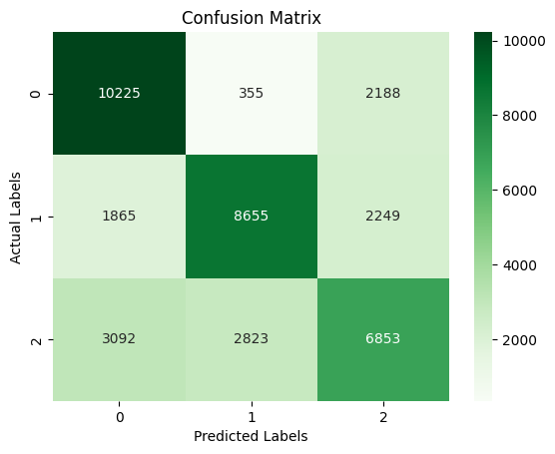

-----------------------

Ensemble Classifiers:

Classifier: Random Forest

Classification Report

precision recall f1-score support

0 0.88 0.96 0.92 12768

1 0.88 0.91 0.90 12769

2 0.90 0.79 0.84 12768

accuracy 0.89 38305

macro avg 0.89 0.89 0.89 38305

weighted avg 0.89 0.89 0.89 38305

---------------------------------------------

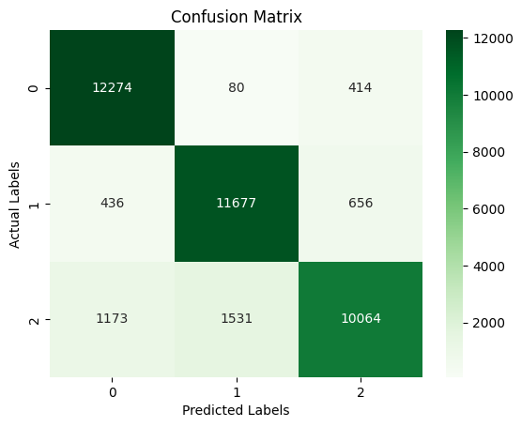

-----------------------

Classifier: Gradient Boosting

Classification Report

precision recall f1-score support

0 0.73 0.86 0.79 12768

1 0.78 0.76 0.77 12769

2 0.74 0.63 0.68 12768

accuracy 0.75 38305

macro avg 0.75 0.75 0.75 38305

weighted avg 0.75 0.75 0.75 38305

---------------------------------------------

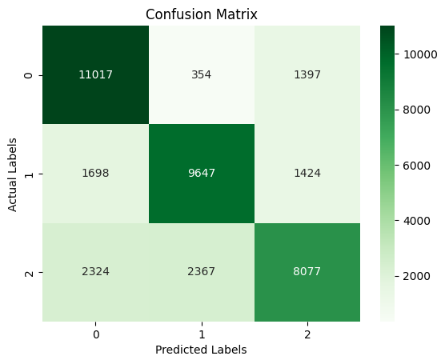

-----------------------

Classifier: AdaBoost

/usr/local/lib/python3.10/dist-packages/sklearn/ensemble/_base.py:166: FutureWarning: `base_estimator` was renamed to `estimator` in version 1.2 and will be removed in 1.4.

warnings.warn(

Classification Report

precision recall f1-score support

0 0.70 0.84 0.77 12768

1 0.75 0.70 0.72 12769

2 0.69 0.60 0.64 12768

accuracy 0.71 38305

macro avg 0.71 0.71 0.71 38305

weighted avg 0.71 0.71 0.71 38305

---------------------------------------------

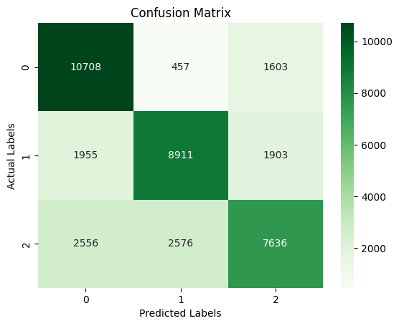

-----------------------

Boosting Classifiers:

Classifier: XGBoost

Classification Report

precision recall f1-score support

0 0.82 0.91 0.86 12768

1 0.84 0.82 0.83 12769

2 0.81 0.74 0.77 12768

accuracy 0.82 38305

macro avg 0.82 0.82 0.82 38305

weighted avg 0.82 0.82 0.82 38305

---------------------------------------------

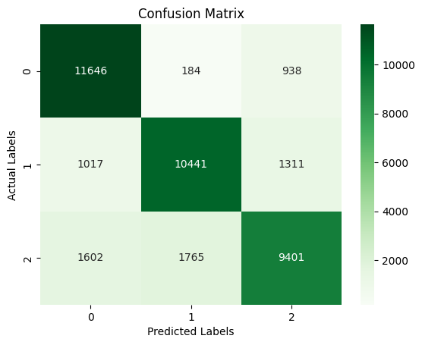

-----------------------

Classifier: LightGBM

[LightGBM] [Info] Auto-choosing col-wise multi-threading, the overhead of testing was 0.037564 seconds.

You can set `force_col_wise=true` to remove the overhead.

[LightGBM] [Info] Total Bins 5864

[LightGBM] [Info] Number of data points in the train set: 153218, number of used features: 23

[LightGBM] [Info] Start training from score -1.098606

[LightGBM] [Info] Start training from score -1.098625

[LightGBM] [Info] Start training from score -1.098606

Classification Report

precision recall f1-score support

0 0.78 0.90 0.83 12768

1 0.82 0.78 0.80 12769

2 0.78 0.70 0.74 12768

accuracy 0.79 38305

macro avg 0.79 0.79 0.79 38305

weighted avg 0.79 0.79 0.79 38305

---------------------------------------------



