Base Classifiers:

Classifier: Decision Tree

Classification Report

precision recall f1-score support

0 0.81 0.83 0.82 13599

1 0.75 0.75 0.75 11663

2 0.72 0.70 0.71 12765

accuracy 0.76 38027

macro avg 0.76 0.76 0.76 38027

weighted avg 0.76 0.76 0.76 38027

---------------------------------------------

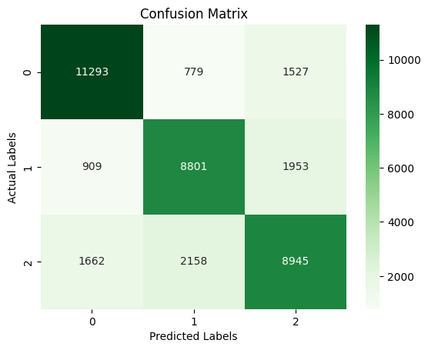

-----------------------

Classifier: KNN

Classification Report

precision recall f1-score support

0 0.80 0.99 0.89 13599

1 0.80 0.92 0.86 11663

2 0.94 0.57 0.71 12765

accuracy 0.83 38027

macro avg 0.85 0.83 0.82 38027

weighted avg 0.85 0.83 0.82 38027

---------------------------------------------

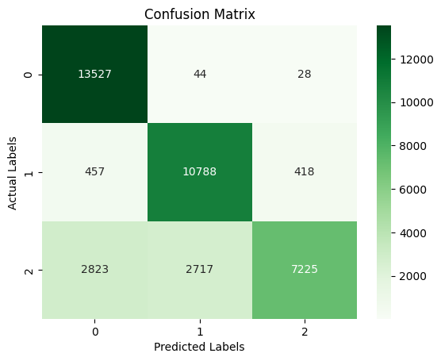

-----------------------

Classifier: Gaussian NB

Classification Report

precision recall f1-score support

0 0.59 0.85 0.70 13599

1 0.67 0.63 0.65 11663

2 0.62 0.38 0.47 12765

accuracy 0.62 38027

macro avg 0.63 0.62 0.60 38027

weighted avg 0.63 0.62 0.61 38027

---------------------------------------------

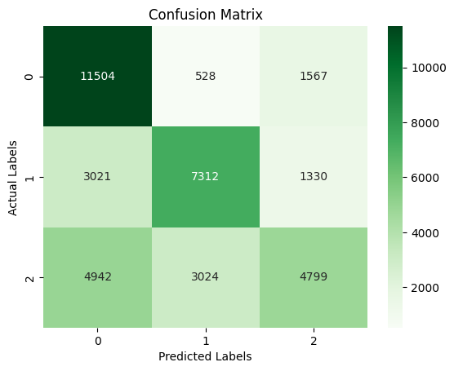

-----------------------

Classifier: Logistic Regression

/usr/local/lib/python3.10/dist-packages/sklearn/linear_model/_logistic.py:458: ConvergenceWarning: lbfgs failed to converge (status=1):

STOP: TOTAL NO. of ITERATIONS REACHED LIMIT.

Increase the number of iterations (max_iter) or scale the data as shown in:

<https://scikit-learn.org/stable/modules/preprocessing.html>

Please also refer to the documentation for alternative solver options:

<https://scikit-learn.org/stable/modules/linear_model.html#logistic-regression>

n_iter_i = _check_optimize_result(

Classification Report

precision recall f1-score support

0 0.64 0.78 0.71 13599

1 0.67 0.58 0.62 11663

2 0.57 0.51 0.54 12765

accuracy 0.63 38027

macro avg 0.63 0.62 0.62 38027

weighted avg 0.63 0.63 0.62 38027

---------------------------------------------

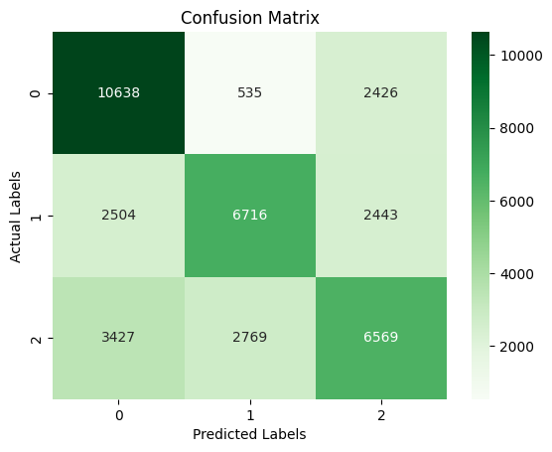

-----------------------

Ensemble Classifiers:

Classifier: Random Forest

Classification Report

precision recall f1-score support

0 0.88 0.97 0.92 13599

1 0.87 0.90 0.88 11663

2 0.91 0.79 0.85 12765

accuracy 0.89 38027

macro avg 0.89 0.89 0.88 38027

weighted avg 0.89 0.89 0.89 38027

---------------------------------------------

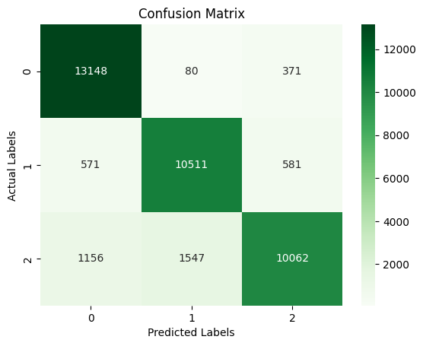

-----------------------

Classifier: Gradient Boosting

Classification Report

precision recall f1-score support

0 0.71 0.86 0.78 13599

1 0.73 0.69 0.71 11663

2 0.73 0.61 0.67 12765

accuracy 0.72 38027

macro avg 0.72 0.72 0.72 38027

weighted avg 0.72 0.72 0.72 38027

---------------------------------------------

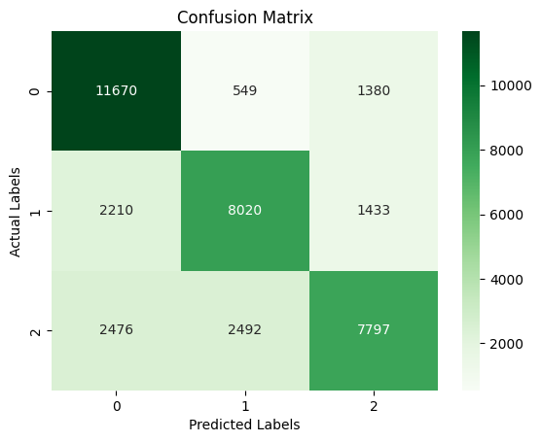

-----------------------

Classifier: AdaBoost

/usr/local/lib/python3.10/dist-packages/sklearn/ensemble/_base.py:166: FutureWarning: `base_estimator` was renamed to `estimator` in version 1.2 and will be removed in 1.4.

warnings.warn(

Classification Report

precision recall f1-score support

0 0.69 0.82 0.75 13599

1 0.68 0.60 0.64 11663

2 0.67 0.59 0.63 12765

accuracy 0.68 38027

macro avg 0.68 0.67 0.67 38027

weighted avg 0.68 0.68 0.67 38027

---------------------------------------------

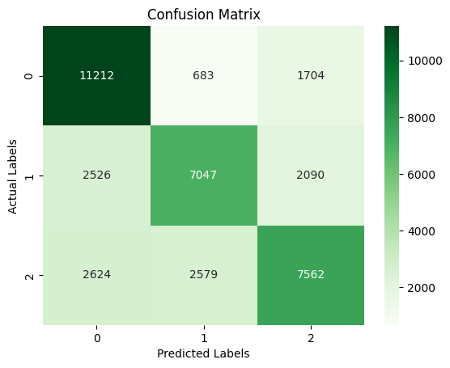

-----------------------

Boosting Classifiers:

Classifier: XGBoost

Classification Report

precision recall f1-score support

0 0.81 0.91 0.85 13599

1 0.81 0.77 0.79 11663

2 0.80 0.73 0.76 12765

accuracy 0.80 38027

macro avg 0.80 0.80 0.80 38027

weighted avg 0.80 0.80 0.80 38027

---------------------------------------------

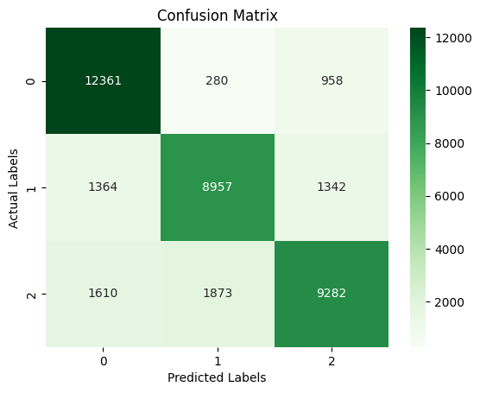

-----------------------

Classifier: LightGBM

[LightGBM] [Info] Auto-choosing row-wise multi-threading, the overhead of testing was 0.011532 seconds.

You can set `force_row_wise=true` to remove the overhead.

And if memory is not enough, you can set `force_col_wise=true`.

[LightGBM] [Info] Total Bins 5865

[LightGBM] [Info] Number of data points in the train set: 152108, number of used features: 23

[LightGBM] [Info] Start training from score -1.028245

[LightGBM] [Info] Start training from score -1.181918

[LightGBM] [Info] Start training from score -1.091609

Classification Report

precision recall f1-score support

0 0.76 0.89 0.82 13599

1 0.77 0.72 0.75 11663

2 0.78 0.69 0.73 12765

accuracy 0.77 38027

macro avg 0.77 0.77 0.77 38027

weighted avg 0.77 0.77 0.77 38027

---------------------------------------------



