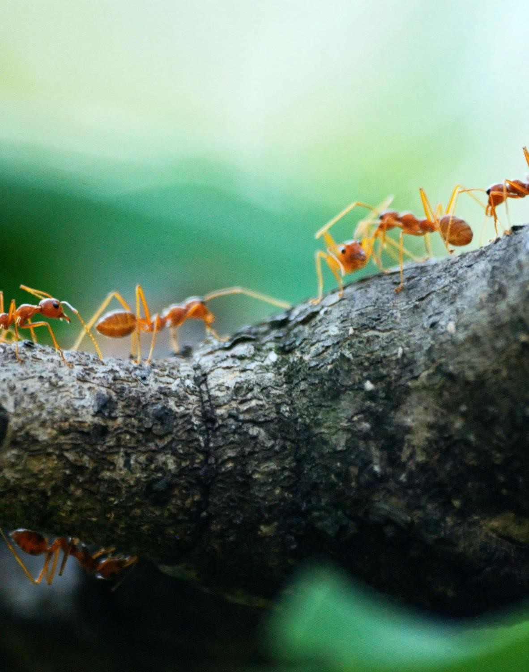
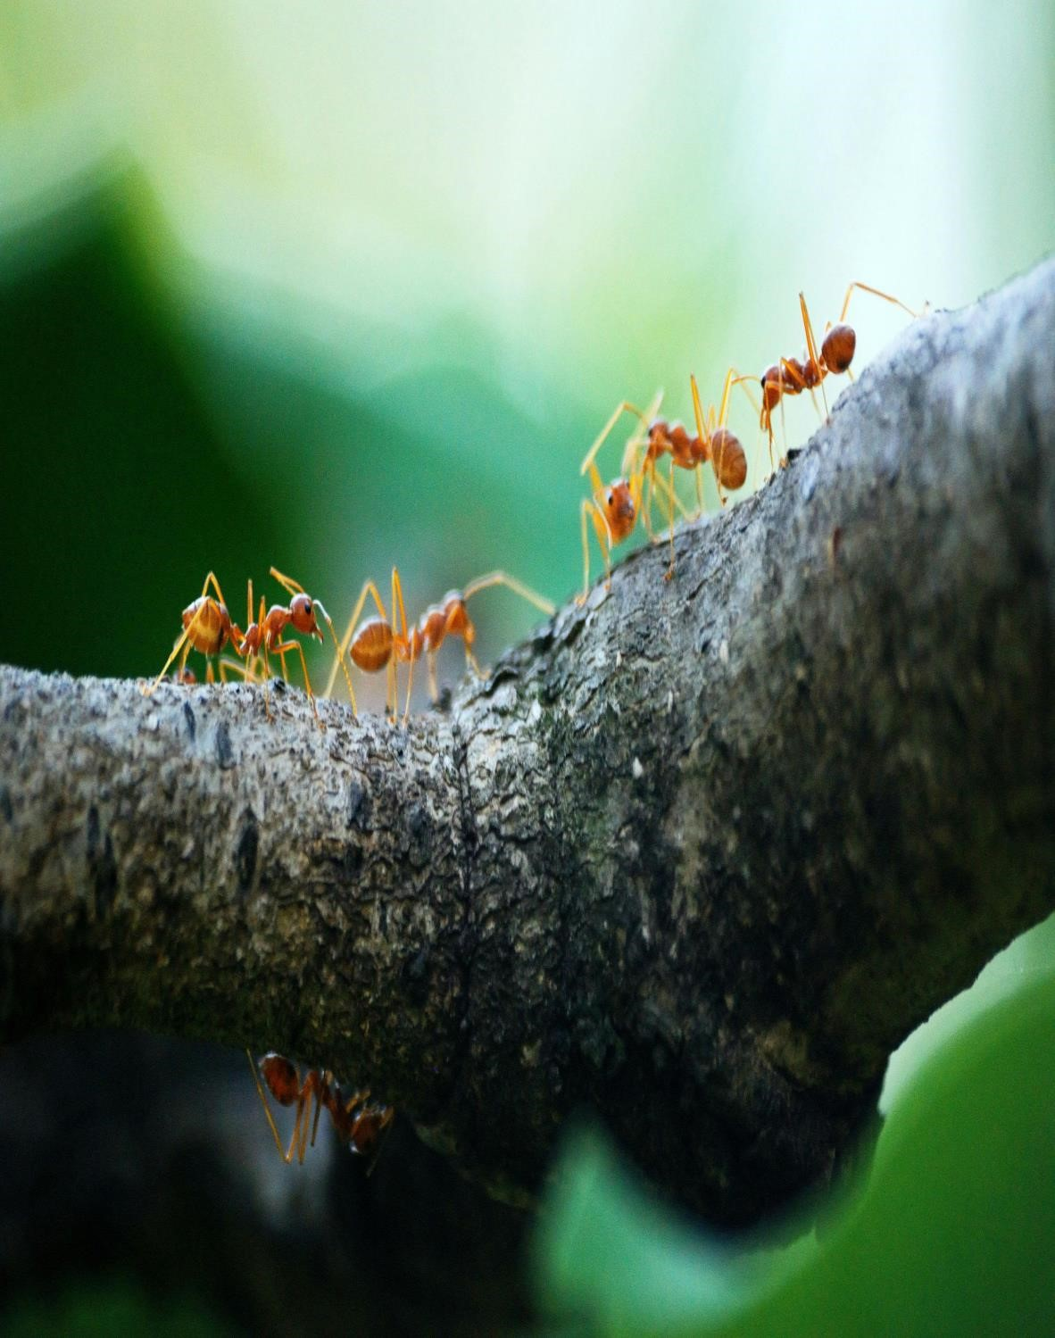
ANT COLONY OPTIMIZATION

INTRODUCTION
Ant colony optimization is a class of algorithm, which is classified under the branch of study swarms intelligence.

There are a lot of algorithms based on natural behavior, and they are called metaheuristics. Metaheuristics are made of two words: meta, which means one level above, and heuristics, which means to find.
Particle Swarm Optimization and Ant Colony Optimization are examples of these swarm intelligence algorithms. The objective of the swarm intelligence algorithms is to get the optimal solution from the behavior of insects, ants, bees, etc.
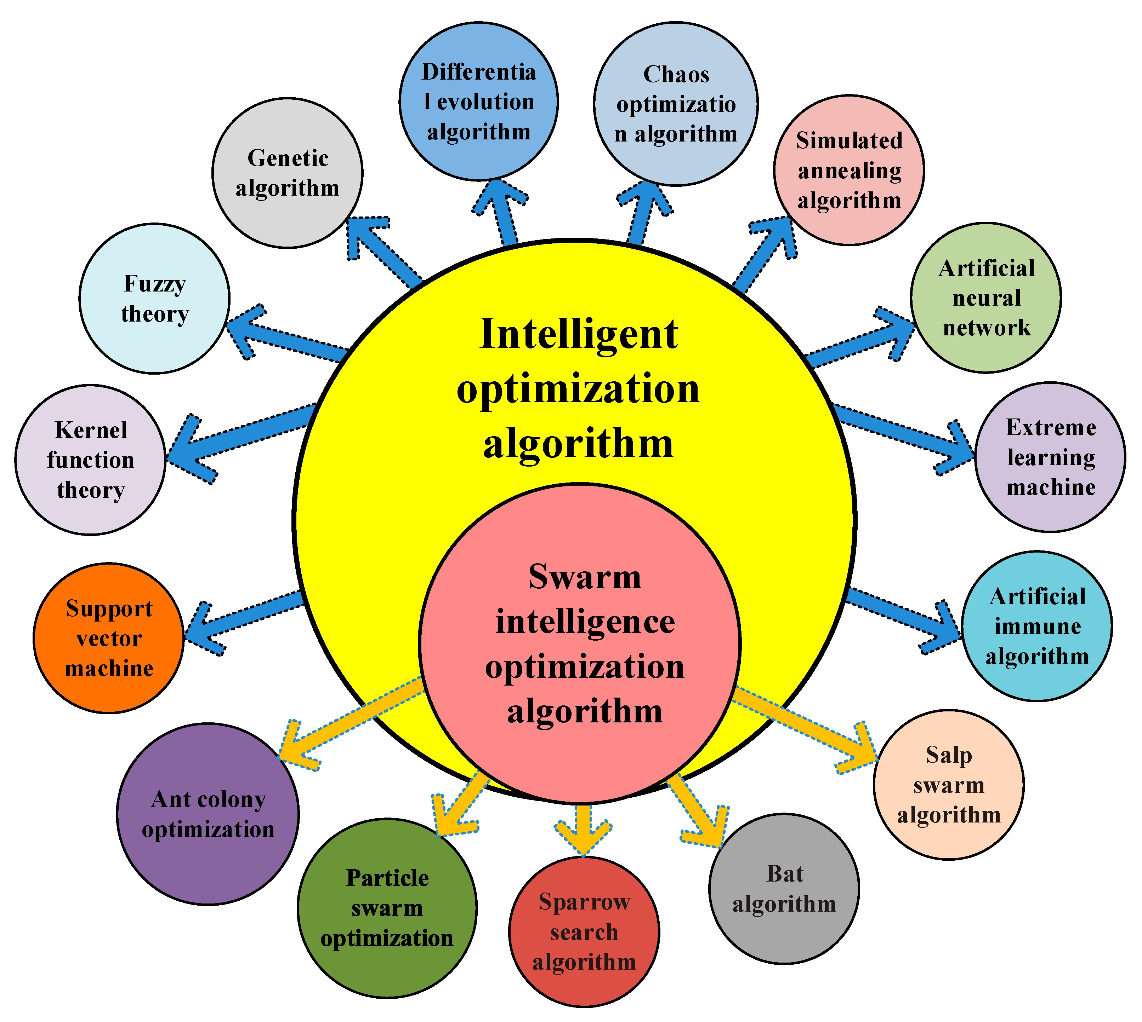

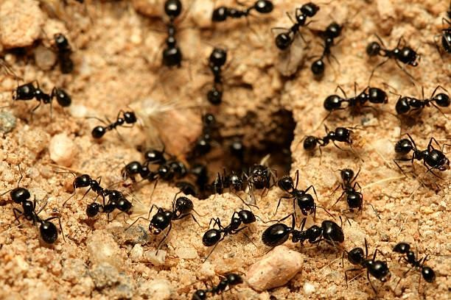
Principle of Ant Colony Optimization
This technique is derived from the behavior of ant colonies. Ants are social insects that live in groups or colonies instead of living individually. For communication, they use pheromones. Pheromones are the chemicals secreted by the ants on the soil, and ants from the same colony can smell them and follow the instructions.
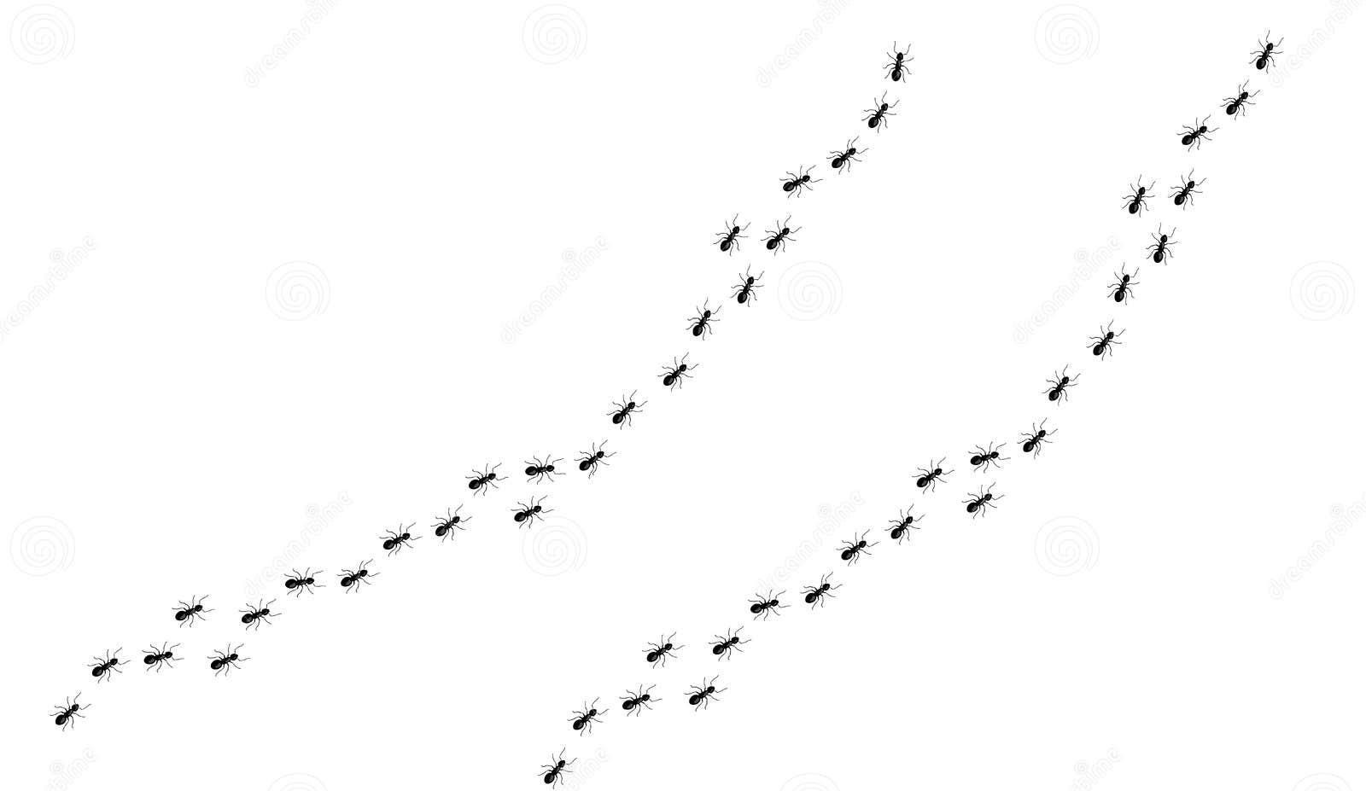
To
get
the
food,
ants
use
the
shortest
path
available
from
the
food
source
to
the
colony
.
Now
ants
going
for
the
food
secret
the
pheromone
and
other
ants
follow
this
pheromone
to
follow
the
shortest
route
.
Since
more
ants
use
the
shortest
route
so
the
concentration
of
the
pheromone
increase
and
the
rate
of
evaporation
of
pheromone
to
other
paths
will
be
decreased,
so
these
are
the
two
major
factors
to
determine
the
shortest
path
from
the
food
source
to
the
colony
.

How ants navigate obstacles and optimize their paths ?
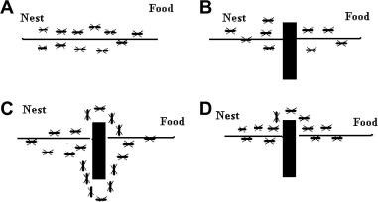
FIGURE:1.1
From the figure 1.1 there are four different scenarios (A, B, C, D) of ant colonies and their paths from the nest to food.
•Scenario A: The ants have a direct path from the nest to the food. There are no obstacles, and the ants follow a straight line.
•Scenario B: An obstacle is placed directly in the path between the nest and food. The ants navigate around it, creating a detour but eventually reaching the food.
•Scenario C: A larger obstacle is placed in their path. The ants spread out to find a way around it, with some going left and others going right.
•Scenario D: An obstacle is placed closer to the nest. The ants navigate around it on both sides but converge into a single path as they approach the food.
This image is a great representation of how ants use pheromone trails to find the shortest path to food sources, a behavior that has inspired algorithms in computer science known as Ant Colony Optimization algorithms.

ANT COLONY OPTIMIZATION ALGORITHM
1.Initialize necessary parameters and pheromone trials: Set up the initial parameters such as the number of ants, the evaporation rate of the pheromone, and the initial amount of pheromone on each path.
2.Generate ant population: Create a population of ants. Each ant represents a potential solution to the problem.
3.Calculate fitness values associated with each ant: Evaluate the quality of each ant’s solution. This could be the length of the path in a routing problem, or some other measure of quality depending on the problem at hand.
4.Find the best solution through selection methods: Compare the solutions found by the different ants and select the best one.
5.Update pheromone trial: Increase the amount of pheromone on the paths that were part of the best solution, and decrease the amount of pheromone on all other paths due to evaporation.
6.Repeat the process: The above steps are repeated until a termination condition is met. This could be a certain number of iterations, or no improvement in the best solution for a certain number of iterations

FLOW CHART
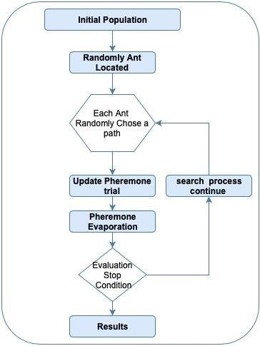
concentration of the pheromone and rate of evaporation of pheromone are the two major factors to determine the shortest path from the food source to the colony.
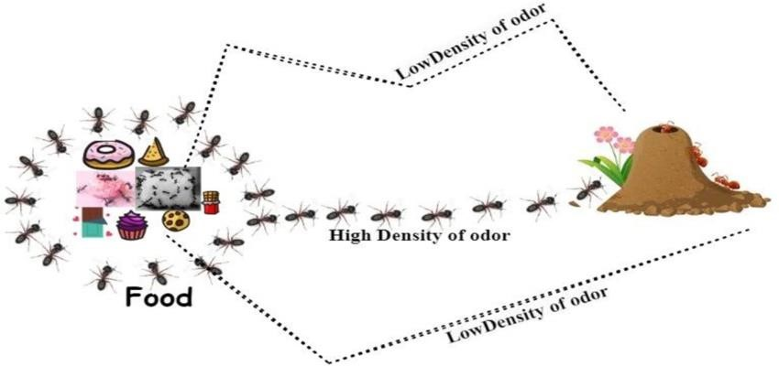
Effect of pheromone concentration for shortest path

FIGURE:1.2

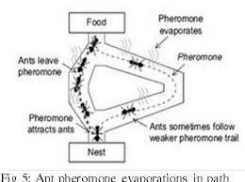
Ant pheromone evaporation in path

FIGURE:1.3

Let's suppose there are only two paths which are P₁ and P₂. C₁ and C₂ are the weight or the pheromone concentration along the path, respectively.
So we can represent it as graph G(V, E) where V represents the Vertex and E represents the Edge of the graph.
Initially, for the i^{th} path, the probability of choosing is:
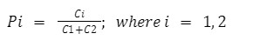
If C₁ > C₂, then the probability of choosing path 1 is more than path 2. If C₁ < C₂, then Path 2 will be more favorable.
For the return path, the length of the path and the rate of evaporation of the pheromone are the two factors.

- Concentration of pheromone according to the length of the path:
Where L_{i} is the length of the path and K is the constant depending upon the length of the path. If the path is shorter, concentration will be added more to the existing pheromone concentration.
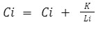
j
- Change in concentration according to the rate of evaporation:
Here parameter v varies from 0 to 1. If v is higher, then the concentration will be less.
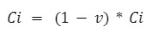

Applications of Ant colony optimization
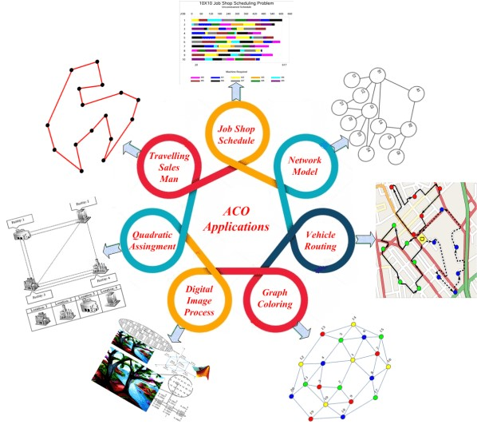
  - Routing and Network Optimization  Resource Allocation
  - Supply Chain and Logistics
  - Robotics and Swarm Intelligence
  - Machine Learning and Data Mining
  - Telecommunications and Signal Processing

ADVANTAGES OF ANT COLONY OPTIMIZATION
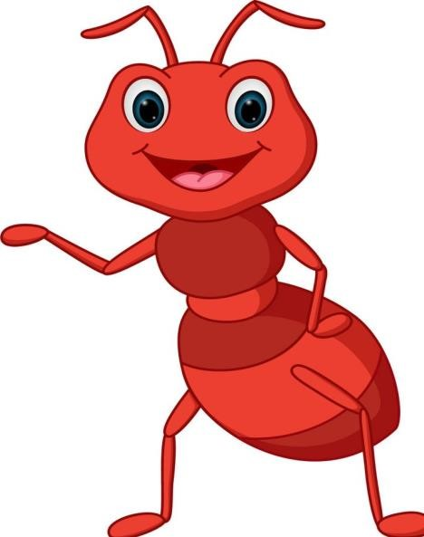
- Ability to find near-optimal solutions
- Adaptability to dynamic environments
- Scalability
- Robustness
- Exploration of solution space

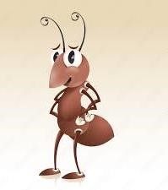
DISADVANTAGES OF ANT COLONY OPTIMIZATION
- Computational Complexity
- Convergence Speed
- Parameter Sensitivity
- Memory Usage
- Lack of Theoretical Foundations

THANK YOU
!
