Project Proposal
This proposal describes the document preview initiative. It contains formatted text, a table, an image and lists so rendering fidelity can be checked.

Goals
- Preview every common attachment
- Search inside documents
- Compare two files side by side

Budget
Phase | Owner | Cost
Discovery | Guru | $12,000
Build | Team | $48,500
Launch | Ops | $7,250

Architecture sketch
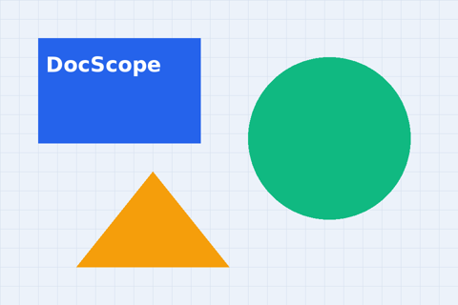
The proposal concludes with next steps and a timeline.

Appendix
- Appendix item 1: proposal detail and supporting notes.
- Appendix item 2: proposal detail and supporting notes.
- Appendix item 3: proposal detail and supporting notes.
- Appendix item 4: proposal detail and supporting notes.
- Appendix item 5: proposal detail and supporting notes.

