GLOBAL QUEST TECHNOLOGIES



**Resume**

Using HTML &CSS

**B.DHANUNJAYA**

**(GQT-SO171)**

Under the Guidance of Trainer

**KESHAV MURTHY**

(Web Development trainer at GQT)

____________ ____________

Signature of Trainer Signature of CEO(GQT)

# RESUME

# Scope of the Document

A resume webpage is a dedicated online platform where We can showcase your professional qualifications, skills, work experience, and achievements. It serves as a digital representation of your resume, making it easily accessible to potential employers or collaborators. This webpage typically includes well-organized sections with details about your education, work history, projects, skills, and contact information. Creating a resume webpage can help you stand out in the digital job market and provide a more comprehensive overview of your qualifications.

**History of HTML**

HTML stands for Hyper Text Markup Language.

* It is used to share the information over the internet.
* HTML id developed by Tim Berner’s Lee in 1991.But officially in 1993.
* The First version of HTML consists of “18 tags”
* HTML follows certain rules and regulations setup by “ISO”.(International Organization for standardization). These set of rules and regulation are present in ‘SGML document’.

**Versions of HTML**

1. HTML-1 version in the year 1993.
2. Html-2 version in the year 1995.
3. HTML-3.02 version in the year 1997.
4. HTML-4.1 version in the year 1999.
5. HTML-5 version in the year 2014

**Features of HTML**

* It is easy to Learn.
* It is a tag based language.
* HTML is supported by multiple browsers.
* First web browser is Netscape navigation which was developed by the “Mosiac”.
* It is a portable language.
* WORA (write once run anywhere).

**Limitation of HTML**

* HTML has less designing capabilities.
* It is dependent on other technology such as CSS in order to develop well designed Web pages.
* HTML has no programming capabilities.
* Using HTML and CSS we can develop only static Web page.
* In order to write the HTML code required an editor such as VS Code, Notepad, Eclipse.
* In order to execute the HTML code we required Web browsers.Like Chrome, Firefox, edge, Opera Safari .

**CSS**

* CSS stands for Cascading Style Sheets.
* It was developed by W3C to add stylings to the HTML elements.
* W3C stands for World Wide Web.com

**Versions of CSS:**

1. CSS-1 (level-1) in the year 1996.
2. CSS-2 (level-2) in the year 1998.
3. CSS-3 (level-3) in the year 1999.

**Why do we required CSS ?**

* Since HTML has less designing capabilities we cannot create well designed or most appealing Websites.
* Using HTML we cannot add style, animation and transitions to the Webpage.
* Therefore we require CSS to create well designed Webpages.

**Advantages of CSS**

* It allows to add styles, animation and various effects to the Webpage.
* It allows us to develop the Webpage rapidly. It is also know as RAD ( rapid application Developer).
* It allows us to separate from formatting develop page to the presentation of Webpage.
* It allows to create well designed Websites.

**Limitations of CSS**

* Using CSS we can perform static styles for the Webpages.
* In order to create dynamic styling for the Websites. We must make use of scripting language such as JavaScript and Libraries of JavaScript.

**Types of CSS:**

1. Inline CSS
2. Internal CSS
3. External CSS
4. Default Browser CSS

**Inline CSS:** Defining all the CSS properties within the style attribute inside the opening of the tag is referred to as Inline CSS.

**Internal CSS:** Defining all the CSS properties within <style> inside the HTML document is referred to as Internal CSS.

**External CSS:** Defining all the CSS properties within as external Script or File with an extension CSS is referred to as External CSS.

* In order to link external CSS file within the HTML document we must use of <link>.
* The value for the ‘ref’ attribute should be ‘stylesheet’.

**File Structure:**

Dhanu-resume/

│

├─ code/

│ │

│ ├─ Newresume.html

│ ├─ Newresume.css

│ ├─ Images/

│ ├─Profile

│

├─ Screenshots

├─ Screenshot1

├─ Screenshot2

**Architecture Diagram:**

Newresume.css

Newresume.html

**Home Page:**

**/*Newresume.html*/**

<!DOCTYPE html>

<html lang="en">

<head>

<meta charset="UTF-8">

<meta name="viewport" content="width=device-width, initial-scale=1.0">

<title> Personal Resume</title>

<script src="https://kit.fontawesome.com/1da18cb119.js" crossorigin="anonymous"></script>

<link rel="stylesheet" href="Newresume.css">

</head>

<body>

<div class="head1">

<div style="float:right;margin-right:30%;">

<h1 style="margin-top:15%;">DHANUNJAYA B</h1>

</div>

</div>

<div class="body-container">

<!--div 2-->

<div id="div-block-2">

<img src="Profile1.jpg" alt="profile" id="img1">

<!--Profile-->

<div style="padding:10px;margin-top:-20px;">

<h2 style="margin-left:40px;" class="color-gold">PROFILE</h2>

<div style="border-top:4px solid gold;height:20px;width:90%;float:right;margin-top:-15px;" ></div><br>

<p style="margin-top:-30px;margin-left:40px;text-align: justify;line-height: 25px;">

Seeking a challenging career with a growth oriented organization that offers the opportunity to improve my professional skills.Organized with the ability to motivate various teams to coordinate innovative production.

</p>

</div>

<!--skills-->

<div style="padding:10px;margin-top:-30px;">

<h2 style="margin-left:40px;" class="color-gold">SKILLS</h2>

<div style="border-top:4px solid gold;height:20px;width:90%;float:right;margin-top:-15px;"></div><br>

<br>

<div style="margin-top:-40px;">

<p style="margin-left:40px;">HTML ,CSS ,Bootstrap</p>

<p style="margin-left:40px;">Python</p>

<p style="margin-left:40px;">Core Java</p>

</div>

</div>

<!--Contact-->

<div style="padding:10px;margin-top:-30px;">

<h2 style="margin-left:40px;" class="color-gold">CONTACT</h2>

<div style="border-top:4px solid gold;height:20px;width:90%;float:right;margin-top:-15px;"></div><br>

<br>

<h4 style="margin-top:-25px;margin-left:40px;"><i class="fa fa-envelope" aria-hidden="true">&nbsp;&nbsp;&nbsp;&nbsp;</I>G-mail </h4>

<p style="margin-top:-15px;margin-left:40px;">bdhanunjaya006@gmail.com</p>

<h4 style="margin-top: 20px;margin-left:40px;"><i class="fa-solid fa-phone"></i>&nbsp;&nbsp;&nbsp;&nbsp;&nbsp;Phone </h4>

<p style="margin-top:-15px;margin-left:40px;">+91 9642889026</p>

<h4 style="margin-top: 20px;margin-left:40px;"><i class="fa-brands fa-linkedin"></i>&nbsp;&nbsp;&nbsp;&nbsp;LinkedIn </h4>

<nav style="margin-top:-10px;margin-left:40px;color:white;"><a href="https://www.linkedin.com/in/bushappa-gari-dhanunjaya-127917245" id="linked-in">https://www.linkedin.com/in/bushappa-gari-dhanunjaya-127917245 </a></nav>

</div>

<!--Strengths-->

<div style="padding:10px;margin-top:-18px;">

<h2 style="margin-left:40px;" class="color-gold">STRENGTHS</h2>

<div style="border-top:4px solid gold;height:20px;width:90%;float:right;margin-top:-15px;"></div><br>

<br>

<div style="margin-top:-40px;">

<p style="margin-left:40px;">Quick Learner</p>

<p style="margin-left:40px;">Time Management</p>

</div>

</div>

</div>

<!--div 3-->

<div id="div-block-3">

<!--Project-->

<div>

<div>

<h2 id=”projects” class="color-gold">PROJECT</h2>

<div style="border-top:4px solid gold;margin-top:-12px;margin-left:30px;"></div><br>

<div style="margin-left:30px;">

<h3 style="margin-top:-5px">Agro Assist for farmers By using Machine learning</h3>

<ul style="text-align:justify;padding:20px;margin-top:-20px;">

<li>Agro Assist for farmers , The main purpose of this project to

help farmers in crop prediction , fertilizer recommendation ,

disease detection to get the precise forming.</li><br>

<li>Crop prediction and fertilizer recommendation is done

based on soil parameters like nitrogen , phosphorus and

potassium.</li><br>

<li>

User just need to upload the image of diseased crop yield

to find out the disease.

</li><br>

<li>HTML , CSS , Bootstrap, these are the front end technologies

used in this project and machine learning algorithms such

XG boost and Random forest algorithm.</li>

</ul>

</div>

</div>

</div>

<!--certifications-->

<div>

<h2 id=” certifications” class="color-gold">CERTIFICATIONS</h2>

<div style="border-top:4px solid gold;margin-top:-12px;margin-left:30px;"></div>

<div style="margin-left:30px;margin-top:40px;">

<ul style="margin-left:-18px;margin-top:-20px;">

<li>Web Development internship at Exposys Data Labs.</li><br>

<li>Participated in Data Science Workshop at Jntua Kalikiri.</li><br>

<li>Currently Persuing Full Stack Development At Global Quest Technologies.</li>

</ul>

</div>

</div>

<!--Education-->

<div>

<h2 id="headings" class="color-gold">EDUCATION</h2>

<div style="border-top:4px solid gold;margin-top:-12px;margin-left:30px;"></div>

<table cellspacing="5px;" cellpadding="10px;" align="center" style="margin-top:20px;margin-left:40px;" >

<thead>

<tr>

<th>

2020-2023

</th>

<th style="padding-left:100px">

Jntua College of Enginnering ,Kalikiri

</th>

</tr>

<tr>

<td style="padding-left:40px">B.Tech , CSE</td>

<td style="padding-left:100px">Percentage &nbsp;&nbsp;65%</td>

</tr>

<tr>

<th>

2017-2020

</th>

<th style="padding-left:30px">

Govt Polytechnic,Proddatur

</th>

</tr>

<tr>

<td style="padding-left:40px">

Diploma

</td>

<td style="padding-left:100px">

Percentage - 86%

</td>

</tr>

<tr>

<th>

2016-2017

</th>

<th style="padding-left:20px">

ZP High School, Amidyala

</th>

</tr>

<tr>

<td style="padding-left:40px">SSC</td>

<td style="padding-left:100px">CGPA &nbsp; 7.7</td>

</tr>

</thead>

</table>

</div>

</div>

</div>

</body>

</html>

**/*Newresume.css*/**

body{

margin-left:100px;

font-family:'Segoe UI', Tahoma, Geneva, Verdana, sans-serif;

}

.head1{

height:120px;

padding:10px;

width:90.6%;

background-color:gold;

border:1px solid rgb(196, 193, 193);

border-bottom:none;

box-shadow:1px 0px 4px -4px black;

border-top-left-radius: 4px;

border-top-right-radius: 4px;

}

#img1{

width:180px;

height:180px;

margin-left:26%;

margin-top: -100px;

border:2px solid;

border-radius:90px;

object-fit: cover;

}

.body-container{

display: flex;

flex-direction: row;

}

#headings{

font-size:x-large;

}

#linked-in{

text-decoration: none;

color: white;

}

#linked-in:hover{

color:gold;

}

#div-block-2{

width:31%;

background-color: rgba(37, 37, 37, 0.966);

color:white;

border:1px solid rgba(27, 27, 27, 0.966);

padding:10px;

border-bottom-left-radius: 4px;

}

#div-block-3{

width:58.08%;

border:1px solid rgb(196, 193, 193);

padding:10px;display: flex;

flex-direction: column;

border-bottom-right-radius: 4px;

}

.color-gold{

color:gold;

}

#projects{

margin-top:20px;

margin-left:30px;

background-color: black;

width:130px;

padding-left:25px;

border-radius:20px 0px;

}

#headings{

font-size:x-large;

margin-top:27px;

margin-left:30px;

background-color: black;

width:160px;

padding-left:25px;

border-radius:20px 0px;

}

#certifications{

margin-left:30px;

margin-top:-4px;

background-color: black;

width:215px;

padding-left:25px;

border-radius:20px 0px;

}

**OUTPUT:**

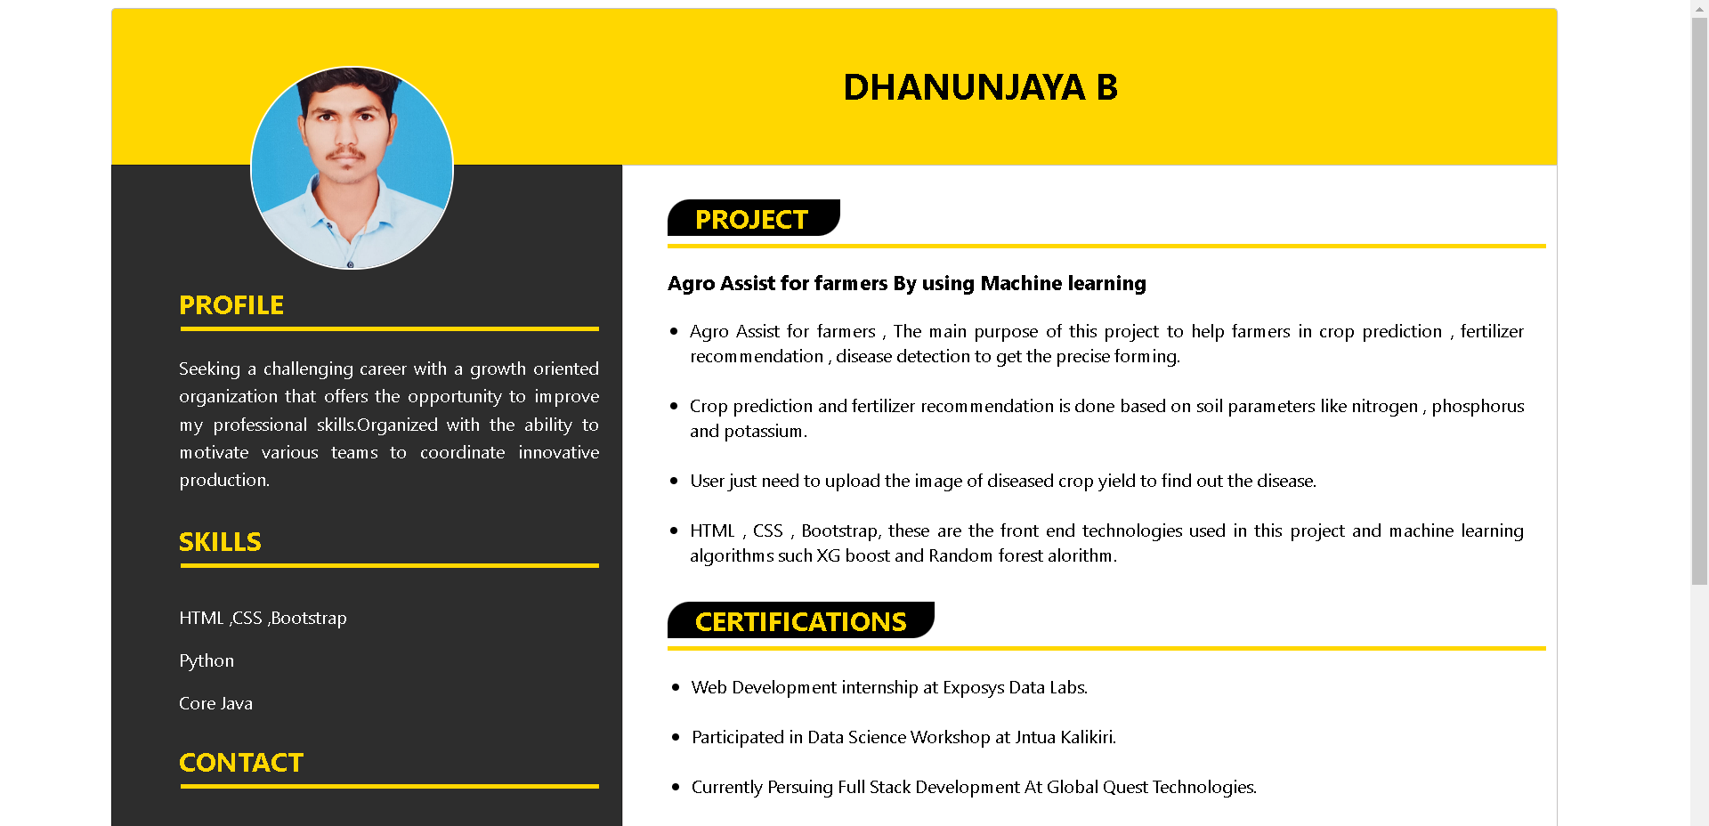

**Fig -01**

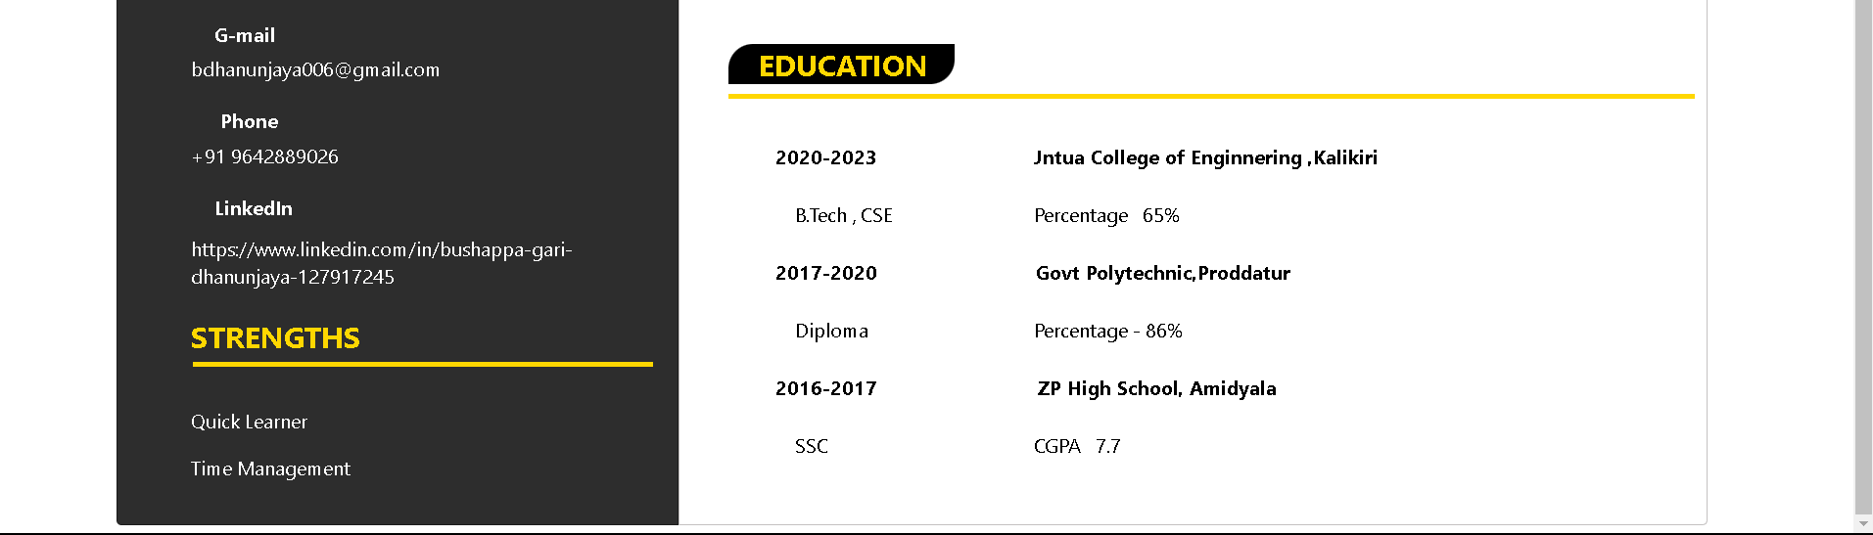

**Fig -02**

**Conclusion**: -

Creating a resume using HTML and CSS offers several advantages in terms of customization, design flexibility, and ease of sharing in digital formats. In conclusion, here are some key points to consider when building a resume using these technologies:

Customization: HTML and CSS allow for unparalleled customization of your resume. You have full control over the layout, typography, colors, and overall design, ensuring that your resume truly reflects your personality and skills.

Design Flexibility: With CSS, you can create responsive designs that adapt to different screen sizes, making your resume look great on both desktop and mobile devices. This ensures that potential employers can access your resume easily, regardless of the device they use.

Digital Accessibility: HTML-based resumes are easily shareable via email, links, or even as downloadable PDFs. This makes it convenient for recruiters and employers to access your resume, and it also reduces the risk of compatibility issues that can arise with proprietary formats.

Search Engine Optimization (SEO): By creating an HTML-based resume and publishing it online, you can optimize it for search engines. This can increase your online visibility and make it easier for potential employers to find you.

Interactivity: HTML and CSS allow you to include interactive elements in your resume, such as clickable links to your portfolio, LinkedIn profile, or contact information. This can enhance the overall user experience for recruiters and hiring managers.

Learning Opportunity: Building your resume with HTML and CSS can be a valuable learning experience. It not only demonstrates your technical skills but also shows your commitment to going the extra mile to create a unique and professional document.

using HTML and CSS to build your resume offers a range of benefits, from customization and design flexibility to digital accessibility and search engine optimization. By taking advantage of these technologies, you can create a standout resume that showcases your qualifications and helps you stand out in the competitive job market.