Jonas Mockūnas  
**Fast Food Marketing Campaign A\B Test**

**Turing College**

# **Goal of the Test** The main goal of this A/B test was to test which promotion has the greatest effect on sales.

Three different promotions are used at each location, and the weekly sales of the new item are recorded for the first four weeks.

For analysis of A/B test results we will use a confidence level of 99%.  
**Target Metric**The dataset provides these metrics:

* *MarketID*: unique identifier for market
* *MarketSize*: size of market area by sales
* *LocationID*: unique identifier for store location
* *AgeOfStore*: age of store in years
* *Promotion*: one of three promotions that were tested
* *week*: one of four weeks when the promotions were run
* *SalesInThousands*: sales amount for a specific *LocationID*, *Promotion*, and *week*

Since the goal of the A/B test is to see which promotion has the greatest effect on sales, the target metric is sales so we will be using the SalesInThousands.  
**Calculations:**

First, we calculate using SQL the average sales, the standard deviation, and the sample amount for each promotion.  
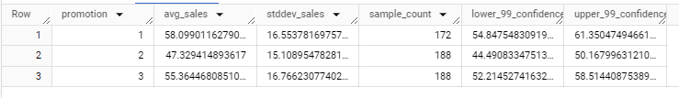

Secondly, we use t-test for all comparisons between promotions.  
Promotion 1 vs Promotion 2  
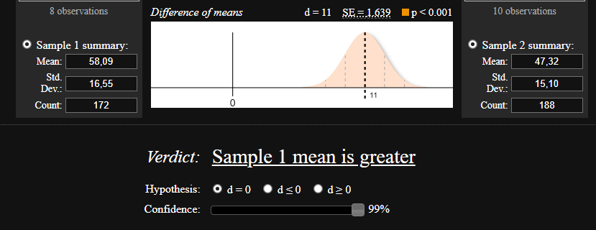  
As the p < 0,001 we reject the H0 of the promotion having no effect between promotion 1 and promotion 2. And also, we can see that the mean of promotion 1 is higher than promotion 2.

Promotion 3 vs Promotion 2  
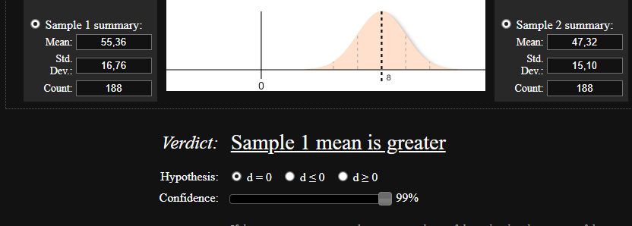As the p < 0,001 we reject the H0 of the promotion having no effect between promotion 2 and promotion 3. And also, we can see that the mean of promotion 3 is higher than promotion 2.  
Promotion 3 vs Promotion 1

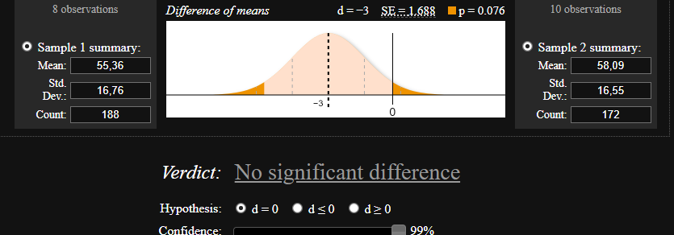  
As the p = 0.076 we can not reject the H0 of the promotion having no effect between promotion 3 and promotion 1.

By using the t-test we reject the first two null hypothesis of promotions having no effect. After that, we put the calculated means to a ANOVA calculator which comes back with these results while renaming the promotions from 1 to A, 2 to B, 3 to C:  
  
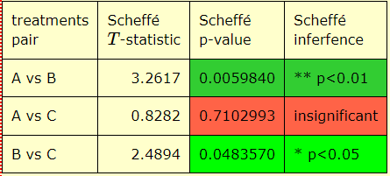

With this, we can see that promotion 1 vs 2 and 3 vs 2 shows clear differences between them, but the difference between promotion 1 and promotion 3 is insignificant. But as we can see from the results above, the average for promotion 1 is slightly larger than the average for promotion 3, and in the comparison of the Scheffe test, promotion 1 vs 2 has a lower p value than 3 vs 2. Thus we conclude that the 1st promotion is the most effective.  
**Decision**

Based on the results of the test, the recommendation is to not move on with the promotion 2, but keep the promotion 1 and 3 to further the info on it. But if only 1 promotion is needed to pick, the conclusion leans more towards promotion 1.

**Appendix:**  
  
Query for table 1

SELECT

promotion,

AVG(sales_in_thousands) AS avg_sales,

STDDEV(sales_in_thousands) AS stddev_sales,

COUNT(week) AS sample_count,

AVG(sales_in_thousands) - 2.576 * (STDDEV(sales_in_thousands) / SQRT(COUNT(week))) AS lower_99_confidence,

AVG(sales_in_thousands) + 2.576 * (STDDEV(sales_in_thousands) / SQRT(COUNT(week))) AS upper_99_confidence

FROM

`turing_data_analytics.wa_marketing_campaign`

GROUP BY

promotion

ORDER BY

promotion;

Query for calculating all the values for average sales in each location:  
SELECT

location_id,

promotion,

AVG(sales_in_thousands) AS avg_sales,

STDDEV(sales_in_thousands) AS stddev_sales,

COUNT(week) AS sample_count,

AVG(sales_in_thousands) - 2.576 * (STDDEV(sales_in_thousands) / SQRT(COUNT(week))) AS lower_99_confidence,

AVG(sales_in_thousands) + 2.576 * (STDDEV(sales_in_thousands) / SQRT(COUNT(week))) AS upper_99_confidence

FROM

`turing_data_analytics.wa_marketing_campaign`

WHERE

promotion = 1/2/3 (change when viewing each promotion)

GROUP BY

location_id, promotion

ORDER BY

promotion;

*The results of all promotion average calculations:*  
[Module 3 Sprint 4](https://docs.google.com/spreadsheets/d/1fpGuakzwFttiwYEXGXS66qYIebFHl7s_GLJbeEsizX4/edit?usp=sharing)