|  |
| --- |
| **”Proposal”** |

**Introduction:-**  
University Management System (UMS) is a flagship product of easy solution which covers all aspects of universities, colleges or school. UMS covers every minute aspects of a universities work flow and integrates all processes with user friendly interface. With hundreds of satisfied customers UMS is first choice of several state, governments/semi government universities and institutions. UMS is an outcomes of hard work done by our expert technical team in supervision of several renowned educationalist which includes controller of examination faculties. UMS is a rare combination of experience and precision. UMS streamline path of information flow in organization by taking care of following department:

1. Fee Department
2. Examination Department
3. Attendance
4. Faculty Information Portal
5. Student Information Portal

**Purpose:-**

The purpose of this system is to:

* Drive operational efficiency.
* Self-service systems with simple to use with little or no training.
* Elimination of duplicate data entry processes.
* Integrated with online application workflow with unified data model.
* Monitoring and decision support system.
* Automatic of all the academic/examination/administration operations.
* Ease and accuracy of reporting.

**Scope:-**

This project deals with the various functionality in University Management Process. The main idea is to implement a proper process to system. In our existing system contains a many operations registration, student search, fees, attendance, exam records, performance of the student etc. All these activity takeout manually by administrator.

**Requirement Analysis:-**

**ER Diagram:**

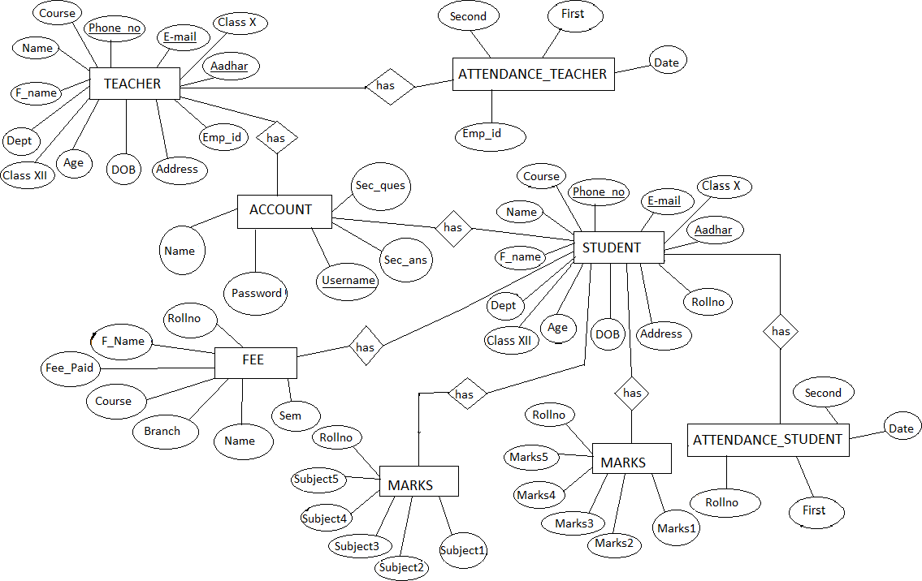

**Conclusion:-**

The project entitled as university management system is the system that deals with the issues related to the particular institution. This project is successfully implemented with all the features mention in the system requirements specification. The application provides appropriate information to the user according to the chosen service. The project is designed keeping in view the day to day problems faced by university. Deployment of this application will certainly help the university to reduce unnecessary wastage of time in personally going to each department for some information.

Awareness and right information about university is essential for both the development of student as well as faculty. So this serves the right purpose in achieving the desired requirements of both the communities.