1. Project Overview
Universal Stationery is a premium e-commerce web platform designed for stationery enthusiasts. The website features a modern, clean interface with a focus on high-quality visual presentation for products like art supplies, journals, and professional office tools.

Core Branding
Primary Colors: Black (#000000) and Sober Yellow (#c2c603).
Typography: 'Inter', sans-serif (Clean and professional).
Theme: Modern minimalist with isomorphism effects (blur backgrounds).
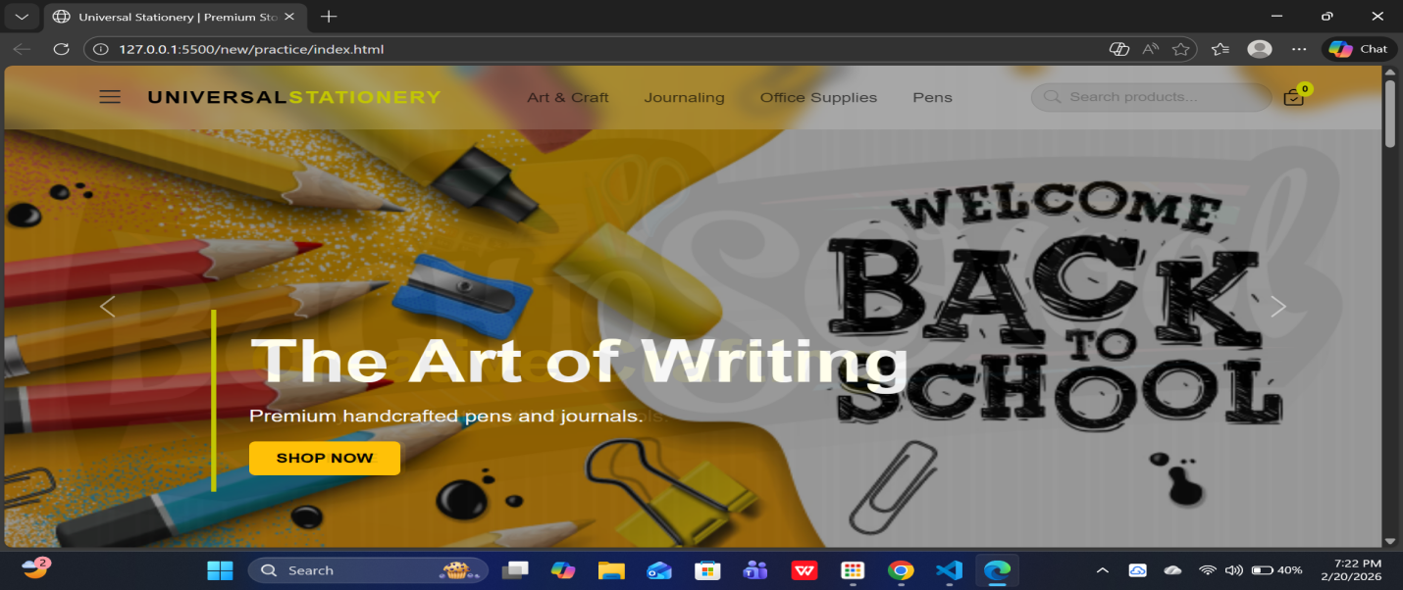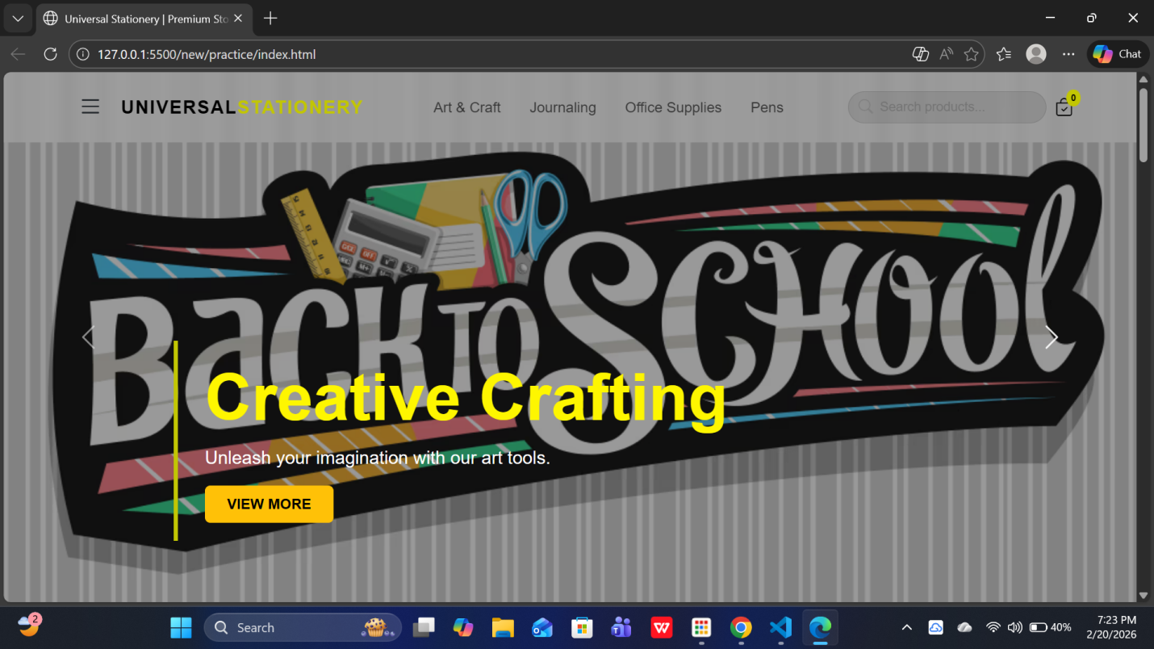

2. Key Features
The website is built as a dynamic Single Page Application (SPA) style layout using JavaScript to render content.
- Responsive Navigation: A "sticky" NAVBAR that changes color when scrolling and includes an Offcanvas (side-drawer) menu for mobile users.
- Dynamic Product Rendering: Products are not hardcoded in HTML; they are stored in a JavaScript array and injected into the page automatically.
- Interactive Cart: A real-time cart counter that updates whenever a user clicks "Add to Cart."
- Hero Carousel: A full-screen slider showcasing featured collections like "The Art of Writing."
- Contact & Location: Integrated "Get in Touch" form and a live Google Maps embed for the physical store location.

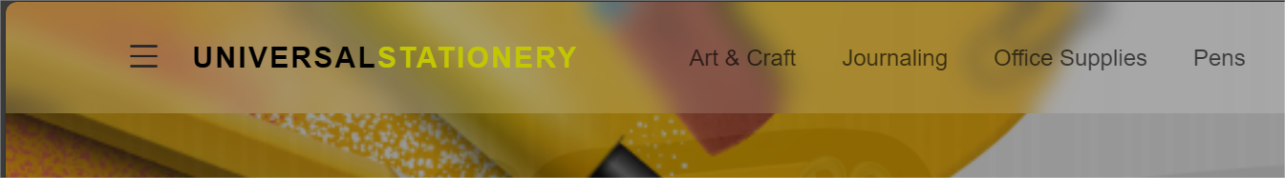
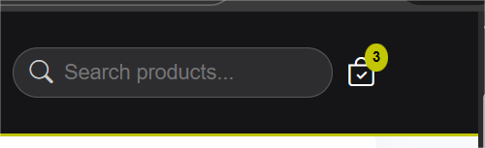
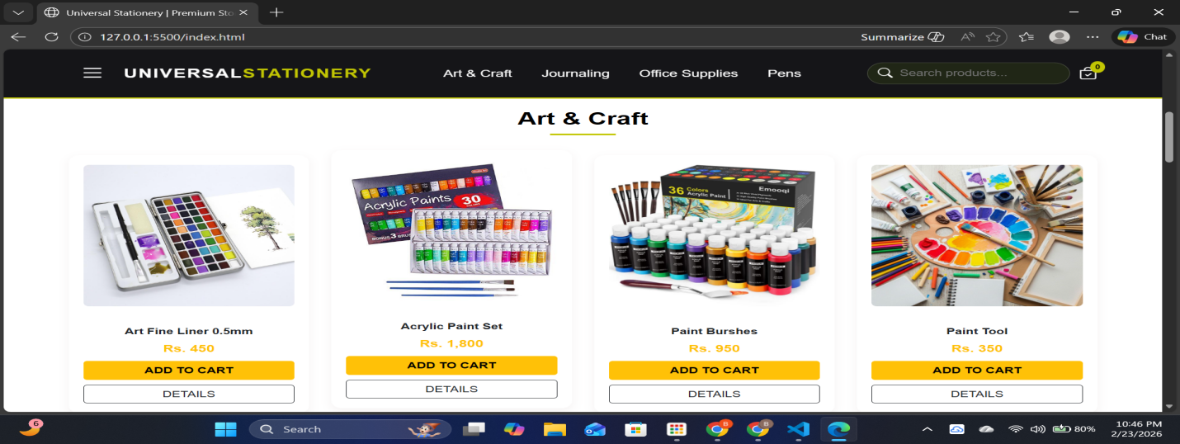
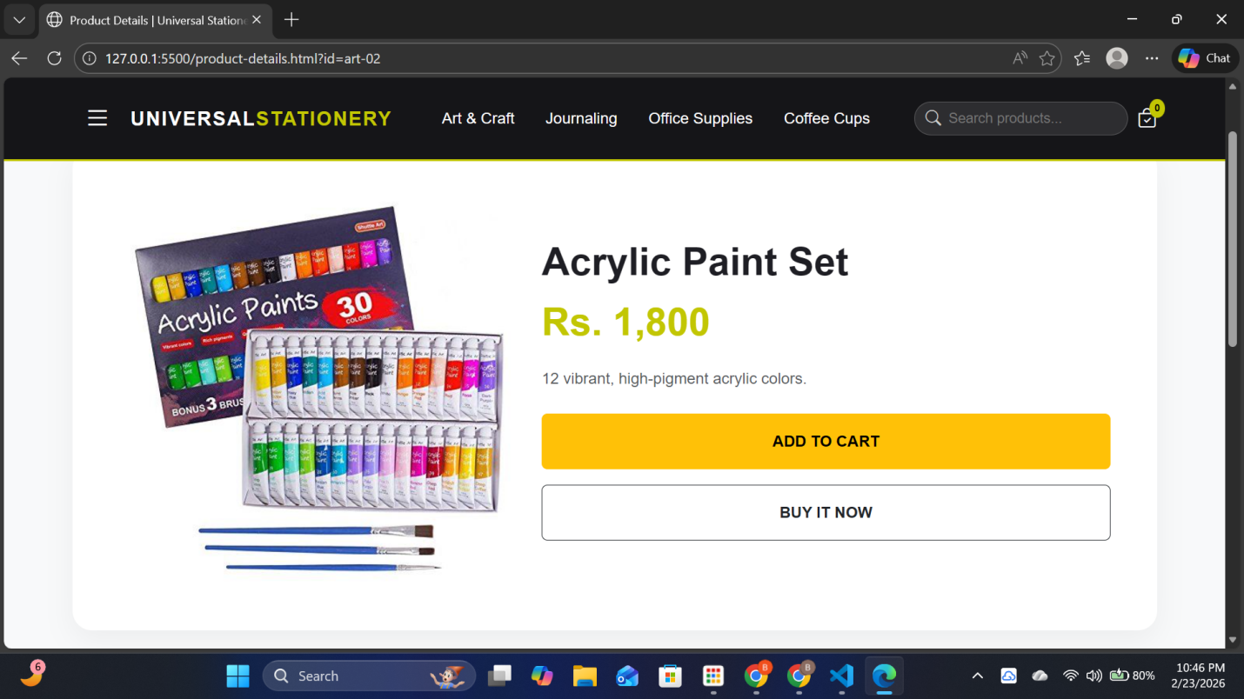

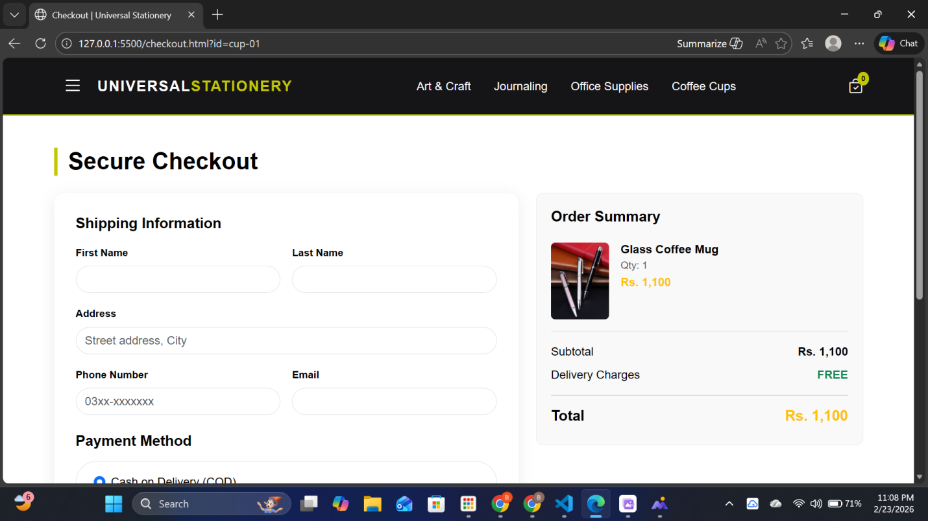
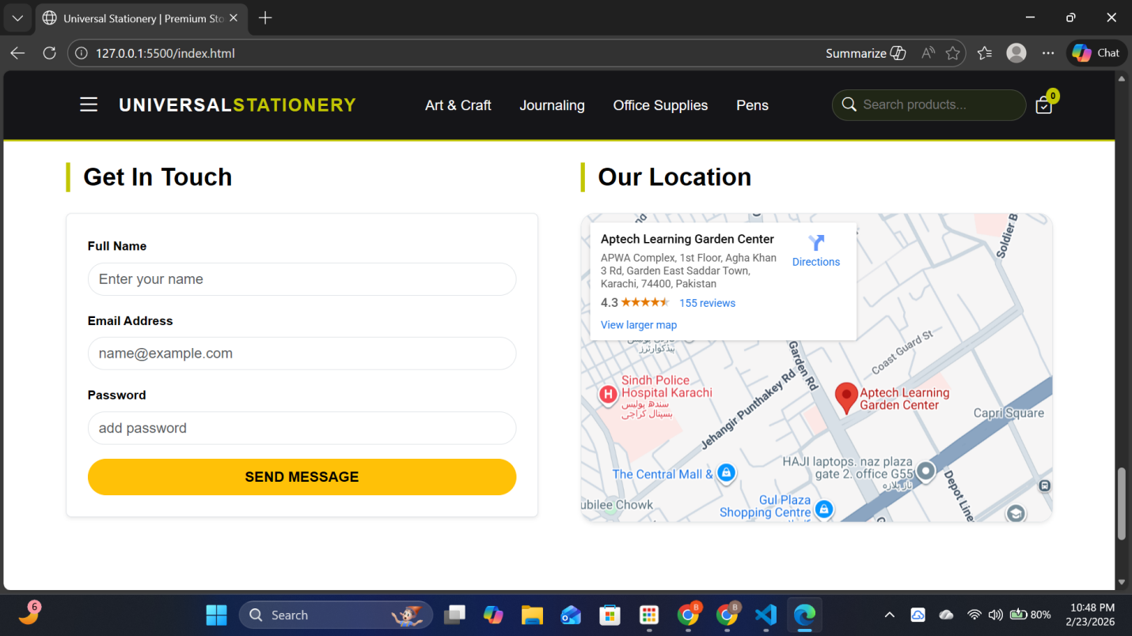

3. Technical Structure

A. UI Frameworks
- Bootstrap 5.3: Used for the grid system, buttons, carousels, and responsive behavior.
- Bootstrap Icons: Used for the search, cart, and menu icons.

B. JavaScript Logic
The render() function is the heart of the site. It performs four main tasks:
- Unique Categories: Identifies categories from the product list.
- Auto-Navigation: Creates top menu links based on available categories.
- Sidebar Sync: Populates the mobile side-menu.
- Product Grid: Generates the HTML cards for every item, including price, image, and action buttons.

C. Data Schema
Each product is stored as an object:
JavaScript
{
id: "art-01",
name: "Art Fine Liner 0.5mm",
category: "art",
price: "Rs. 450",
image: "photos/art1.jpg"
}

4. Visual Component Map
Component | Description
Sticky Navbar | Transparent at top, turns dark on scroll for better readability.
Product Cards | Features a "hover-up" animation and shadow effect for a premium feel.
Category Headers | Underlined with a yellow accent to separate different shopping sections.
Footer | Three-column layout containing branding, quick links, and contact info.

5. User Journey
- Discovery: User arrives at the Hero Carousel and sees featured banners.
- Browsing: User scrolls through categories (Art, JOURNALING, Office) or uses the sidebar.
- Interaction: Users can click Details to see more or Add to Cart to update their shopping bag.
- Inquiry: Users can fill out the contact form at the bottom to ask questions or find the store on the map.

