**Description of data analysis approach and methodology** –

1. Extracted meaningful information from the McDonald's menu nutritional dataset.
2. Performed exploratory data analysis to understand the nutritional distribution and trends.
3. Created visualizations to present the calorie count and nutrition facts of different menu items.
4. Identified healthy and less healthy menu options based on nutritional content.

**Exploratory data analysis findings and insights—**

Findings and Insights:

Calorie Distribution: The analysis revealed a wide range in calorie counts across menu items, with chicken nuggets higher in calories than others. This indicates a variety of options for customers with different dietary preferences and needs.

Nutritional Content: The exploration of nutritional content highlighted variations in fat, protein, carbohydrates, and other nutrients across menu items. Some categories, such as desserts, tended to have higher levels of sugar and fat, while others, like salads, offered more balanced nutritional profiles.

Menu Category Comparison: By comparing nutritional content across food categories, we identified trends in calorie distribution and nutritional balance. This information can help customers make informed choices based on their dietary goals, whether they're looking for a lighter option or indulging in a treat.

Healthy vs. Less Healthy Options: Menu items with the highest calorie counts is chicken nuggets, allowing customers to be aware of potentially less healthy choices. Conversely, items with lower calorie counts is diet coke.

**Visualizations depicting nutritional information—**

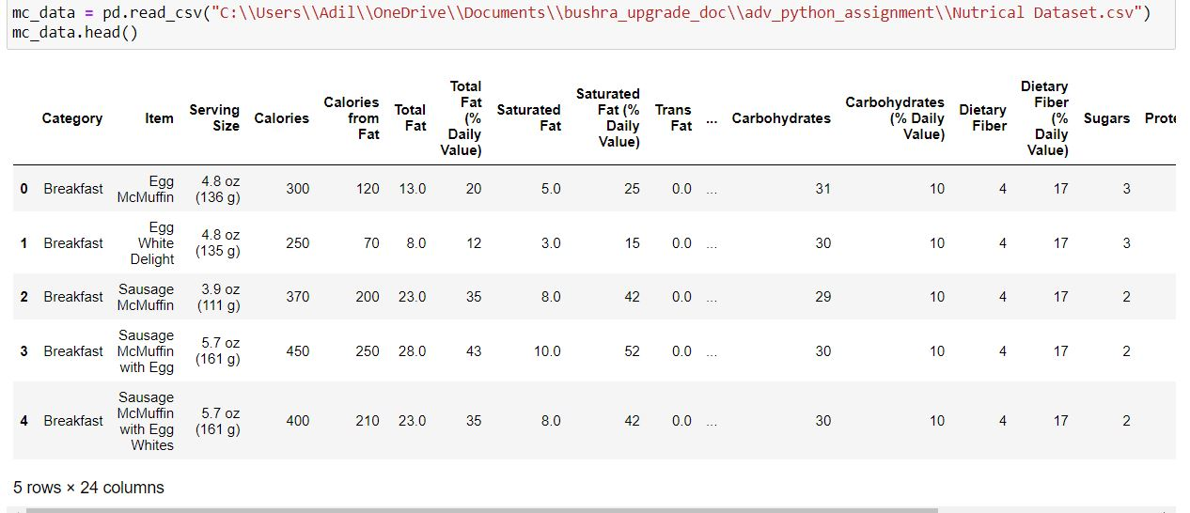

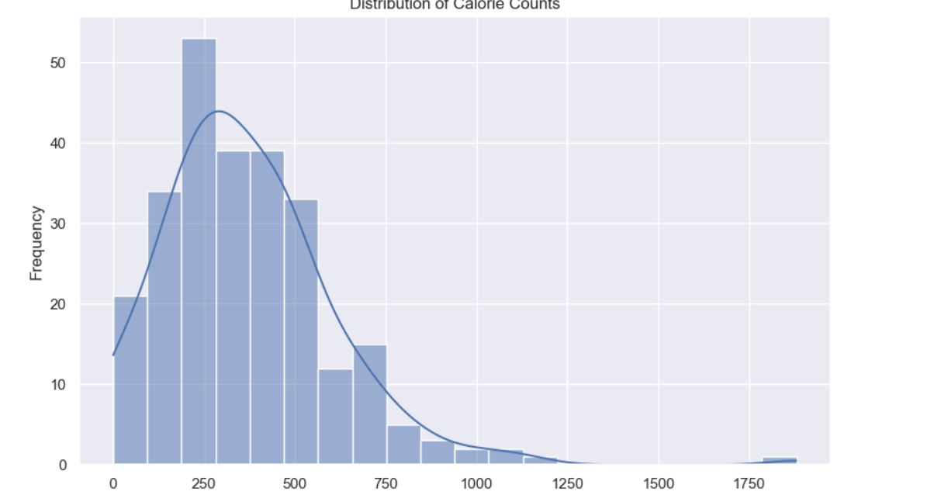

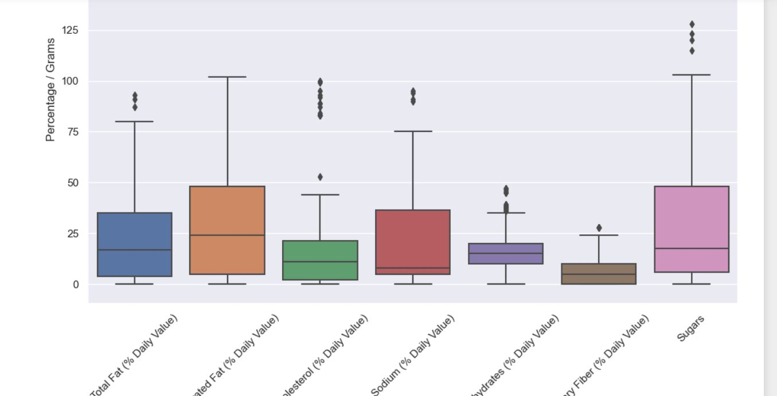

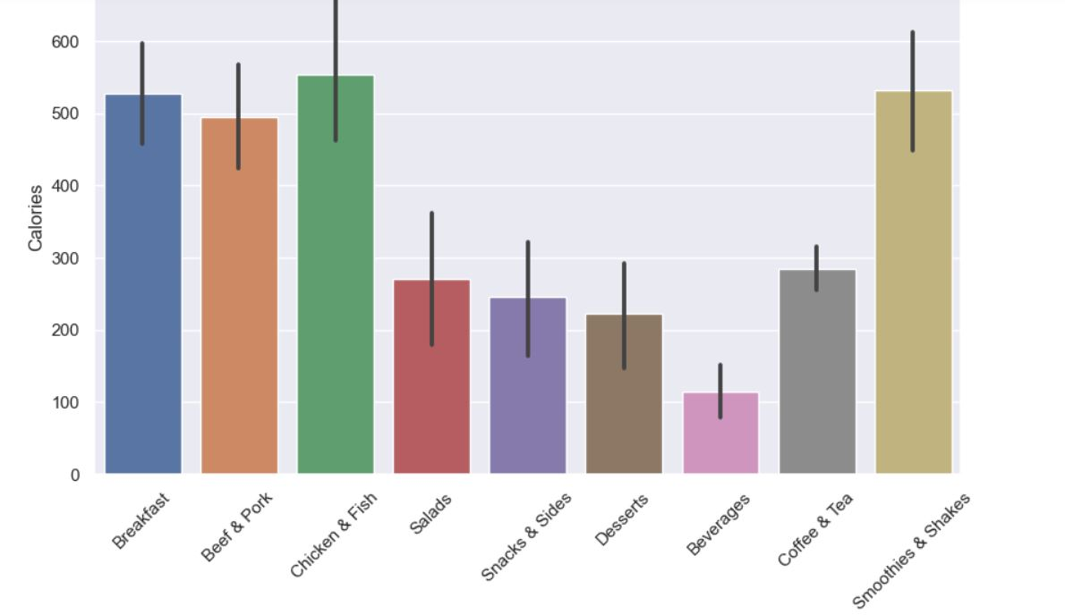

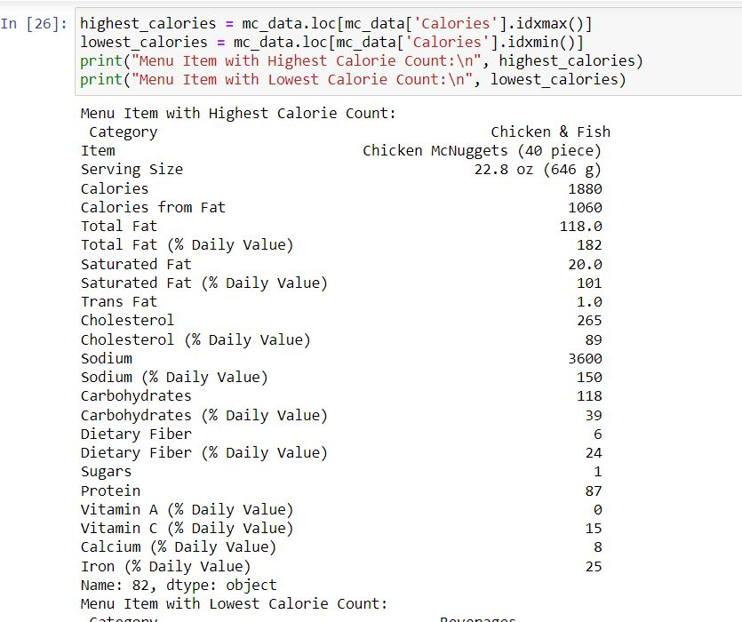

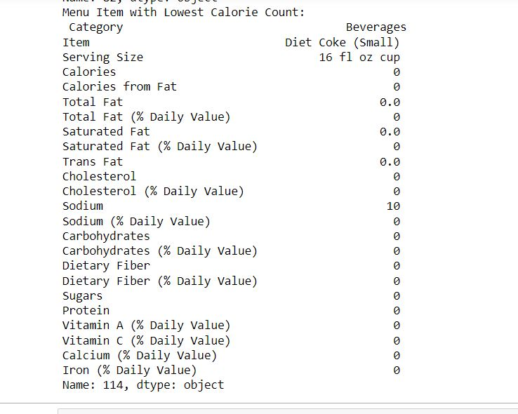

**Source code used for data preprocessing, analysis, and visualization—**

import pandas as pd

import numpy as np

import matplotlib.pyplot as plt

%matplotlib inline

import seaborn as sns

sns.set(color_codes = True)

mc_data = pd.read_csv("C:\\Users\\Adil\\OneDrive\\Documents\\bushra_upgrade_doc\\adv_python_assignment\\Nutrical Dataset.csv")

mc_data.head()

mc_data.dropna(inplace=True)

plt.figure(figsize=(10, 6))

sns.histplot(mc_data['Calories'], bins=20, kde=True)

plt.title('Distribution of Calorie Counts')

plt.xlabel('Calories')

plt.ylabel('Frequency')

plt.show()

nutritional_cols = ['Total Fat (% Daily Value)', 'Saturated Fat (% Daily Value)', 'Cholesterol (% Daily Value)',

'Sodium (% Daily Value)', 'Carbohydrates (% Daily Value)', 'Dietary Fiber (% Daily Value)',

'Sugars']

plt.figure(figsize=(12, 8))

sns.boxplot(data=mc_data[nutritional_cols])

plt.title('Nutritional Content Distribution')

plt.ylabel('Percentage / Grams')

plt.xticks(rotation=45)

plt.show()

plt.figure(figsize=(10, 6))

sns.barplot(x='Category', y='Calories', data=mc_data)

plt.title('Calories by Food Category')

plt.xlabel('Food Category')

plt.ylabel('Calories')

plt.xticks(rotation=45)

plt.show()

highest_calories = mc_data.loc[mc_data['Calories'].idxmax()]

lowest_calories = mc_data.loc[mc_data['Calories'].idxmin()]

print("Menu Item with Highest Calorie Count:\n", highest_calories)

print("Menu Item with Lowest Calorie Count:\n", lowest_calories)

**Benefits for Customer and The Organization**—

**Benefits of Nutritional Analysis for Customers:**

1. **Informed Decision-Making:** Providing detailed nutritional information empowers customers to make informed decisions about their food choices. Whether they're looking to manage their calorie intake, reduce specific nutrients like sodium, or increase their protein intake, having access to this information helps them align their meals with their dietary goals.
2. **Dietary Preferences:** Customers with specific dietary preferences or restrictions, such as vegetarian, vegan, gluten-free, or low-carb diets, can easily identify suitable options on the menu. This improves their dining experience and satisfaction with the available offerings.
3. **Health Consciousness:** As societal awareness of nutrition and health increases, customers are more likely to prioritize healthier options. By highlighting nutritional content, McDonald's can cater to health-conscious individuals and attract a broader customer base.

**Benefits for McDonald's Organization:**

1. **Customer Satisfaction:** Providing transparent nutritional information enhances trust and credibility with customers. By offering a diverse range of menu items with detailed nutritional data, McDonald's demonstrates a commitment to meeting the diverse needs of its customer base.
2. **Menu Optimization:** Analyzing nutritional data allows McDonald's to identify popular menu items and assess their nutritional value. This insight can inform menu optimization efforts, such as introducing healthier alternatives, reducing sodium content, or adjusting portion sizes to align with customer preferences and health trends.
3. **Brand Reputation:** By promoting transparency and a commitment to health and wellness, McDonald's can enhance its brand reputation as a responsible and customer-centric fast-food chain. This can lead to increased customer loyalty and positive word-of-mouth recommendations.

In summary, conducting nutritional analysis provides valuable insights for both McDonald's customers and the organization itself. It supports informed decision-making, caters to diverse dietary preferences, and promotes health-conscious choices, ultimately contributing to improved customer satisfaction and brand reputation.

Top of Form