

Submitted By:
Bushra Raees Butt – 2025-CYS-17
Assignment :
Pacman Game Report
Submitted To:
Sir Shahmeer Nawaz

For the fulfillment of,
Object-Oriented Programming Lab
Department of Computer Engineering
University of Engineering and Technology, Lahore

PACMAN CONSOLE GAME IN JAVA
PROJECT REPORT

1.INTRODUCTION:
This project is a simple console-based Pacman game developed using Java programming language. The purpose of this project is to demonstrate the use of Object-Oriented Programming (OOP) concepts in a real application.
The game simulates a basic Pacman environment where a player controls Pacman on a grid, collects food, and avoids a ghost enemy. The system shows how different objects interact with each other to perform game functions in an organized way.

2. Objectives of the Project:
The main objectives of this project are:
- To apply Object-Oriented Programming concepts in Java
- To understand interaction between multiple classes and objects
- To implement real-time user input handling
- To develop logical thinking through game design
- To simulate basic game mechanics like movement and collision

3. Tools and Technologies Used
- Programming Language: Java
- IDE: IntelliJ IDEA
- Concept Used: Object-Oriented Programming (Classes, Objects, Interaction, Encapsulation , Association , Composition , Class-based design )

4. System Description (CEP Requirement)
The Pacman game is developed using multiple classes including Pacman, Ghost, Food, and GameBoard, all controlled by the main class PacmanGame.
The PacmanGame class contains the main method and runs the game loop. It initializes all objects and continuously updates the game state based on user input.
The player controls Pacman using the following keys:
- U = Move Up
- D = Move Down
- L = Move Left
- R = Move Right
The Ghost moves randomly within the grid, creating challenge for the player. The Food remains on the board and must be collected by Pacman.

5. Working of the Game
The game starts by displaying a grid-based board. Each element is represented using symbols:
- P → Pacman
- G → Ghost
- . → Food
- # → Empty space
Game Flow:
- The board is displayed on screen
- User enters movement command (U/D/L/R)
- Pacman moves accordingly
- Ghost moves randomly
- Game checks conditions:
  - If Pacman reaches food → Player wins
  - If Ghost touches Pacman → Game over
The loop continues until a win or lose condition is reached.

6 . OOP Concepts Used:
Encapsulation:
Data(position,score)is stored inside classes using private varaiables
Aggregation
GameBoard contains maze and food elements
Composition
PacmanGame creates and manges all objects
Abstraction
Each class performs a specific role.

7 .Architecture Diagram:

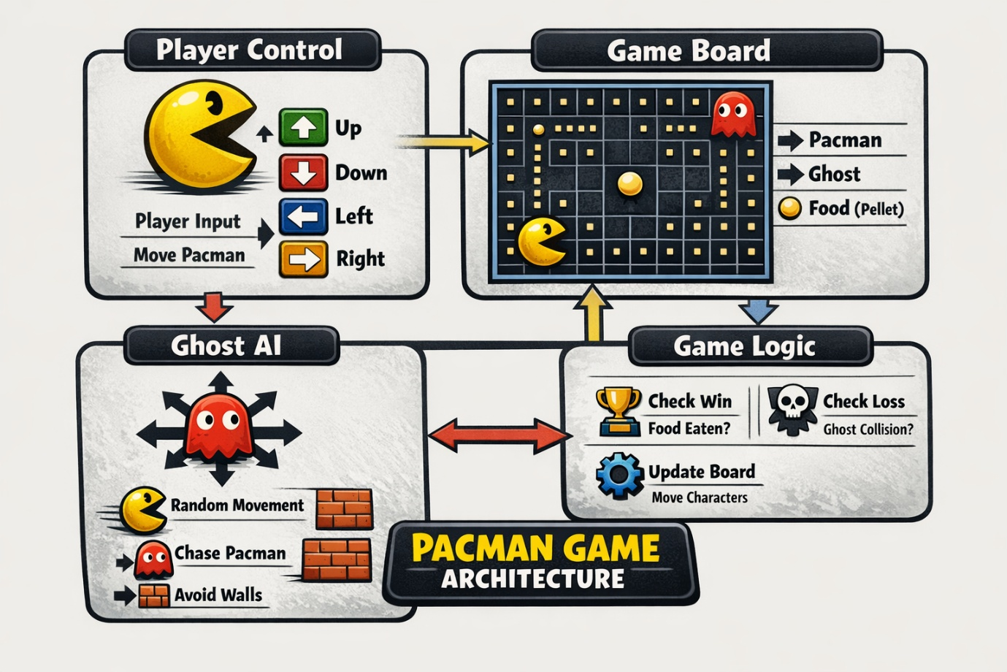

8. Key Features:
- Simple grid-based game design
- User-controlled Pacman movement
- Random ghost movement for challenge
- Win and lose conditions
- OOP-based modular structure

9.Conclusion:
This project successfully demonstrates the implementation of Object-Oriented Programming concepts in Java. It shows how multiple classes can work together to create a simple game system.
The project helps in understanding class interaction, user input handling, and basic game logic. It also improves problem-solving and programming skills in a practical way.

