

**University of Engineering and Technology, Taxila Pakistan**

**Mobile Android Development**

Quiz: 02

Reg No: 21-SE-50

Section: Omega

Department: Software Engineering

Semester No: 6th Sem

Submitted To: Dr. Kanwal Yousaf

Submitted By: Bushra Arshad

**Name: QnA App**

**Documentation outlining changes made in code**

**1. Code Reuse and Cleanup**

The GitHub repository <https://github.com/KanYousaf/Lecture-10-11-12-ReactNative2024> was reused and underwent significant enhancements, including an improved UI with style.js modifications, integration of menu for seamless navigation, and the addition of a new Tensor Flow model named as “qna”, while also removing/commenting out unnecessary code. These changes aim to elevate the application's user experience, streamline navigation, and leverage advanced AI capabilities, ensuring a more professional and efficient codebase.

**2. UI Enhancement**

For the UI enhancement, several key improvements were proposed and implemented to elevate the overall user experience of the application.

**Goals**

* Elevate aesthetics, usability, and accessibility.
* Streamline navigation and improve visual coherence.
* Ensure intuitive interaction for users.

**Specific Enhancements**

1. **Button and Text Elements**

Adjustments were made to the layout and styling of buttons and text elements to enhance readability and clarity. This involved refining font sizes, spacing, and alignment to improve usability.

1. **Navigation Components**

Enhancements focused on refining navigation components to streamline user flow and improve accessibility. This included optimizing navigation bars, menus, and buttons for easier interaction.

1. **Home Screen**

Added a Home Screen for more clarity to the user showing how to use the app and what is its main purpose.

1. **Visual Coherence**

Color schemes and visual elements were refined to create a more visually appealing and cohesive interface. This involved ensuring consistency in color usage, iconography, and visual hierarchy.

**Enhanced UI ScreenShots**

* **SignUp Page**

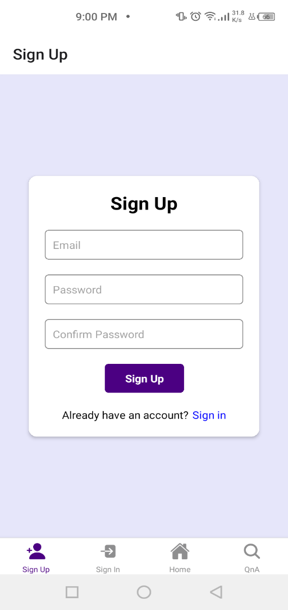

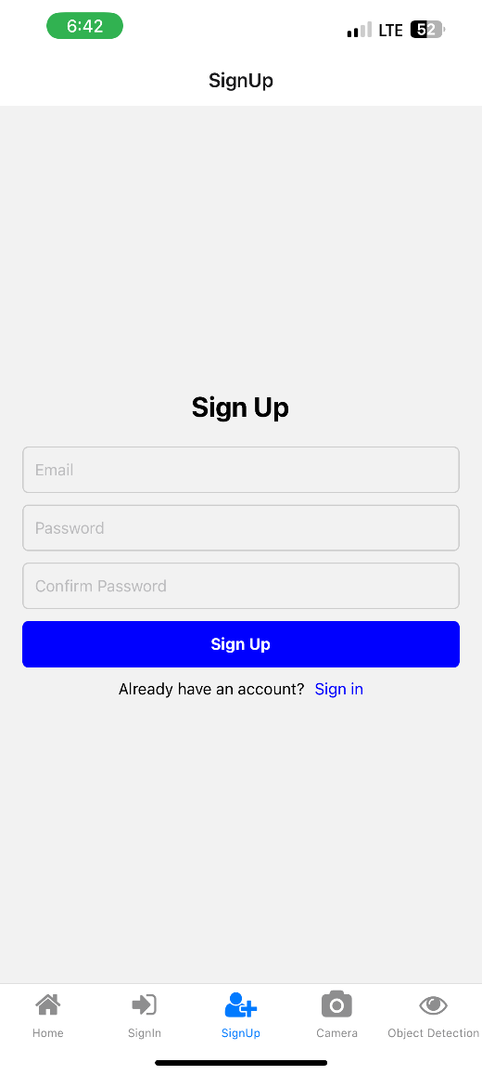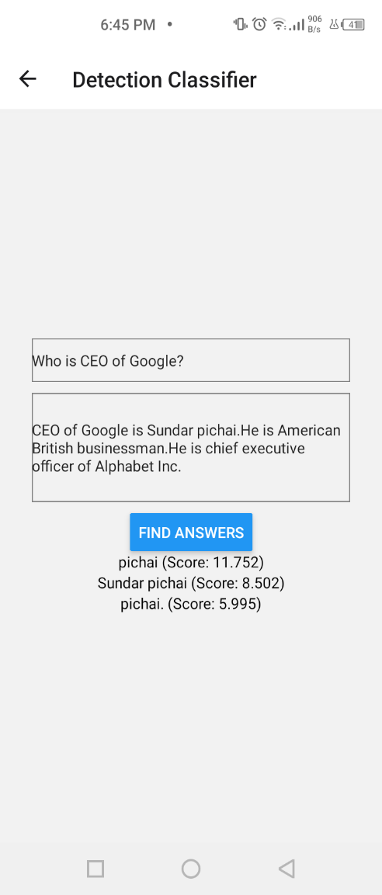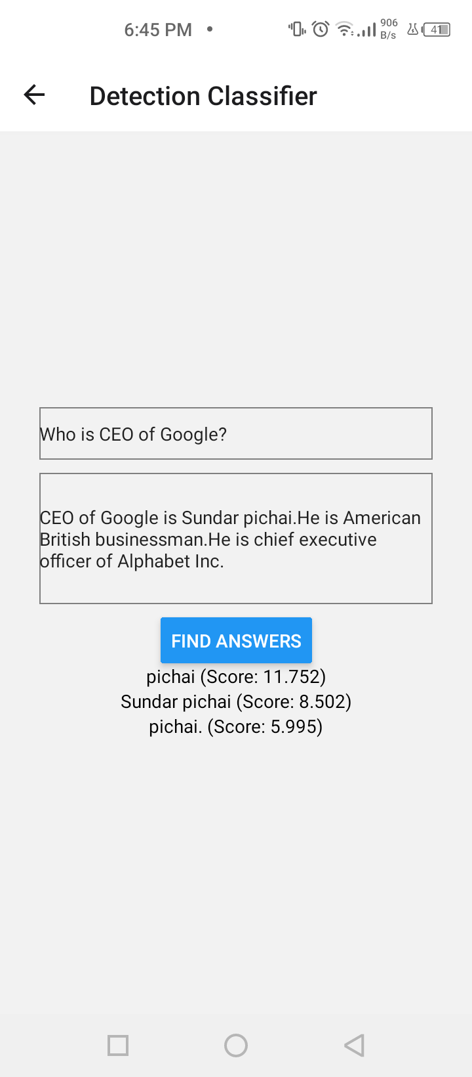

(Previous UI) (Enhanced UI)

* **SignIn page**

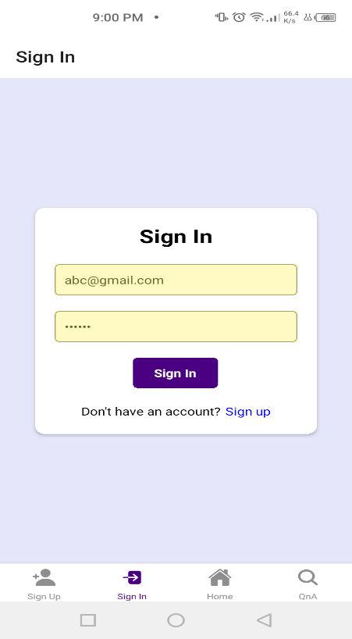

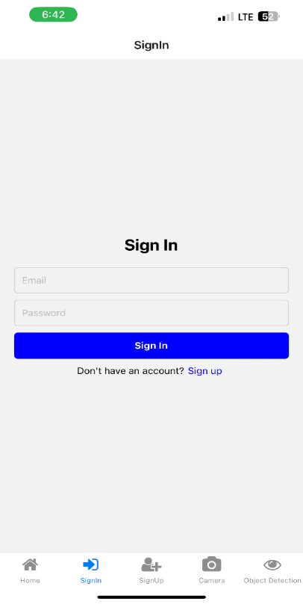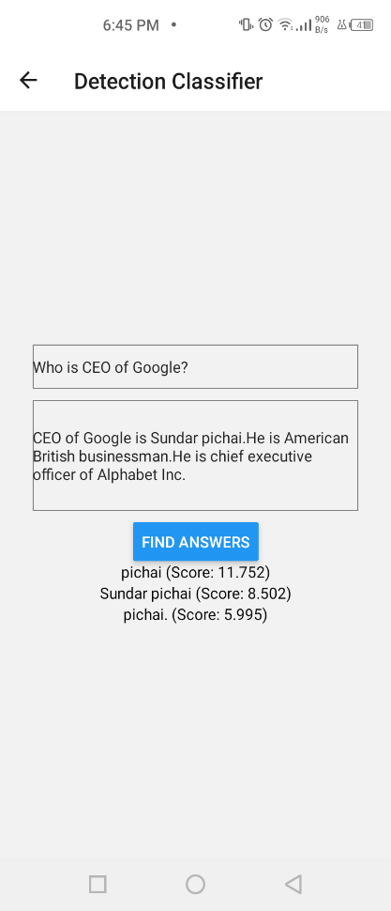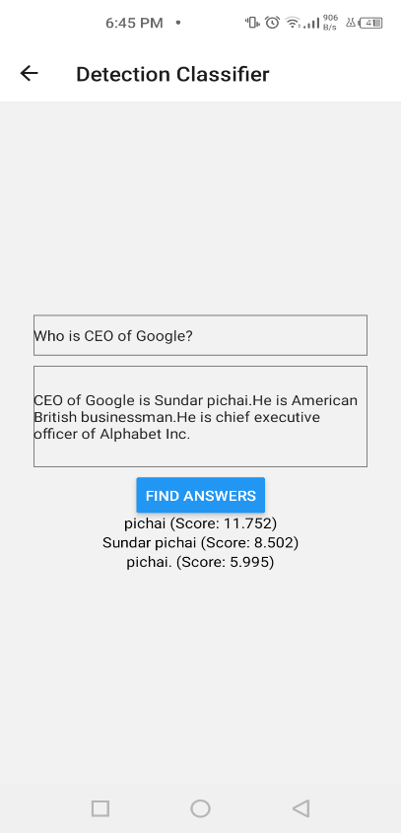

(Previous UI) (Enhanced UI)

* **HomeScreen (New Added HomeScreen is named SplashScreen.js in the hierarchy)**

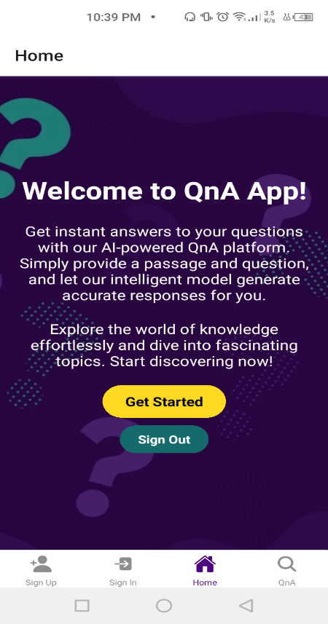

**3. Menu Integration**

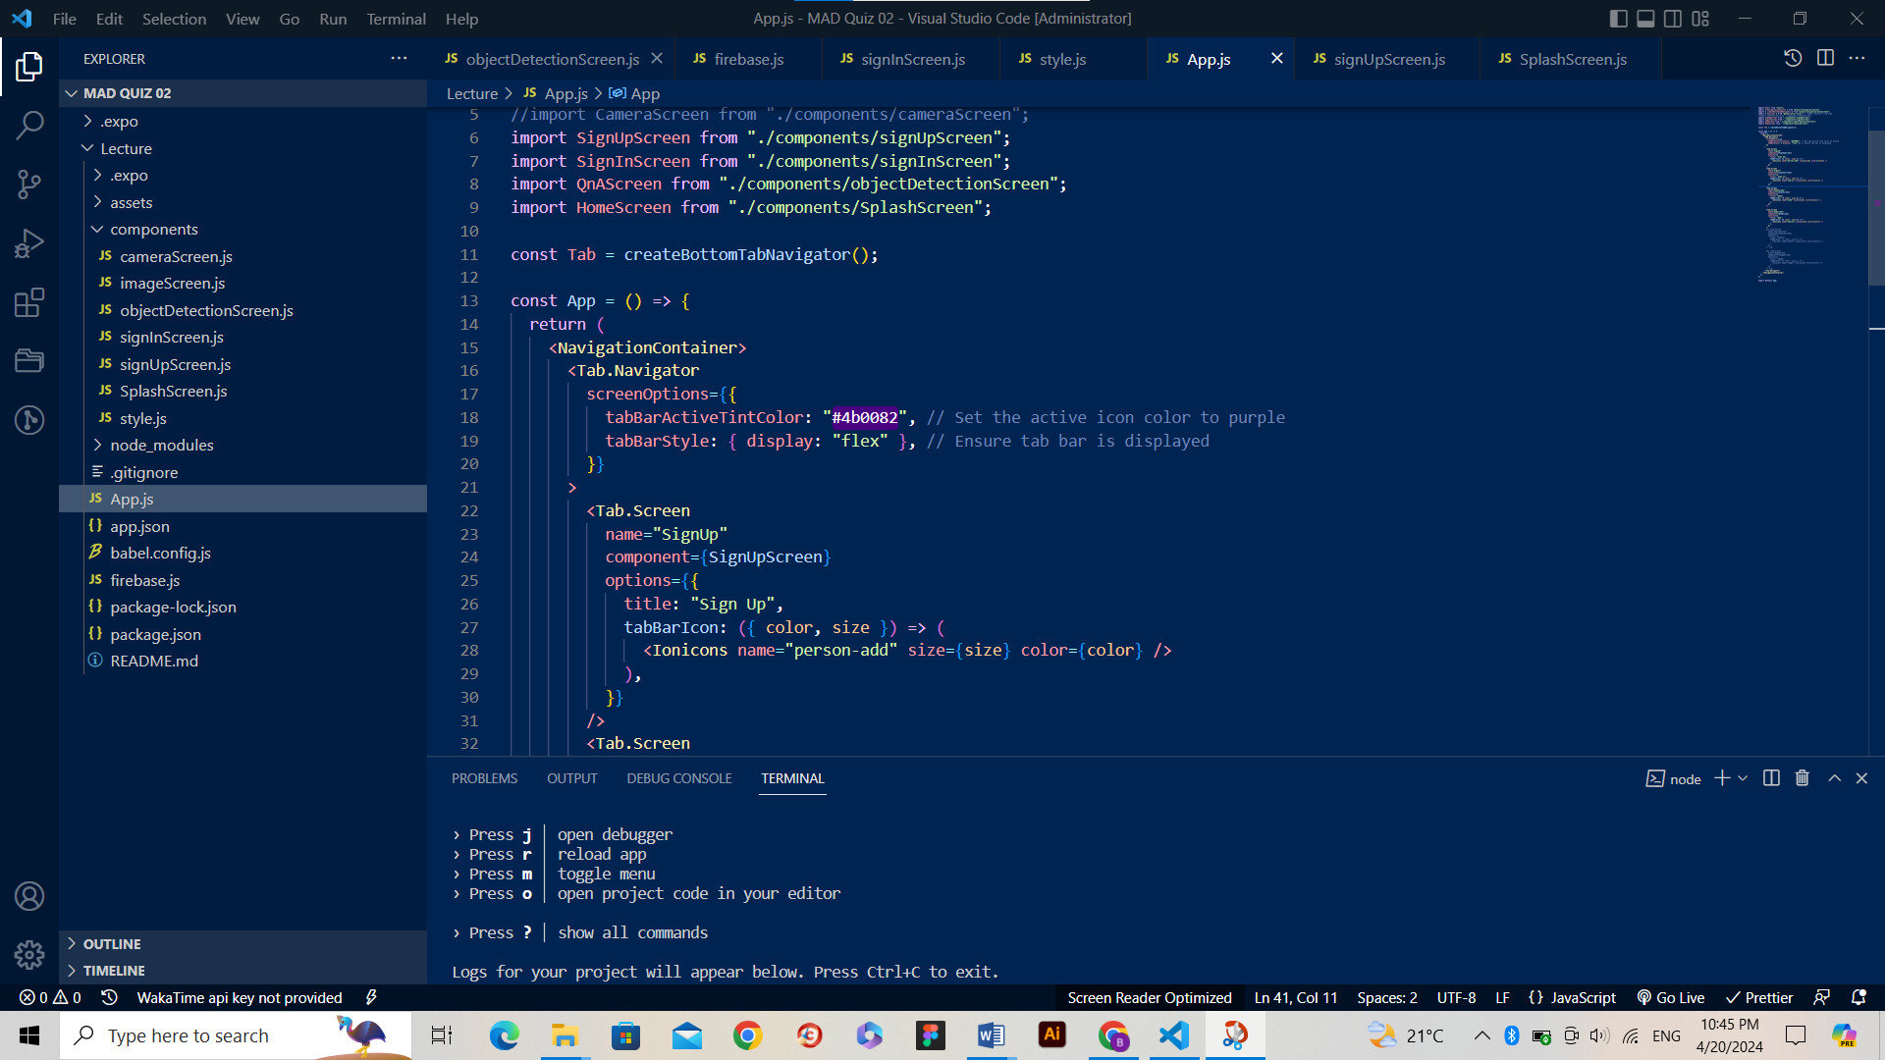The addition of a bottom tab navigator aimed to increase usability and provide seamless navigation within the application. This enhancement offers users a more intuitive way to access different sections of the app, improving overall navigation efficiency.

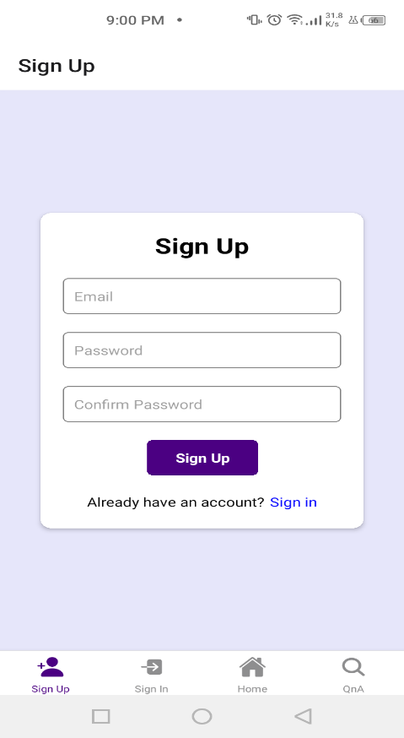

**4. AI Model Integration**

The model chosen is the QnA Model. The QnA Model utilizes a deep learning architecture, likely based on transformer-based models such as BERT (Bidirectional Encoder Representations from Transformers) or similar architectures optimized for question-answering tasks. The link is <https://www.npmjs.com/package/@tensorflow-models/qna>.

**Functionality and Purpose**

The integrated QnA Model serves the purpose of providing accurate and relevant responses to user queries within the application. Leveraging TensorFlow.js, the model is capable of understanding natural language questions and retrieving corresponding answers from a given context or knowledge base along with their corresponding confidence scores.

**Integration Process in Application**

1. **Model Initialization**

The QnA Model is initialized within the application using TensorFlow.js. After importing the model this involves loading the pre-trained model and associated metadata required for inference.

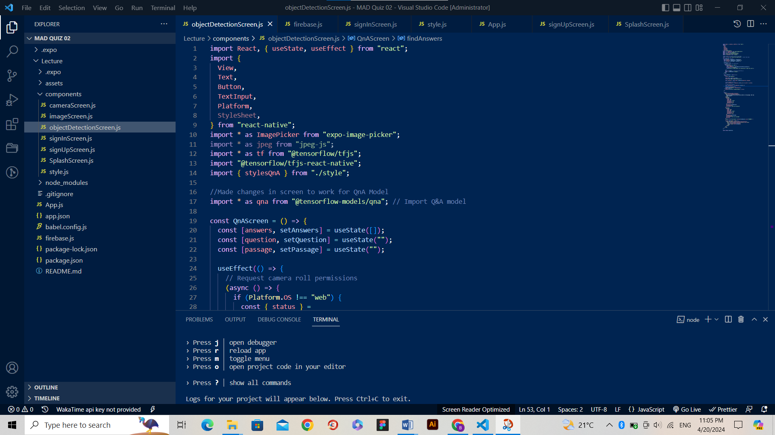

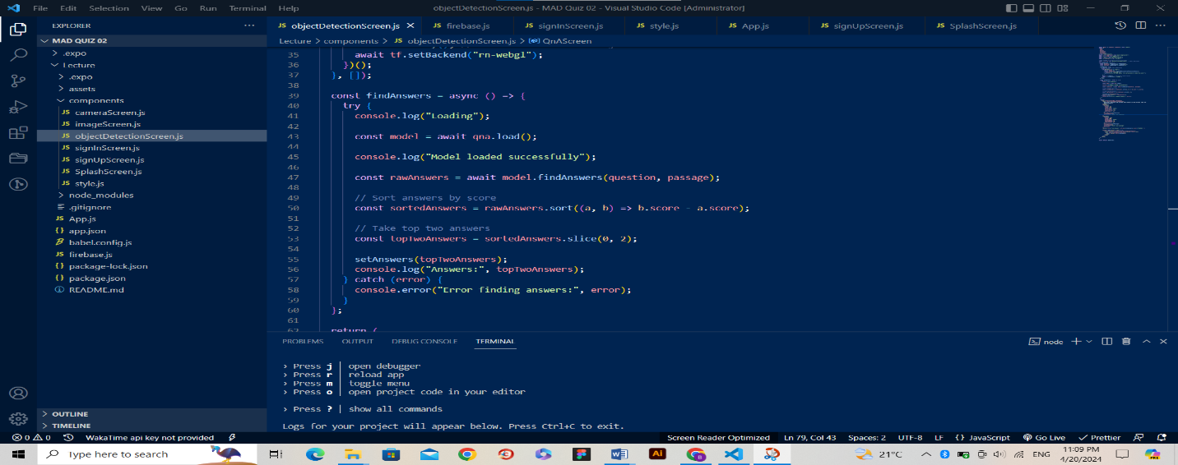

1. **Input Processing**

When a user submits a question through the application interface, the input text is pre-processed to ensure compatibility with the model's requirements.

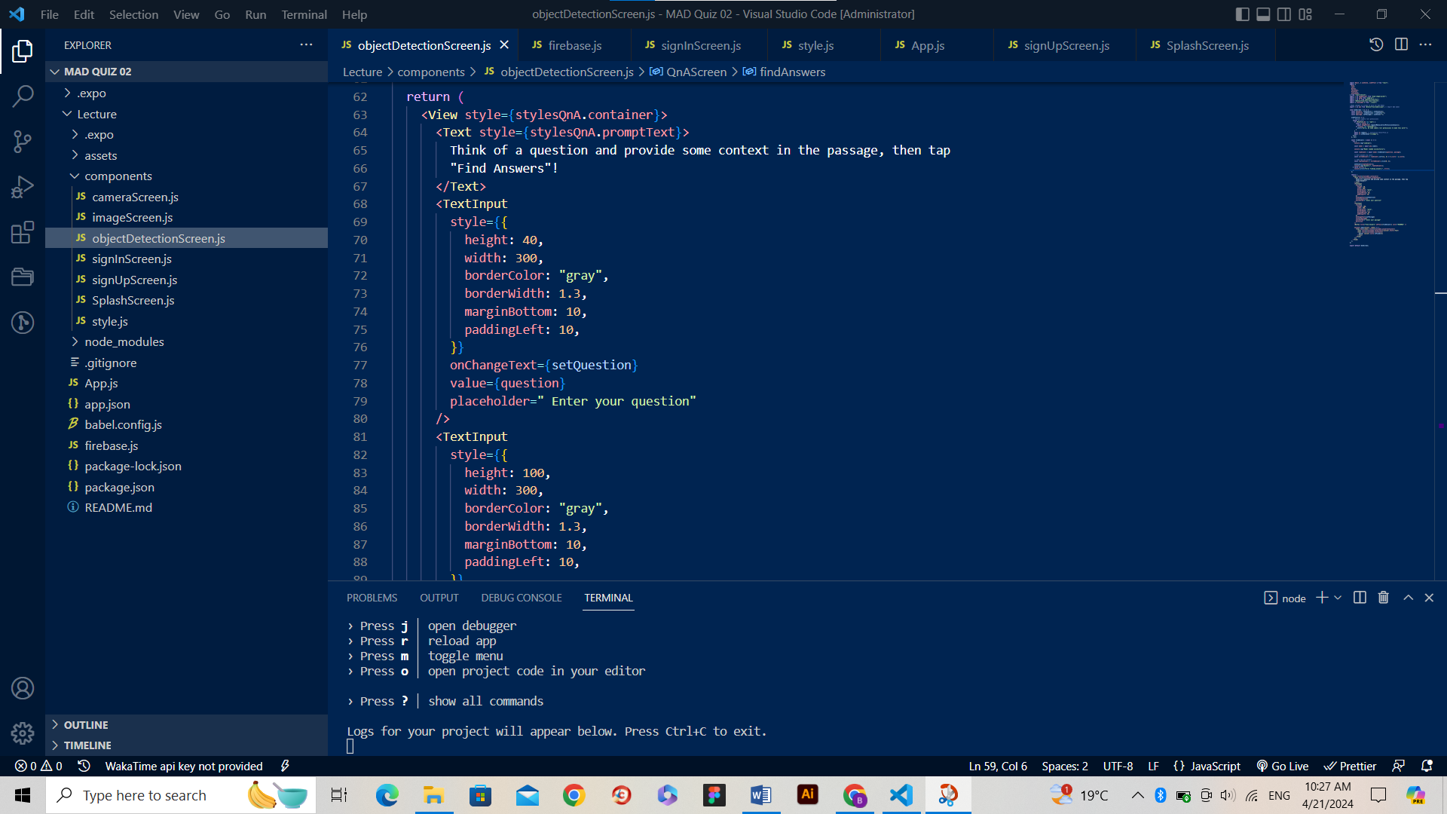

1. **Inference**

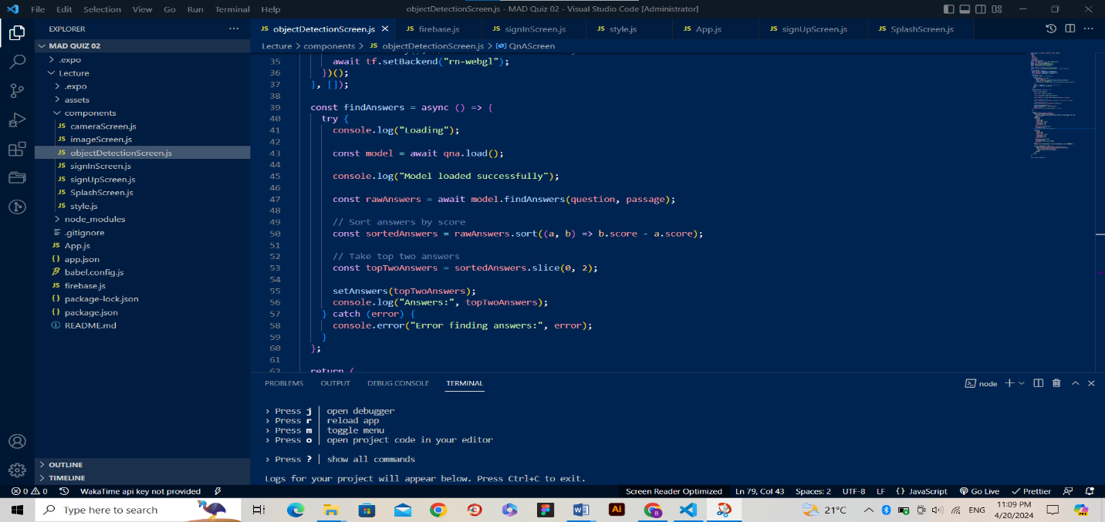The pre-processed question is passed to the QnA Model for inference, which involves predicting the most relevant answer based on the input question and provided context or knowledge base.

1. **Output Handling**

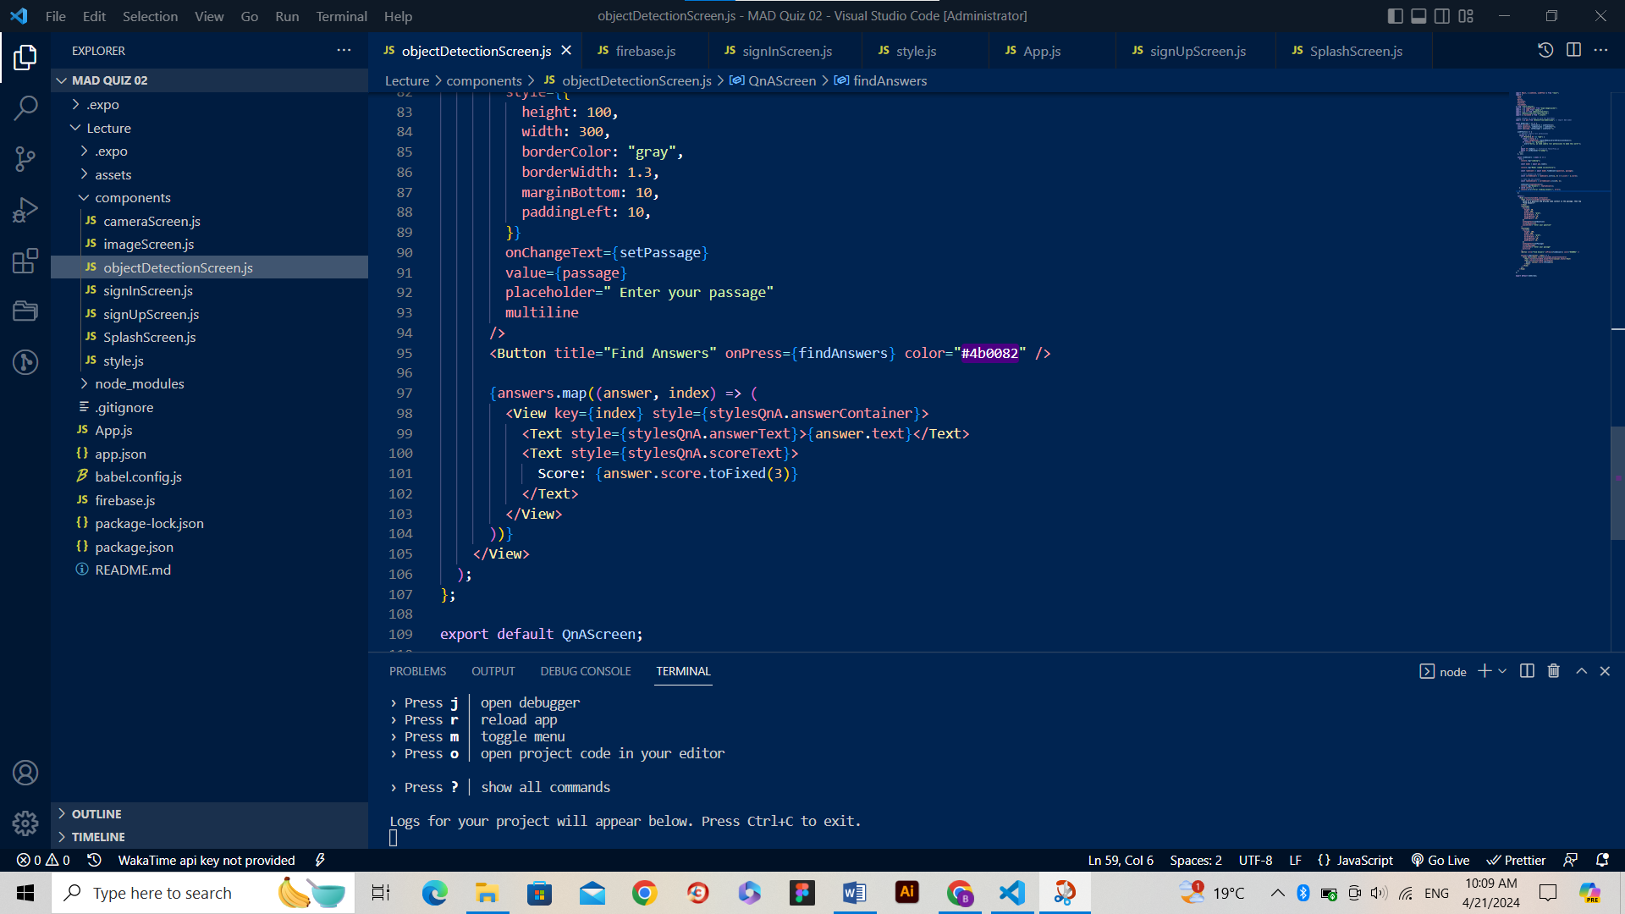The model returns a list of potential answers along with their corresponding confidence scores. The application can then handle the output accordingly, displaying the most relevant top two answers to the user.

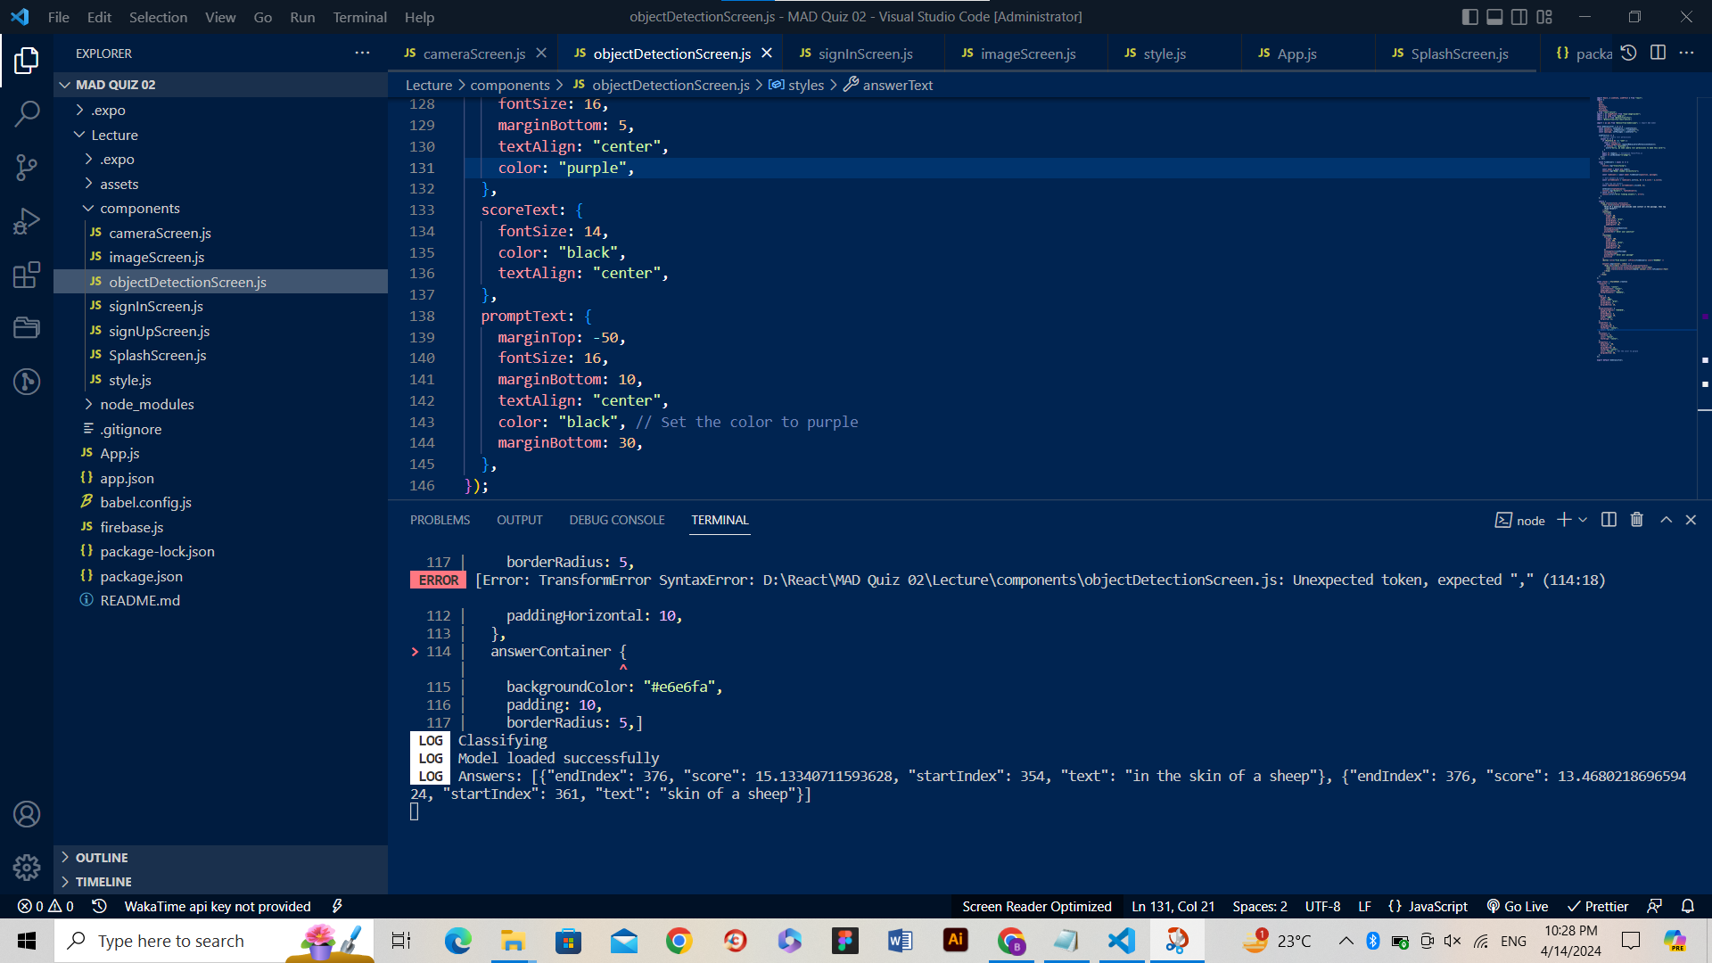

**Impact of Integrated AI on User Experience**

**1. Improved Accessibility**

The integration of the QnA Model enhances accessibility by providing users with instant access to relevant information without the need to navigate away from the application.

**2. Enhanced Interactivity**

Users can engage with the application more conversationally, asking questions and receiving immediate responses, which fosters a more interactive and engaging user experience.

**3. Increased Knowledge Retrieval**

The QnA Model enables users to quickly retrieve information or answers to their queries, empowering them to make informed decisions and resolve queries efficiently.

**4. Potential Limitations**

While the QnA Model offers significant benefits, its accuracy and performance may vary based on factors such as the quality of the training data and the complexity of the questions asked. Users should be aware of potential limitations and use cases where the model may not provide accurate responses.

**Output of QnA Screen**

**Question given by User:** Where the wolf hid himself?

**Passage/Context given by User:** One day a wolf felt very hungry. He wandered here and there in search of food but he could not find anything to eat. At last, he saw a flock of sheep in a pasture. He wanted to eat one but they were guarded by a hound. The shepherd’s son was also tending the flock vigilantly. The wolf found himself helpless. At last, he hit upon a plan. **He hid himself in the skin of a sheep and safely went into the flock.** The hound could not find out the woof in disguise. He killed a sheep and ate it without being caught. In this way, he ate up many sheep and their number began to fall every day. The shepherd was greatly worried but could not find the thief.

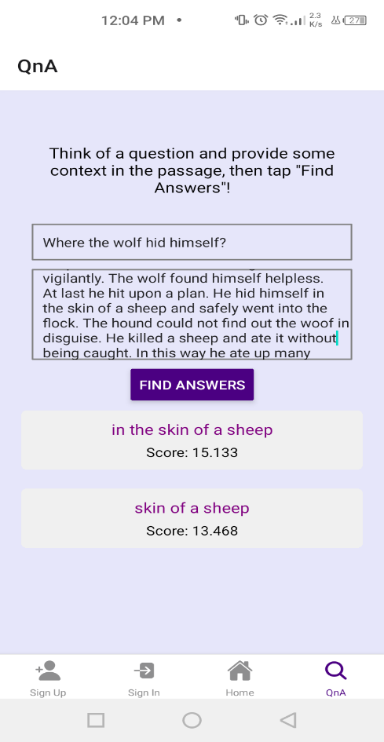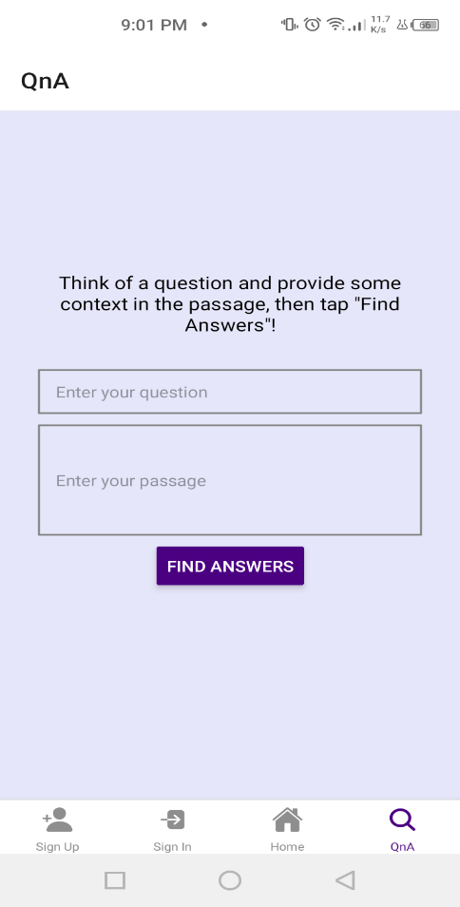

Regarding running the application and accessing features ReadMe.md is provided in the below GitHub repository.

**Github Repo Link:** [**https://github.com/BushraArshad358/QnA-App.git**](https://github.com/BushraArshad358/QnA-App.git)

**\*\*\*\*\*\*\*\*\*\*\*\*\*\*\*\*\*\*\*\***