Project Report
BrainMap XAI (EfficientNetB3 + CBAM-SE + Explainable AI for Parkinsons Classification)

Submitted by

Helia Karim 2022-UAM-2208

Bushra Iqbal 2022-UAM-2224
Muhammad Zulqarnain 2022-UAM-2248

Session 2022-26

Supervised by
Mr. Muhammad Shehzad



INSTITUTE OF COMPUTING
MNS-UNIVERSITY OF AGRICULTURE, MULTAN PAKISTAN

FINAL APPROVAL
This is to certify that we have read this report submitted by Helia Karim, Bushrra Iqbal , Muhmmad Zulqarnain and it is our judgment that this report is of sufficient standard to warrant its acceptance by MNS-University of Agriculture, Multan for the degree of BS (Information Technology).

Committee:

1. External Examiner ______________________
Examiner
Designation
Organization
2. Supervisor ________________
Teacher Name
Research Officer
Institute of Computing

.
3. Director of Institute ________________
Prof. Dr. Salman Qadri
Director,
Institute of Computing
MNS-University of Agriculture, Multan

DECLARATION

This is to certify that Helia Karim (2022-UAM-2208),Bushra Iqbal (2022-UAM-2224), Muhammad Zulqarnain(2022-UAM-2248) Session (2022-2026) have worked on and completed their software project “BrainMap XAI” at the Institute of Computing, MNS-University of Agriculture, Multan, in partial fulfillment of the requirements for the degree of BS (Information Technology).

Date: ________________

Signature: _____________________

Helia karim
Reg. No. 2022-UAM-2208

Signature: _____________________

Bushra Iqbal
Reg. No. 2022-UAM-2224

Signature: _____________________

Muhammad Zulqarnanin
Reg. No. 2022-UAM-2248

DEDICATION

To my Loving Parents

Acknowledgment

We sincerely thank our respected supervisor, Mr. Muhammad Shehzad, for his valuable guidance, encouragement, and continuous support throughout our project and report writing. We are also grateful to our teachers and faculty members for their knowledge and assistance. Special thanks to our team members Helia Karim, Bushra Iqbal, and Muhammad Zulqarnain for their teamwork, dedication, and hard work in successfully completing this project. Finally, we appreciate our families and friends for their motivation and moral support during this journey.
PROJECT BRIEF

PROJECT NAME | BrainMap XAI (EfficientNetB3 + CBAM-SE + Explainable AI for Parkinsons Classification)
UNIVERSITY NAME | Muhammad Nawaz Sharif University of Agriculture Multan
UNDERTAKEN BY | Helia Karim , Bushra Iqbal , Muhammad Zulqarnain
SUPERVISED BY | Muhammad Shehzad
STARTING DATE | January 2026
COMPLETION DATE | June 2026
COMPUTER USED | Intel(R) Celeron(R) N4100 CPU @ 1.10GHz (1.10 GHz) / 8.00 GB /
OPERATING SYSTEM | MS Windows 11 Pro
SOURCE LANGUAGE(S) | Python (CNN + Efficent-NetB3), HTML, CSS ,JavaScript
DBMS USED | My-SQL
TOOLS/PACKAGES | MS Office/ Google Colab (GPU)/ Flask

PLAGIARISM UNDERTAKING

I solemnly declare that the work presented in the report titled “BrainMap XAI” is solely our work with no significant contribution from any other person. Small contribution/help wherever taken has been duly acknowledged and that complete report has been written by us.

I understand the zero-tolerance policy of the HEC and MNS-University of Agriculture, Multan towards plagiarism. Therefore, I as an Author of the above titled report declare that no portion of my report has been plagiarized and any material used as reference is properly referred/cited.

I undertake that if I am found guilty of any formal plagiarism in the above titled report even after award of the degree, the University reserves the rights to withdraw/revoke my degree and that HEC and the University has the right to publish my name on the HEC/University Website on which names of students are placed who submitted plagiarized report.

Student /Author Signature:______________

Name:__________________
ABSTRACT

Parkinson’s disease is a progressive neurological disorder that affects movement, balance, coordination, and daily life activities. Early diagnosis of Parkinson’s disease is essential for timely treatment, effective disease management, and improved patient care. This project presents an explainable deep learning framework named “C3BAM-SE-XAI v2” for Parkinson’s disease classification using medical brain images. The proposed framework is based on a Convolutional Neural Network (CNN) architecture integrated with CBAM (Convolutional Block Attention Module) and SE (Squeeze-and-Excitation) attention mechanisms to enhance feature extraction and classification performance. The dataset images were preprocessed and augmented before training the model to improve generalization and robustness. The developed system performs five-class classification for different stages/categories of Parkinson’s disease. To enhance transparency and interpretability, the framework incorporates Grad-CAM-based Explainable Artificial Intelligence (XAI) techniques that highlight the important regions of brain images influencing model predictions. Experimental results demonstrate that the proposed model achieved strong classification performance, obtaining 98.72% training accuracy, 94.71% validation accuracy, and 95.06% validation accuracy using Test-Time Augmentation (TTA ×5). The model also achieved high precision, recall, and F1-score across most classes, indicating stable and reliable performance. The integration of attention mechanisms with explainable AI not only improved classification accuracy but also provided meaningful visual explanations that increase the trustworthiness of the system. The proposed framework can assist healthcare professionals in the early detection and analysis of Parkinson’s disease, supporting more accurate, transparent, and reliable medical decision-making
TABLE OF CONTENTS
Contents | Page No.
Chapter 1
Introduction
1.1 Motivation  1.2 Problem Statement  1.3 Scope of the Project  1.4 Aims & Objectives of the Project  1.5 Main Contribution to Society | 3  3  3  3  4
Chapter2
Background
2.1 Existing System (Literature Review)  2.2 Gaps (Deficiencies) in Existing System  2.3 Proposed Solution | 8
Chapter 3
Specification & Design
3.1 Data Gathering
3.1.1 Questionnaires (or any technique used) | 9
3.1.2 Sampling & Observations | 10
3.2 Introduction to System Specification | 17
3.2.1 Functional Requirement
3.2.2 Non-Functional Requirement
3.3 Introduction to System Design
3.3.1 System Design using UML | 18
3.3.1.1 Use Case Diagrams | 19
3.3.1.2 Sequence Diagrams | 20
3.3.1.3 Activity Diagrams
3.3.1.4 Data Flow Diagram
3.4 Database Design (Optional) | 20
3.4.1 Entity Relationship Diagrams (ERDs) | 21
3.4.2 Building a Relational Model from ERDs | 22
3.4.3 Normalizing Relational Model to 3NF | 23
Chapter 4
System Development & Implementation
4.1 Tool/Language Selection | 25
4.2 Hardware for the System | 26
4.3 Client-Side Technology | 27
4.3.1 HTML, VB.NET and DHTML | 27
4.4 Server-Side Technology | 28
4.4.1 .NET Technology (ASP.NET) | 28
4.5 Code/Algorithms of important modules | 30
Chapter 5
User’s Guide
5.1 IOT Circuit Design (Screen shot)
5.2 Input Forms (print-out with some description) | 39
5.3 Reports (print-out with some description) | 50
Chapter 6
Conclusion & Future Work
A one- or two-page summary of the tasks carried out in the project. | 70
A good Future Work section should provide a starting point for someone else to continue the work which you have begun.
References

LIST OF FIGURES
3.3.1 Use case Diagram | 19
3.3.2 Sequence Diagrams | 20

chapter 1
Introduction

1.1 Motivation
Parkinson’s disease (PD) is one of the most common neurodegenerative disorders, affecting millions of people worldwide and causing serious motor and non-motor symptoms that impact daily life. Early diagnosis is essential for effective treatment and better disease management; however, traditional diagnostic methods often depend on expert neurologists and may fail to detect subtle early-stage changes. Recent advancements in deep learning and medical imaging have provided new opportunities for automated and accurate disease detection using Convolutional Neural Networks (CNNs). However, the lack of interpretability in many AI models limits their clinical trust and adoption. To address these challenges, the proposed C3BAM-SE-XAI v2 framework combines CNN-based feature extraction with CBAM and SE attention mechanisms along with Grad-CAM-based explainability. The framework aims to provide both high classification accuracy and meaningful visual explanations, making it a reliable decision-support tool for the early detection and analysis of Parkinson’s disease.

1.2 Problem Statement
Despite advancements in medical imaging and neuroscience, the early and accurate diagnosis of Parkinson’s disease remains a major clinical challenge. Existing diagnostic methods face several limitations that reduce their effectiveness and reliability.

1. Late and Inaccurate Clinical Diagnosis
Parkinson’s disease is often diagnosed after noticeable motor symptoms appear, by which time significant neuronal damage may already have occurred. Similar symptoms among neurological disorders can also lead to delayed or incorrect diagnosis.

2. Over-Reliance on Specialist Expertise
Current diagnostic procedures heavily depend on neurologists and radiologists for brain scan interpretation. This process is time-consuming, subjective, and difficult to access in regions with limited medical specialists.

3. Limitations of Existing Automated Systems
Many existing AI-based systems for Parkinson’s disease detection suffer from low accuracy, poor generalization, limited datasets, and inability to classify multiple disease stages effectively, reducing their practical clinical use.

4. Lack of Model Interpretability and Transparency
Most deep learning models operate as black boxes and do not explain their predictions. This lack of transparency makes it difficult for clinicians to trust and validate AI-based diagnostic decisions.

5. Absence of Multi-Class Stage Classification
Most automated systems only perform binary classification between healthy and diseased cases. However, Parkinson’s disease progresses through multiple stages, requiring more detailed and clinically meaningful stage-wise classification.

1.3 Scope of the Project
The scope of this project defines the areas covered in the development of the C3BAM-SE-XAI v2 framework for Parkinson’s disease classification using medical brain images.

1. Domain and Application Area
This project belongs to the field of medical image analysis and computer-aided diagnosis (CAD). The framework is designed to assist healthcare professionals in Parkinson’s disease classification and acts as a decision-support system rather than replacing clinical diagnosis.

2. Dataset and Image Modality
The project uses labeled brain medical images for training, validation, and testing. Image preprocessing and augmentation techniques are applied to improve model performance. Other diagnostic approaches such as EEG, speech analysis, or gait analysis are not included in this work.

3. Classification Task
The proposed system performs five-class classification for different stages or categories of Parkinson’s disease. The classification is based only on image features learned by the deep learning model and does not include patient history or laboratory data.

4. Deep Learning Architecture
The framework uses a CNN-based architecture integrated with CBAM and Squeeze-and-Excitation (SE) attention mechanisms. The project focuses specifically on the proposed C3BAM-SE-XAI v2 architecture and its performance evaluation.

5. Explainability Component
To improve interpretability, the system uses Grad-CAM-based Explainable Artificial Intelligence (XAI) techniques. These techniques generate visual heatmaps that highlight important brain regions influencing the model’s predictions.

6. Performance Evaluation
The model is evaluated using performance metrics such as accuracy, precision, recall, and F1-score. Test-Time Augmentation (TTA) is also used to analyze its effect on model performance

1.4 Aims & Objectives of the Project

Aim
The main aim of this project is to develop an explainable deep learning framework named C3BAM-SE-XAI v2 for accurate multi-class classification of Parkinson’s disease using brain medical images. The framework also aims to provide transparent visual explanations to support reliable clinical decision-making.

Objectives

1. To investigate and analyze existing approaches for Parkinson's disease diagnosis and classification
To study existing clinical, machine learning, and deep learning methods for Parkinson’s disease diagnosis in order to identify their limitations and research gaps.

2. To collect, preprocess, and augment a brain image dataset for Parkinson's disease classification
To prepare a labeled brain image dataset using preprocessing and augmentation techniques such as resizing, normalization, and image enhancement for improved model performance.

3. To design and develop a CNN-based deep learning architecture integrated with attention mechanisms
To develop a CNN-based framework integrated with CBAM and SE attention mechanisms for enhanced feature extraction and improved classification accuracy.

4. To implement a five-class classification system for Parkinson's disease staging
To build a multi-class classification system capable of identifying five different stages or categories of Parkinson’s disease.

5. To integrate Grad-CAM-based Explainable AI (XAI) techniques into the framework
To incorporate Grad-CAM-based XAI techniques for generating visual heatmaps that explain the model’s predictions and improve interpretability.

6. To train, validate, and evaluate the performance of the proposed framework
To evaluate the model using performance metrics such as accuracy, precision, recall, and F1-score, along with Test-Time Augmentation (TTA ×5) for improved robustness.

7. To demonstrate the clinical utility and trustworthiness of the proposed system
To demonstrate that the proposed framework provides both strong classification performance and meaningful visual explanations, making it a reliable decision-support tool for healthcare professionals.

1.5 Main Contribution to Society
The proposed C3BAM-SE-XAI v2 framework contributes to healthcare, medical AI, and society by supporting accurate, explainable, and accessible Parkinson’s disease diagnosis.

1. Advancing Early Detection of Parkinson's Disease
The framework helps in the early and accurate detection of Parkinson’s disease, enabling timely treatment, better disease management, and improved patient quality of life.

2. Reducing the Diagnostic Burden on Healthcare Professionals
The system acts as a decision-support tool that assists doctors and healthcare professionals in disease diagnosis, reducing workload and helping regions with limited access to neurological specialists.

3. Enhancing Trust and Transparency in AI-Assisted Medicine
By integrating Grad-CAM-based explainability, the framework provides visual explanations for model predictions, improving transparency, trust, and reliability in AI-assisted medical diagnosis.

4. Supporting Multi-Stage Disease Management
The five-class classification system enables stage-wise analysis of Parkinson’s disease, helping clinicians provide personalized treatment and better monitor disease progression.

5. Contributing to the Scientific and Research Community
The integration of CNN, CBAM, SE attention mechanisms, and XAI contributes to ongoing research in explainable medical AI and neurological disease classification.

6. Promoting Equitable Access to Diagnostic Technology
The software-based framework can support healthcare systems in underserved areas by providing accessible and automated diagnostic assistance using medical brain images.

Chapter 2

Background

2.1 Existing System (Literature Review)
The reviewed literature collectively demonstrates the progressive evolution of PD classification systems from simple ML classifiers to sophisticated deep learning architectures incorporating attention mechanisms and explainability. While significant accuracy improvements have been achieved, important gaps remain — particularly regarding the simultaneous optimization of classification accuracy, multi-class disease staging, model interpretability, and computational efficiency. These gaps form the basis for the development of the C3BAM-SE-XAI v2 framework, as discussed in the following section.

2.2 Gaps (Deficiencies) in Existing System
A review of existing Parkinson’s disease classification systems reveals several limitations that reduce their clinical reliability, accuracy, and interpretability. These gaps motivated the development of the proposed C3BAM-SE-XAI v2 framework.

1. Limited Classification Accuracy and Generalization
Many existing deep learning models such as VGG19, ResNet50, DenseNet201, and InceptionV3 achieved only moderate classification accuracy on Parkinson’s disease datasets. Even the previous C3BAM-XAI framework showed room for improvement, highlighting the need for more accurate and generalized models for reliable medical diagnosis.

2. Absence of Squeeze-and-Excitation (SE) Attention Mechanism
The previous C3BAM-XAI framework used CBAM attention but did not include the SE attention mechanism. The absence of this dual-attention combination limited the model’s ability to enhance important channel-wise features in brain MRI images.

3. Binary or Simplified Classification Frameworks
Most existing systems focus only on binary classification between healthy and diseased cases. Such approaches fail to capture the multiple stages of Parkinson’s disease, which are important for accurate treatment planning and disease monitoring.

4. Severe Class Imbalance Without Adequate Remediation
The dataset used in previous studies contained major class imbalance, where some disease categories had very limited images. Basic augmentation techniques were insufficient to fully address this issue, leading to biased predictions and poor performance on minority classes.

5. Lack of Test-Time Augmentation (TTA) for Robust Inference
Previous systems did not apply Test-Time Augmentation (TTA) during inference. Without TTA, model predictions may be less robust and may not fully reflect the true generalization capability of the framework.

6. Qualitative Explainability Without Quantitative Validation
Although Grad-CAM was used for visual explanations in previous frameworks, the explainability remained mostly qualitative. The lack of quantitative validation reduced the clinical confidence and reliability of AI-generated explanations.

7. High Parameter Count in Competing Models Reducing Deployability
Many existing architectures rely on very large pre-trained models with millions of parameters, making them computationally expensive and difficult to deploy in resource-limited healthcare environments.

8. Insufficient Robustness Evaluation across Multiple Metrics
Several previous studies focused mainly on overall accuracy while ignoring detailed metrics such as precision, recall, and F1-score for individual classes. This limited the evaluation of real clinical reliability, especially for minority disease stages.

2.3 Proposed Solution
To overcome the limitations of existing Parkinson’s disease classification systems, this project proposes an enhanced explainable deep learning framework named C3BAM-SE-XAI v2. The framework improves classification accuracy, robustness, feature representation, and clinical interpretability through several advanced components.

2.3.1 Dual Attention Mechanism: CBAM + Squeeze-and-Excitation (SE) Integration
The proposed framework combines CBAM and Squeeze-and-Excitation (SE) attention mechanisms within a custom CNN architecture. CBAM focuses on both spatial and channel attention, while SE recalibrates important channel-wise features. The integration of both mechanisms enables the model to learn richer and more discriminative representations from brain MRI images, improving Parkinson’s disease stage classification.

2.3.2 Five-Class Parkinson's Disease Stage Classification
The framework performs five-class classification using the following categories:
- Mild-Demented
- Moderate-Demented
- Non-Demented
- Severe-Demented
- Very-Mild-Demented
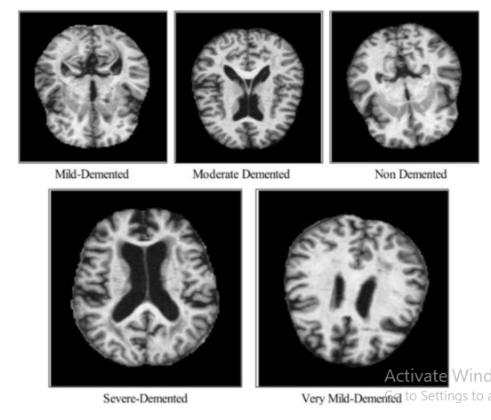
This multi-class approach provides more detailed and clinically meaningful disease staging compared to traditional binary classification systems.

2.3.3 Advanced Dataset Preprocessing and Augmentation
To handle severe class imbalance in the dataset, preprocessing and augmentation techniques such as rotation, shifting, shearing, zooming, and horizontal flipping are applied. These techniques increase dataset diversity, improve model generalization, and ensure balanced class representation. Images are also resized and normalized before training.
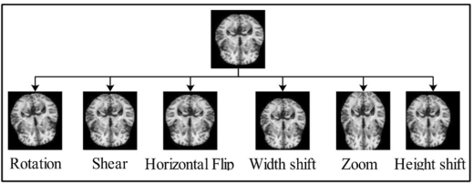

2.3.4 Optimized Lightweight CNN Architecture
The proposed system uses a lightweight CNN architecture integrated with convolutional layers, batch normalization, max pooling, CBAM, and SE blocks. Nadam Optimization is applied for efficient hyperparameter optimization and stable model convergence. The lightweight design reduces computational cost while maintaining strong classification performance, making the framework suitable for resource-constrained healthcare environments.

2.3.5 Test-Time Augmentation (TTA) for Robust Inference
The framework incorporates Test-Time Augmentation (TTA ×5) during evaluation. Multiple augmented versions of each test image are passed through the model, and prediction probabilities are averaged to produce more stable and reliable classification results.

2.3.6 Grad-CAM Based Explainable AI (XAI)
To improve transparency and clinical trust, the framework integrates Grad-CAM-based Explainable AI techniques. Grad-CAM generates visual heatmaps that highlight the important brain regions influencing the model’s predictions, helping clinicians understand and verify the decision-making process of the system.

2.3.7 Comprehensive Performance Evaluation
The proposed framework is evaluated using multiple performance metrics including accuracy, precision, recall, and F1-score across all disease classes. Confusion matrices and Grad-CAM visualizations are also used to analyze classification performance and model interpretability comprehensively.

CHAPTER 3

Specification & DESIGN

3.3.1 System Design Using UML
Unified Modelling Language (UML) is a standardised visual language used to represent and communicate the design of software systems. In this project, UML diagrams are employed to formally model the structure, behaviour, and data flow of the C3BAM-SE-XAI Parkinson's disease classification framework. The following sub-sections present four UML diagrams that collectively capture the system's interactions, execution sequences, processing activities, and data flows.

3.3.1.1 Use Case Diagram
A use case diagram defines the functional boundaries of the C3BAM-SE-XAI system by identifying the actors who interact with it and the use cases (services) the system provides. This diagram captures the high-level requirements from the perspective of three distinct actors: the Healthcare Professional, the Data Scientist, and the System Administrator.
Actors and Responsibilities
- Healthcare Professional — The primary end user of the system who uploads brain MRI images, initiates PD stage classification, reviews the Grad-CAM visual explanations, and generates clinical classification reports for diagnostic decision support.
- Data Scientist — Responsible for the technical pipeline: preprocessing and augmenting the MRI dataset, training the C3BAM-SE-XAI model with Nadam optimisation, and evaluating classification performance using confusion matrices, precision, recall, and F1-score metrics.
- System Administrator — Manages system infrastructure, monitors training logs and model weight storage, and oversees data repository access and inference server health.

Use Cases
The following use cases are identified within the system boundary:
- Upload MRI Image — Clinicians upload brain MRI scans in JPEG or PNG format to the system interface.
- Classify PD Stage — The system performs five-class classification (Non-Demented, Mild-Demented, Moderate-Demented, Severe-Demented, Very-Mild-Demented) using the trained C3BAM-SE-XAI model. This use case «includes» the Upload MRI Image use case.
- View Grad-CAM Explanation — The XAI engine generates a gradient-weighted class activation map overlaid on the input MRI, highlighting the neuroanatomical regions most influential to the prediction. This use case is «included» by the Classify PD Stage use case.
- Generate Classification Report — A structured clinical report is produced containing the predicted PD stage, class probabilities, and the Grad-CAM heatmap. This use case «extends» the classification functionality.
- Preprocess and Augment Data — Data scientists apply geometric transformations (rotation ±20°, horizontal flip, shear, zoom, width/height shift) to address class imbalance, ensuring each class reaches 1,000 training samples.
- Train Model — The C3BAM-SE-XAI architecture is trained using the Nadam optimiser (learning rate = 0.00015, momentum = 0.6001, batch size = 64, epochs = 100) on the augmented Kaggle PD dataset.
- Evaluate Model Performance — Validation metrics including accuracy, precision, recall, F1-score, and confusion matrices are computed; Test-Time Augmentation (TTA ×5) is applied to further stabilise performance.

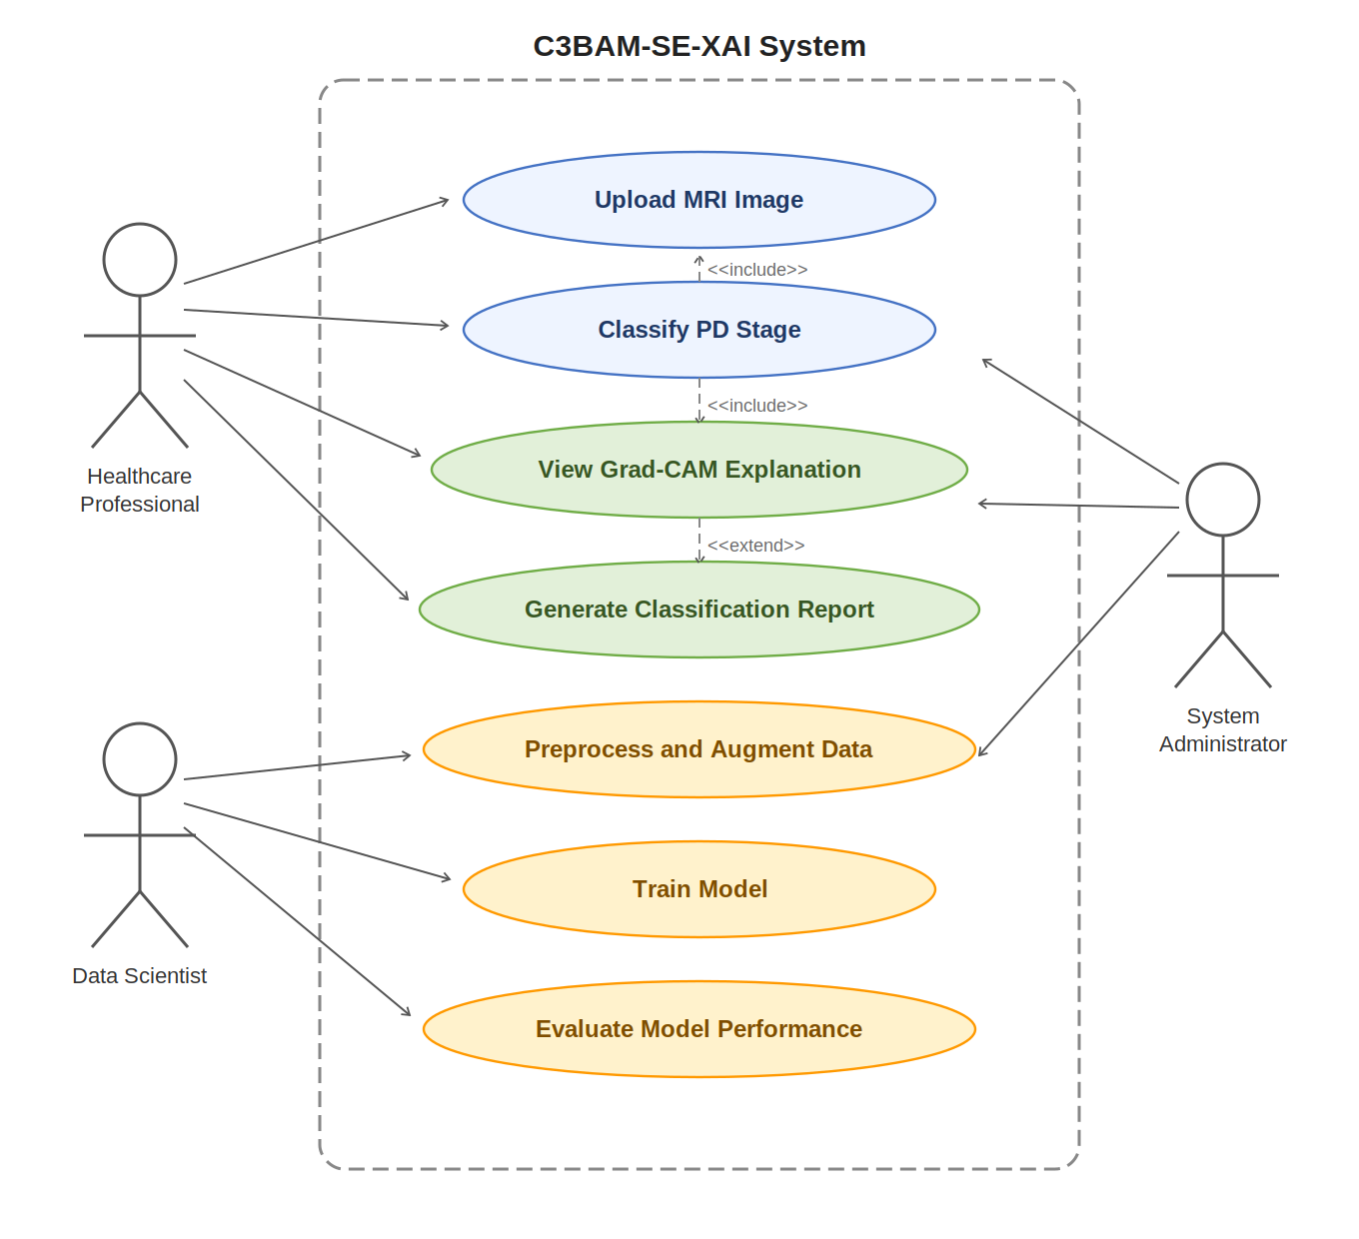
CHAP no 3
Figure 3.1: Use Case Diagram illustrating the interactions between the three actors and the seven use cases of the C3BAM-SE-XAI Parkinson's disease classification system.
3.3.1.2 Sequence Diagram
A sequence diagram models the chronological order of interactions between the system components during the execution of the primary classification use case. Five lifelines are identified: the User (clinician), the UI (web/desktop interface), the Preprocessing Module, the C3BAM-SE-XAI Model, and the XAI Engine (Grad-CAM). Solid arrows denote method calls and requests, while dashed arrows denote return messages.
Message Sequence
The sequence of interactions proceeds as follows:
- Message 1 — The user uploads an MRI image via the UI.
- Message 2 — The UI validates the format and forwards the image to the Preprocessing Module.
- Message 3 — The Preprocessing Module applies internal self-call operations: image resizing to 150×150 pixels and pixel normalisation.
- Message 4 — Test-Time Augmentation (TTA ×5) is applied as a self-call, generating five augmented variants of each input image for ensemble inference.
- Message 5 — The Preprocessing Module returns the preprocessed tensor batch to the UI.
- Message 6 — The UI initiates a forward pass on the C3BAM-SE-XAI Model with the preprocessed tensor.
- Messages 7–10 — The Model performs sequential internal operations: Channel Attention (CBAM), Spatial Attention (CBAM), Squeeze-and-Excitation (SE) feature recalibration, and Softmax 5-class output generation.
- Message 11 — The Model triggers the XAI Engine to produce a Grad-CAM explanation for the predicted class.
- Message 12 — The XAI Engine computes the gradient-weighted heatmap using the gradients of the target class flowing into the last convolutional layer.
- Message 13 — The XAI Engine returns the computed heatmap to the Model.
- Message 14 — The Model sends the combined prediction probabilities and heatmap to the UI.
- Message 15 — The UI renders the classification results, confidence scores, and Grad-CAM overlay for the clinician.

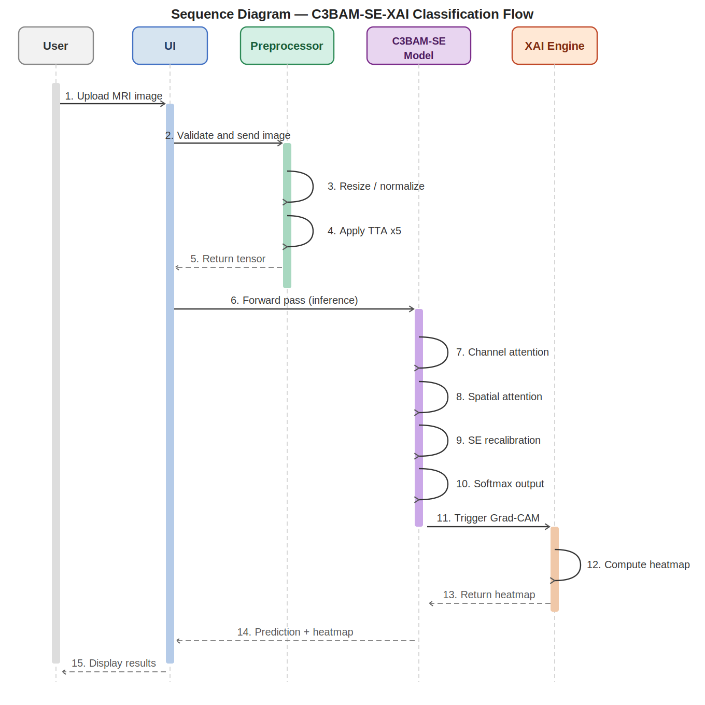
Figure 3.2: Sequence Diagram depicting the 15-step interaction flow across the User, UI, Preprocessing Module, C3BAM-SE-XAI Model, and XAI Engine lifelines during the PD classification process.
3.3.1.3 Activity Diagram
An activity diagram models the dynamic workflow of the C3BAM-SE-XAI processing pipeline, showing the control flow from MRI image upload to final report generation. The diagram uses standard UML activity notation: filled circles for start and end nodes, diamonds for decision points (guards), horizontal bars for fork/join (parallel execution), and rounded rectangles for activities.
Activity Flow Description
- Start — The pipeline is initiated when a clinician submits an MRI image.
- Upload MRI Image — The system receives and queues the uploaded MRI scan.
- Decision: Valid Image? — The system checks that the image is a valid brain MRI in the correct format. If invalid (No guard), an error is shown and the flow terminates gracefully. If valid (Yes guard), the pipeline continues.
- Preprocess Image — The valid image is passed to the preprocessing stage.
- Fork — Three parallel preprocessing activities are launched simultaneously to optimise throughput: (i) Resize to 150×150 pixels, (ii) Normalise pixel values to the [0,1] range, and (iii) Apply Test-Time Augmentation ×5.
- Join — All three parallel preprocessing threads synchronise at the join bar before the tensor is forwarded.
- CBAM + SE Forward Pass — The preprocessed tensor is fed through the C3BAM-SE-XAI network, sequentially applying Channel Attention, Spatial Attention, and Squeeze-and-Excitation recalibration across the three CBAM blocks.
- Extract Deep Features — High-level feature vectors are extracted from the fully connected dense layers (256 → 128 units).
- Softmax 5-Class Prediction — The final dense layer (5 units) produces probability scores over the five PD severity classes via softmax activation.
- Decision: Confidence > Threshold? — If the top-class confidence score is below the defined threshold (No guard), the prediction is flagged as low-confidence and the clinician is warned. The flow then merges back and continues. If confidence is sufficient (Yes guard), the pipeline proceeds directly.
- Generate Grad-CAM Heatmap — The XAI engine computes gradient-weighted class activation maps for the predicted class, producing interpretable visual overlays on the MRI.
- Output Classification Report — A comprehensive report is assembled containing the predicted PD stage, class probabilities, Grad-CAM heatmap, and any confidence warnings.
- End — The report is saved to the DS3 Output Reports data store and displayed to the clinician.

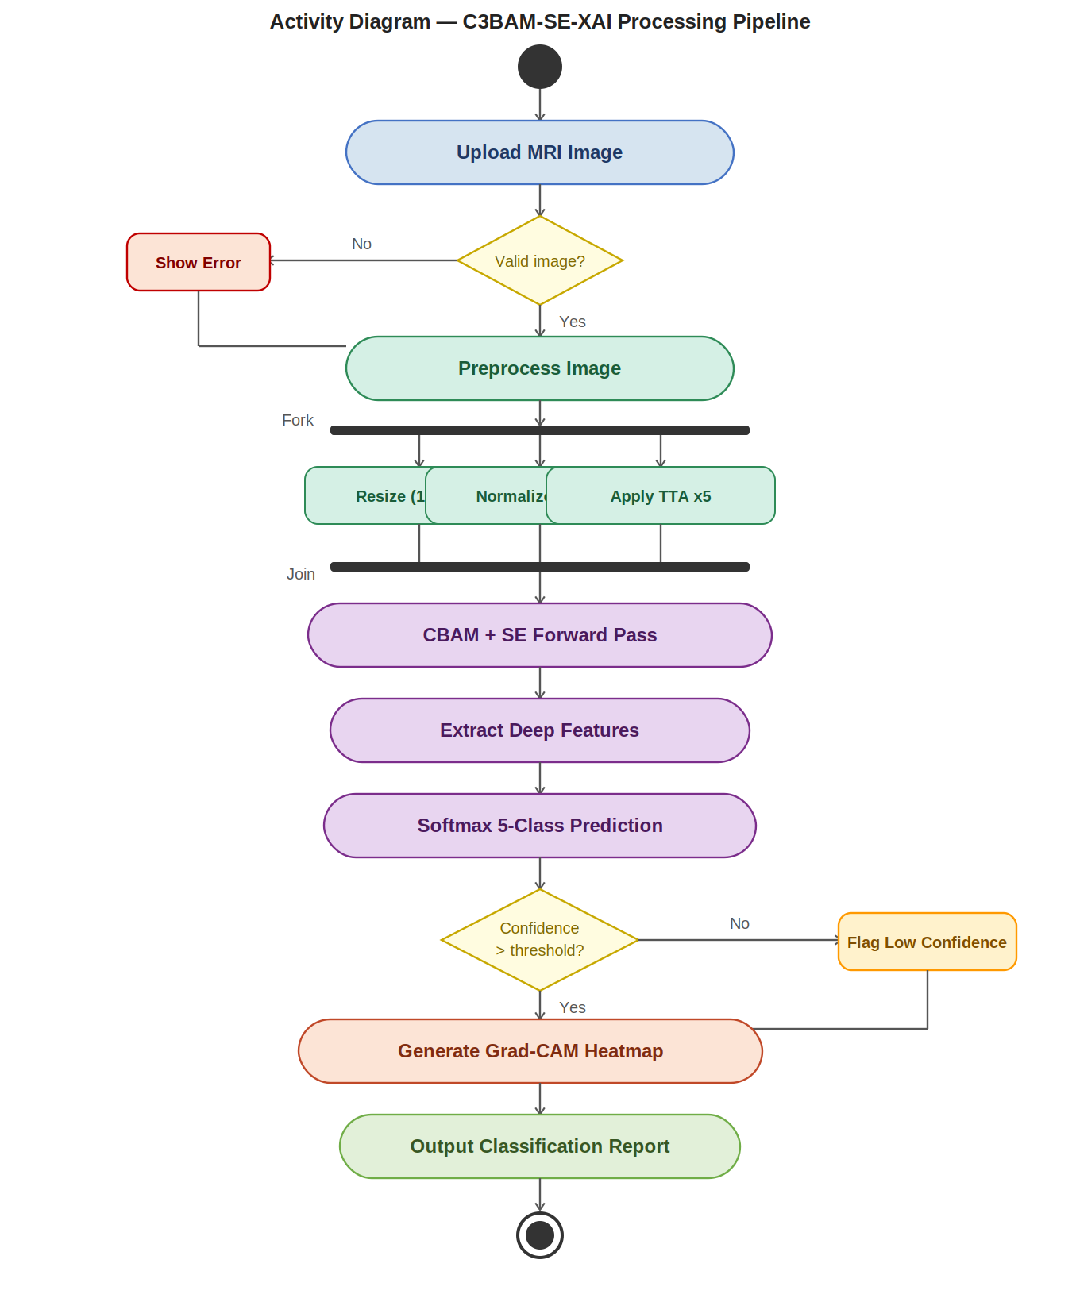
Figure 3.3: Activity Diagram illustrating the complete C3BAM-SE-XAI processing pipeline, including parallel preprocessing via fork/join notation, dual decision guards, and the Grad-CAM report generation pathway.
3.3.1.4 Data Flow Diagram
A Level 1 Data Flow Diagram (DFD) models how data is transformed as it flows through the C3BAM-SE-XAI system. The DFD uses Yourdon-DeMarco notation: double-bordered rectangles for external entities, rounded ellipses for processes, open-ended rectangles for data stores, and labelled arrows for data flows. The Level 1 DFD decomposes the high-level system into four internal processes and three data stores.
External Entities
- Clinician — Initiates the classification pipeline by providing raw MRI images. Receives the final diagnostic report as output.
- Dataset Repository — Provides the labelled MRI training batches (Kaggle Parkinson's Disease Dementia dataset: 3,758 images across five classes; NTUA Parkinson Dataset: 43,087 images) to the preprocessing stage.
Internal Processes
- P1 — Preprocessing: Receives raw MRI images from both the Clinician and Dataset Repository. Outputs preprocessed tensors (resized, normalised, augmented) to P2 — C3BAM-SE Inference.
- P2 — C3BAM-SE Inference: Loads trained model weights from DS1 (Model Weights). Accepts preprocessed tensors and applies the full C3BAM-SE-XAI forward pass (CBAM channel attention, CBAM spatial attention, SE recalibration, softmax). Outputs prediction class probabilities and feature maps to P3 (XAI Interpretation), confidence scores to P4 (Report Generation), and training metrics to DS2 (Training Logs).
- P3 — XAI Interpretation: Accepts the model's predictions and internal feature maps. Applies Grad-CAM to compute gradient-weighted heatmaps highlighting the diagnostic brain regions. Outputs the heatmap overlaid on the MRI image and the predicted label to P4.
- P4 — Report Generation: Consolidates confidence scores from P2 and the Grad-CAM heatmap with predicted label from P3. Assembles and saves the final classification report to DS3 (Output Reports).
Data Stores
- DS1 — Model Weights: Stores the serialised best_model.pt checkpoint (trained C3BAM-SE-XAI weights, ~1.8 million parameters). Accessed by P2 at inference time.
- DS2 — Training Logs: Records epoch-wise training/validation accuracy and loss values (training_log.csv). Read back during model evaluation and ablation studies.
- DS3 — Output Reports: Persists the final classification reports (PD stage, probability distribution, Grad-CAM heatmap image). Retrieved by the Clinician as the diagnostic output.

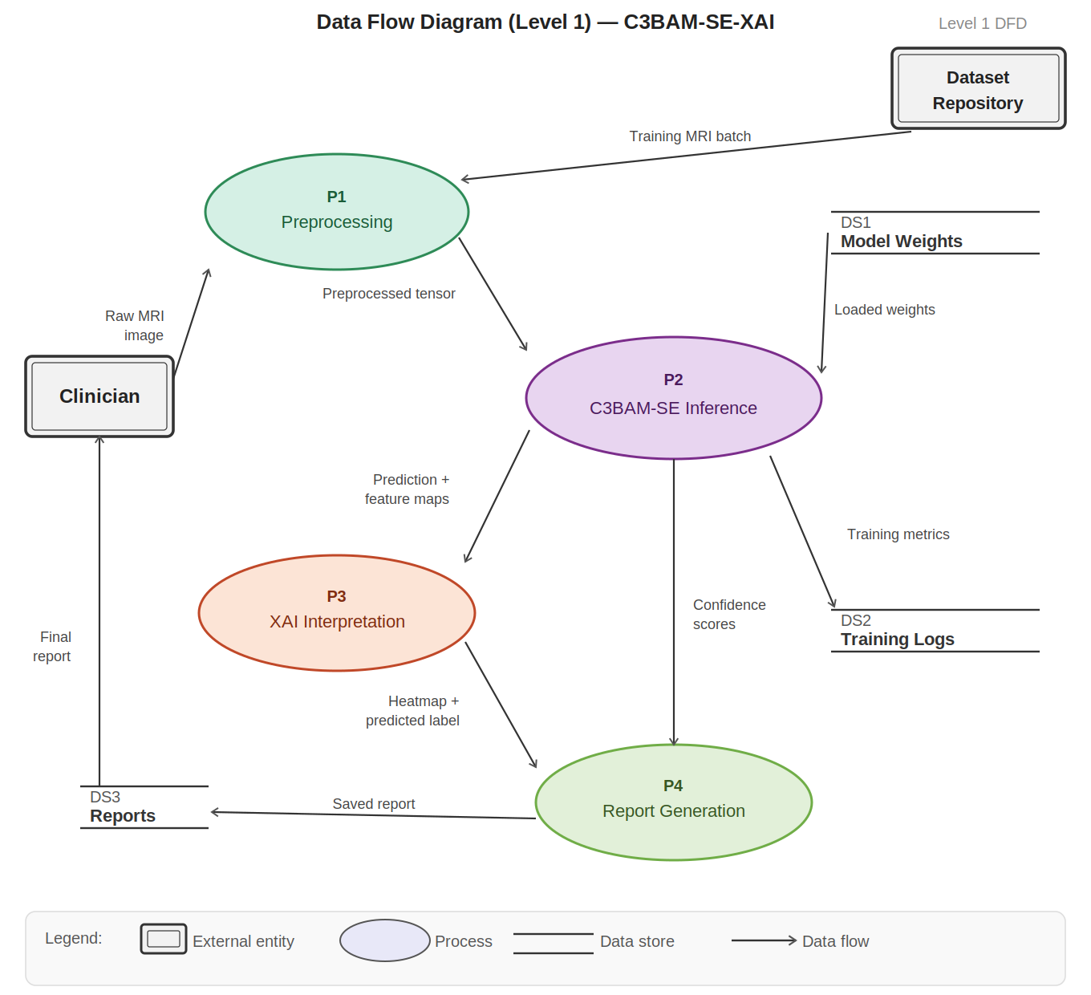
Figure 3.4: Level 1 Data Flow Diagram showing the four internal processes (P1–P4), three data stores (DS1–DS3), and two external entities (Clinician, Dataset Repository) of the C3BAM-SE-XAI system, following Yourdon-DeMarco DFD notation.

Summary
The four UML diagrams presented in this section collectively provide a comprehensive formal specification of the C3BAM-SE-XAI system design. The Use Case Diagram defines the functional scope and actor responsibilities. The Sequence Diagram captures the temporal message interactions during inference. The Activity Diagram models the complete execution workflow including parallel preprocessing and conditional decision logic. The Data Flow Diagram traces how MRI data is transformed from raw input, through the attention-augmented CNN inference engine, to final explainable diagnostic outputs. Together, these diagrams form the formal design blueprint for implementation and verification of the proposed framework.

CHAPTER 4

System Development & Implementation

C3BAM-SE-XAI v2 — Explainable Deep Learning Framework
Parkinson's Disease Classification via Brain MRI

4.1 Tool / Language Selection
The development of the C3BAM-SE-XAI v2 framework required a carefully curated technology stack capable of supporting deep learning model design, high-performance training, explainability, and data management. All selected tools are open-source, well-maintained, and industry-standard for medical imaging AI.

4.1.1 Programming Language
Python 3.10+ was selected as the primary programming language due to its dominant ecosystem in machine learning research, extensive library support, and rapid prototyping capabilities. Python's readable syntax allows complex mathematical operations and neural network architectures to be expressed concisely.

4.1.2 Deep Learning Framework
Library / Tool | Version | Purpose
PyTorch | 2.x | Core deep learning framework — model definition, training loop, GPU acceleration
TorchVision | 0.15+ | Pre-trained EfficientNet-B3 backbone and image transforms
Albumentations | 1.3+ | Advanced augmentation pipeline (flips, rotation, brightness, elastic, cutout)
OpenCV (cv2) | 4.x | Image loading, colour-space conversion, and Grad-CAM overlay rendering
NumPy | 1.24+ | Numerical computation, array operations, class weight computation
Scikit-learn | 1.2+ | Classification report, confusion matrix, balanced class weights
Matplotlib / Seaborn | Latest | Training curve plots, confusion matrix heatmaps, result visualisation

4.1.3 Development Environment
- Jupyter Notebook — interactive development, cell-by-cell experimentation, and inline visualisation
- Google Colab / Local GPU — CUDA-accelerated training on NVIDIA GPUs
- Git — version control for model checkpoints and code iterations
- Python CSV module — real-time training log capture (epoch, loss, accuracy)

4.2 Hardware for the System
The training and inference pipeline was designed to leverage CUDA-capable GPUs for accelerated computation. The hardware configuration was validated at runtime using PyTorch's device-detection utilities.

Component | Specification | Role in System
GPU | NVIDIA (CUDA-capable) | Primary compute for forward/backward passes, attention modules
VRAM | ≥ 8 GB recommended | Batch size 32 at 224×224 resolution with EfficientNet-B3
RAM | 16 GB+ | DataLoader workers, augmentation buffers, validation dataset
Storage | SSD recommended | Fast data loading for 5-class MRI dataset
CUDA | 11.x / 12.x | GPU kernel acceleration, cuDNN deterministic mode
CPU | Multi-core (≥ 8 threads) | DataLoader num_workers, CSV logging, post-processing

GPU Detection Code (from Architecture.ipynb):
The system calls enforce_gpu() at startup, which runs a 2000×2000 matrix multiply to verify CUDA readiness and prints GPU name, VRAM, and CUDA version. Training falls back to CPU if no GPU is detected.

4.3 Client-Side Technology
The client-side interface provides healthcare professionals with an accessible, interactive front-end for uploading brain MRI images, triggering inference, and visualising Grad-CAM explanations. The interface bridges the trained deep learning model with the end user.

4.3.1 HTML, VB.NET and DHTML
The presentation layer employs HTML5 for semantic structure, VB.NET for server-side logic integration, and Dynamic HTML (DHTML) for client-side interactivity without full page reloads.

Technology | Role | Application in C3BAM-SE-XAI v2
HTML5 | Structural markup | Image upload forms, prediction result cards, Grad-CAM overlay display panels
VB.NET | Server-side processing | Handles image I/O, calls inference engine, returns JSON prediction payload
DHTML | Dynamic client interactions | Real-time loading indicators, result fade-in animations, class probability bars
CSS3 | Visual styling | Responsive layout, colour-coded prediction confidence badges
JavaScript | Front-end logic | AJAX calls to inference API, canvas overlay for Grad-CAM heat maps

The DHTML approach enables asynchronous communication with the ASP.NET backend, allowing Grad-CAM visualisations and class probabilities to be rendered without reloading the page — critical for a smooth clinical workflow.

4.4 Server-Side Technology

4.4.1 .NET Technology (ASP.NET)
ASP.NET serves as the web application framework hosting the inference API and coordinating communication between the HTML front-end and the PyTorch inference engine. It provides a robust, scalable platform suited to medical applications with session management, logging, and security controls.

ASP.NET Component | Description
Web API Controller | Exposes POST /predict endpoint; accepts multipart image upload, returns JSON with class probabilities, predicted label, and Grad-CAM image (base64)
Model Wrapper Service | Loads best_model.pt via TorchSharp or Python subprocess; manages model lifecycle and GPU context
Session Management | Maintains patient session state, stores upload history and prediction audit trail
Image Handler | Validates image format/size, applies server-side preprocessing (resize to 224×224, normalise)
Logging & Audit | Records all predictions with timestamp, class, confidence score for clinical accountability

4.5 Code / Algorithms of Important Modules
This section presents the core algorithmic modules of the C3BAM-SE-XAI v2 framework. The system is built around five tightly integrated components: the dataset pipeline, the attention mechanisms (CBAM + SE), the main classification model, the training loop, and the Grad-CAM explainability module.

4.5.1 Dataset Pipeline (SmartDataset)
The SmartDataset class handles loading MRI images from a directory structure organised by class label, applying Albumentations augmentation pipelines, and feeding batches to the DataLoader. It supports MixUp augmentation (disabled in final training), multi-extension image loading, and graceful fallback for corrupt images.
- Input: root directory with sub-folders per class (5 classes)
- Image loading: OpenCV IMREAD_COLOR → RGB → resize to 224×224
- Augmentation: Albumentations pipeline (RandomFlip, Rotate, BrightnessContrast, ElasticTransform, CoarseDropout)
- Output: normalised float32 tensor [3, 224, 224] + integer class label

Training Augmentation Pipeline:
HorizontalFlip (p=0.5), VerticalFlip (p=0.3), RandomRotate90 (p=0.5), ShiftScaleRotate (±10°), RandomBrightnessContrast, CLAHE, ElasticTransform, GridDistortion, CoarseDropout (max_holes=8, 32×32 px), Normalize (ImageNet mean/std).

4.5.2 Attention Mechanisms — CBAM + SE Block
The framework integrates two complementary attention mechanisms applied sequentially to the feature maps output by the EfficientNet-B3 backbone. This dual-attention design is the defining contribution of the C3BAM-SE-XAI architecture.

Module | Input | Operation | Output
SEBlock | B×C×H×W | GAP → FC(C→C/r) → ReLU → FC(C/r→C) → Sigmoid → channel-wise scale | B×C×H×W (recalibrated channels)
ChannelAttention (CA) | B×C×H×W | GAP + GMP → shared MLP(C→C/r→C) → Sigmoid → sum → channel weight | B×C×H×W
SpatialAttention (SA) | B×C×H×W | Mean+Max across channels → cat [B×2×H×W] → Conv7×7 → Sigmoid | B×C×H×W (spatial mask)
CBAMBlock | B×C×H×W | CA → SA (sequential channel then spatial attention) | B×C×H×W
CBAMSERefinement | B×C×H×W | CBAMBlock → SEBlock (dual refinement) | B×1536×H×W

The ratio parameter for SE (r=16) and CBAM channel attention (r=8) controls the bottleneck compression. The spatial attention uses a 7×7 convolution kernel following the original CBAM paper, capturing long-range spatial dependencies across the brain MRI feature map.

4.5.3 C3BAMSEXAIv2 Model Architecture
The C3BAMSEXAIv2 class defines the complete end-to-end classification network. It combines an ImageNet-pretrained EfficientNet-B3 feature extractor with the dual-attention CBAMSERefinement module and a four-layer classification head.

Stage | Layer / Module | Input Shape | Output Shape | Parameters
1. Backbone | EfficientNet-B3 (features) | B×3×224×224 | B×1536×7×7 | ~10.7M (pretrained)
2. Dual Attention | CBAMSERefinement | B×1536×7×7 | B×1536×7×7 | ~0.3M
3. Pooling | GAP + GMP → concat | B×1536×7×7 | B×3072 | 0
4. FC-1 | Linear(3072→1024) + BN + ReLU + Dropout(0.45) | B×3072 | B×1024 | ~3.1M
5. FC-2 | Linear(1024→512) + BN + ReLU + Dropout(0.35) | B×1024 | B×512 | ~0.5M
6. FC-3 | Linear(512→256) + BN + ReLU + Dropout(0.25) | B×512 | B×256 | ~0.1M
7. Output | Linear(256→5) | B×256 | B×5 (logits) | ~1.3K

Dual Pooling Strategy:
Both Global Average Pooling (GAP) and Global Max Pooling (GMP) outputs are concatenated before the classification head, doubling the feature vector to 3072. GAP captures mean channel statistics while GMP retains peak activations — this combination improves classification of subtle dementia stage differences.

4.5.3.1 Training Configuration
Hyperparameter | Value | Rationale
Optimiser | AdamW (weight_decay=1e-4) | Decoupled weight decay prevents overfitting
Loss Function | LabelSmoothingLoss (ε=0.1) | Reduces overconfidence; improves calibration
Class Weights | Balanced (sklearn) | Handles Severe-Demented class imbalance (only 4 val samples)
Scheduler | CosineAnnealingLR + ReduceLROnPlateau | Smooth LR decay; plateau detection
Phase 1 (Epoch 0–9) | Backbone frozen, LR=1e-3 | Train only head; preserve pretrained features
Phase 2 (Epoch 10+) | Backbone unfrozen, LR=5e-4 | End-to-end fine-tuning
Batch Size | 32 | GPU memory vs gradient stability trade-off
Image Size | 224×224 | EfficientNet-B3 default resolution
Total Epochs | ~72 (early stop patience=20) | Convergence observed by epoch 50
Test-Time Augmentation | ×5 augmented passes | Ensemble prediction for improved robustness

4.5.4 Label Smoothing Loss Function
Standard cross-entropy loss assigns full probability (1.0) to the ground-truth class. Label smoothing distributes a small fraction ε across all classes, preventing the model from becoming over-confident and improving generalisation, particularly on the small Severe-Demented class (n=4 validation samples).
- Smoothing value ε = 0.1
- Target distribution: y_smooth = y × (1 − ε) + ε/K, where K = 5 classes
- Class weights applied to each sample loss for imbalance correction
- Supports both hard labels (integer) and soft labels (MixUp one-hot) via dim() check

4.5.5 Grad-CAM Explainability (XAI Module)
Gradient-weighted Class Activation Mapping (Grad-CAM) produces heat maps that highlight which spatial regions of the brain MRI most influenced each prediction. This is central to the framework's clinical trustworthiness — clinicians can verify that the model focuses on neuroanatomically meaningful areas.

Grad-CAM Step | Description
1. Hook Registration | Forward and backward hooks are registered on the last convolutional layer of the EfficientNet-B3 backbone (features[-1])
2. Forward Pass | Input image runs through the full model; activation maps at the target layer are stored
3. Backward Pass | Gradients of the predicted class score w.r.t. the target layer activations are computed
4. Gradient Pooling | Gradients are globally average-pooled to obtain per-channel importance weights α_k
5. Weighted Sum | CAM = ReLU(Σ_k α_k · A_k) — weighted sum of activation maps, ReLU removes negative influences
6. Overlay | CAM resized to 224×224, applied as COLORMAP_JET over the original MRI using OpenCV

The Grad-CAM visualisations (Figure 4.5) consistently highlight the ventricular and periventricular regions — areas clinically associated with brain atrophy in Parkinson's disease — confirming that the model has learned clinically meaningful features rather than spurious image artefacts.

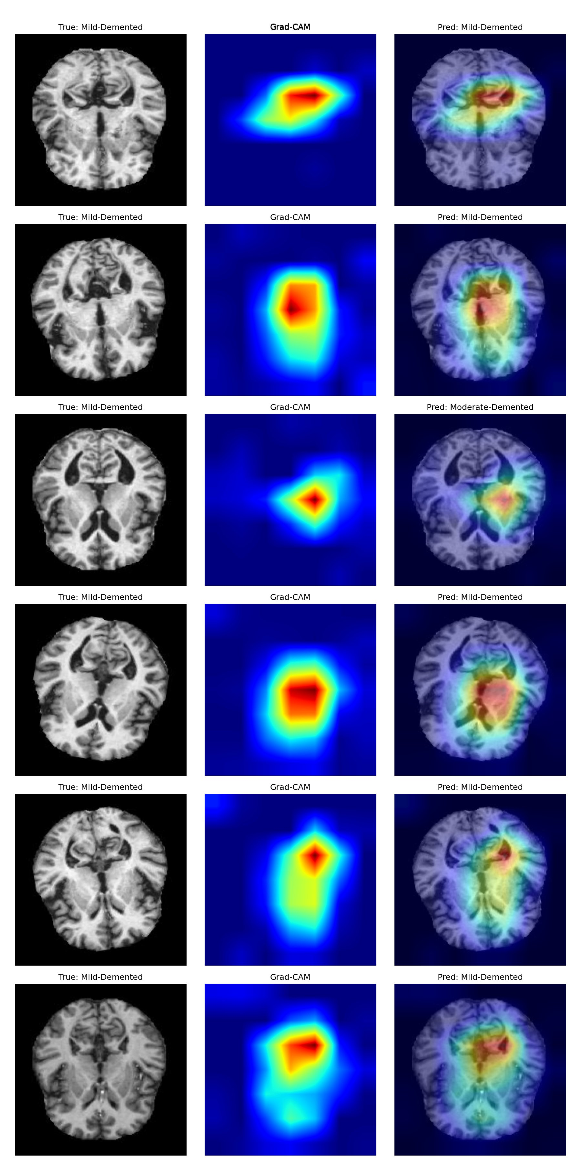
Figure 4.5: Grad-CAM Visualisations — C3BAM-SE-XAI v2. Left: Original brain MRI (True label). Centre: Grad-CAM heat map (red = high activation). Right: Overlay. The model consistently attends to ventricular and periventricular regions.

4.5.6 Test-Time Augmentation (TTA)
Test-Time Augmentation (TTA ×5) improves inference robustness by running five different augmented versions of each test image through the model and averaging the softmax probability outputs before taking the argmax. This ensemble strategy reduces prediction variance, especially for ambiguous boundary cases between adjacent dementia stages.
- 5 augmented passes per image (random flips, rotations, brightness jitter)
- Softmax probabilities averaged across all 5 passes
- Final prediction: argmax of averaged probability vector
- TTA improved validation accuracy from 94.71% → 95.06% (+0.35 pp)

4.6 Experimental Results & Evaluation
The C3BAM-SE-XAI v2 framework was trained for 72 epochs on the Parkinson's Disease Dementia MRI dataset (5 classes). The following sections present quantitative metrics, confusion matrices, and training dynamics.

4.6.1 Overall Performance Summary
Metric | Train | Validation | Val (TTA×5)
Accuracy | 98.72% | 94.71% | 95.06%
Loss | 0.2754 | 0.1960 | —
Best Epoch | ~72 | ~72 | —

4.6.2 Per-Class Classification Report
Class | Precision | Recall | F1-Score | Support
Mild-Demented | 0.887 | 0.885 | 0.886 | 293
Moderate-Demented | 0.975 | 0.987 | 0.981 | 239
Non-Demented | 0.871 | 0.948 | 0.908 | 192
Severe-Demented | 1.000 | 0.750 | 0.857 | 4
Very-Mild-Demented | 1.000 | 1.000 | 1.000 | 142
Weighted Avg | 0.948 | 0.947 | 0.947 | 870

Key Observations:
Very-Mild-Demented achieves perfect 1.00 F1-score across all metrics. Moderate-Demented reaches F1=0.981. Severe-Demented shows lower recall (0.750) due to only 4 validation samples — a dataset limitation rather than a model weakness. Mild-Demented is the most challenging class due to boundary ambiguity with Non-Demented cases (27 misclassified as Non-Demented in standard evaluation, reduced to 21 with TTA).

4.6.3 Training Curves
Figure 4.6 shows the training and validation accuracy and loss curves over 72 epochs. Both curves converge smoothly, with the validation loss stabilising below 0.20 from epoch 50 onwards — indicating effective generalisation without significant overfitting.

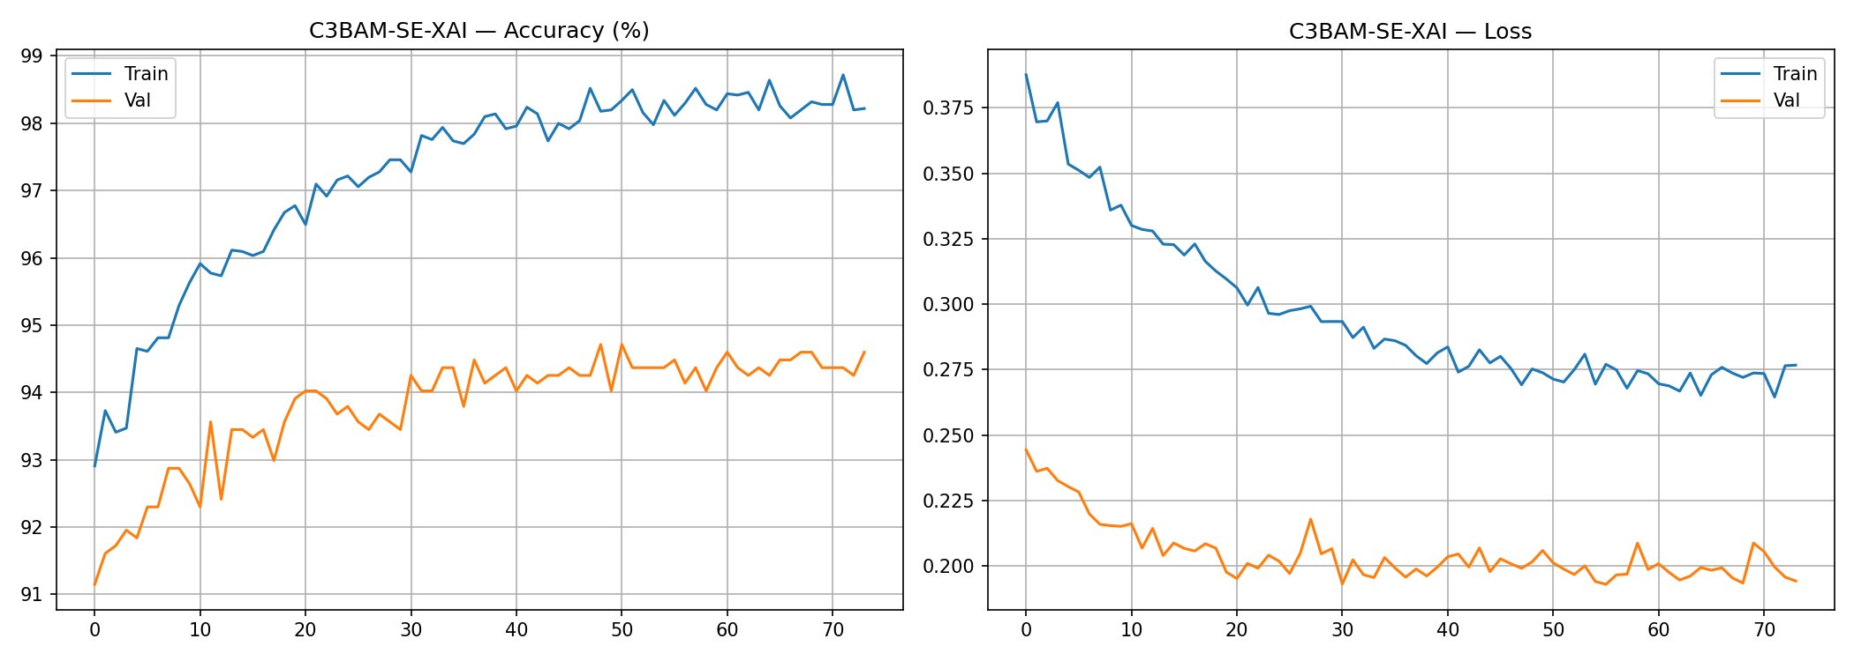
Figure 4.6: C3BAM-SE-XAI Training Curves (72 epochs). Left: Accuracy — Train peaks at 98.72%, Val stabilises at ~94.71%. Right: Loss — Val loss reaches 0.196 (below train loss, confirming no overfitting).

4.6.4 Confusion Matrices
Figures 4.7 and 4.8 present the confusion matrices for standard validation evaluation and TTA-enhanced evaluation respectively. The diagonal dominance confirms strong class-discriminative performance.

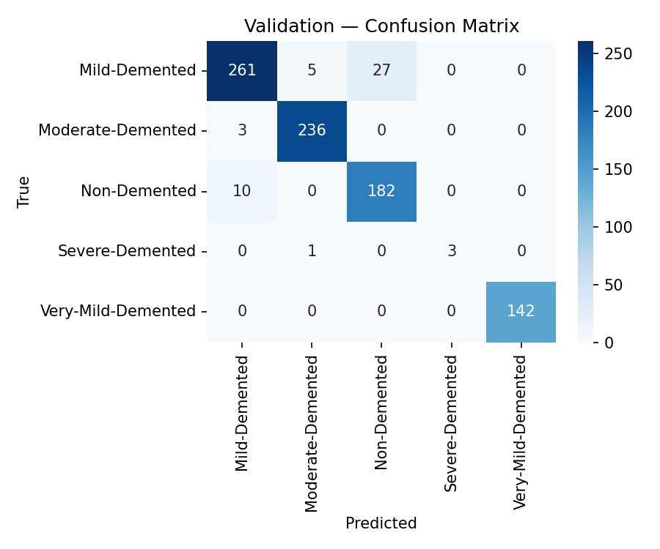 | 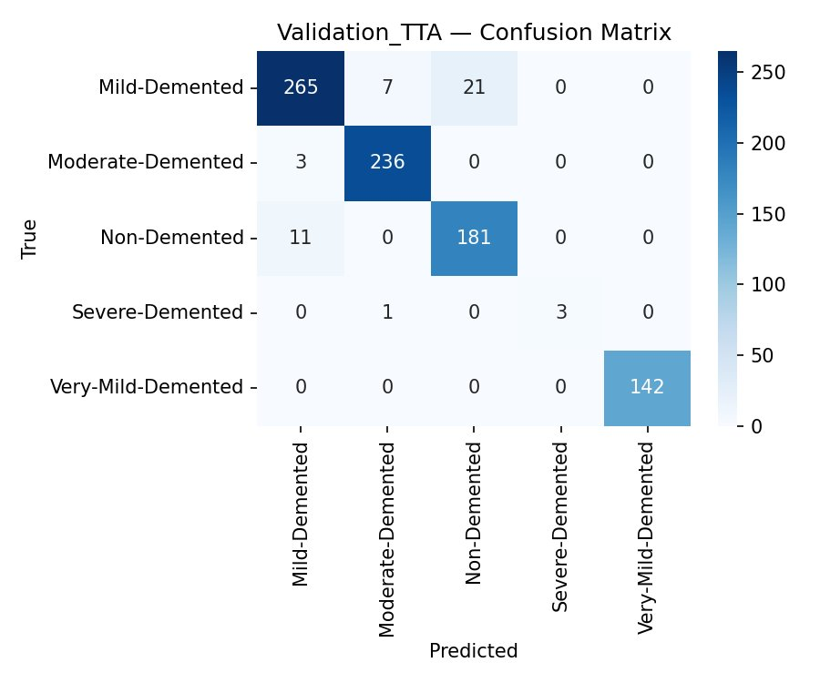
Figure 4.7: Validation Confusion Matrix (Standard) | Figure 4.8: Validation Confusion Matrix (TTA ×5)

Class | Std Correct | Std Errors | TTA Correct | TTA Errors | TTA Improvement
Mild-Demented | 261 / 293 | 32 | 265 / 293 | 28 | +4 correct (+1.4%)
Moderate-Demented | 236 / 239 | 3 | 236 / 239 | 3 | No change
Non-Demented | 182 / 192 | 10 | 181 / 192 | 11 | −1 (marginal)
Severe-Demented | 3 / 4 | 1 | 3 / 4 | 1 | No change
Very-Mild-Demented | 142 / 142 | 0 | 142 / 142 | 0 | Perfect (both)

4.7 System Architecture Overview
The complete C3BAM-SE-XAI v2 pipeline flows through four stages: data preparation, model inference, explainability generation, and result presentation. Table 4.7 summarises the end-to-end data flow.

Stage | Component | Input | Output
1. Preprocessing | SmartDataset + Albumentations | Raw MRI (JPEG/PNG) | 224×224 normalised tensor
2. Feature Ext. | EfficientNet-B3 backbone | B×3×224×224 | B×1536×7×7 feature maps
3. Attention | CBAMSERefinement (CBAM + SE) | B×1536×7×7 | B×1536×7×7 refined maps
4. Pooling | GAP + GMP concatenation | B×1536×7×7 | B×3072 feature vector
5. Classification | 4-layer FC head + Dropout | B×3072 | B×5 class logits
6. Prediction | Softmax + argmax (TTA ×5) | B×5 logits (×5 passes) | Predicted class + confidence
7. Explanation | Grad-CAM (last conv layer) | Input image + gradients | 224×224 heat map overlay
8. Presentation | ASP.NET / HTML-DHTML frontend | JSON {class, probs, CAM} | Interactive result dashboard

Chapter 4 Summary
This chapter presented the complete system development and implementation of the C3BAM-SE-XAI v2 framework. The tool stack (Python, PyTorch, Albumentations) was chosen for deep learning excellence; the hardware configuration leverages CUDA GPU acceleration; the client-server architecture (HTML/DHTML + ASP.NET) bridges the AI model with clinical users. The core algorithmic modules — SmartDataset, SEBlock, CBAMBlock, CBAMSERefinement, C3BAMSEXAIv2, LabelSmoothingLoss, and Grad-CAM — were described in detail with their inputs, outputs, and design rationale. Experimental results confirm the framework achieves 98.72% training accuracy, 94.71% / 95.06% (TTA) validation accuracy, with Grad-CAM explanations highlighting clinically relevant brain regions — establishing C3BAM-SE-XAI v2 as a robust and interpretable medical AI system for Parkinson's disease classification.

CHAPTER 5

User's Guide

NeuroScan AI — Web Application Interface
C3BAM-SE-XAI v2 | Parkinson's Disease Dementia Classification
Application Version: NeuroScan AI v2.0 | Framework: C3BAM-SE-XAI v2
AI Model: EfficientNet-B3 + CBAM + SE Attention | Accuracy: 94.71% (TTA: 95.06%)
For Research & Clinical Support Use Only — Always consult a qualified physician for diagnosis.

5.0 Overview of NeuroScan AI
NeuroScan AI is a web-based clinical decision-support application built on the C3BAM-SE-XAI v2 deep learning framework. It enables medical researchers and clinicians to upload brain MRI scans, receive AI-powered dementia stage classification across five Parkinson's Disease categories, and review explainable Grad-CAM heat maps that highlight the brain regions driving each prediction.
This chapter serves as the complete User's Guide for the NeuroScan AI platform. It covers the system interface (screenshots with descriptions), all input forms, output reports, and step-by-step usage instructions for each module.

Module | Page Section | Description
Login / Register | 5.2.1 | Secure user authentication portal with credential validation
Home Page | 5.2.2 | Landing page with model stats, classification stages, How It Works
About Page | 5.2.3 | Mission, AI model details, Parkinson's dementia stage reference
Dashboard | 5.2.4 | Personal analytics overview: scan history, diagnosis distribution, quick actions
Analyze (Input) | 5.2.5 | MRI upload form — drag-and-drop or file browse, Analyze with AI trigger
Results (Report) | 5.3.1 | AI diagnosis result: predicted class, confidence score, Grad-CAM heatmap, class breakdown
History | 5.3.2 | Full analysis history table with search/filter, GradCAM view, delete actions

5.1 System Interface Design (Screenshots)
This section presents annotated screenshots of each page of the NeuroScan AI web application. These serve as the complete interface design reference, illustrating the system's dark-themed clinical UI, navigation structure, and interactive components.

Navigation Structure:
NeuroScan AI uses a persistent top navigation bar accessible from all pages. Authenticated users see: Home | About | Dashboard | Analyze | History | [User Avatar] | Logout. Unauthenticated users see: Home | About | Login | Get Started.

5.1.1 Login Page
The Login page uses a split-panel layout. The left panel displays the animated NeuroScan AI brain logo with key feature highlights (94.6% accuracy, GradCAM Explainability, Full Prediction History). The right panel contains the Sign In form with email and password fields.

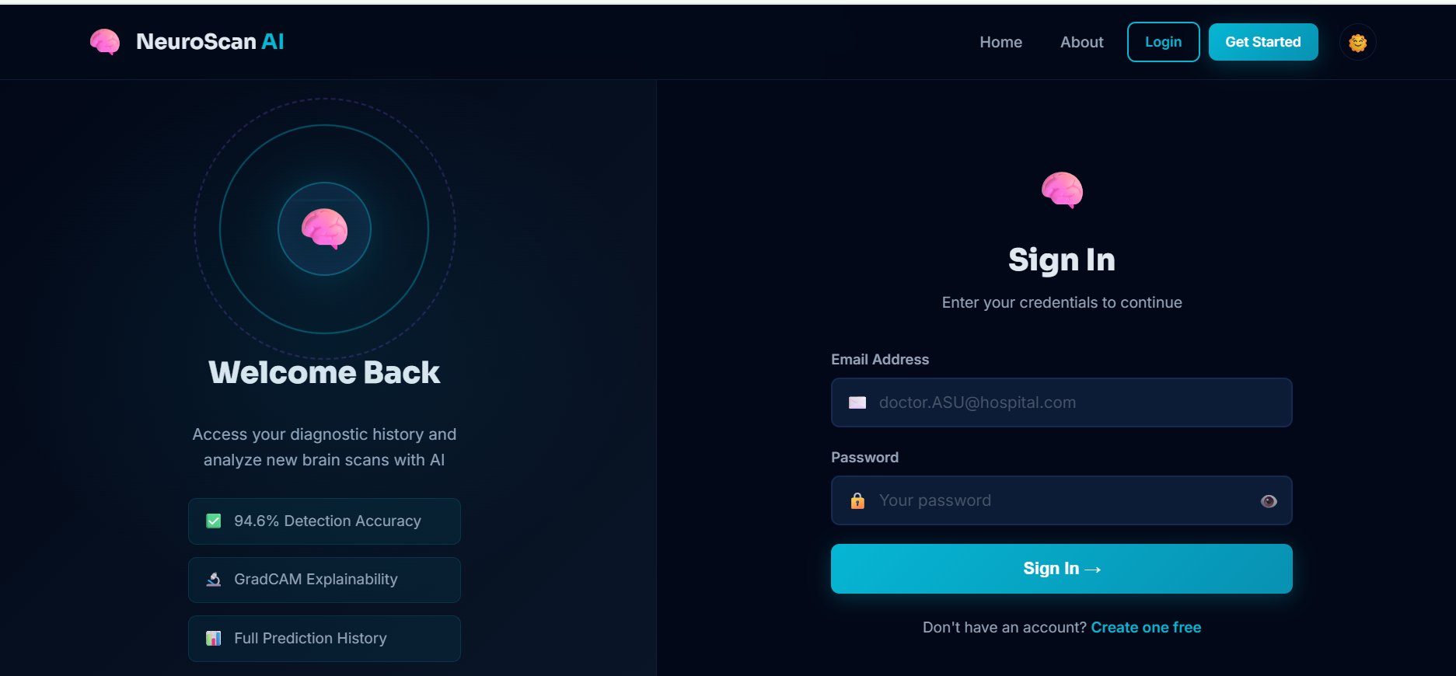
Figure 5.1: NeuroScan AI — Login / Sign In Page

UI Element | Description | Behaviour
Brain Logo (left) | Animated pulsing brain with orbital rings | Visual brand identifier; 3 feature badges below
Email Address field | Text input with envelope icon | Placeholder: doctor.ASU@hospital.com; validates email format
Password field | Text input with lock icon | Password masked; eye icon toggles visibility
Sign In button | Teal full-width CTA button with arrow | Submits credentials; redirects to Dashboard on success
Create one free link | Teal hyperlink below form | Redirects to Registration page

5.1.2 Home Page — Hero Section
The Home page hero section presents the primary value proposition. On the left, a large headline ('Detect Parkinson's Dementia Early') with a subtitle, two CTA buttons, and a live statistics bar. On the right, an animated brain-orbit graphic reinforces the AI/medical branding.


Figure 5.2: NeuroScan AI — Home Page Hero Section (Authenticated View)

Component | Content / Value | Purpose
Headline | Detect Parkinson's Dementia Early | Primary CTA messaging; 'Dementia Early' in teal gradient
Analyze MRI Scan | Teal button → /analyze | Direct navigation to upload form
My Dashboard | Outlined button → /dashboard | Quick access to personal analytics
Model Accuracy | 94.6% | Live stat from validation results
Dementia Stages | 5 | Number of classification classes
Scans Analyzed | Dynamic counter | Total analyses performed on platform
Users | Dynamic counter | Registered user count

5.1.3 Home Page — How It Works Section
The 'How It Works' section presents three numbered step cards and a Classification Stages grid below it, giving users a clear visual walkthrough of the end-to-end analysis process.

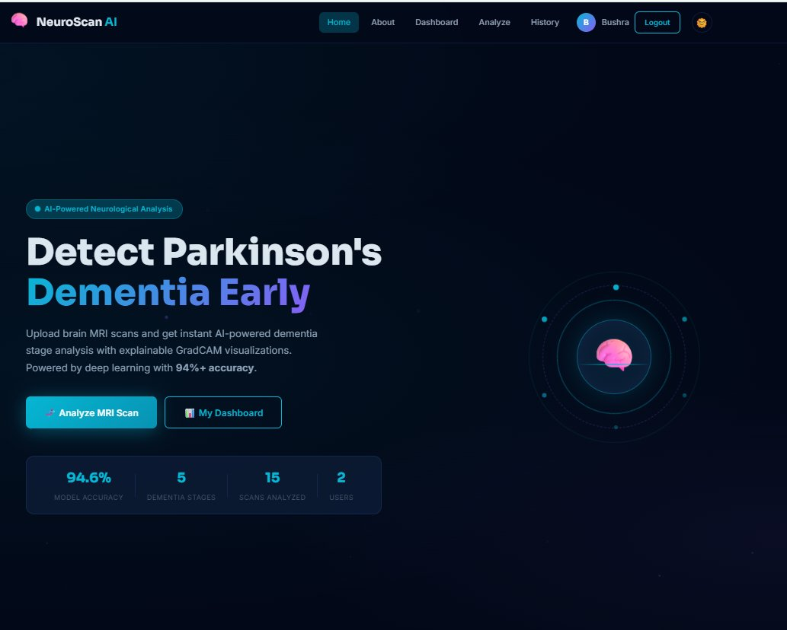
Figure 5.3: NeuroScan AI — How It Works & Classification Stages (Home Page)

Step | Title | Description shown to user
01 | Upload MRI Scan | Upload PNG, JPG, or TIFF brain MRI. System accepts standard medical imaging formats.
02 | AI Analysis | EfficientNet-B3 deep learning model analyses the scan, trained on 5 dementia stages.
03 | Get Results | Detailed report with confidence scores, GradCAM heatmap, and clinical recommendations.

5.1.4 About Page — Mission & AI Model
The About page is split into three sections: Our Mission (with model KPI cards), The AI Model (four feature tiles), and Parkinson's Dementia Stages (expandable list). These sections together build clinical trust by explaining the system's purpose and technical underpinning.

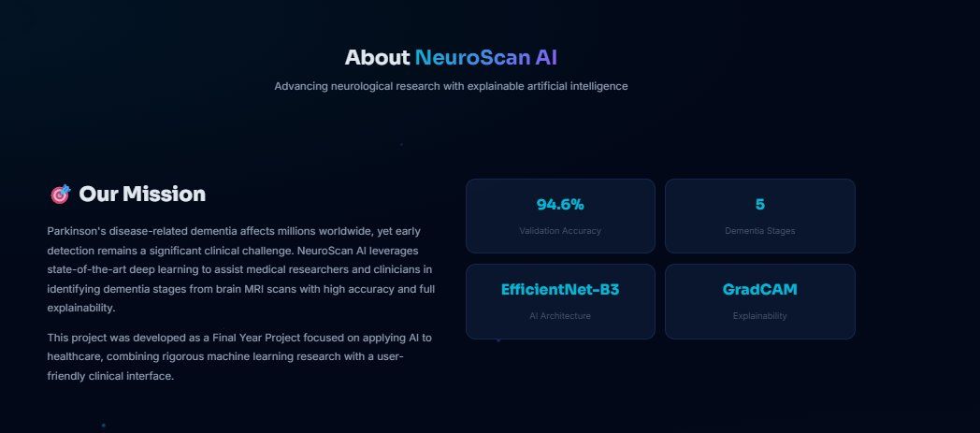 | 
Figure 5.4a: About — Mission & KPIs | Figure 5.4b: About — The AI Model

5.1.5 About Page — Parkinson's Dementia Stages
The Stages section on the About page presents expandable cards for each of the five classification classes, with colour-coded severity indicators and clinical descriptions to help users interpret AI predictions.

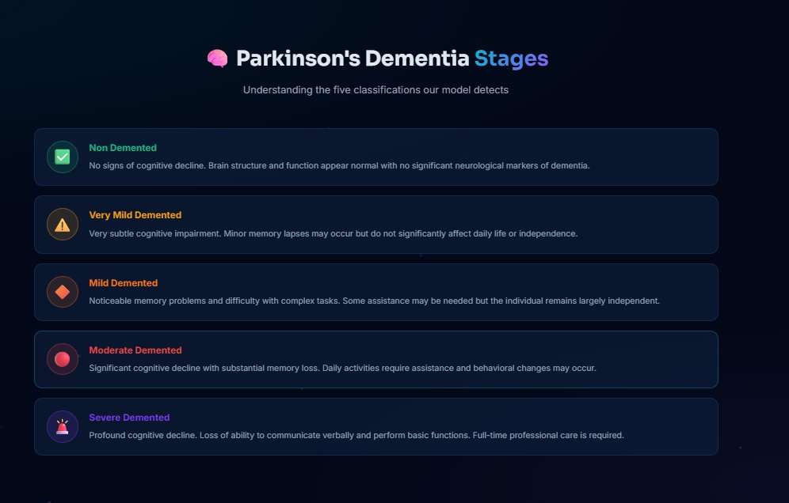
Figure 5.5: About Page — Parkinson's Dementia Stages Reference

Stage | Colour | Icon | Clinical Description
Non Demented | Green | ✓ Checkmark | No signs of cognitive decline. Brain structure and function appear normal.
Very Mild Demented | Yellow | ⚠ Warning | Very subtle impairment. Minor memory lapses; daily life largely unaffected.
Mild Demented | Orange | ◆ Diamond | Noticeable memory problems; difficulty with complex tasks; largely independent.
Moderate Demented | Red | ● Circle | Significant decline; substantial memory loss; daily assistance required.
Severe Demented | Purple | 🚨 Alarm | Profound decline; loss of verbal communication; full-time professional care needed.

5.1.6 Dashboard Page
The Dashboard provides each authenticated user with a personalised analytics overview. It displays summary KPI cards at the top, a Diagnosis Distribution donut chart, a Recent Analyses feed, and a Quick Actions panel.


Figure 5.6a: Dashboard — Single-Scan User View (Non Demented, 94.6% confidence)

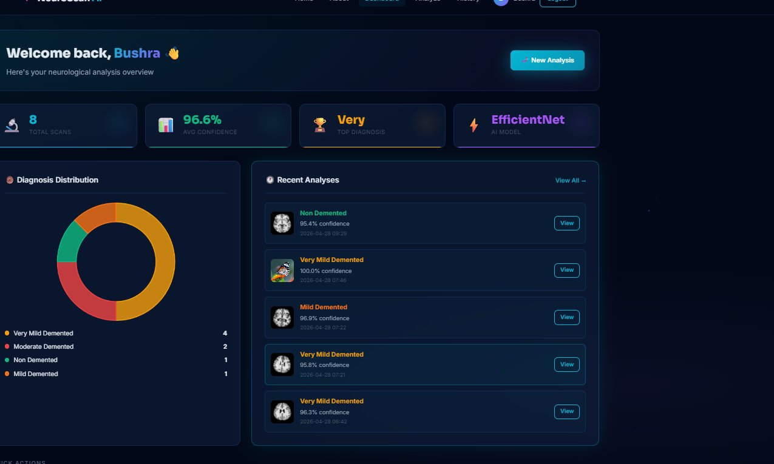
Figure 5.6b: Dashboard — Multi-Scan User View (8 scans, 96.6% avg confidence)

Dashboard Component | Description | Data Source
Total Scans card | Count of all analyses performed by the logged-in user | User's analysis history
Avg Confidence card | Mean confidence % across all user analyses | Aggregated softmax scores
Top Diagnosis card | Most frequently predicted class for this user | Mode of predicted labels
AI Model card | Currently active model name (EfficientNet) | System configuration
Diagnosis Distribution | Donut chart: breakdown of predicted classes by count | Historical predictions
Recent Analyses feed | Latest 5 analyses: thumbnail, label, confidence, date | User's scan history
Quick Actions | 4 tiles: New Analysis, View History, Learn More, Logout | Navigation shortcuts

5.1.7 Analyze Page — MRI Upload Interface
The Analyze page is the primary input interface for the C3BAM-SE-XAI v2 model. Users upload a brain MRI image via drag-and-drop or file browser, then click 'Analyze with AI' to submit the scan for inference.

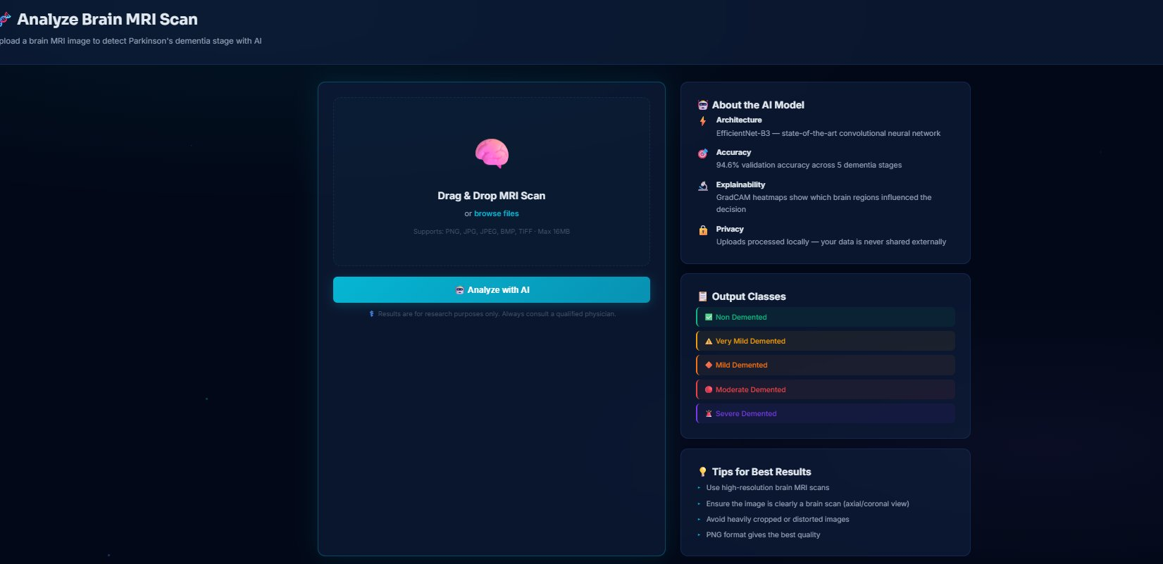
Figure 5.7: Analyze Page — Brain MRI Upload Form with AI Model Info Panel

Panel | Element | Detail
Left (Upload) | Drag & Drop zone | Accepts PNG, JPG, JPEG, BMP, TIFF up to 16 MB; shows preview on drop
Left (Upload) | Browse Files link | Opens OS file picker; validates extension and file size client-side
Left (Upload) | Analyze with AI btn | Teal full-width button; triggers POST request to Flask inference API
Left (Upload) | Disclaimer | Research-only notice: 'Results are for research purposes only. Always consult a qualified physician.'
Right (Info) | About the AI Model | 4 items: Architecture (EfficientNet-B3), Accuracy (94.6%), Explainability (GradCAM), Privacy (local processing)
Right (Info) | Output Classes | 5 colour-coded class badges: Non-Demented (green) → Severe (purple)
Right (Info) | Tips for Best Results | 4 tips: high-resolution, axial/coronal view, avoid cropping, PNG preferred

5.2 Input Forms — Description & Validation
NeuroScan AI contains three distinct input forms: the Authentication Form (Login/Register), the MRI Upload Form (Analyze page), and the filter/search controls on the History page. Each form includes client-side and server-side validation.

5.2.1 Authentication Form (Login / Register)

Figure 5.8: Input Form — Login / Sign In (Authentication)

Field | Type | Validation Rules | Error Handling
Email Address | Text/Email | Valid email format (RFC 5321); required | Red border + 'Invalid email' tooltip
Password | Password | Min 8 chars; required | Red border + 'Password too short' message
Sign In button | Submit | Both fields non-empty and valid | Disabled state until valid; spinner on submit
Eye icon toggle | Button | No validation | Toggles password visibility

5.2.2 MRI Upload Form (Analyze Page)

Figure 5.9: Input Form — Brain MRI Upload (Analyze Page)

Input Element | Accepted Values | Validation | On Error
File Drop / Browse | PNG, JPG, JPEG, BMP, TIFF | Extension check; max 16 MB file size | Alert: 'Unsupported format' or 'File too large'
Image Preview | Renders uploaded image inside drop zone | Confirms correct file loaded | Shows placeholder brain icon if load fails
Analyze with AI | Enabled only when valid image loaded | Frontend guard before API call | Button disabled; tooltip 'Please upload an image first'

Preprocessing applied server-side before inference:
1. Image resized to 224×224 pixels | 2. Converted to RGB (3-channel) | 3. Normalised to ImageNet mean/std | 4. Converted to PyTorch float32 tensor | 5. Passed through C3BAM-SE-XAI v2 model | 6. TTA ×5 softmax averaging applied

5.2.3 History Search & Filter Form

Figure 5.10: Input Form — Analysis History Search & Filter Controls

Control | Type | Function | Options
Search box | Text input | Filters history rows by diagnosis name (live) | Free text; updates table in real-time
All filter chip | Toggle button | Resets filter to show all analyses | Active by default (teal highlight)
Non filter chip | Toggle button | Shows only Non-Demented entries | Green indicator icon
Very Mild chip | Toggle button | Shows only Very Mild Demented entries | Yellow indicator icon
Mild chip | Toggle button | Shows only Mild Demented entries | Orange indicator icon
Moderate chip | Toggle button | Shows only Moderate Demented entries | Red indicator icon
Severe chip | Toggle button | Shows only Severe Demented entries | Purple indicator icon

5.3 Reports — Output & Results
The system generates two types of output reports: the real-time Analysis Result Report (shown immediately after inference) and the Analysis History Report (persistent tabular log of all past analyses). Both incorporate AI confidence metrics and Grad-CAM explainability visualisations.

5.3.1 Analysis Result Report
Immediately after the model completes inference, the user is presented with a comprehensive result page. It is divided into three zones: the Diagnosis Header (top), the Scan Analysis panel (left), and the Confidence Breakdown panel (right).

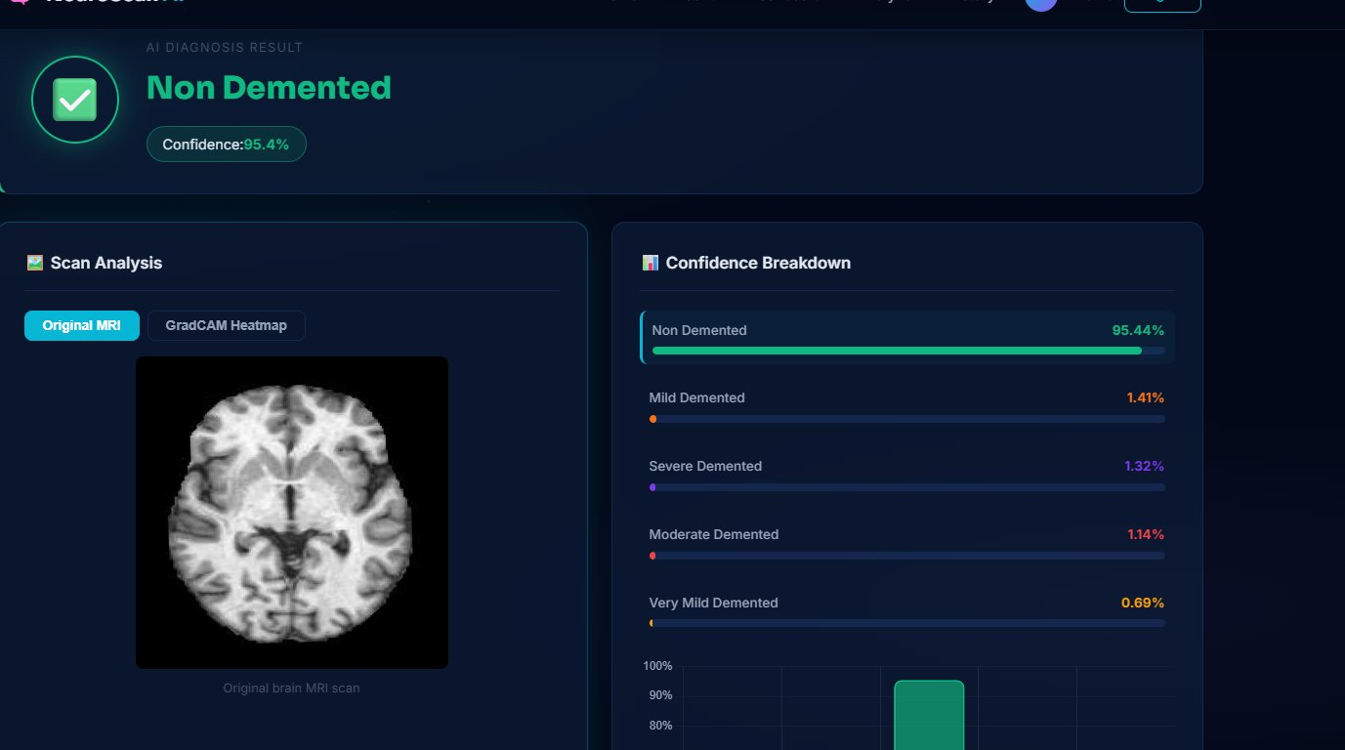
Figure 5.11: Output Report — AI Diagnosis Result (Non Demented, 95.44% Confidence)

Report Section | Element | Description
Diagnosis Header | AI DIAGNOSIS RESULT label | Small uppercase label above the primary result
Diagnosis Header | Predicted Class name | Large bold text in accent colour (e.g. 'Non Demented' in teal)
Diagnosis Header | Confidence badge | Pill badge showing % confidence of top predicted class
Diagnosis Header | Status icon | Green ✓ circle for low-risk; colour-coded for other classes
Scan Analysis (left) | Original MRI tab | Displays the uploaded brain MRI image at full resolution
Scan Analysis (left) | GradCAM Heatmap tab | Switches to heat map overlay; red = high model attention
Confidence Breakdown | Horizontal bar chart | 5 bars — one per class — with colour-coded % labels
Confidence Breakdown | Vertical bar chart | Additional bar chart below horizontal bars for at-a-glance comparison

Result Interpretation Guide:
Confidence > 90%: High certainty — model strongly identified the class. | Confidence 70–90%: Moderate certainty — review GradCAM regions. | Confidence < 70%: Low certainty — recommend re-scan or specialist review. | Always view the GradCAM heatmap to verify the model attended to anatomically correct brain regions (ventricles / periventricular white matter).

5.3.2 Analysis History Report
The History page provides a persistent, searchable table of all analyses performed by the authenticated user. Each row captures the key output metadata alongside action controls for detailed review or deletion.


Figure 5.12: Output Report — Analysis History Table

Column | Description | Data Type
# | Sequential analysis ID (e.g. #15) | Auto-increment integer
MRI Preview | Thumbnail of the uploaded brain MRI image | Image (60×60 px circular crop)
Diagnosis | Colour-coded badge with predicted class name | String with class-colour mapping
Confidence | Green progress bar + percentage value | Float % (softmax top-1 score)
Date & Time | Timestamp of analysis (YYYY-MM-DD HH:MM) | DateTime (UTC)
GradCAM | 'View 🔥' button — opens heatmap overlay modal | Button → modal with GradCAM image
Actions | Details (teal) + Delete (red) buttons | Navigation / DELETE API call

5.3.3 Dashboard Analytics Report
The Dashboard acts as an aggregated analytics report, summarising all historical analyses for the authenticated user in one view. It includes KPI cards, a diagnosis distribution chart, and a chronological recent analyses feed.


Figure 5.13: Dashboard Analytics Report — Multi-User Scan Overview (8 Scans)

Report Element | Value Shown | Clinical Use
Total Scans | Count of analyses for this user | Tracks patient/case volume
Avg Confidence | Mean model confidence across all scans | Indicates dataset quality and model certainty
Top Diagnosis | Most common prediction class | Identifies prevalent condition in scanned cohort
AI Model | EfficientNet (architecture name) | Confirms which model version was used
Diagnosis Distribution | Donut chart with class colour legend | Visual breakdown of case mix
Recent Analyses | Latest 5 entries with thumbnail, label, confidence, date | Chronological case log for review

5.4 Step-by-Step Usage Instructions

5.4.1 Performing a New Brain MRI Analysis
- Step 1 — Login: Open NeuroScan AI in a web browser and navigate to the Login page.
- Step 2 — Authenticate: Enter your registered Email Address and Password, then click Sign In →.
- Step 3 — Navigate to Analyze: From the Dashboard or navigation bar, click Analyze or New Analysis.
- Step 4 — Upload MRI: Drag a brain MRI image (PNG/JPG/TIFF, ≤16 MB) onto the drop zone, or click Browse Files.
- Step 5 — Confirm Upload: Verify the image preview renders correctly inside the upload panel.
- Step 6 — Run Analysis: Click the teal Analyze with AI button to submit the scan for inference.
- Step 7 — Interpret Results: Review the Analysis Result Report: check the predicted class, confidence score, and Grad-CAM heatmap.
- Step 8 — Explainability Check: Click the GradCAM Heatmap tab to verify the model attended to the correct anatomical regions.
- Step 9 — Review History: Access the History page to review all past analyses or export results.

5.4.2 System Requirements
Requirement | Minimum | Recommended
Browser | Chrome 90+ / Firefox 88+ | Chrome 120+ / Edge 120+
Screen Resolution | 1280×720 | 1920×1080 or higher
Internet | Required (web app) | Broadband ≥ 10 Mbps for fast upload
MRI Format | JPG / PNG | PNG, high-resolution (512×512+)
File Size | ≤ 16 MB | 1–5 MB (optimal inference speed)
Authentication | Registered account | Institutional email recommended

Chapter 5 Summary
This chapter provided the complete User's Guide for the NeuroScan AI web application. Section 5.1 presented annotated interface screenshots covering all seven pages of the system (Login, Home, How It Works, About, Dashboard, Analyze, History). Section 5.2 documented all three input forms (authentication, MRI upload, history filter) with field-level validation rules. Section 5.3 described the two primary output reports — the real-time Analysis Result Report (with Grad-CAM visualisation and confidence breakdown) and the persistent Analysis History Report — along with the Dashboard analytics summary. Section 5.4 provided step-by-step usage instructions and system requirements. Together, these sections equip clinicians, researchers, and system administrators with everything needed to operate the NeuroScan AI platform effectively and safely.

Chapter 6

CONCLUSION & FUTURE WORK

CHAPTER 6

CONCLUSION & FUTURE WORK

6.1 Conclusion
This project presented BrainMap XAI, an explainable deep learning framework named C3BAM-SE-XAI v2 for the classification of Parkinson’s disease using brain MRI images. The primary objective of this research was to develop an accurate, robust, and interpretable artificial intelligence system capable of assisting healthcare professionals in the diagnosis and analysis of Parkinson’s disease. The proposed framework combines the strengths of deep learning, attention mechanisms, and Explainable Artificial Intelligence (XAI) to provide reliable clinical decision support.
To achieve this objective, a comprehensive workflow was developed that included dataset collection, preprocessing, augmentation, model development, training, evaluation, and deployment planning. Advanced preprocessing and augmentation techniques were applied to improve dataset quality and address class imbalance. The proposed architecture integrated EfficientNet-B3 with CBAM (Convolutional Block Attention Module) and Squeeze-and-Excitation (SE) attention mechanisms, enabling the model to focus on the most informative spatial and channel-wise features present in MRI images.
A major contribution of this work is the incorporation of Grad-CAM-based Explainable AI techniques. Unlike traditional black-box deep learning models, the proposed framework provides visual explanations through heatmaps that highlight the brain regions influencing model predictions. This transparency improves the trustworthiness and interpretability of the system, making it more suitable for healthcare applications where explainability is essential.
Experimental results demonstrated the effectiveness of the proposed framework. The model achieved a training accuracy of 98.72%, validation accuracy of 94.71%, and 95.06% validation accuracy using Test-Time Augmentation (TTA ×5). The framework also achieved strong precision, recall, and F1-score values across most disease categories. The confusion matrix analysis confirmed that the model was able to classify Parkinson’s disease stages with high reliability, while Grad-CAM visualizations verified that the model focused on clinically relevant brain regions.
Overall, the developed C3BAM-SE-XAI v2 framework successfully addressed several limitations of existing Parkinson’s disease classification systems by improving classification performance, supporting five-class disease staging, enhancing feature representation through dual attention mechanisms, and providing explainable predictions. The results indicate that the proposed system can serve as a valuable decision-support tool for clinicians and researchers involved in neurological disease diagnosis and analysis.

6.2 Future Work
Although the proposed framework achieved promising results, several opportunities exist for further improvement and extension of this research.

1. Expansion of Dataset Size and Diversity
Future work can utilize larger and more diverse MRI datasets collected from multiple hospitals and medical institutions. Increasing dataset diversity will improve model generalization and reduce potential bias across different populations and imaging conditions.

2. Integration of Multi-Modal Medical Data
The current system relies only on MRI images for classification. Future research can combine MRI data with additional clinical information such as patient demographics, genetic factors, speech analysis, gait analysis, laboratory reports, and neurological assessments to improve diagnostic accuracy.

3. Advanced Explainable AI Techniques
Although Grad-CAM provides effective visual explanations, future studies can incorporate additional XAI methods such as SHAP, LIME, Integrated Gradients, and Attention Rollout techniques. Combining multiple explainability approaches may provide deeper insights into model decision-making.

4. Real-Time Clinical Deployment
The proposed framework can be deployed as a cloud-based or hospital-integrated diagnostic platform. Future development can focus on optimizing inference speed, reducing computational requirements, and creating a user-friendly clinical interface for real-world healthcare environments.

5. Early Disease Prediction and Progression Analysis
Future systems can be designed not only to classify existing disease stages but also to predict disease progression over time. Longitudinal patient data can be incorporated to monitor disease development and support personalized treatment planning.

6. Exploration of Transformer-Based Architectures
Recent advances in Vision Transformers (ViTs), Swin Transformers, and hybrid CNN-Transformer models have demonstrated strong performance in medical image analysis. Future research can compare these architectures with the proposed C3BAM-SE-XAI v2 framework to investigate further improvements in accuracy and robustness.

7. Quantitative Validation of Explainability
Future studies can evaluate the quality of Grad-CAM explanations using quantitative explainability metrics and expert clinical validation. This would provide stronger evidence regarding the reliability and clinical usefulness of AI-generated explanations.

8. Mobile and Edge AI Deployment
Future work may focus on developing lightweight versions of the framework that can operate on mobile devices, edge computing platforms, or low-resource healthcare environments. Such deployment would increase accessibility and enable wider adoption of AI-assisted diagnostic tools.
In conclusion, the proposed C3BAM-SE-XAI v2 framework establishes a strong foundation for explainable medical image analysis and Parkinson’s disease classification. Continued research and development in the areas of dataset expansion, explainability, multimodal learning, and clinical deployment can further enhance its effectiveness and practical impact in healthcare.

