**Cccc**

***GIT COMMANDS (ADD,COMMIT,STATUS,PUSH,PULL,MERGE,MERGECONFLICT,BRANCHING)***

1. **First we set path and then run clone command and sign-in**

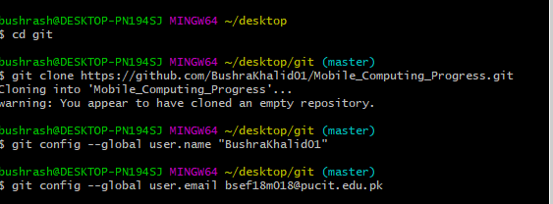

1. **Run add command**

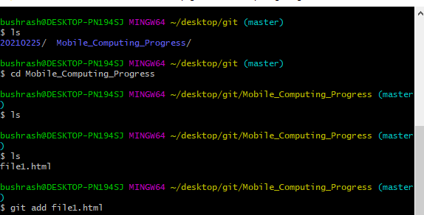

1. **Run commit command**

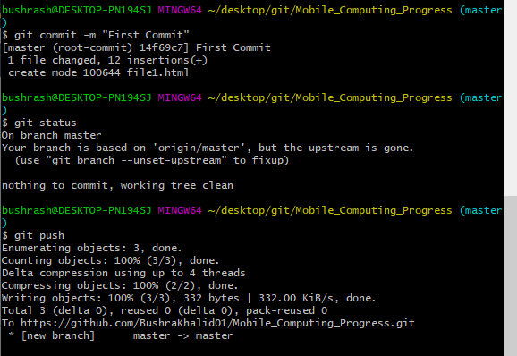

1. **Run push command**

1. **Run pull command**

1. **Merge conflict concept**

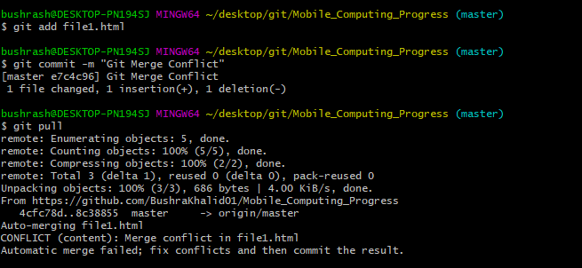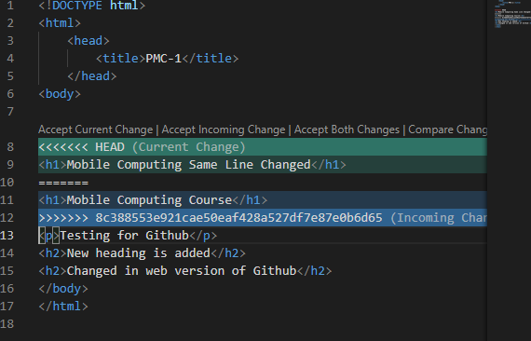

1. **Resolving merge issue**

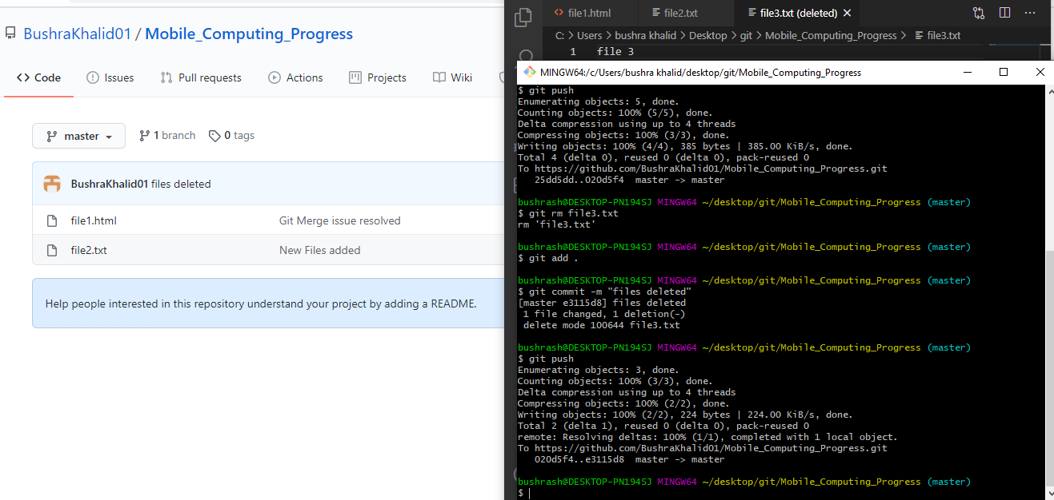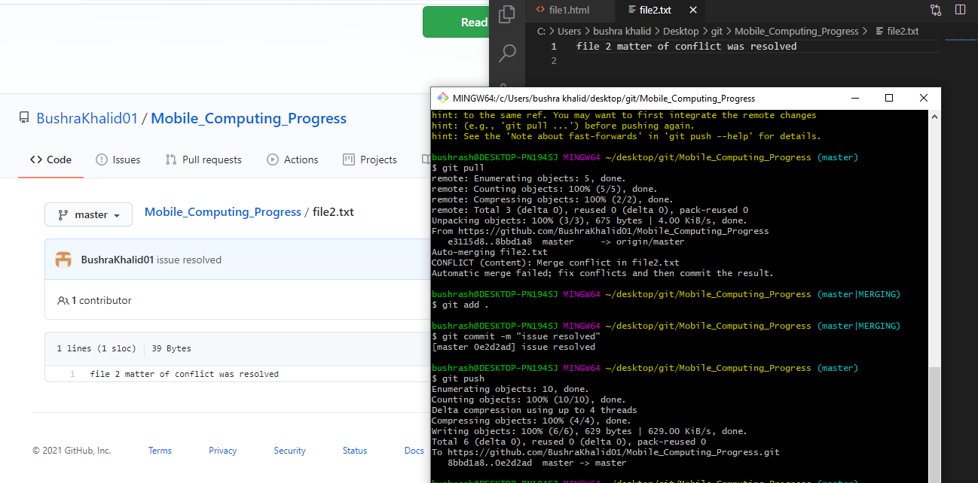

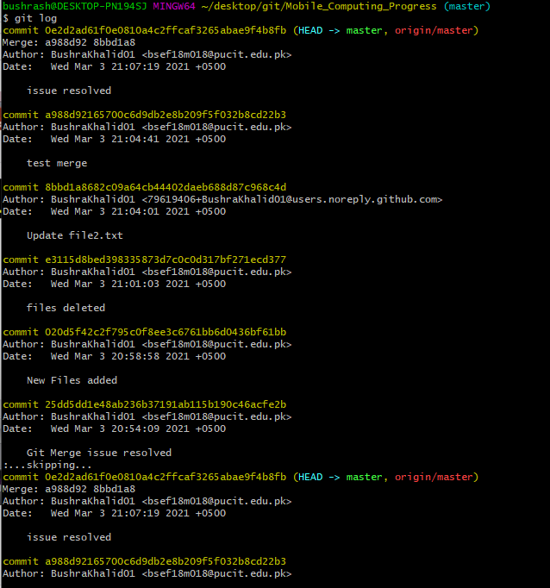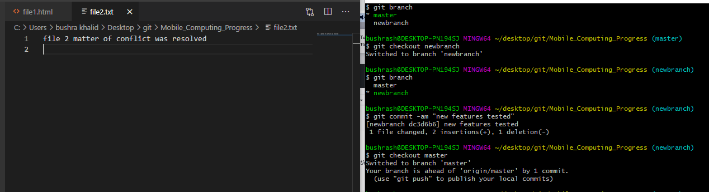

**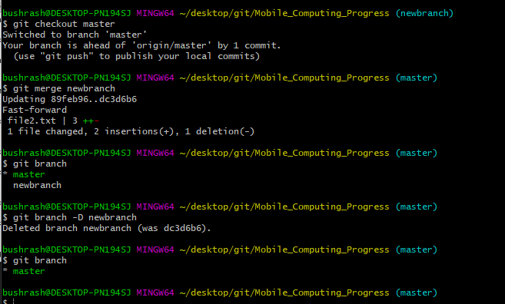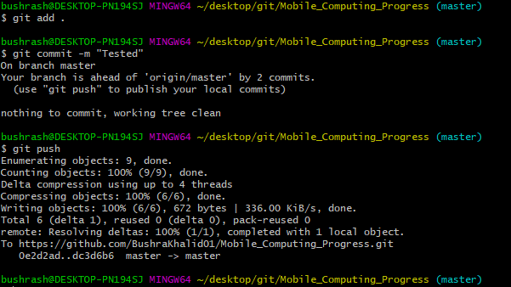

**ANDRIOD STUDIO**

After installing, and making a new project , made a screen and run on virtual device

1. **Add heading** 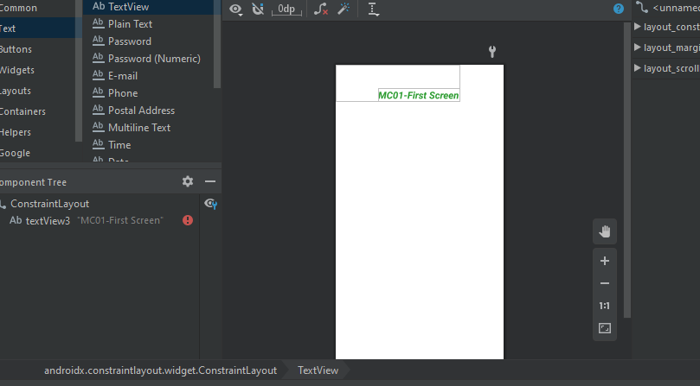
2. **Now create text-view field** 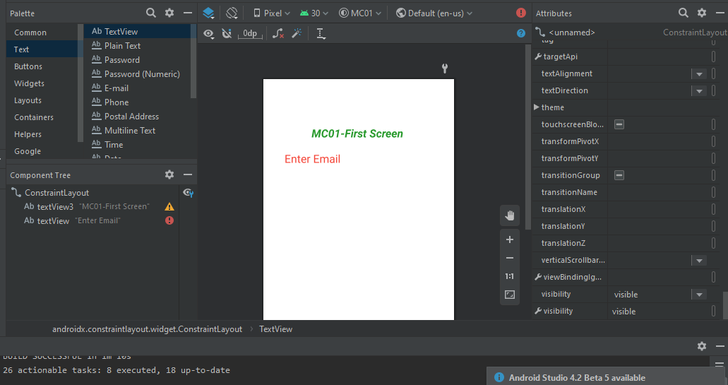
3. **now creating plain-text view field.**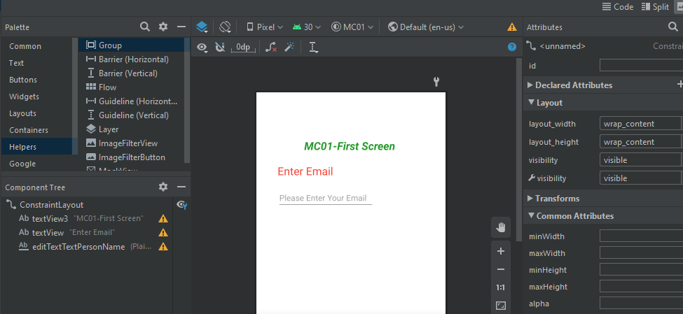
4. **adding radio button**

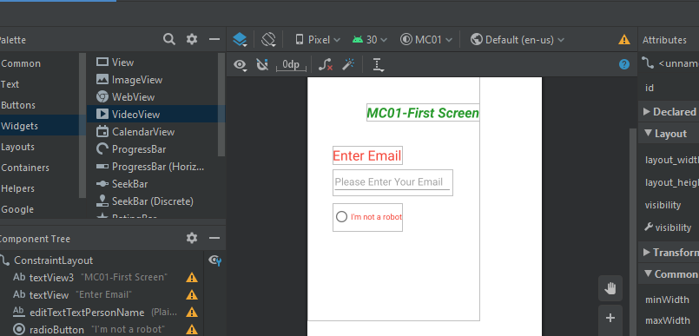

1. **adding button**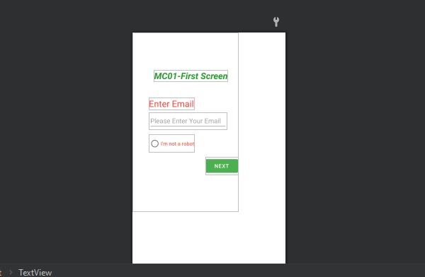
2. **after setting all the margin and field, run app on virtual device**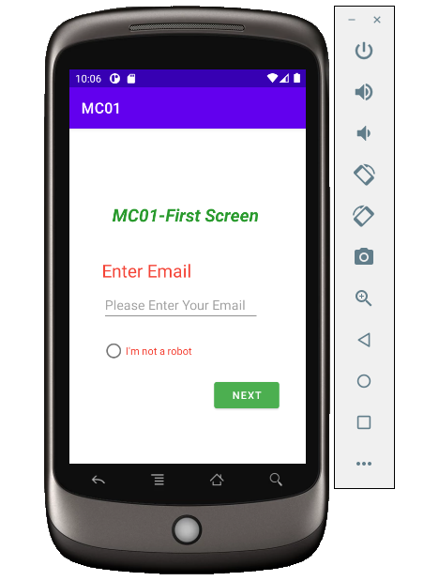

**Linear Layout Example:**

1. **first adding button**

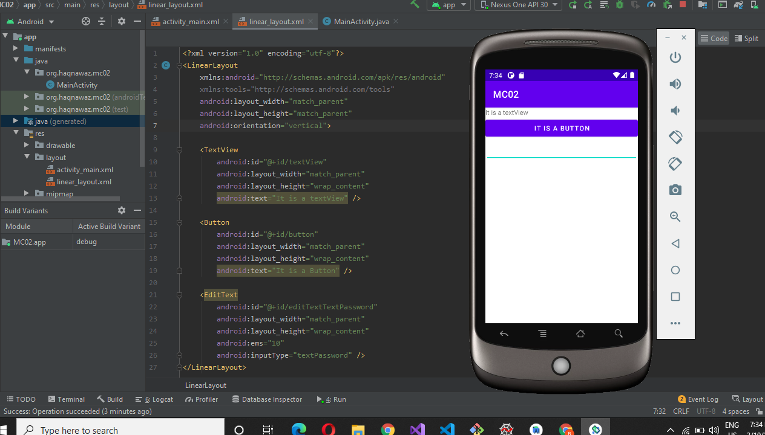

1. **By adding image**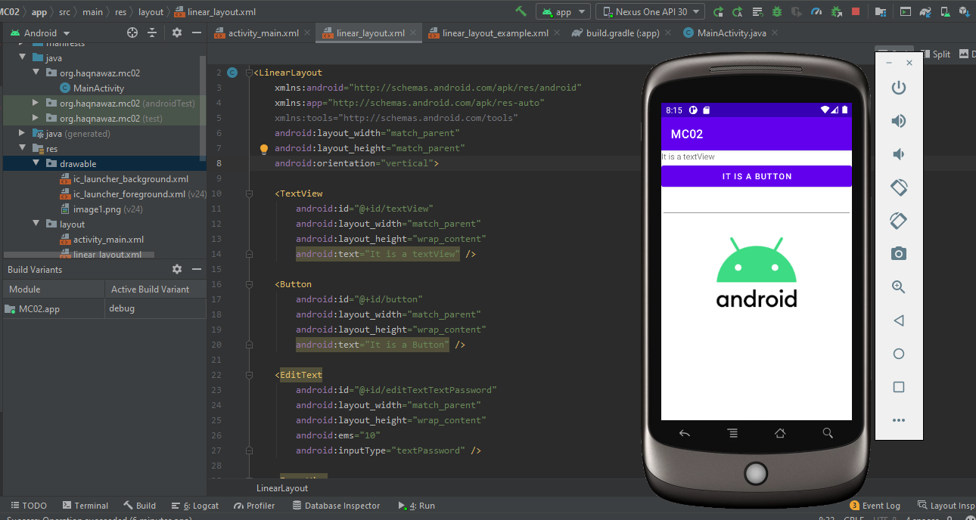

**Move from one Activity to other Activity Example Task**

1. **Create function in new Activity to call a Dialler and for a Link**

1. **Creating a function in main to call new activity**

1. **A close-up of a cell phone

   Description automatically generated with medium confidenceMobile view of Main Activity**
2. **Mobile view of new Activity**

**5-Dialler**

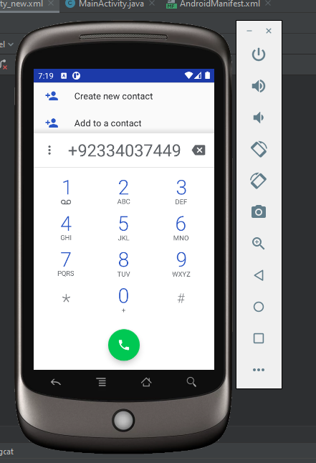

**6-Link**

**Counter Practice**

**Logcat onCreate, onResume, onStop, onPause, onDestroy, onStart Function practice**

1. **Main Activity**

1. **Main 2 Activity**

1. **Main 3 Activity**

1. **Screens**

**activity_main.xml**

**Activity_main2.xml**

**activity_main3.xml**

**Mobile View of activities on rotations**

**List-View-Practice**

