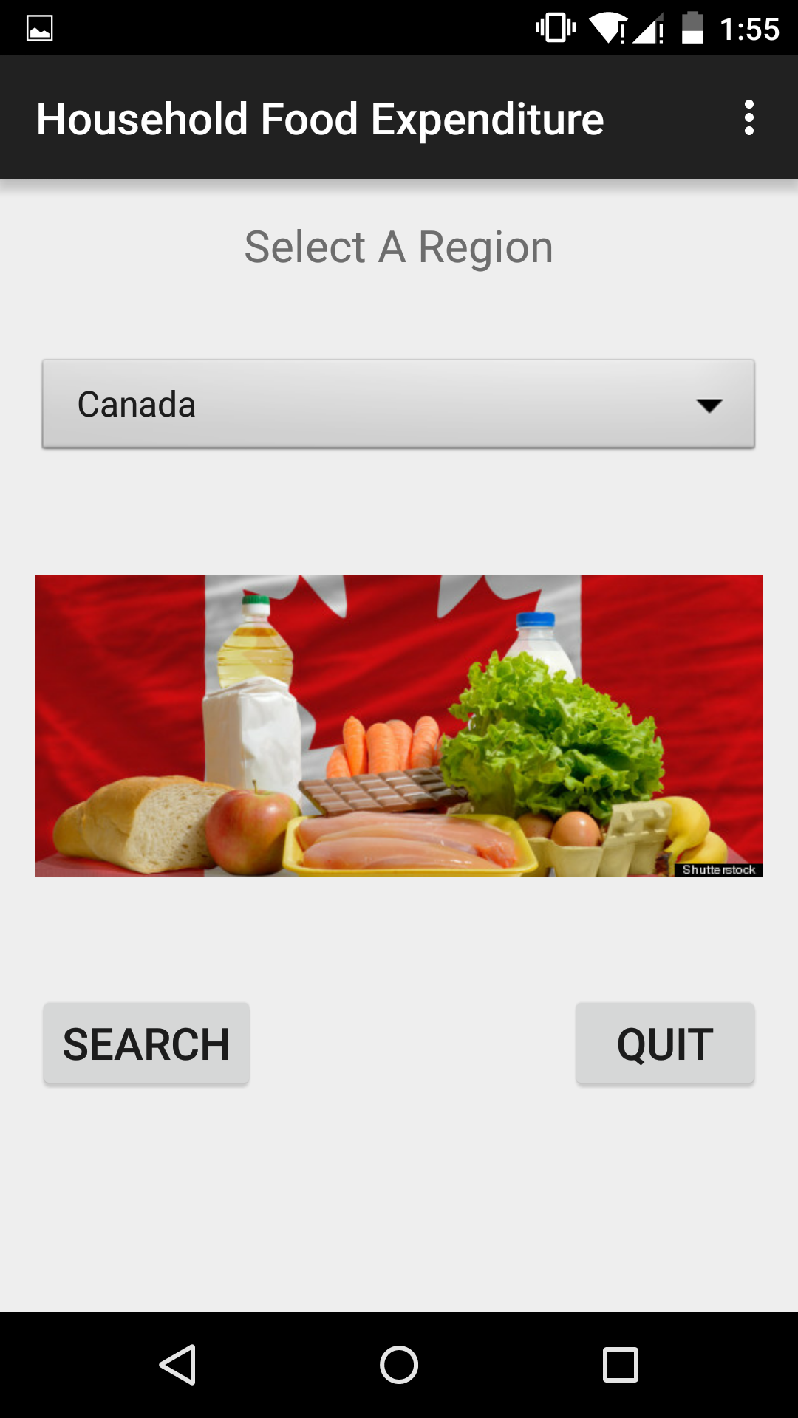
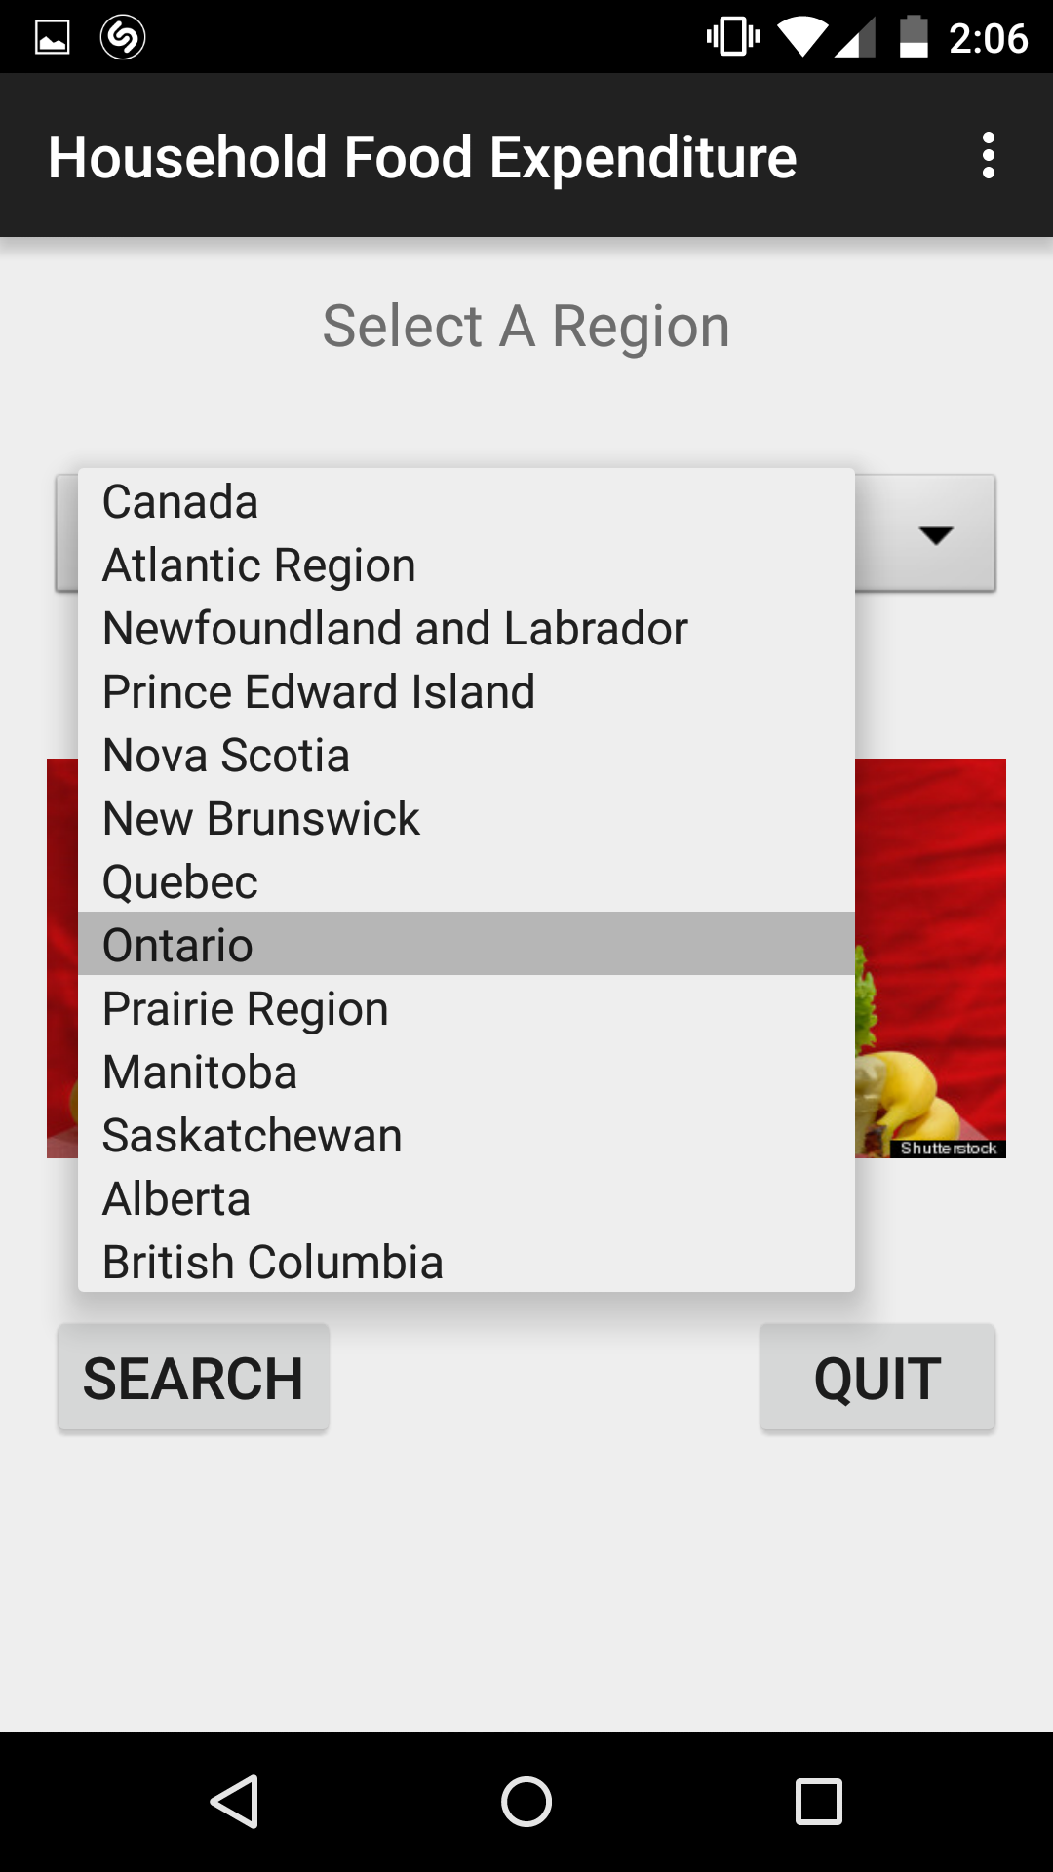
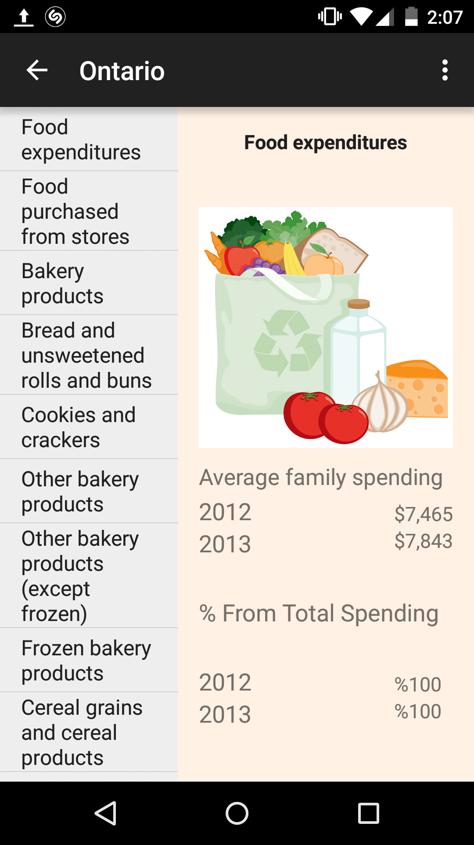
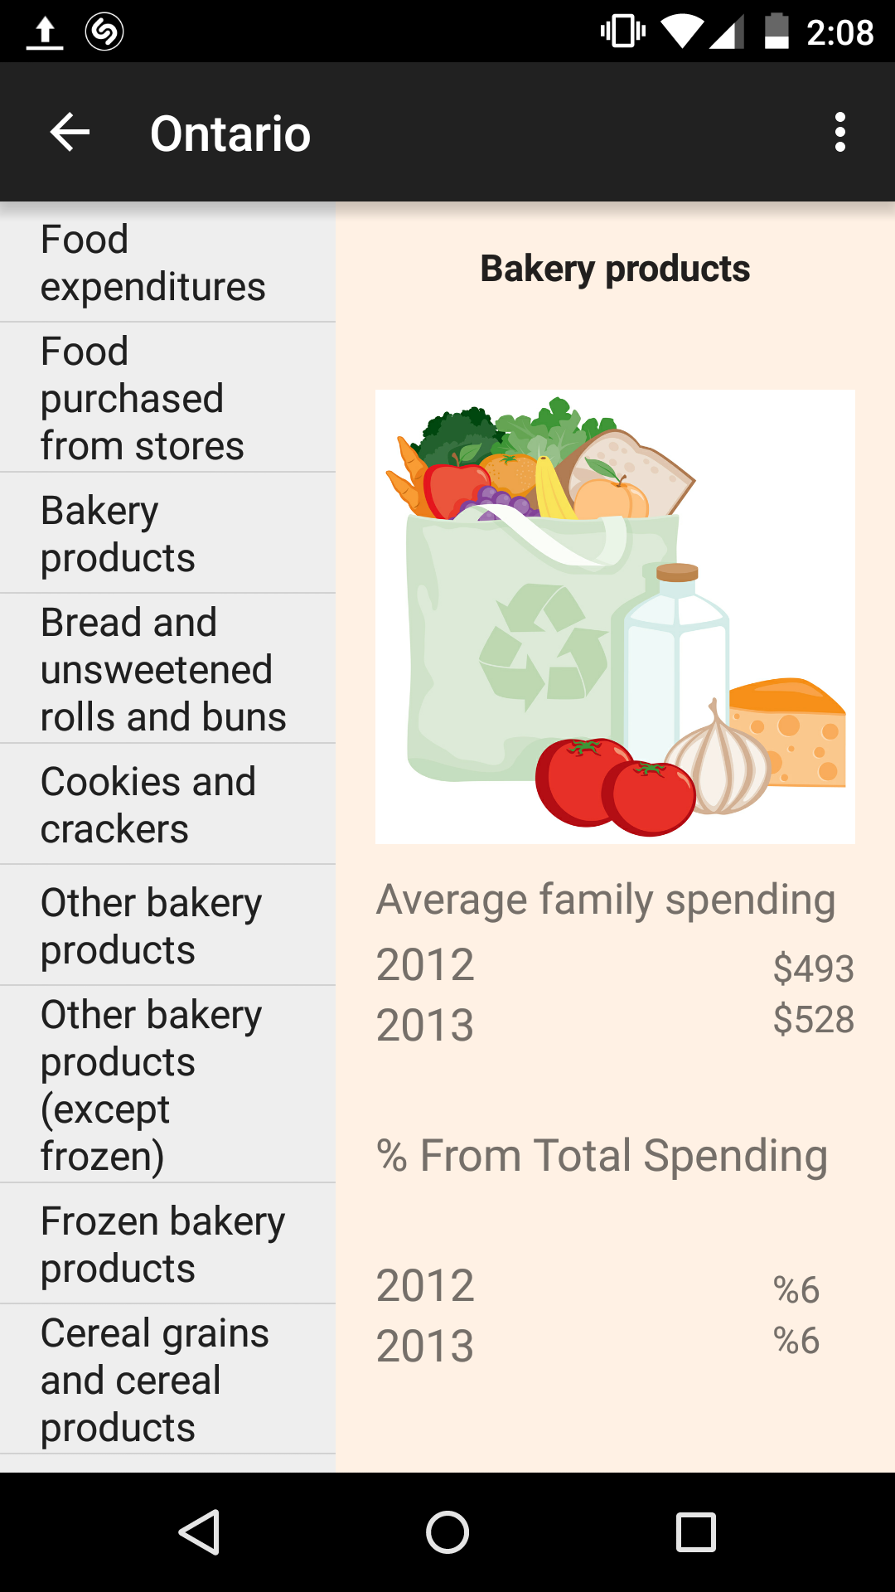
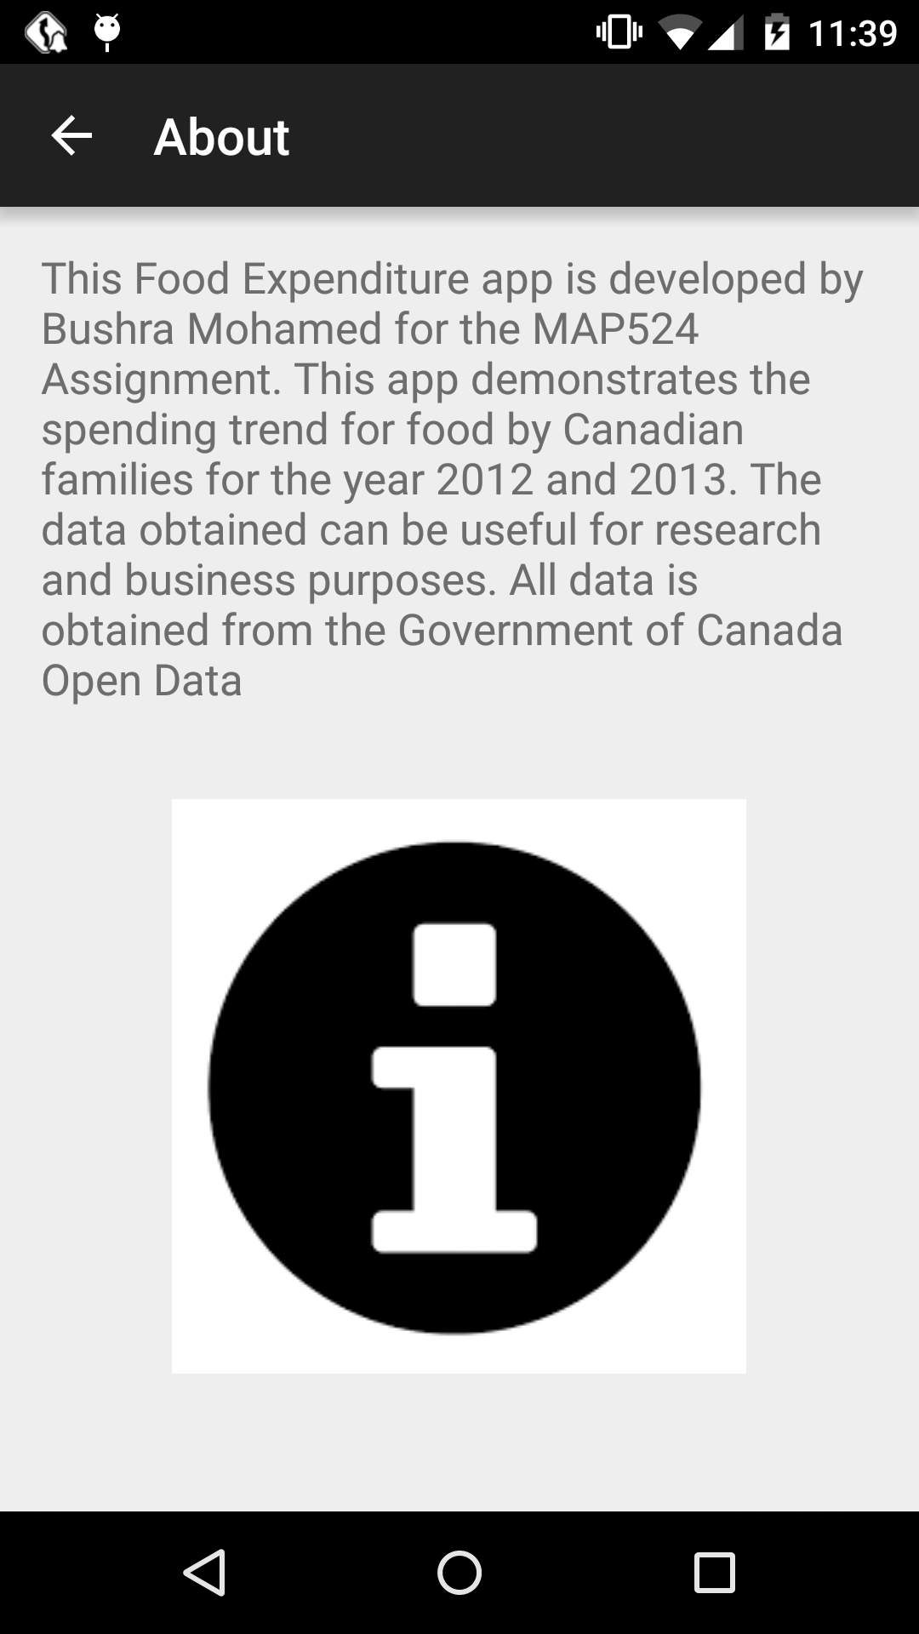
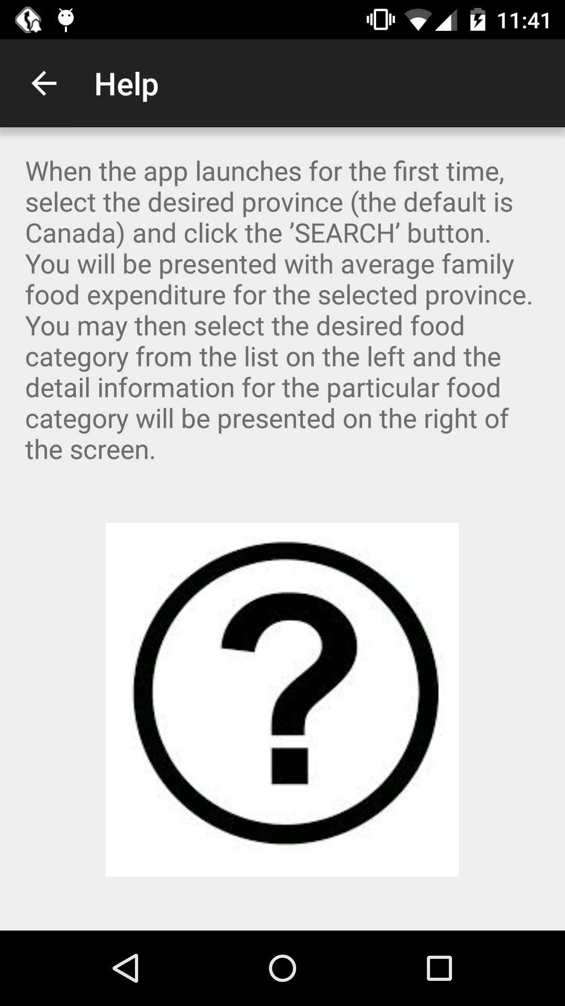

Course: MAP524A
Assignment #2

Professor: John Selmys

Due Date: April 10, 2015

Date Submitted: April 10, 2015

Student Name: Bushra Mohamed
Seneca 9-Digit ID: 018-633-123

Executive summary

For the course MAP524 android assignment, I have developed an app called “Food Expenditure”. I have chosen to use the “Average household food expenditure, by province” dataset, which is available in the Canadian government’s website. This dataset contains the average amount a family spends for the following food categories: food purchased from stores, food purchased from restaurants, bakery products, cereal grain and cereal products, fruit/fruit preparation and nuts, vegetables and vegetable preparations, dairy products and eggs, meat, processed meat, fish and seafood, non-alcoholic beverages and many other food products. This android app utilizes the dataset to display the average amount a family spends for the selected food category and for the selected province/region.

The goal of this app is to demonstrate the trend in food expenditure by Canadian families. Furthermore, the data obtained can be used for research purposes; for example, one can determine the number of heart disease diagnosis’ in Canada and use the average amount spent on items that contribute to heart disease to support their findings. The data can also be used by businesses to determine the food products that are popular and thus order food inventory accordingly.

Description of the final App

After closely examining the XML dataset, I came to learn that the dataset contains not only about food expenditure for Canada, but also for different provinces within Canada. Therefore, unlike my initial proposal, I decided to give the user the option of selecting a province or region to fetch data for.

List of features that work

- Displays all the provinces listed in the government dataset and allows the user to fetch data based on the selected province/region
- Display a list of food categories based on the “Average household food expenditure” dataset's list of categories
- Display the average amount spent on a food category by citizens of the selected province/region
- Calculates and displays the spending percentage for a category from the average total food spendings by families

Snapshots of working app

- The first UI when the app loads 2) User selects a province from the list
(default is Canada)

3) Default view when the Detail View 4) When user selects a food category from the
is loaded for the selected province list

5) When the about page is selected from 6) When the help page is selected from
action bar’s menu items action bar’s menu items

Conclusion

All the features that were listed in the initial proposal were successfully implemented in the app. Furthermore, after looking at the government xml file in detail, I decided to include data for different provinces within Canada and give the user the ability to select their desired province.

If I had more time, the feature that I would like to implement is some kind of graph, that will help to visualize the food expenditure between all provinces in Canada.

Overall, since I did not use a database to store the data, I expected the app to run slower. However, the app runs fast and smooth, even though it is parsing data every time a user selects a province and/or food category. I believe this app is user friendly and performs all the tasks that was initially proposed and more.

